

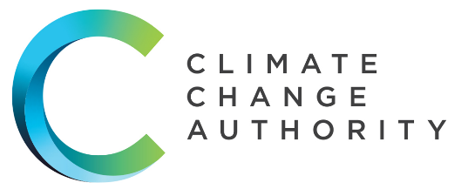
ENGAGEMENT STRATEGY
2023-25

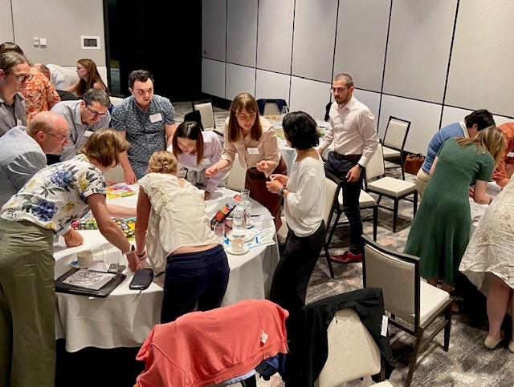
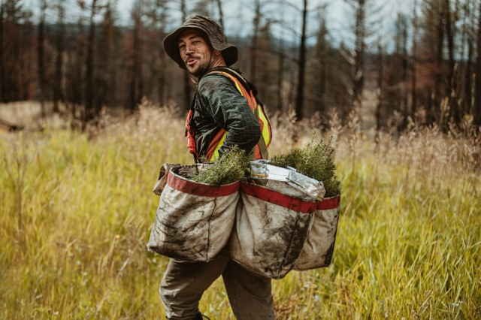

Copyright
Published by the Climate Change Authority www.climatechangeauthority.gov.au.
This work is licensed under the Creative Commons Attribution 3.0 Australia Licence. To view a copy of this license, visit http://creativecommons.org/licenses/by/3.0/au.
The Climate Change Authority asserts the right to be recognised as author of the original material in the following manner:
 or 
©Commonwealth of Australia (Climate Change Authority) 2023.
IMPORTANT NOTICE – PLEASE READ
This document is produced for general information only and does not represent a statement of the policy of the Commonwealth of Australia. The Commonwealth of Australia and all persons acting for the Commonwealth preparing this report accept no liability for the accuracy of or inferences from the material contained in this publication, or for any action as a result of any person’s or group’s interpretations, deductions, conclusions or actions in relying on this.


The Authority recognises the First Peoples of this nation and their ongoing connection to culture and Country. We acknowledge First Nations peoples as the Traditional Owners, Custodians and Lore Keepers of the world’s oldest living and continuous cultures and pay our respects to their Elders – past and present.

Who are we?
The Climate Change Authority is a statutory agency established under the Climate Change Authority Act 2011. Our purpose is to provide evidence-based advice on the response to climate change in order to:
- accelerate emissions reductions and help Australia play its role in the global effort to limit temperature increases; and
- enhance Australia’s prosperity and resilience as the climate changes and the world transitions to net zero emissions.

The Authority comprises nine members including a Chair and Australia’s Chief Scientist, and a secretariat. All our advice, publications, reports, and biographies of our members are available on our website.
This Engagement Strategy 2023-25 reinforces the Authority’s ongoing commitment to listen in order to:
- better understand the ways Australians experience climate change and the economic response to it
- increase awareness of the challenges and opportunities Australia faces into the future
- build understanding of the advice we provide, including the principles, evidence and logic underpinning our recommendations.
By recently passing legislation that reinforces and expands the Authority’s mandate, the Government has signalled it will listen to and value the outcomes of our consultation.
With our restored resources comes a restored vision and responsibility – to strive for best practice community consultation, including taking account of the views and concerns of Australians whose voices and experiences are not always heard. We intend to treat consultation as an opportunity to drive positive change in Australia’s net zero transformation journey.

The Climate Change Authority
Mr Grant King – Chair | Dr Virginia Marshall – Member
Prof. Lesley Hughes – Member | Dr Russell Reichelt AO – Member
Mr John McGee – Member | Ms Susie Smith – Member
Ms Sam Mostyn AO – Member | Mr Mark Lewis – Member
Dr Cathy Foley AO, PSM, FAA, FTSE – Chief Scientist


What do we do?
The Authority undertakes three main types of work:
- We provide advice to the Minister that relates to:
  - annual climate change statements, for which we will track and advise on progress towards Australia’s emissions reduction targets and adapting to the impacts of climate change
  - any new or updated emissions reduction targets for Australia’s Nationally Determined Contributions (NDC) to the Paris Agreement.
- We conduct reviews, namely:
  - the Carbon Credits (Carbon Farming Initiative) Act 2011, which includes the Emissions Reduction Fund. This review is done every 3 years.
  - the National Greenhouse and Energy Reporting Act 2007, which includes the Safeguard Mechanism. This is done every 5 years.
  - we conduct Special Reviews on other matters as requested by the Parliament or the Minister responsible for climate change.
- We conduct self-initiated research and analysis on climate change matters that support our broader work.
The full work program of the Authority can be found in our Corporate Plan on our website, as well as publications of all our previous work.


Why do we consult?
Consultation works best with a view on how consultation leads to change (see the Authority’s Theory of Change in Figure 1, below).
The Authority’s plan for policy evolution, like the Paris Agreement itself, is to review, ratchet and repeat. Providing input to our work is one way for individuals, organisations and communities to influence government action
We use the input we receive in submissions, along with information from other sources, when formulating our advice. We also share real world stories by including case studies and quotes in our reports, and we publish submissions on our website unless we are asked not to.
Consultation not only ensures our advice is based on best available information from diverse sources, but it also builds understanding of our advice and how we arrive at providing the recommendations we do. Consultation and understanding are the important ingredients in the recipe for social licence for change.
The Authority’s aim is to engage and listen in an open way, working towards a more prosperous, resilient nation. Consultation is a crucial step towards achieving this goal. 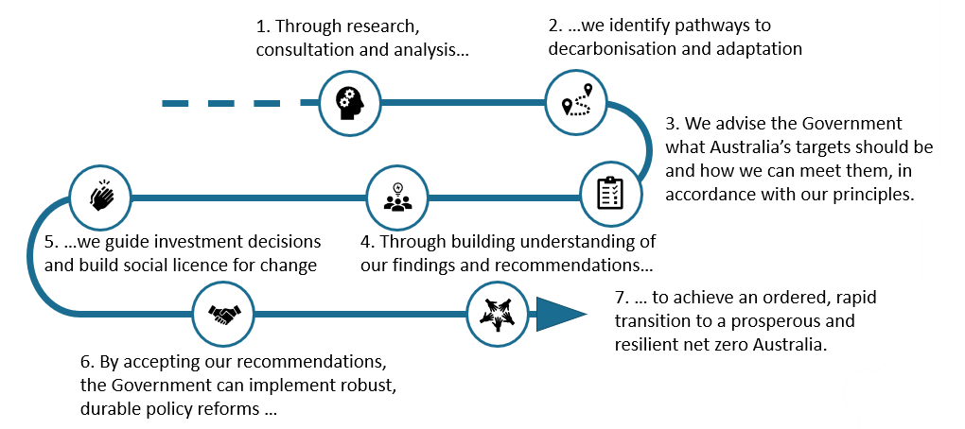
Figure 1: The Authority's Theory of Change. This illustrates how we envisage our role in assisting the Government to continuously improve its climate change related targets and policies.

What do we consult on?

We consult on all our projects in line with our principles, the needs of the project, and legislated requirements.
We seek to collaborate with others through the sharing of information, data and new research, through cooperating on analysis, and through partnering on some self-initiated reports. This improves our collective knowledge and practices and supports the development of our independent advice.

Who do we consult?

Climate change affects us all, and its impacts and our experiences differ depending on where we live, what we do for work, age, income, culture, and many other factors. Likewise, opportunities to benefit from change vary greatly too.
The Authority aims to consult as broadly as possible to best represent this variety of experiences and perspectives, including by engaging directly with communities, industry stakeholders, non-government organisations, First Nations peoples, and a broad range of experts and research institutes.
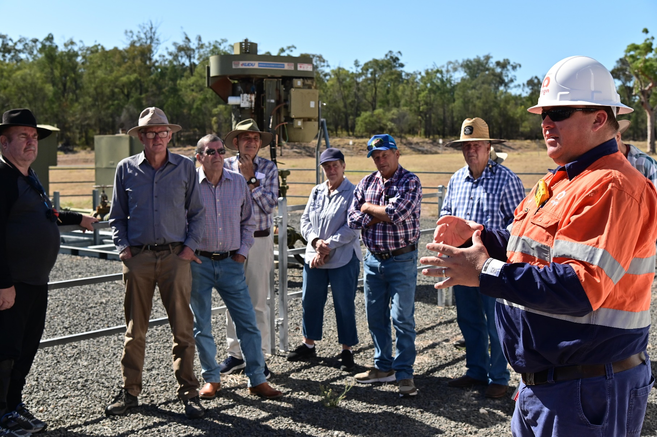
The Authority also engages with Australia’s governments at federal, state and territory and local levels, and with our international counterparts. This ensures we are up to date on domestic and international developments, and we are contributing to the coordinated national and global effort to address climate change.



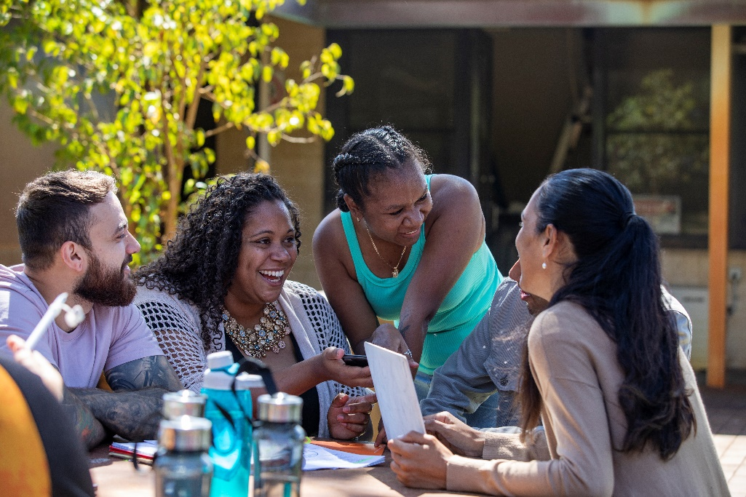


First Nations Australians can expect the Authority to listen to their needs and experiences. Many First Nations people and communities face challenges from both the physical and economic impacts of climate change. We will take the time to understand and recognise cultural and community differences, difficulties, and strengths. We will consult First Nations peoples to inform how our advice to Government on climate change policies can help address long-standing challenges and build community resilience.
The Authority recognises that each community is diverse and has different cultural protocols and requirements, including who to consult, critical development issues, specific rights and responsibilities of community members, and rules for cross-cultural consultation.
Reconciliation plays an important role in developing meaningful policy advice in response to a changing climate. The Authority recognises that Australia will benefit from becoming a more equitable society, one in which institutions, communities and individuals celebrate the unique and important contributions that have been, and continue to be made, by First Nations Australians.
The Authority seeks to build relationships and establish partnerships with First Nations peoples, where it is mutually beneficial to do so. Our aim is to better understand the issues and shape our policy advice to ensure it improves the resilience of First Nations peoples to climate change impacts and enables their capacity to take advantage of the opportunities available through net zero transformation.
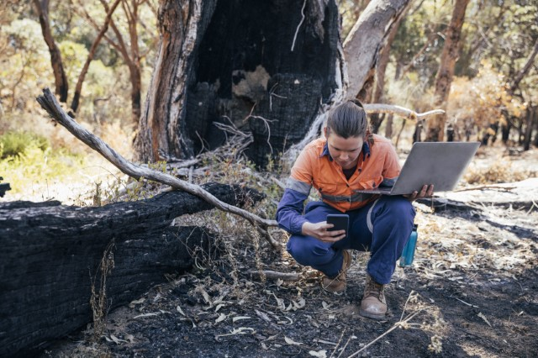
Rural, regional and remote communities can expect the Authority to engage with them in a way that respects their geographic and situational uniqueness. Many communities across Australia are facing the physical impacts of climate change, like worsening floods, droughts and heatwaves that affect their homes, health and livelihoods. Some regional, rural and remote communities are also facing social and economic impacts as the industries around them undergo the major transition to net zero emissions. Jobs and communities are changing. The Authority’s engagement approach aims to be place-based, participatory, demographically representative, honest, and accessible.
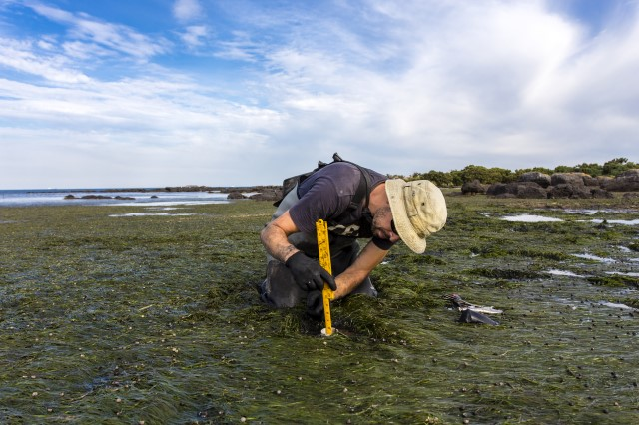
Climate change experts including climate scientists, environmental scientists, economists, industry specialists, social researchers and many others hold a wealth of information, data and evidence that can inform our advice to Government. Expertise is crucial for understanding how we can rapidly reduce emissions, transition our economies and communities, and adapt to locked-in climate impacts. Close consultation with experts is necessary to achieving our purpose: providing evidence-based advice on the response to climate change.

How do we engage?
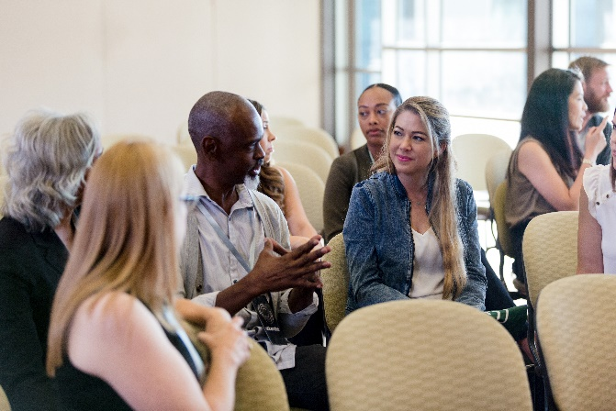
The Authority aims for best practice consultation. We follow the Australian Public Service Framework for Engagement and Participation, which follows the International Association for Public Participation best practice guidance.
Following these best practice frameworks does not mean that we engage in the same way for every project. In fact, quite the opposite. We will determine which engagement approaches best fit the project on a case-by-case basis. This depends on the situation, the needs of the project, the interests of the community and potential impacts they may be vulnerable to, and the time and resources available to stakeholders and to the Authority.
Our engagement approaches are outlined below.
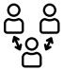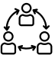
Inform
Consult
Involve
Collaborate
Goal
Promise to Australians
To provide objective information to assist participants in understanding the problem, alternatives, opportunities and solutions.
To obtain participant feedback on analyses, options, alternatives and decisions.
To work directly with participants throughout the process to ensure their concerns and aspirations are well understood and considered.
To partner with participants to develop options, alternatives and identify preferred solutions.
We will keep you informed of the most rigorous, up-to-date climate science and policy, and what impacts they are having.
We will listen to and value your concerns and aspirations and provide feedback on how your input can influence decisions.
We will work with you to ensure we can take account of your concerns and aspirations in our work and provide feedback on how your input can influence decisions.
We will look to you for advice and innovative solutions and incorporate this into our work to undertake reviews and prepare advice to Government.
Engagement Approaches

Consultation Principles
The Authority will follow the principles below when engaging, consulting and partnering. If the Authority commissions any consultation, it will require contractors to also follow these principles.
Principles | Practice
- Free, prior and informed consent (FPIC) | Provide clarity on purpose, scope and timeframes, including information on the aims, processes, activities, uses and outcomes of the research. This should be clearly communicated in a concise, accessible and culturally appropriate way to promote open and honest exchange between the Authority and participants.  Ensure enough time is provided that the information can be read and understood.  Make participants aware that their consent in may be withdrawn at any time.
- Respect | Ensure activities are culturally and individually appropriate. Consider the diversity of communities and stakeholders and their differing aspirations.  Do not expect people to gift you their knowledge and time; do not ask too much.  Understand social and cultural rules. This can include:  - understanding local community sensitivities towards different organisations, groups, disaster events and government departments  - respecting privacy and confidentiality  - observing local First Nations history, cultures and social dynamics, such as men’s and women’s business, cultural traditions, and important historical sites.
- Equity and community self-determination | Equity is a legislated principle of the Authority, and consultation is a key area where we should ensure an equitable approach.  Consultation is the first step towards ensuring the Authority hears what Australian communities really want and need.  Consultation is more fruitful and implementation is more successful when it is community-supported and, where possible, community-led.  Community engagement and buy-in is particularly important for marginalised and vulnerable groups, and groups which have fewer positive experiences dealing with government. This can include First Nations communities, some rural and regional communities, and other marginalised demographics.  More resources and new approaches may be required to consult with such groups.
- Accessibility | Ensure language is accessible, engaging and fit-for-purpose for the intended audience.  Consider how to make consultation as accessible as you can, e.g., help address any transport needs, consider the time of year, consider location and venue facilities.  Provide avenues for ongoing communication and information exchange.  Have flexible, adaptive approaches tailored to needs and capacity of participants. Allow time for flexibility, extensions, and changes to plans.
- Relationship-focused | Facilitate long-term relationships of trust, respect and honesty at both individual and organisational levels.  Collaborate with community leaders, organisations, government departments active in the space, and with colleagues to build broadly productive relationships.  Involve staff with existing relationships, relevant experiences and pursue relevant training and education.
- Transparency and reporting results | Share the results of consultation (e.g., key messages) with participants and publish the results online.  Allow participants to redact, clarify, expand or simply review our findings before we use them in our advice to government.  Share the outcomes of the relevant projects, including the recommendations, government responses and any benefits from research undertakings.
- Seeking feedback and pursuing improvements | Seek regular feedback on consultation activities and ask for feedback directly at town halls or other in person events.  Provide opportunities for participants, experts and peers to review our consultation activities and make suggestions, complaints or praise. This allows for refinement of engagement activities and ongoing improvement of our works.

Our engagement framework
This strategy is part of a broader framework that guides our community engagement and consultation activities. Our engagement framework ensures engagement activities and objectives are considered early in the project lifecycle so that we are well-prepared to consult appropriately, and that it is well-planned and best practice.
Engagement Framework
Corporate Plan
Reflects the Authority’s strategic priorities and describes what we will do in the year ahead.
Engagement Strategy
Sets out the objectives and guides the Authority’s engagement practice approach.
Consultation Plans
Set out the engagement approach for each of the Authority’s projects.

Public engagement process
The Authority follows the process set out below when developing and implementing public engagement plans.
Engagement Strategy
Stakeholder mapping
Preparation
Engagement
Reporting
1. Set the vision and level of ambition for engagement and consultation activities.
2. Identify, categorise and prioritise stakeholder groups and select appropriate engagement mechanisms.
3. Set short and long-term goals, determine logistics and set the format for engagement actions.
5. Collate and analyse contributions, forming key themes and findings to form robust evidence to support the project
4. Conduct engagement actions, ensure equitable participation, and stay focused on the objectives.
Closing the loop
6. Evaluate the engagement process, develop feedback and inform all participants of consultation findings and project outcomes.
PUBLIC ENGAGEMENT PROCESS
EVALUATION & FEEDBACK
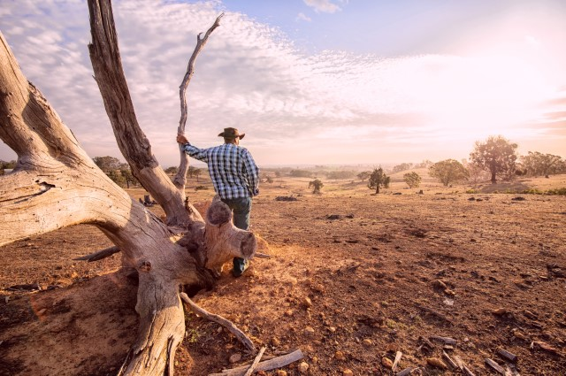

What do we already know?

The science tells us that climate change is real, it is caused by human activity, and it is here. The evidence also shows that it is possible to reduce the impacts of climate change by reducing global emissions, eliminating other kinds of pollution, restoring healthy ecosystems, and living in wiser ways that are sensitive to the climatic system. The faster we take these actions, the greater the benefits.
World-leading scientific institutions, including CSIRO, Bureau of Meteorology, Intergovernmental Panel on Climate Change (IPCC) and many United Nations organisations, all publish evidence showing that humans are causing climate change, and equally, that there are solutions.

The Authority agrees with and supports the Government’s acceptance of the science of climate change. Our job is to advise the Government on policies which respond to this knowledge. We use the best available information from a variety of reputable, expert sources including climate and environmental science, social science, economics, business and policy making. We aim to involve as many Australians in this process as possible so that our advice reflects the of the best interests and needs of Australian communities.





How to connect with us:

Sign up for news and access reports at www.climatechangeauthority.gov.au

Contact us at enquiries@climatechangeauthority.gov.au

Call us at (02) 6243 7684

Follow us on LinkedIn

