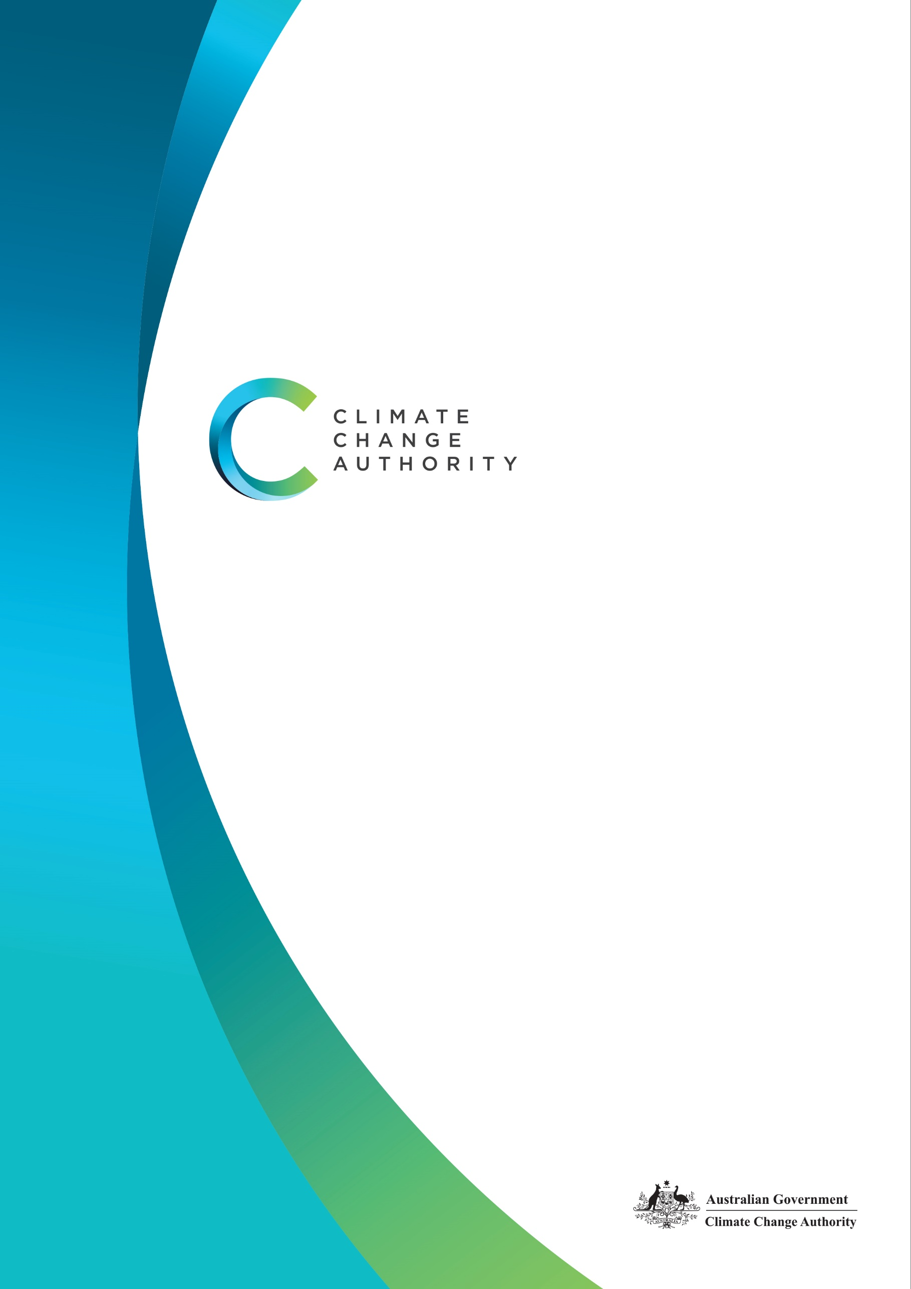

# Climate Change Authority

# Corporate Plan 2021-22

# August 2021

**The Authority recognises the First Peoples of this nation and their ongoing connection to culture and country. We acknowledge First Nations peoples as the Traditional Owners, Custodians and Lore Keepers of the world’s oldest living cultures, and pay our respects to their elders – past, present and future.**

Published by the Climate Change Authority

[www.climatechangeauthority.gov.au](http://www.climatechangeauthority.gov.au)

© Commonwealth of Australia 2021

This work is licensed under the Creative Commons Attribution 3.0 Australia Licence. To view a copy of this license, visit http://creativecommons.org/licenses/by/3.0/au

The Climate Change Authority asserts the right to be recognised as author of the original material in the following manner:

 

© Commonwealth of Australia (Climate Change Authority) 2021.

IMPORTANT NOTICE – PLEASE READ

This document is produced for general information only and does not represent a statement of the policy of the Commonwealth of Australia. The Commonwealth of Australia and all persons acting for the Commonwealth preparing this report accept no liability for the accuracy of or inferences from the material contained in this publication, or for any action as a result of any person’s or group’s interpretations, deductions, conclusions or actions in relying on this material.



Contents

Chair’s opening statement 3

Chief Executive’s foreword 4

Our purpose 5

Our functions 5

Our approach 5

Our guiding principles 6

Who we are 7

Our activities 8

Our operating context 9

Performance 14

Chair’s opening statement

I have joined the Climate Change Authority at a critical time. We have more information than ever before about the science of climate change and the urgency of action, and countries and companies are accelerating their decarbonisation efforts in response. We know that we need to achieve net zero emissions, globally, as soon as possible.

Australia is at the forefront of the impacts of climate change and, as an emissions intensive, trade-based economy, we are also exposed to the economic challenges of global decarbonisation. While the challenges are significant, I am optimistic that Australia can continue to contribute to the global effort and that our institutions, including the Climate Change Authority, will assist not only Government but business and the community to achieve the nation’s emission reduction goals and prosper.

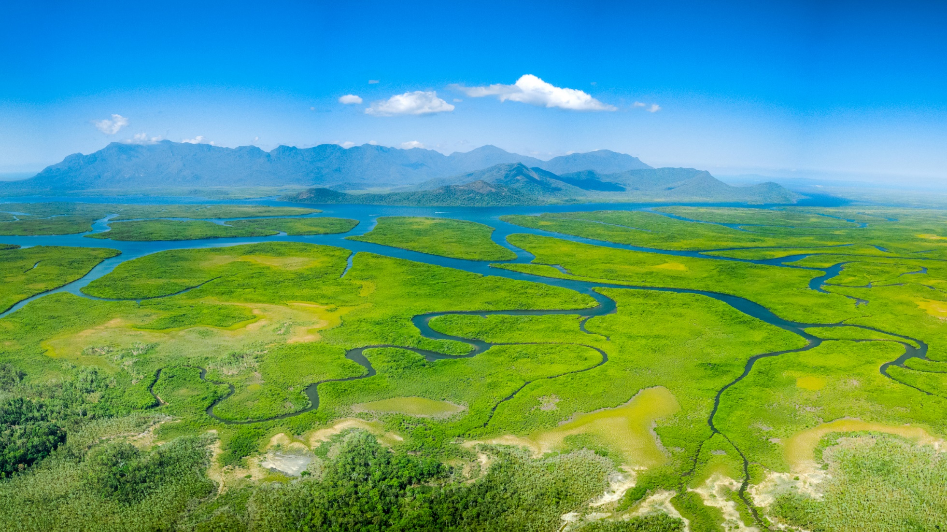We will continue to advise the Minister for Energy and Emissions Reduction, the Parliament and the broader community by providing balanced, evidence-based advice on how Australia could achieve and strengthen its goals in response to climate change. Our advice is underpinned by guiding principles, set out in legislation, to take a balanced and holistic view of climate change - one that delivers results for the entire nation.

In the coming years, as the world transitions to net zero emissions, the Authority will advise on ways to accelerate emissions reductions, help Australia play its role in the global effort to limit temperature increases, and enhance Australia’s prosperity and resilience as the climate changes. I look forward to working alongside Authority members, staff and with our Minister and stakeholders, to deliver the priorities outlined in this plan.

**Grant King**Chair



Chief Executive’s foreword

I am pleased to present the Climate Change Authority’s eighth corporate plan, which will guide our activities over the next four years.

The direction outlined in this plan builds on the foundations of an agency with a proven track record of undertaking rigorous, independent reviews and research and providing evidence-based, balanced advice on climate change matters. This Corporate Plan outlines who we are, what we will do, and how we will measure our performance in achieving our purpose over the life of the plan.

Over the past twelve months, the Authority has:

* released its second statutory review of the Emissions Reduction Fund (ERF), incorporating CSIRO analysis we commissioned of the risks that climate change poses to storing and maintaining carbon in the landscape
* continued its self-initiated research on the trade and investment trends in a decarbonising world and the economic implications for Australia
* released its weekly media digest, On Good Authority, to a growing audience of subscribers
* integrated the Climate Compass framework, a whole-of-government approach to climate risk management, into its risk management framework
* developed its first Reconciliation Action Plan, which sets out defined, measurable actions that the Authority will take to contribute to national reconciliation.

In all of its work, the Authority seeks to embody its principles and values of independence; broad and meaningful stakeholder engagement; excellence in research and analysis; transparency; good governance and accountability; and capacity building.

Earlier this year I welcomed new Chair Mr Grant King and members Ms Susie Smith and Mr John McGee, and the wealth of relevant expertise and knowledge they bring to the Authority with them. They join with ongoing members Mr Mark Lewis, Mr Russell Reichelt AO and Chief Scientist Dr Cathy Foley AO PSM, in leading the future work of the Authority.

I would like to express my thanks and appreciation to Dr Wendy Craik AM for her leadership in guiding the Authority from 2016 and upholding it as an institution of high repute and capability during her term as Chair. I would also like to thank Mr Stuart Allinson, Ms Kate Carnell AO, and the Hon John Sharp AM for their commitment and service to the Authority. Over the past five and half years they led the substantial work program of the Authority, including [reviews](https://www.climatechangeauthority.gov.au/publications/legislative-reviews) of the ERF and the National Greenhouse and Energy Reporting scheme and research into the significant opportunities that global action on climate change presents for Australia.

The Authority is supported by an expert secretariat. I thank them for their hard work, commitment to excellence, collegiality and good humour.

**STATEMENT OF PREPARATION**

I, Brad Archer, as the Accountable Authority of the Climate Change Authority, present the Authority’s *Corporate Plan 2021-22*, which covers reporting periods 2021-22 to 2024-25 as required under s35(1)(b) of the *Public Governance, Performance and Accountability Act 2013* (Cth) and Division 8 of the *Climate Change Authority Act 2011* (Cth). The plan is prepared in accordance with the Public Governance, Performance and Accountability Rule 2014.

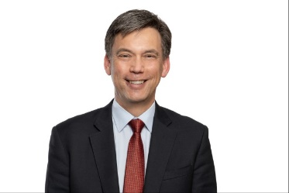**Brad Archer**  
Chief Executive Officer



Our purpose

The Climate Change Authority’s purpose is to provide balanced, evidence-based advice on the response to climate change, in order to:

* accelerate emissions reductions and help Australia play its role in the global effort to limit temperature increases; and
* enhance Australia’s prosperity and resilience as the climate changes and the world transitions to net zero emissions.



Our functions

The Authority’s functions are set out in its enabling legislation, the *Climate Change Authority Act 2011* (Cth), and can be summarised as follows.

* conduct reviews of the Emissions Reduction Fund and the National Greenhouse and Energy Reporting Scheme
* conduct special reviews of matters relating climate change as requested by the Minister responsible for climate change or by both Houses of the Australian Parliament
* undertake research about matters relating to climate change and other matters relating to the performance of our functions



Our approach

We strive to deliver on our purpose and functions by:

* conducting and publishing robust and transparent reviews and research, taking an holistic and strategic approach
* taking account of diverse perspectives by engaging with a wide range of contributors
* partnering and collaborating with others, in the public and private sectors
* meeting our statutory obligations, including by completing statutory and special reviews on time

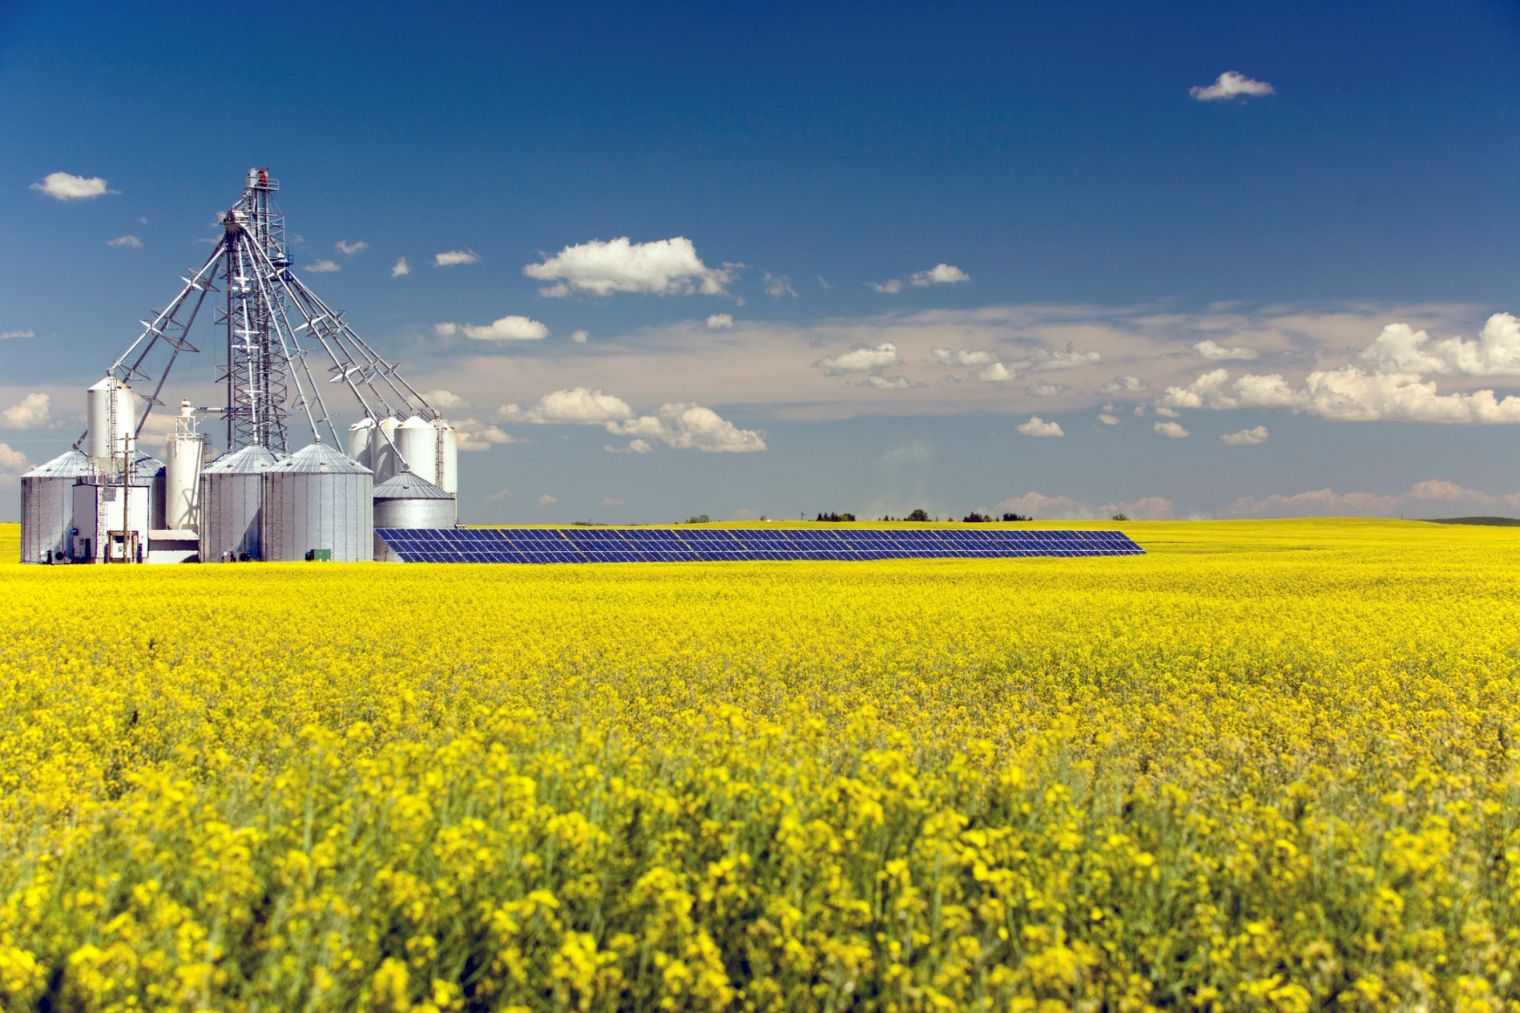

 Our guiding principles

In performing our functions, our legislation requires us to have regard to the principle that any measures to respond to climate change should:

* be economically efficient
* be environmentally effective
* be equitable
* be in the public interest
* take account of the impact on households, business, workers and communities
* support the development of an effective global response to climate change
* be consistent with Australia’s foreign policy and trade objectives

Additional principles that the Authority considers relevant to its work are:

Independence

The Authority operates independently under its own legislation, budget allocation and staff, as a non-corporate, statutory body located in the Industry, Science, Energy and Resources portfolio. We are committed to independence and impartiality when undertaking research and reviews and in providing advice is based on our own research and judgements.

Broad and positive stakeholder engagement

The Authority takes account of all available inputs and perspectives by engaging with a wide range of stakeholders and other contributors with an interest in climate change policy and related matters. We consult the public on every review, consistent with the requirements set out in our legislation.

Excellence in research and analysis

The credibility of the Authority relies on the quality of its research, analysis and reporting. We undertake detailed planning and thorough research and analysis, drawing on the best available knowledge. We also have a skilled workforce with a broad range of experience, and established links to relevant national and international expert organisations.

Transparency

The Authority operates in an open and transparent manner. We have a statutory obligation to publish our research and review reports and all (non-confidential) public submissions to our review reports. Our reports are a result of reviewing and synthesising existing materials, engaging with stakeholders and undertaking independent research to generate original reporting, analysis and advice.

Good governance and accountability

The Authority maintains high standards of accountability and governance. As a Government agency, the Authority is subject to the *Public Governance, Performance and Accountability Act 2013* (Cth) and Public Service Act 1999 (Cth), and has specific additional governance requirements under the *Climate Change Authority Act 2011* (Cth).

Valuing our most valuable asset

The Authority's professional, capable and committed workforce is its most valuable resource. Continued investment in our staff, in an inclusive way that respects and reflects the diversity of our skills, knowledge and backgrounds, is vital for maintaining and enhancing the Authority's performance. We provide all staff with the opportunity to develop skills and knowledge through formal training and other development opportunities.

 Who we are

The Climate Change Authority consists of a Chair, the Chief Scientist and up to seven other members. The members are supported by a Chief Executive Officer (CEO), who is the Accountable Authority responsible for the day-to-day running of the Authority, and secretariat staff engaged under the *Public Service Act 1999* (Cth).

Authority members

The current membership comprises:

*Chair*: Mr Grant King

*Member*: Ms Susie Smith

*Member*: Dr Russell Reichelt AO

*Member*: Mr John McGee

*Member*: Mr Mark Lewis

*Ex officio member*: Dr Cathy Foley AO PSM (Chief Scientist of Australia)

The Authority members bring substantial experience, knowledge and standing in the vast majority of fields that underpin our work and are identified in our Act, including economics, industry, technology development and adoption, energy production and supply; greenhouse gas emissions measurement and reporting, greenhouse gas abatement measures, financial markets and investment, trading of environmental instruments, land resource management, environmental management and public administration. Details of Authority members’ qualifications and expertise can be found on the Authority’s website at [www.climatechangeauthority.gov.au](http://www.climatechangeauthority.gov.au/).

Authority secretariat

The Authority is supported by a secretariat with an average staffing level of nine employees engaged under the *Public Service Act 1999* (Cth), including its CEO. The secretariat’s small corporate team manages finance, human resources, procurement, accommodation and security, risk and governance and information technology. Secretariat staff members have expertise and qualifications in climate change, science, economics, law, international relations, public affairs and communications.

 Our activities

The Authority’s activities over the reporting period will focus on statutory reviews of the Carbon Credits and National Greenhouse and Energy Reporting legislation, self-initiated research on climate change matters and other Special Reviews as requested by the Minister or the Parliament.

This corporate plan covers the four years from July 2021 to June 2025. In line with its functions and available resourcing, the Authority will focus on the following activities.

**Activity 1: Complete reviews of the National Greenhouse and Energy Reporting and Carbon Credits legislation**

In 2023, the Climate Change Authority will review the legislation underpinning the Emissions Reduction fund and the national emissions reporting framework concurrently for the first time.

The Authority is legally required to review, by 31 December 2023:

* the *Carbon Credits (Carbon Farming Initiative) Act 2011* (Cth)*,* whichunderpins the Emissions Reduction Fund
* the *National Greenhouse and Energy Reporting Act 2007* (Cth), which establishes a single national reporting framework for greenhouse gas emissions and companies’ energy consumption and production. The legislation also supports the safeguard mechanism, which sets limits on the emissions of large businesses.

**Activity 2: Other reviews requested by the Government or Parliament**

In 2021–22 and for the remaining three work periods, the Authority may be asked to perform other Special Reviews by the Minister or the Parliament.

**Activity 3: Self-initiated research and analysis**

In the lead up to the statutory reviews (Activity 1), the Authority intends to continue to undertake self-initiated research and analysis into how Australia can prosper in a world transitioning to net zero emissions.

During the life of this corporate plan, the Authority will identify and undertake further research on climate change matters if opportunities arise between statutory and special reviews.

 Our operating context

Governance framework

The Authority undertakes its work within a strong governance framework, including meeting governance requirements under the *Public Governance, Performance and Accountability Act 2013* (Cth). To ensure it complies with governance requirements, the Authority will continue to:

* ensure that delegations for human resources and finances are appropriate
* ensure there is control and oversight to deal with fraud and risk
* maintain an Audit Committee
* educate its staff to apply APS Code of Conduct and Values on a day-to-day basis
* educate new staff on the Authority’s governance practices
* maintain governance issues as standing agenda items on regular senior management meetings.

Operating environment

The Intergovernmental Panel on Climate Change has recently made clear the need for increased urgency in tackling the global challenge of climate change.[1] Human-induced climate change is already affecting many weather and climate extremes, and unless deep reductions in greenhouse gases occur in coming decades, the temperatures goals of the Paris Agreement will soon be exceeded, further intensifying impacts on global climate systems. Countries around the world have been raising the ambition of their climate change policies and this momentum appears set to continue in the lead-up to the United Nations climate change conference in Glasgow in November 2021 (COP26). Governments, investors and consumers will increasingly favour lower emissions goods and services. As a small, open economy heavily depending on international trade and investment flows, Australia faces both significant challenges and opportunities as the world accelerates action to reduce emissions.

The Australian Government has announced significant, new climate change initiatives in recent years, including for example the Climate Solutions Fund, the Low Emissions Technology Roadmap, development of the Future Fuels Strategy and, together with the states and territories, the National Hydrogen Strategy. The Government is also refreshing the National Climate Resilience and Adaptation Strategy and improving information on the risks posed by a changing climate, for example through the Australian Climate Service initiative.

Much more work is needed to support Australia’s strategic response to climate change and put Australia on a prosperous and resilient path to net zero emissions. Operating within the context of significant ongoing changes in global political, economic, societal, technological and environmental systems, the challenges of advising on the response to climate change have become increasingly complex. The Authority actively scans the operating environment and aim to provide timely advice when new challenges and opportunities arise.

In 2019, the Government reversed a policy to wind up the Authority and allocated additional funding to support ongoing operations at current levels. This additional funding currently lapses after 2023-24. The Authority is categorised as a micro-agency and maintains an Average Staffing Level (ASL) of 9. Having limited resources, we work with other organisations to keep abreast of developments and to leverage expertise.

Capability

#### Workforce

The Authority relies on its staff to undertake the research and analysis that supports its reviews and reports, and to manage the corporate functions of the agency. Staff expertise and professionalism are critical to the production of high-quality reports, building and maintaining good stakeholder relationships, and ensuring the smooth operation of the agency.

The Authority encourages employees to undertake learning and development to build up competencies relevant to their roles. The Authority has a study assistance policy that sets out the assistance provided to staff for learning and development opportunities. The policy provides financial and leave assistance to its staff enrolled in study or training that is relevant to the operational needs of the agency.

The Authority also provides one-on-one coaching to address particular development needs and extensive on-the-job training. Each staff member has the opportunity to identify and access appropriate training through the Authority’s Performance and Development Program.

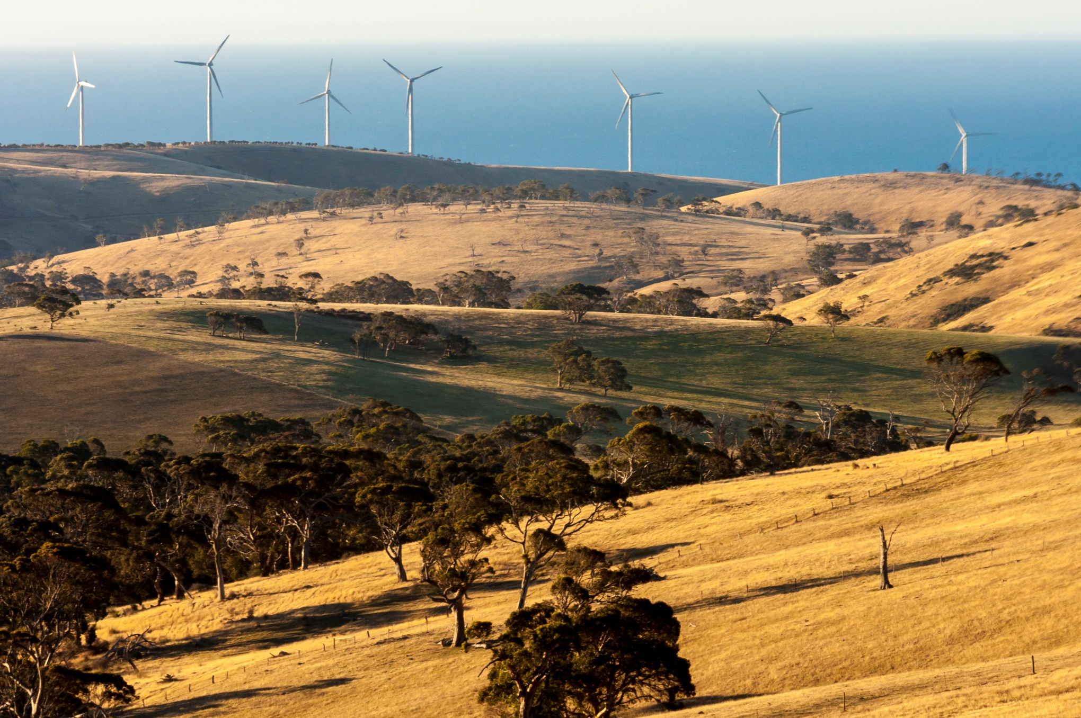

Cooperation – partnerships

#### Our contributions

The Authority is increasingly seen as a trusted source of information and expert policy advice on climate change. We respond to requests from Members of Parliament, government agencies, other organisations, and from the public.

# *“On Good Authority” from the Climate Change Authority has matured marvellously over the last year and I look forward to reading it each time it lands in my inbox. It is a balanced, trustworthy summary of some of the key events in the climate change space over the preceding week or two.*

# Dr Alan Finkel, Special Adviser to the Australian Government on Low Emissions Technology

In 2020, we made our weekly media digest, ’On Good Authority’ available to the public. On Good Authority is well received by a growing number of subscribers

#### Shared services arrangements

As a small agency, the Authority maintains agreements for the receipt of corporate and IT services from the Department of Industry, Science, Energy and Resources. These cover the provision of finance, payroll, human resources and legal services, and information technology systems and support. These arrangements were implemented following the Machinery of Government changes in early 2020 where the Authority became part of the Industry Portfolio.

These arrangements are performed on a fee-for-service basis. They are appropriate for a small agency, in line with the Government’s shared services agenda.

#### Strategic Relationship Agreement – Climate Science Advice

This year, the Authority and the Bureau of Meteorology intend to enter a Strategic Relationship Agreement to strengthen engagement and enhance coordination between the two agencies. The Bureau of Meteorology partners with Geoscience Australia, CSIRO and Australian Bureau of Statistics to bring together world leading science, information and expertise on climate and natural hazards.

#### Other contractual arrangements

The Authority contracts for services such as media management and specialised work. For example, as part of our 2020 review of the Emissions Reduction Fund, the Authority commissioned the CSIRO to undertake a technical review of physical risks to carbon sequestration.

#### Thought leaders

From time to time, we invite thought leaders from the private sector, think tanks, academia and government to share their insights, for example by presenting at an Authority meeting or reviewing a draft report. For example, earlier this year Dr Andrew Forrest AO, Chairman of the Minderoo Foundation and Fortescue Metals Group, joined us at an Authority meeting. Dr Forrest spoke of Fortescue’s commitment to carbon neutrality, ambitious goals to demonstrate hydrogen-based clean energy technologies, and growing opportunities for manufacturing in Australia. Other guest speakers include Geoff Summerhayes in his former position as CEO of the Australian Prudential Regulatory Authority and Professor Mark Howden, Vice-Chair of the Intergovernmental Panel on Climate Change.

#### Membership

The Climate Change Authority is an associate member of the Carbon Markets Institute, which facilitates knowledge sharing and insights on how business can manage risks and capitalise on opportunities in the transition to a net-zero emissions economy.

#### Indigenous partners

This year we developed our first Reconciliation Action Plan. Our plan includes actions to build mutually beneficial relationships and, where appropriate, partnerships with Aboriginal and Torres Strait Islander organisations and stakeholders in 2021-22.

#### International partners

Earlier this year, we met with independent climate change agencies like the Climate Change Authority from around the world, coming together as an International Climate Councils Network, to share experiences, discuss common challenges and explore how to support one another in our work.

Risk oversight and management

The Authority has a Risk Management Framework to drive a positive risk management culture. The framework complies with the requirements of the Commonwealth Risk Management Policy 1 July 2014 and the *Public Governance, Performance and Accountability Act 2013* (Cth).

#### Risks

The Authority maintains a risk management framework and policy, which are updated regularly and reviewed by its Audit Committee.

Table 1 sets out the Authority’s high-level strategic risks for the reporting period, along with risk ratings and mitigation strategies. Risk treatments and treatment owners are outlined in the Authority’s risk register, which is updated regularly.

The Authority has also prepared a separate COVID-19 Risk Assessment and Treatment Plan in response to the challenges raised by the pandemic. The Authority has continued to operate effectively during the pandemic and the restrictions imposed by governments to limit harm.

The Authority undertook a scan of the Authority’s exposure to climate risk and proactively embed climate risk considerations into planning and reporting across the organisation. The focus of these initiatives will continue through a climate risk assessment to determine appropriate actions to manage those risks identified.

TABLE 1: CLIMATE CHANGE AUTHORITY STRATEGIC RISKS

|  |  |  |
| --- | --- | --- |
| RISK DESCRIPTION | LIKELIHOOD, CONSEQUENCE AND RATING | MITIGATION STRATEGIES |
| **Managing financial resources** |  |  |
| The Minister responsible for climate change or the Parliament requests a Special Review, putting additional pressure on resources  Government does not address funding shortfall from FY 2024-25 onwards | **Unlikely; moderate; medium** | The Chief Executive Officer and the Chief Finance Officer monitor budget expenditure closely  Funding priorities planned to align with key priorities and closely monitored by Chief Executive Officer and Chief Finance Officer  Actions to increase the Authority’s funding are pursued  The secretariat’s work priorities are managed flexibly, in line with available resources  Funding priorities and constraints communicated to Authority members |
| **Managing people resources** |  |  |
| Inability to retain staff in limited organisational size  The Minister responsible for climate change or the Parliament requests a Special Review, putting additional pressure on resources | **Unlikely; moderate; medium** | Staff encouraged and supported to access learning and development opportunities within the Authority and with partner organisations where appropriate  Staff kept informed about developments in the operational environment and supported with effective change management and resilience strategies, including through the Employee Assistance Program  The secretariat’s work priorities are managed flexibly, in line with available resources  Actively foster a positive work environment and ensure staff can access development opportunities |
| **Capability** |  |  |
| Insufficient number of skilled staff leads to gaps in skillsets required to deliver outcomes. | **Unlikely; moderate; medium** | Appropriate delegation of powers, robust information sharing processes including on lessons learned, transparent decision-making processes  Engage independent consultants where appropriate  Partner with other organisations where appropriate  Support staff learning and development opportunities  Oversight by Audit Committee  Maintenance of fraud plans |
| **Performance** |  |  |
| The Authority’s reviews and research reports contain significant factual errors or fail to meet delivery deadlines  Stakeholders consider that the Authority does not have the expertise or independence to advise the Government effectively | **Possible; moderate; medium** | The Authority maintains quality assurance processes to minimise the chance of factual error  The Authority scopes its work carefully and monitors review time frames  The Authority consults with a wide range of stakeholders to be informed by a broad spectrum of views and evidence  Conduct stakeholder surveys to solicit feedback and tailor engagement approaches accordingly  Develop a stakeholder engagement charter  The Authority explicitly considers stakeholder views and other relevant information sources when taking decisions on its reports and other products  Member handbook kept up to date and induction sessions able to be rolled out quickly |
| **COVID -19 Pandemic** |  |  |
| Harm to staff as a result of contracting COVID-19 in the workplace  Effective operations of the Authority are compromised by one or more of:   * COVID-19 transmission in the workplace * Reduced staff availability * Remote working arrangements which increase OH&S risks * ICT capability hinders remote working productivity | **Possible, moderate, high** | Monitor and act on health advice and Government and ASPC guidance, including the adoption of physical distancing and remote working arrangements.  Re-prioritise work program and resource allocation as required  Frequent communication with all staff, including provision of relevant information and guides for how to respond in relevant circumstances  Frequent check-ins with staff with an emphasis on support networks and tools  Regular liaison/consultation with shared services provider |

Performance

As set out in the Government’s Portfolio Budget Statements, the Authority is responsible for the outcome:

“Provide expert advice to the Australian Government on climate change mitigation initiatives, including through conducting regular and specifically commissioned reviews and through undertaking climate change research”.

Accordingly, our objective is to provide rigorous, independent and balanced advice to the Minister for Energy and Emissions Reduction and to assist the Department and the Australian Parliament on climate change policy, in order to improve the quality of life for all Australians.

##### Outcome strategy

The Authority will deliver influential, independent and expert advice by:

* undertaking extensive and rigorous research and analysis
* engaging stakeholders to gather information and debate policy options
* presenting insightful and practical reports
* operating within a strong governance and accountability framework.

In undertaking its reviews, the Authority must consult publicly, publish reports on its website and take the following principles into account:

* economic efficiency
* environmental effectiveness
* equity
* the public interest
* the impact on households, business, workers and communities
* the development of an effective global response to climate change
* Australian foreign policy and trade objectives.

##### 

##### Delivery strategy

To support the Authority’s work, the secretariat will deliver timely, high-quality reviews for the Authority by:

* undertaking thorough policy development and analysis, including desktop research and analysis
* conducting in-depth analysis of relevant sectors and contemporary research
* commissioning other analytical work (for example, economic modelling) where required
* conducting meaningful and transparent consultation with experts and stakeholders, including business, industry, environment and other community groups
* monitoring developments in climate change policy by reviewing publicly available resources and building networks with expert, local and international organisations.

The secretariat will also facilitate the Authority’s decision-making further by:

* arranging regular meetings of the Authority
* providing briefing, reports and other supporting documents that are fit-for-purpose and of a high quality.

##### Performance framework and indicators

Our performance framework and key performance indicators are set out in tables 2 and 3 below.

TABLE 2: PERFORMANCE FRAMEWORK



TABLE 3: KEY PERFORMANCE INDICATORS

Performance measurement and assessment

We assess and report on our performance each year through our Annual Report, which is available on the Climate Change Authority website. Our performance targets and assessments are set out in table 4 below.

TABLE 4: PERFORMANCE INFORMATION

|  |  |  |  |  |
| --- | --- | --- | --- | --- |
| YEAR | ACTIVITY | KPIs | TARGETS | ASSESSMENT |
| 2021-222023-24 | Complete self-initiated research on enhancing Australia’s competitiveness in a decarbonising world.  Complete reviews of the Carbon Credits legislation and the National Greenhouse and Energy Reporting legislation by December 2023  Complete other Special Reviews as requested by the Government or the Parliament  Identify and undertake other self-generated research on climate change matters. | The Authority’s reviews and research reports are relevant, timely, of high quality and used in public policy forums and discussions.  The Authority’s public consultation processes are transparent, accessible and highly regarded by stakeholders. | Reviews and research reports draw on the best available knowledge and are informed by a broad range of perspectives.  Public consultation is comprehensive, representative and transparent.  The Authority’s analysis, findings and advice is communicated clearly and effectively.  Reviews and research reports are provided by the due date.  Research and review reports are relevant to the government and stakeholders of the day, and influence the public debate on climate change policy.  Government considers the Authority’s findings and recommendations in developing and implementing policy. | Relevant and up-to-date academic, scientific, scholarly and other external sources are referenced in the research and analysis that informs the Authority’s advice.  Levels of stakeholder participation in consultation processes and references to a wide variety of stakeholder views in the Authority’s reports.  Date of delivery to the Minister responsible for climate change or the Parliament and date of publication on the Authority’s website  Analysis of feedback by the Government and other stakeholders on the Authority’s research and analysis.  Analysis of the use and discussion of the Authority’s reports in public policy forums and discussions. |

1. Intergovernmental Panel on Climate Change (2021), *Climate Change 2021 The Physical Science Basis*, https://www.ipcc.ch/report/ar6/wg1/downloads/report/IPCC_AR6_WGI_Full_Report.pdf