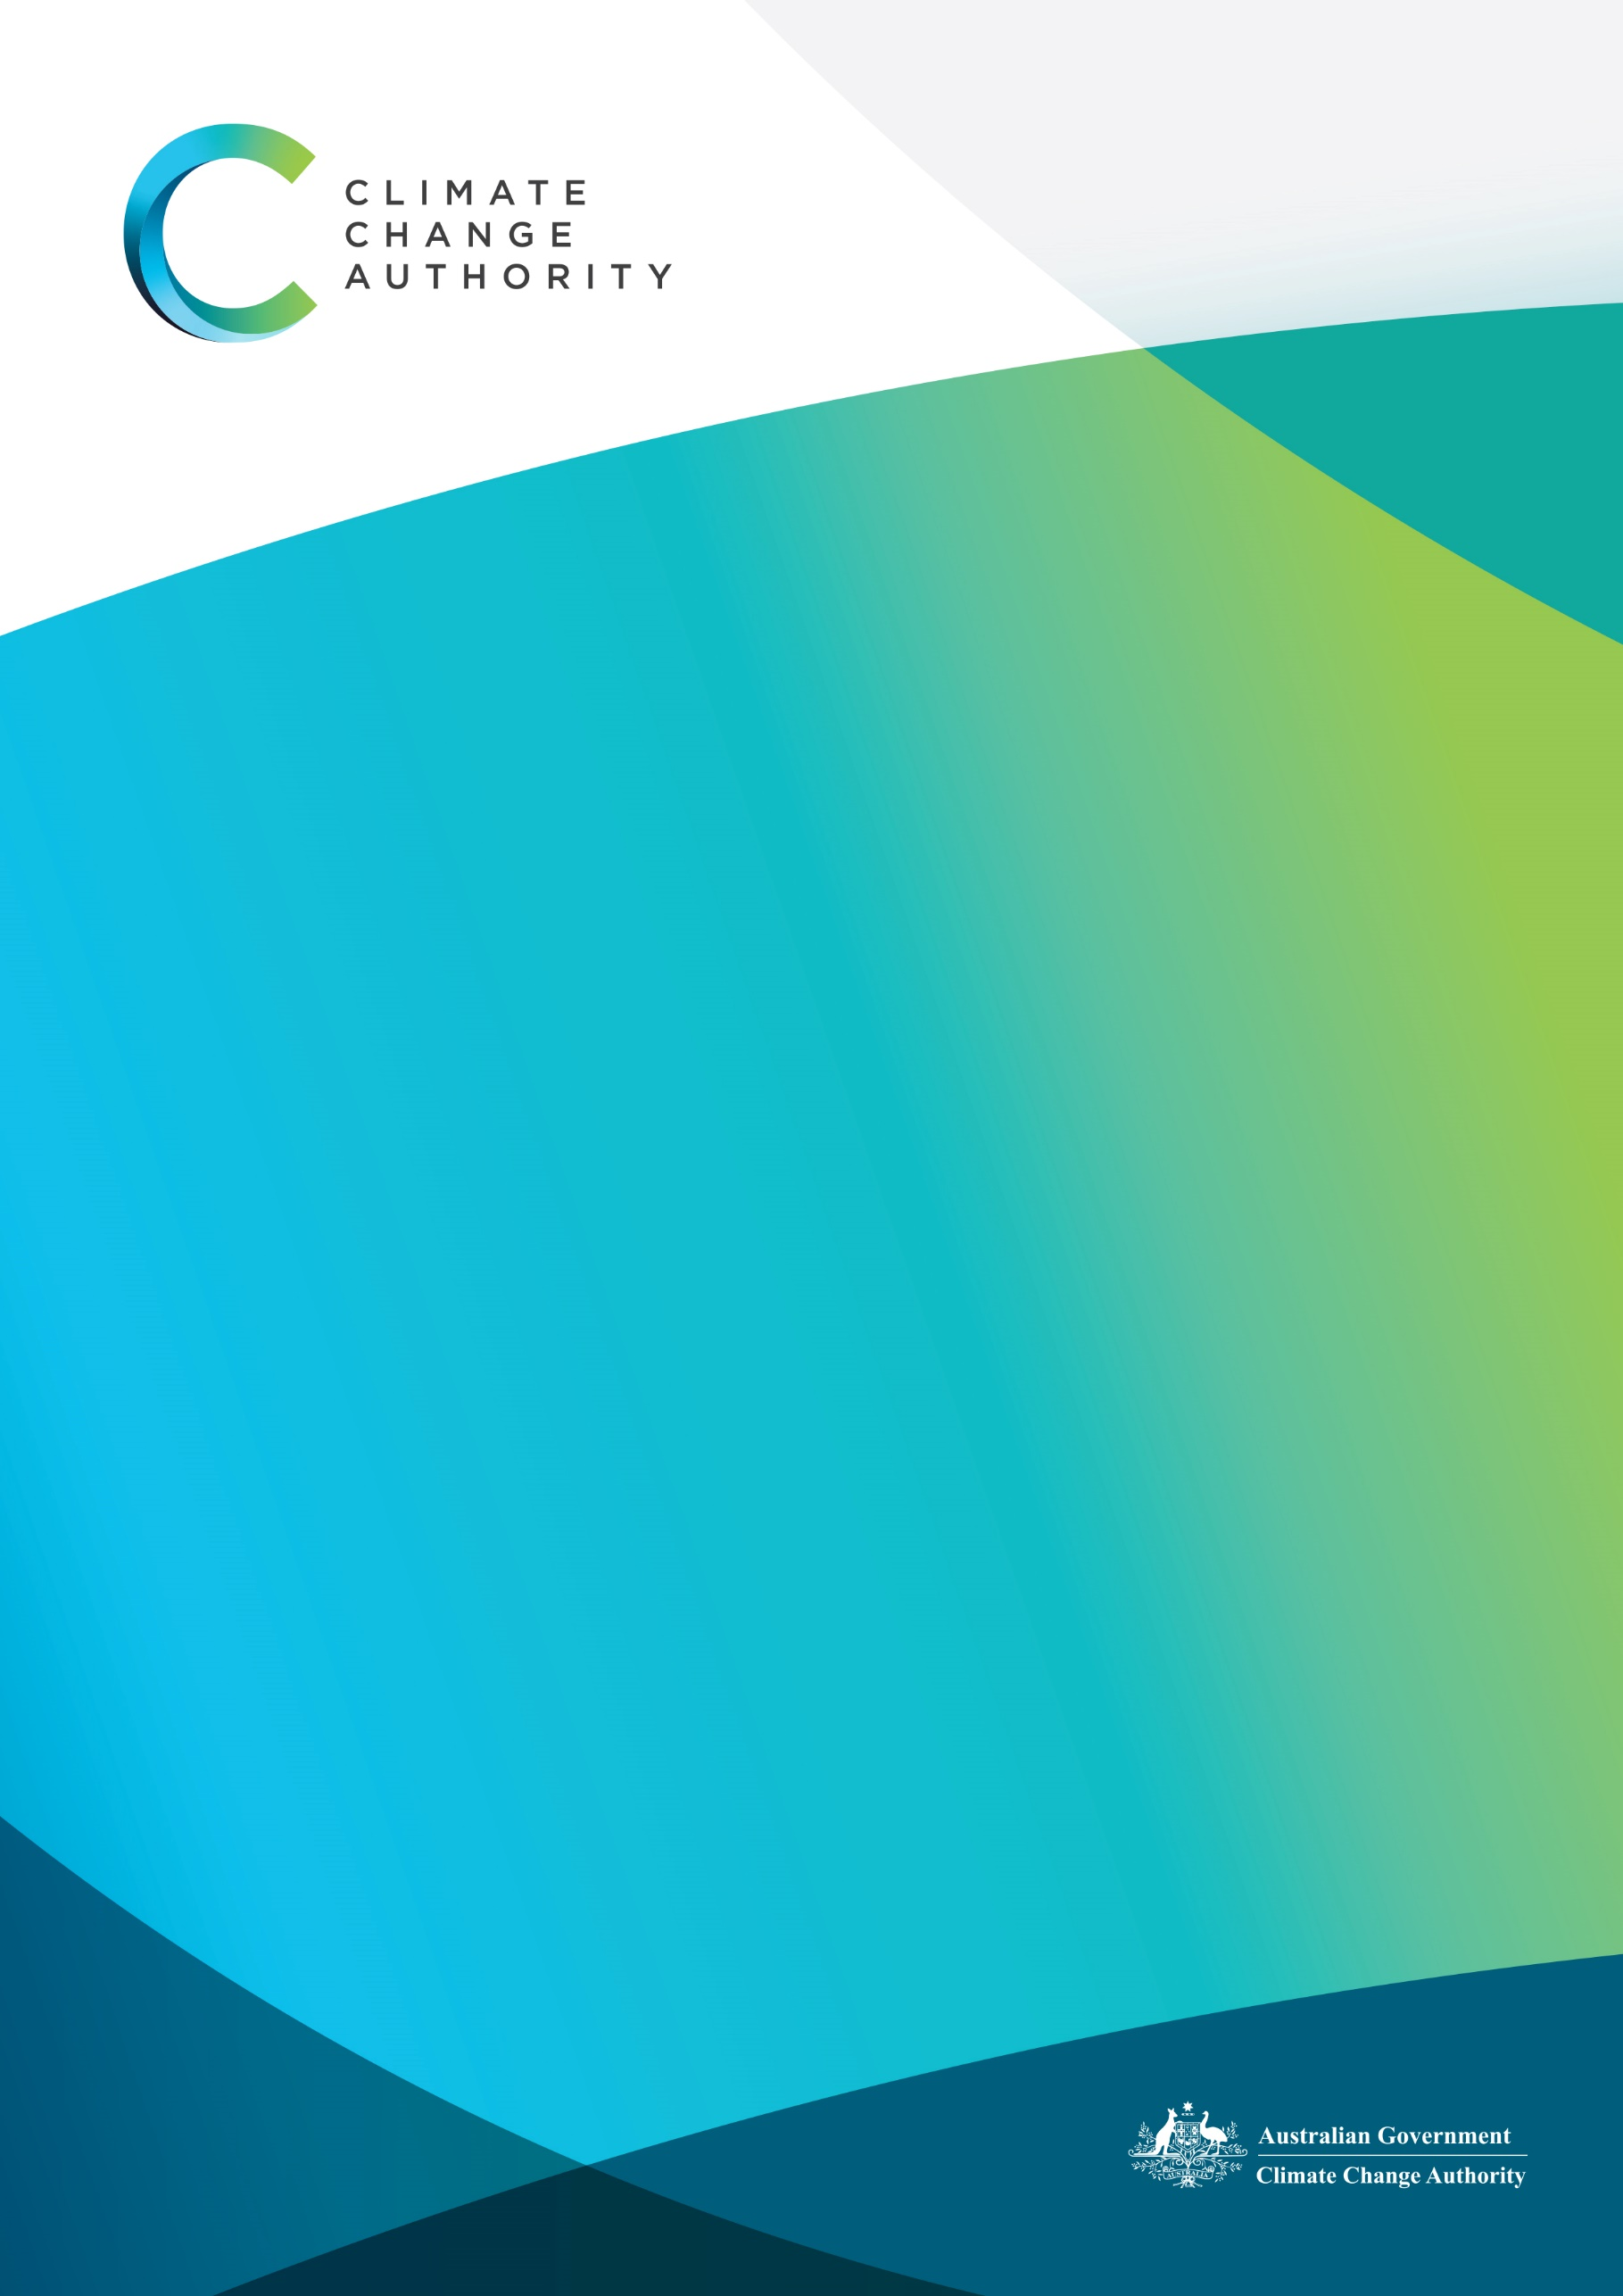

January 2022

Privacy Policy
August 2023

The Climate Change Authority (the Authority) is committed to protecting your privacy and personal information. The Authority respects your right to privacy and complies with the Privacy Act 1988 (Cth) (Privacy Act) in relation to handling your personal information.
This Privacy Policy explains how we collect, use, disclose, store, secure and dispose of your Personal Information in accordance with the Australian Privacy Principles (APPs) made under the Privacy Act.
The APPs can be obtained from the Office of the Australian Information Commissioner (OAIC) website at https://www.oaic.gov.au

What is Personal Information and why do we collect it?
Personal Information is information or an opinion that identifies an individual. Examples of Personal Information includes names, addresses, email addresses and phone numbers.
The Authority;
- collects your personal information where this is reasonably necessary, or directly related to our functions or activities. More information about our functions is available on our website
- collects sensitive information where you consent, where the collection is authorised or required by law, or the collection is otherwise allowed under the Privacy Act;
- will only use and disclose your personal information for the purposes for which it was collected, or otherwise in accordance with the Privacy Act; and
- will notify you of the purpose that your personal information is being collected, either at the time of collection, or as soon as practicable thereafter

What Personal information do we collect?
Personal Information we collect from members of the public when carrying out our functions, such as consultation and engagement during our review work and the preparation of advice, includes, but is not limited to:
- identity information (name, employer, other identifying information)
- contact details (location/address, phone number, email)
- photographic images and/or pictorial representations
- any other information relating to you that you provide to us directly, through our website or through our representatives
Additionally, we collect personal information about our employees, job applicants, contractors, and others in relation to employment or engagement. This includes records relating to:
- personnel (including correspondence, travel records, and remuneration)
- payroll matters
- disciplinary and counselling matters
- applications for employment and curriculum vitae
- identity documents
- information about your financial affairs
- government identifiers
- security clearances and police record checks
- travel records
- WHS matters, including accident and injury records, compensation, and rehabilitation files

How do we collect Personal Information?
We collect personal information in a range of circumstances, including when you:
- call, write to and email us
- subscribe to our mailing list
- use our website
- visit our offices
- apply for a job with us
- respond to our consultation and engagement activities
- participate in our surveys
- interact with us on our website or social media accounts

Sensitive Information
Sensitive information is defined in the Privacy Act to include information or opinion about such things as an individual's racial or ethnic origin, political opinions, membership of a political association, religious or philosophical beliefs, membership of a trade union or other professional body, criminal record, or health information.
Sensitive information will only be used by the Authority:
- for the primary purpose for which it was obtained, or
- for a secondary purpose that is directly related to the primary purpose, or
- with your consent; or where required or authorised by law

Collection of de-identified data
We also collect data when discharging our functions, such as during our climate change review and advisory work, from a range of external sources, including other government agencies. The data is usually de-identified when we collect it, but sometimes Personal Information is included where, for example, an individual is named or their identity can reasonably be ascertained. We handle all such data in accordance with the Privacy Act.

Third Parties
Where reasonable and practicable to do so, we will only collect your Personal Information directly from you. However, in some circumstances we may be provided with Personal Information by third parties. In such a case we will take reasonable steps to ensure that you are made aware of the information provided to us by the third party.

Use and disclosure of Personal Information
We use and disclose personal information for our main functions including conducting analysis, preparing reports and advice for publication, publishing other information, and responding to individuals who contacts us. We also use it to manage our staff and recruitment processes.
We sometimes use or disclose personal information for other purposes. This will only occur when it is permissible under the APPs. Disclosure can occur where:
- you consent, or
- you would reasonably expect that your information will be disclosed, or
- disclosure is required or authorised by or under an Australian law

Disclosure of personal information to service providers
We use a number of service providers to whom we disclose personal information. These include providers that host our website servers, manage our IT and manage our human resources information.
To protect the personal information we disclose we:
- enter into a contract or MOU which requires the service provider to only use or disclose the information for the purposes of the contract or MOU
- include special privacy requirements in the contract or MOU to ensure your personal information is handled securely and in accordance with the Privacy Act

Cloud computing and offshore ICT
Our use of service providers may involve cloud computing or disclosing your personal information overseas. It is not practicable to list every country in which personal information may be held under those arrangements. However, we will ensure our service arrangements comply with applicable guidelines for privacy protection by Australian Government agencies.

Security of Personal Information
Your Personal Information is stored in a manner that reasonably protects it from misuse and loss and from unauthorised access, modification, or disclosure.
When your Personal Information is no longer needed for the purpose for which it was obtained, we will take reasonable steps to destroy or permanently de-identify it. However, most Personal Information is stored in files which are kept for a minimum of 7 years.

Access to your Personal Information
You have a right to access the Personal Information we hold about you and to update and/or correct it, subject to certain exceptions. If you wish to access your Personal Information, please contact us.
There is no fee for making a request, but an administrative charge may be payable for providing a copy of your Personal Information. In order to protect your Personal Information, we may require identification from you before releasing the requested information.

Maintaining the Quality of your Personal Information
We will take reasonable steps to make sure that your Personal Information is accurate, complete, and up to date. If you find that the information we have is not up to date or is inaccurate, please advise us as soon as practicable so we can update our records.

Review of this Policy
This Policy may change from time to time and will be reviewed at least every 3 years.

Privacy Complaints
If you think we may have breached your privacy you can contact us to make a complaint (see contact details below). If you are dissatisfied with our response, you may complain to the OAIC. A complaint to the OAIC needs to be made in writing. For more information, see the OAIC website: https://www.oaic.gov.au

Contact details

Postal
Climate Change Authority
GPO Box 3090
Canberra, ACT 2601

Email
privacy@climatechangeauthority.gov.au

Phone
1800 475 869

