


Advice from Australia’s Climate Change Authority to the President of Negotiations – 31st session of the Conference of the Parties (COP31)

Decarbonisation deals:
A proposed COP Negotiations Presidency initiative

Table of contents
Summary 4
1. The risks and strategic opportunity for Australia 6
2. Part 4 of the 2035 Targets Advice and developments since 8
3. A COP31 Decarbonisation Deals Platform 10
4. Concrete actions Australia could announce at COP31 11
5. Doing deals: Next actionable steps for Australia 12
6. A flagship first deal with the Republic of Korea 14
Conclusion 16


The Authority recognises the First Nations people of this land and their ongoing connection to culture and country. We acknowledge First Nations people as the Traditional Owners, Custodians and Lore Keepers of the world’s oldest living cultures, and pay our respects to their Elders.

Summary
COP31 marks an inflection point in global climate cooperation. Climate impacts are intensifying, trade flows are shifting, and the global economy is becoming more multipolar. Governments are under growing pressure to deliver emissions reductions at the speed and scale required to meet climate goals, while also protecting prosperity, jobs and social cohesion. Australia is uniquely exposed to these forces and uniquely positioned to play a significant leadership role in this next phase of international cooperation.
Against this backdrop, the Climate Change Authority’s 2035 Targets Advice identified COP31 as a strategic opportunity to launch a Decarbonisation Deals Platform. Decarbonisation deals are negotiated arrangements between willing governments, with industry as delivery partners, to align emissions reduction, trade, investment and industrial policy in support of a longer-term prospect for supply chain and market development. They do not require formal multilateral negotiations and endorsement by COP. Nor do they depend on universal participation – an opt-in approach is both sufficient and desirable.
They generally take 2 complementary forms:
- Bilateral clean industrial transformation deals, covering multiple projects and technologies across the value chain. Such agreements might include removal or avoidance of tariffs and import duties, accelerated approval pathways, joint funding and financing platforms, offtake agreements and long-term assured product supply, and collaboration on research, development and deployment. Together, these elements lower costs, de-risk investment and bring forward real-world emissions reductions.
- Plurilateral green industry development clubs where groups of countries agree on shared definitions, taxonomies, standards and rules for low-emissions products and markets. This includes resolving questions such as what qualifies as “green” steel and developing shared standards to reduce uncertainty for investors and enable interoperability across markets.
Decarbonisation deals could provide the missing link between nationally determined contributions and trade cooperation – between climate ambition and economic implementation. By helping to reduce costs, align standards and de-risk investment, decarbonisation deals could make higher ambition more feasible and global decarbonisation faster and cheaper. Yet despite strong momentum, current efforts are fragmented. With greater coordination, a shared platform would enable faster, more coherent deal-making by aligning taxonomies, rules, and ultimately decarbonisation plans.
For Australia, decarbonisation deals are fundamentally about getting ahead of the game. As global markets change what they buy, Australia can either supplement market conditions to support production or risk losing markets that have underpinned national prosperity for decades. Doing nothing is the riskiest option.
Globally, the imperative is even larger: enabling faster, cheaper decarbonisation across borders and supply chains. Decarbonisation deals could help create ‘coalitions of the willing’ that move faster, delivering sectoral progress that can be showcased and scaled, demonstrating that climate action and economic competitiveness can align.
The Authority’s 2035 Targets Advice recognised emissions reduction is now inseparable from trade, investment, and industrial policy. It set out a strategic proposition: Australia can commence a shift from being a net exporter of emissions to a net exporter of abatement, complementing domestic action with international cooperation that accelerates regional decarbonisation.
Since that advice was delivered, several developments make leadership both more urgent and more feasible:
- Australia will be President of Negotiations, a new, specialised function introduced for COP31. Senator The Hon. Penny Wong explained that this means ‘Australia will have ‘“exclusive authority in relation to the negotiations”, to shape and guide global decision making in support of the multilateral system and global trade and investment in clean energy industries.’
- 24 countries, including Australia, signed the Belém Declaration on the Transition Away from Fossil Fuels at COP30, and the Republic of Korea (Korea/RoK) announced a coal-fired power phase-out by 2040, reinforcing the inevitability of declining demand for Australia’s fossil fuel exports.
- 40 countries and organisations, including Australia, signed the Belém Declaration on Global Green Industrialization, complementing the Global Clean Power Alliance (GCPA) Supply Chains Mission established by Australia, Canada, Kenya, the Netherlands, the United Kingdom, and Zambia.
- Brazil launched the Integrated Forum on Climate Change and Trade, intended to generate new international collaboration that aligns trade practices with climate goals. Australia has been working closely with Brazil to develop this concept.
- Carbon border adjustment mechanisms (CBAMs) are moving from theory to practice, with the European Union (EU) progressing to implementation, countries like Türkiye considering their own domestic carbon prices specifically to avoid paying the EU CBAM charge, and other countries including Australia actively considering a CBAM of their own.
Globally, the focus has shifted decisively from ambition-setting to implementation, finance and supply chains. This shift is reshaping the role of COPs, from primarily multilateral United Nations Framework Convention on Climate Change (UNFCCC) negotiations to hubs for plurilateral and bilateral deal-making, often with industry at the table. The creation of a COP negotiations presidency comes at an opportune moment, with scope to define negotiations broadly and to use the presidency’s convening power to advance practical agreements that accelerate real-world outcomes alongside formal United Nations Framework Convention on Climate Change (UNFCCC) processes.
A Decarbonisation Deals Platform at COP31 would offer a practical way for countries to work together on reducing emissions embedded in traded goods, scaling clean supply chains, and managing the orderly transition of emissions-intensive industries – turning climate ambition into trade-linked action.
This concept note updates and builds on the Authority’s earlier advice, providing further guidance on next steps should Australia choose to use its COP31 role to advance a Decarbonisation Deals Platform, a flagship first bilateral decarbonisation deal, or both.

1. The risks and strategic opportunity for Australia
Australia is unusual among advanced economies in that a large share of its climate-related risk exposure sits outside its borders. When Australian coal, gas and other emissions-intensive commodities are used overseas, the resulting emissions are counted in other countries’ inventories. But the commercial risks sit with Australia: those offshore emissions increasingly shape whether overseas customers are willing, or permitted, to keep buying Australian products.
Offshore emissions are not an abstract accounting issue: they are a key determinant of future demand for Australian exports. As countries tighten climate targets, introduce carbon constraints, and respond to domestic political and consumer pressure, demand will increasingly shift away from products that emit greenhouse gases at the point of use. Offshore abatement therefore shapes whether Australia can remain a preferred supplier. In some cases, this will be direct, such as buyers favouring lower-emissions fuels, materials or inputs. In others, it will operate through broader system changes, including industrial standards, procurement rules, carbon border measures, and long-term investment decisions that lock in cleaner supply chains. Retaining market access will increasingly depend on Australia’s ability to offer substitutes that reduce emissions for the buyer. Managing this risk requires engagement well beyond domestic policy settings.
Decarbonisation deals are grounded in a simple but powerful transition: from exporting molecules to exporting materials. The world is moving from a place where energy was expensive to extract, but cheap to store and transport, to one where energy is cheap to extract, but expensive to store and transport. This shift favours producing energy-intensive goods close to abundant clean energy sources, and trading finished or semi-finished materials rather than raw fuels.
For Australia, this creates a clear opportunity. Instead of exporting coal and gas that are used overseas to generate power or heat industrial processes, Australia can export energy-intensive materials made with clean energy. This approach captures more value domestically while directly reducing offshore emissions associated with Australia’s exports. Green iron, green steel, aluminium, ammonia, low emissions fuels and processed critical minerals are prime candidates. Domestic policy is already moving in this direction through initiatives such as Future Made in Australia. Decarbonisation deals would complement these efforts by aligning trade, investment and climate objectives with key partners, helping Australian clean industries scale faster and secure durable export markets.
A COP31 strategy centred on decarbonisation deals would deliver clear benefits for Australia:
- Export markets remain open by enabling Australian products to meet emerging climate, industrial and procurement standards in key trading partner markets.
- Regional jobs gain durability through early investment in new, growth industries, reducing the risk of abrupt disruption as demand for emissions-intensive exports declines. Decarbonisation deals can also support more orderly adjustment across the full supply chain, recognising that both exporters and importers face structural change as clean energy reshapes where industry locates and how value is created.
- Private capital receives clearer signals about where to invest, lowering risk and reducing the overall cost of transition by aligning trade, climate and industrial policy.
- Workers and investors gain greater certainty about the pace and direction of change, including the expected long-term decline in demand for emissions intensive products, allowing capital and skills to shift in a more predictable and orderly way.
- Australia’s reputation as a reliable partner in a changing global economy is strengthened.
As incoming COP President of Negotiations, Australia can shape COP31 around a practical, investor-credible agenda that helps countries move faster at lower cost, while supporting regional jobs and managing the transition from emissions-intensive exports to clean alternatives. The benefits extend well beyond Australia and would be a major contribution to advancing global cooperation and climate progress. Decarbonisation deals would allow countries to:
- reduce emissions where it is cheapest and fastest across borders
- align climate policy with trade, industrial strategy and employment
- provide confidence for investors through shared standards and long-term cooperation.
These contributions will occur at a time when global economies are deeply interconnected through trade and investment, creating strong mutual incentives to cooperate on emissions reduction in ways that sustain prosperity. Coordinated action makes climate progress more likely, faster, and more equitably shared within and between countries. Many countries will be struggling to turn strengthened targets into investable pathways. Trade tensions related to climate policy remain heightened, as countries introduce new climate standards, carbon charges and border measures remain heightened. Particular trade dynamics and tensions will occur around carbon-intensive commodities such as steel, aluminium, cement and fossil fuels. Developing and emerging economies will be seeking partners to finance and deliver clean industrial transitions.
In this context, Australia’s credibility rests on 3 strengths:
- Economic structure as a major exporter of energy, resources and energy-intensive products.
- Geopolitical position as a trusted trade partner across the Asia-Pacific.
- Experience in economy-wide climate policy design, implementation and review.
These strengths position Australia not just to convene, but to lead.

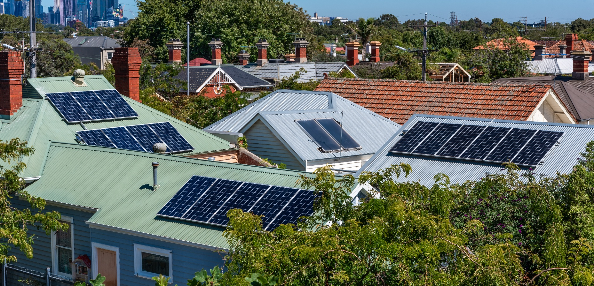

2. Part 4 of the 2035 Targets Advice and developments since
The Authority’s 2035 Targets Advice recognised a simple but powerful truth: Australia’s climate impact, and its economic future, cannot be assessed solely within territorial emissions boundaries.
Key insights included:
- Deals accelerate global action – Decarbonisation deals help accelerate implementation by aligning trade, investment and climate action across countries, delivering more abatement faster at lower overall cost.
- Supply-chain emissions are the next policy frontier – Investors and multinational firms are increasingly accounting for Scope 3 emissions embedded in supply chains, driven by voluntary commitments and evolving regulatory frameworks.
- Offshore emissions matter – Emissions embodied in exports are central to global decarbonisation outcomes.
- Deals beat declarations – Practical agreements linking policy, finance and technology deliver more than standalone targets.
- Comparative advantage can shift – Australia can export abatement, not just commodities, through clean energy, green materials and low-emissions supply chains.
- North-East Asia is a priority – Australia’s North-East Asian trading partners should be a priority focus for new partnerships to decarbonise transnational supply chains, particularly iron and steel.
Since the Authority provided its 2035 targets advice, there have been several major developments, including the announcement of Australia’s role as President of Negotiations for COP31. Others include:
- Global signals on fossil fuel transition – The Belém Declarations and support at COP30 for development of a roadmap to transition away from fossil fuels provided the clearest multilateral signal yet that the global economy is moving to phase out the unabated use of fossil fuels and accelerate the growth of renewables. This has sharpened expectations on exporters to plan for demand decline rather than deny it.
Korea’s coal power phase-out by 2040 underscores that Australia’s major customers are moving decisively. Similar trajectories are evident in Japan, the EU and parts of Southeast Asia, as set out in the Authority’s 2035 Targets Advice report.
- Building momentum for plurilateral deals – Around the world, countries are increasingly pursuing decarbonisation agreements through plurilateral groupings, operating alongside multilateral UNFCCC processes.
Countries on both the supply and demand sides of the fossil fuel market, including producers and consumers, exporters and importers, are advancing discussions on a Fossil Fuel Non-Proliferation Treaty, with Colombia (fossil fuel exporter) and the Netherlands (importer) convening an international conference in April to build momentum. While such an agreement would sit within the broad definition of decarbonisation deals, this concept note focuses on how clean industries can be built faster and cheaper so they naturally replace high-polluting products over time – transitioning to better options, while recognising that managing the transition from fossil fuels also matters. Both demand shifts – from fossil fuels and to clean alternatives – directly affect Australia’s export outlook and regional employment.
Other groups of nations – with some overlap – are pursuing green growth. Forty countries and organisations, including Australia, signed the Belém Declaration on Global Green Industrialization last year, and Australia, Canada, Kenya, the Netherlands, the United Kingdom, and Zambia complemented the Global Clean Power Alliance (GCPA) Supply Chains Mission.
- CBAMs move from concept to reality – Carbon border adjustment mechanisms (CBAMs) send a clear message that emissions embodied in trade are no longer invisible, and that message is reshaping investment decisions, contract structures and supply chain risk management now. The EU CBAM entered its fully operational ‘definitive period’ on 1 January 2026 after a 2-year transitional phase, meaning financial obligations are now imposed on importers of carbon intensive goods.
Decarbonisation deals offer a complementary and more cooperative mechanism – especially for major trade partners – by providing a framework for joint action rather than unilateral penalties. For Australian producers, proactive engagement through decarbonisation deals can mitigate exposure and preserve market access.
- A shift from ambition to delivery – Global climate diplomacy has entered an implementation phase. Investors, firms and workers are asking fewer questions about long-term targets and more about near-term pathways, cost, reliability and fairness across value chains.
For an export-oriented economy like Australia, these developments directly affect national prosperity and we should embrace the opportunity to take a seat at the head of the table.

3. A COP31 Decarbonisation Deals Platform
The Authority proposes that Australia, as COP31 President of Negotiations, establish a Decarbonisation Deals Platform. The purpose would be to make bilateral and plurilateral initiatives easier to scale by developing shared rules, trusted accounting approaches and a common language, reducing friction, building confidence among partners and investors, and accelerating uptake beyond first movers.
Pillars of a COP31 Decarbonisation Deals Platform could include:
Pillar 1: Offshore emissions and shared accounting
- Establish common principles for recognising and reporting offshore emissions and offshore abatement linked to traded goods.
- Support transparency without reopening settled accounting rules.
- Enable countries to cooperate without fear of double counting or trade disputes.
Pillar 2: Trade-linked abatement pathways
- Develop bilateral and plurilateral pathways to decarbonise emissions-intensive sectors such as steel, aluminium, cement and fuels, integrating technology deployment, investment coordination and trade arrangements across producers and consumers.
- Align standards, certification and disclosure to ease CBAM pressures.
- Lauch a pilot decarbonisation deal.
Pillar 3: Finance and risk-sharing
- Subsidise first-of-a-kind projects to show ‘proof of concept’, establish supply chains and contribute to cost reduction so private investors feel confident to follow.
- De-risk early investments in clean industrial supply chains.
- Support developing country participation through concessional finance and technology transfer.
Pillar 4: Just and orderly transition
- Embed workforce transition, regional development, and community benefits into deal design.
- Support re-skilling, retraining and redeployment of workers from emissions-intensive sectors.

4. Concrete actions Australia could announce at COP31
As President of Negotiations, Australia could credibly announce:
- A COP31 Decarbonisation Deals Platform – A global launchpad for countries to announce voluntary decarbonisation deals that reshape clean trade and accelerate the transition to net zero.
- Foundational partner deals – Initial agreements with key trading partners, potentially including Korea and Japan, focused on green iron, low-emissions fuels, and industrial electrification.
- CBAM readiness partnerships – Cooperative arrangements to help exporters and importers align standards and reduce border exposure through genuine abatement.
- A regional clean industry initiative – Targeted support for Indo-Pacific partners to participate in clean supply chains, strengthening regional stability and prosperity.
- A work program on offshore abatement integrity – Building confidence in environmental outcomes while enabling faster cooperation.
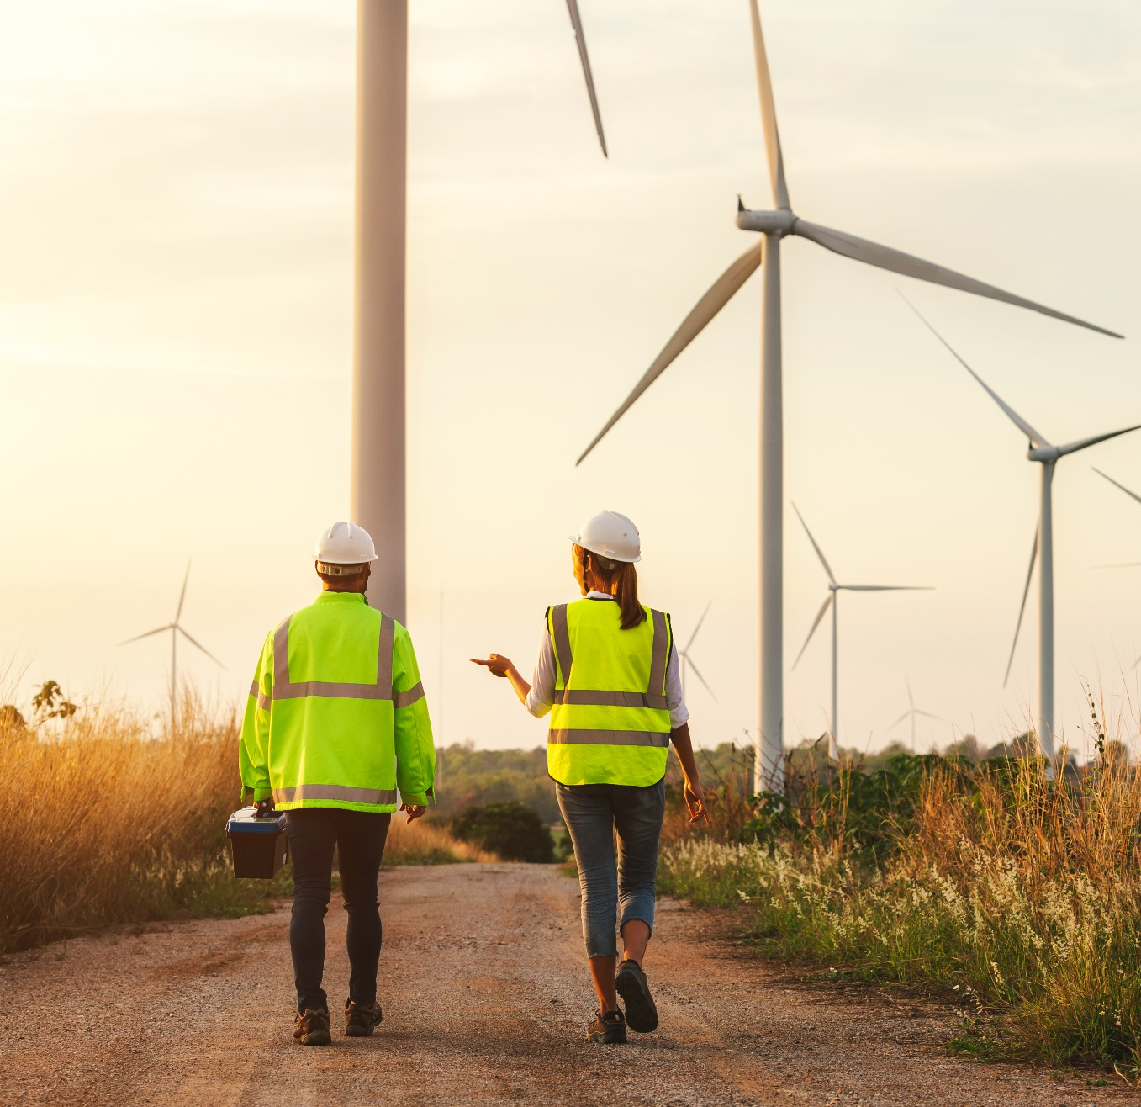

5. Doing deals: Next actionable steps for Australia
The steps below set out a practical pathway for the Australian Government to fully embrace decarbonisation deals.
1. Define decarbonisation deals as a form of climate-economic diplomacy
Cabinet should formally recognise decarbonisation deals as bilateral or plurilateral agreements between governments that align emissions reduction, trade, investment and industrial policy. Decarbonisation deals would:
- involve governments setting the framework and objectives
- have industry participate as implementers and investors
- sit alongside trade agreements, not project contracts.
2. Identify priority partner countries
Australia should focus first on key trading partners where joint action can deliver material global abatement and protect Australia’s economic interests. Based on the Authority’s analysis of exports and offshore emissions, priority partners might include Korea, Japan and emerging clean-materials markets in Southeast Asia. These partners share strong incentives to decarbonise supply chains, not just domestic production.
3. Select priority value chains for cooperation
For each partner, governments should jointly identify specific value chains where cooperation can shift emissions outcomes at scale, such as steel and aluminium, chemicals and fertilisers, liquid natural gas transition pathways, critical minerals and downstream processing.
4. Agree shared emissions and transition objectives
Partner governments should agree on shared emissions intensity reduction objectives for priority value chains, consistent with each country’s national emissions targets, long-term decarbonisation pathways, and domestic policy frameworks.
The agreement should provide direction and increase certainty, while leaving policy choice and implementation to each government.
5. Align domestic policy and regulatory settings
Each government should commit to efforts towards interoperability and harmonisation of its policy levers in support of the agreed objectives, including carbon pricing and regulation, planning and approvals, energy and infrastructure policy, standards and certification. The deal should not replace domestic policy but instead coordinate it across borders.

6. Mobilise and coordinate public finance
Governments should coordinate their public finance and risk-sharing tools to support delivery, including concessional finance, guarantees, first-of-a-kind support, and shared infrastructure investment. Support should remain conditional and time-limited, with private capital doing the heavy lifting.
7. Engage industry as delivery partners
Industry participation should be structured through voluntary commitments aligned to deal objectives, investment plans and project pipelines, and transparent reporting against agreed metrics.
8. Establish governance, transparency and review
Each deal should include clear milestones, public reporting on emissions outcomes, review points and adjustment mechanisms.
9. Pilot with one or 2 flagship deals
Australia should start with one or 2 high-impact bilateral deals, demonstrate credibility and delivery. A potential flagship first deal with the Republic of Korea is set out below.

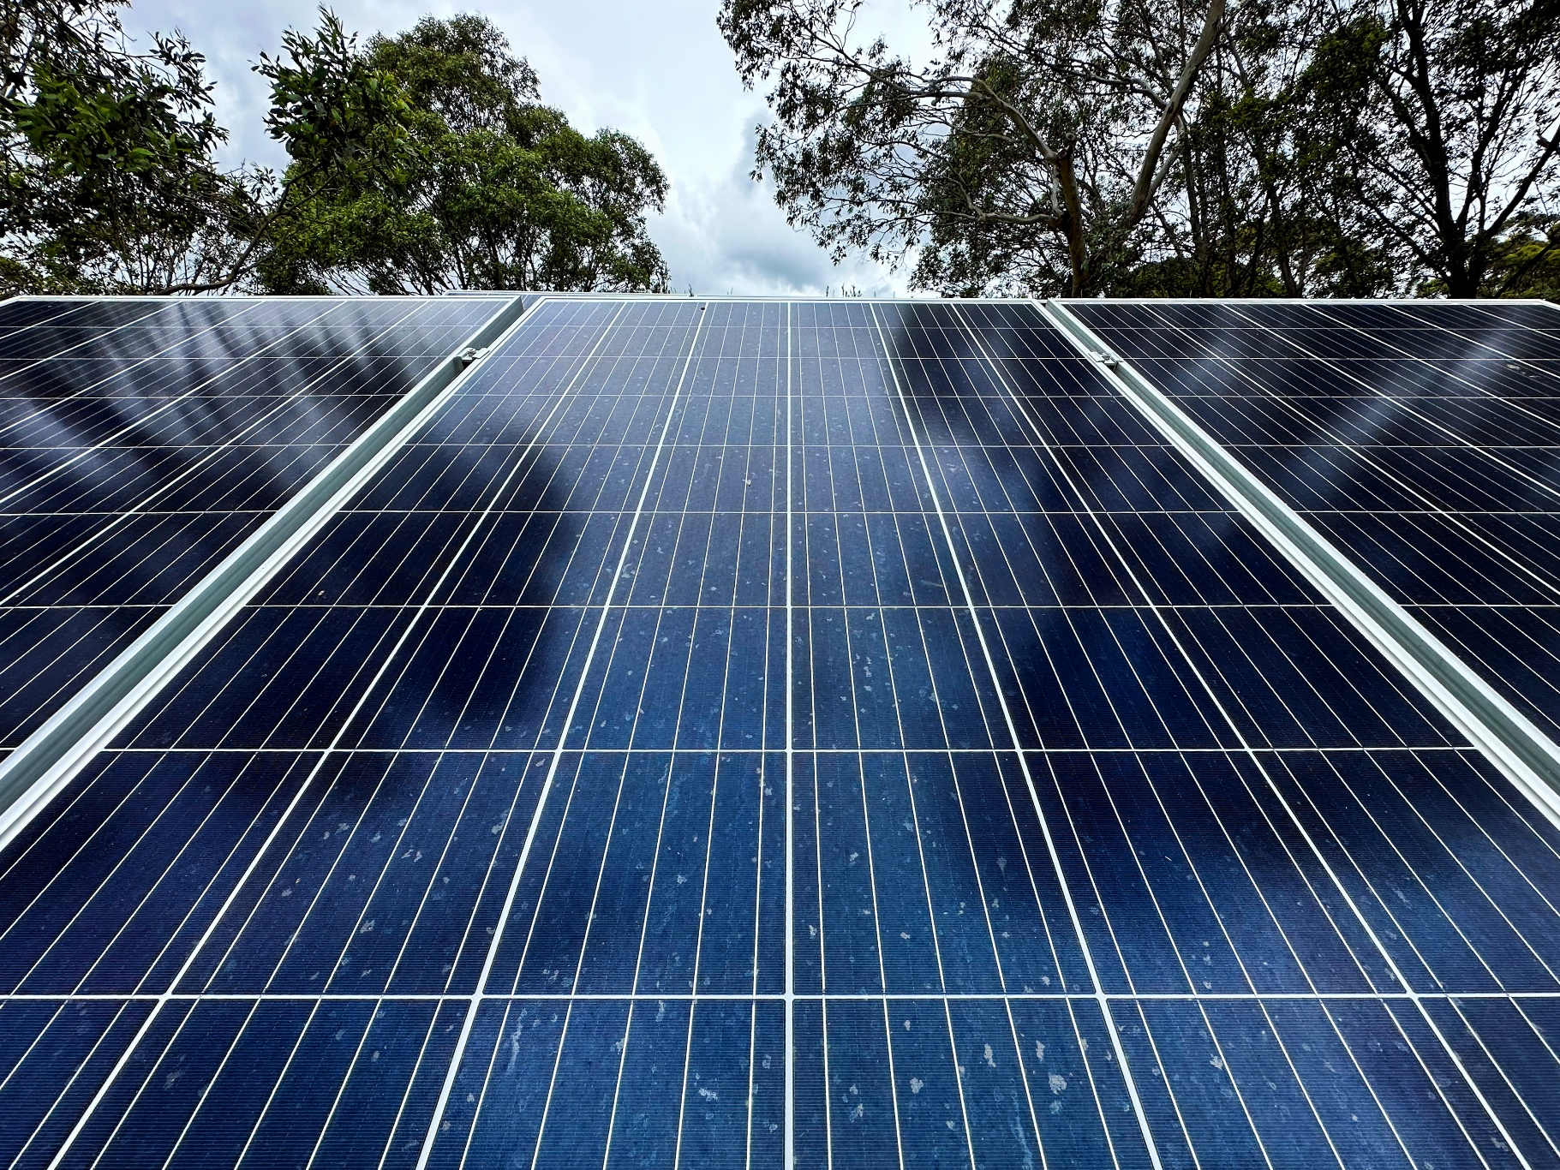

6. A flagship first deal with the Republic of Korea
Why Korea
Korea has recently signalled a significant acceleration in its climate and energy transition, including:
- a commitment to retire most coal-fired power generation by around 2040
- a strengthened national emissions target for 2035, implying deep reductions across power, industry and imports
- increasing focus on clean industrial supply chains, including steel, chemicals and energy-intensive manufacturing.
Korea is currently Australia’s third-largest export market and around the fourth-largest two-way trading partner, with Australian exports valued at approximately AUD41.7 billion in 2024 (made up of coal at AUD8.0 billion, gas at AUD8.0 billion, and iron ores and concentrates at AUD7.2 billion. It is one of Australia’s most fossil fuel-exposed trade relationships.
These policy commitments imply a structural shift in Korean demand. As coal-fired power declines, demand for thermal coal will fall. At the same time, Korea’s steelmakers and manufacturers will need large volumes of low-emissions inputs to meet tighter emissions limits, procurement standards and product requirements in both domestic and export markets. The centre of gravity shifts from importing fuels to importing materials that embody clean energy.
Korean policy settings affecting imports, procurement standards and industrial inputs are being designed now. Early engagement allows Australia to shape demand for clean replacements rather than compete after markets, technologies and suppliers are already locked in.
Why a bilateral decarbonisation deal
A bilateral decarbonisation deal with Korea can convert this transition risk into an opportunity by delivering:
- increased confidence in demand for low-emissions materials, starting with iron and steel supply chains
- a pathway to replace declining fossil fuel exports with higher-value processed materials
- stronger long-term market access as Korean firms decarbonise and seek reliable clean suppliers
- certification interoperability that keeps Australian products “eligible”
- an investable pipeline that de-risks first-of-a-kind projects
- a managed transition pathway that reduces shock risk for workers and regions.
This deal works politically and economically because Korea:
- is a major customer for Australia’s energy and materials
- has announced a clear fossil fuel transition direction
- needs secure, low-emissions inputs for globally competitive manufacturing
- is actively shaping clean-materials standards in global markets.
And because Australia brings:
- renewable energy scale
- critical minerals
- emerging clean processing capability
- and the ability to export abatement, not just commodities.
In short, as Korea moves away from coal, the prize for Australia is positioning to supply the clean industrial inputs that Korea will need to scale for decades to come.
Scope of the Australia–RoK Clean Industrial Transformation Deal
The Australia–RoK Clean Industrial Transformation Deal would be a government-to-government agreement to decarbonise shared industrial supply chains, starting with steel, aluminium and critical materials, while protecting energy security, jobs and competitiveness in both countries.
This deal would position Australia and Korea as first movers in building low-emissions industrial supply chains in the Asia-Pacific.
Priority value chains (phase one)
- Steel and steelmaking inputs.
- Aluminium and alumina.
- Critical minerals and downstream processing.
Government commitments
Both governments would agree to:
- align emissions intensity trajectories for priority materials
- coordinate domestic policy settings that affect those supply chains
- co-deploy public finance and risk-sharing tools
- work toward common standards and certification for low-emissions materials.
Role of industry
Industry would participate as delivery partners, through:
- investment plans aligned to the deal
- project pipelines
- reporting against agreed emissions metrics.

Conclusion
Australia’s presidency of COP31 negotiations is not simply a convening role. It is an opportunity to lead the world from ambition to action.
The next 5 years will determine:
- whether emissions reductions occur smoothly or through disruptive shocks
- whether regions dependent on emissions-intensive industries experience managed transition or sudden decline
- whether Australia captures early-mover advantages or adjusts to rules set by others.
COP31 offers a narrow but powerful window to shape the rules of the next phase.
Part 4 of the Authority’s 2035 Targets Advice laid the conceptual foundations for decarbonisation deals. Global developments since have supplied the momentum. What is now required is political leadership and practical action.
As incoming COP President of Negotiations, Australia can shape COP31 around a practical, investor-credible agenda that helps countries move faster at lower cost, while supporting regional jobs and managing the transition from emissions-intensive exports to clean alternatives. The benefits extend well beyond Australia and would be a major contribution to advancing global cooperation and climate progress.
The Climate Change Authority stands ready to support the Minister in shaping and delivering this agenda.


COP to be hosted by Türkiye with Australia leading negotiations | Australian Minister for Foreign Affairs
At the time of writing, 40 of the ROK’s 61 existing coal power plants are confirmed for phase out by 2040. Phase out date for remaining 21 is expected to be confirmed this year following public consultation. (Powering Past Coal Alliance, 2025)
Colombia's president Gustavo Petro ordered an end to new hydrocarbon exploration and production contracts soon after taking office in August 2022, and in December 2023 became the first major fossil-producing nation to join the Fossil Fuel Non-Proliferation Treaty Initiative (Fossil Fuel Treaty, 2023; NPR, 2025).
Republic of Korea country brief, DFAT 2025

