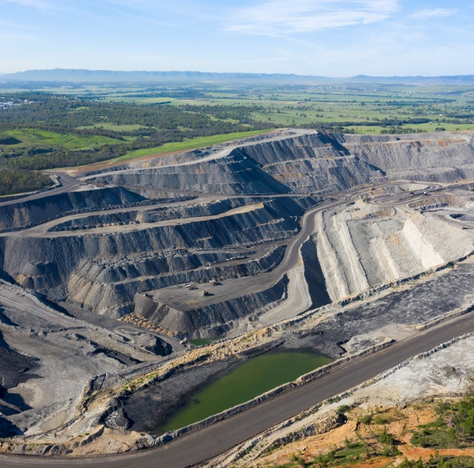

Fossil methane:
A near-term abatement opportunity

Consultation paper
June 2026


The Authority recognises the First Nations people of this land and their ongoing connection to culture and country. We acknowledge First Nations people as the Traditional Owners, Custodians and Lore Keepers of the world’s oldest living cultures, and pay our respects to their Elders.

About consultation papers from the Climate Change Authority
The Climate Change Authority (the Authority) provides independent, expert advice to the Australian Government and Parliament on the response to climate change.
We engage stakeholders because better conversations lead to better climate policy. We see consultation as an opportunity to bring different perspectives into the preparation of our expert advice.

We want to hear from you
We welcome submissions responding to questions in this paper. You can answer as many of these questions as you wish. You can refer us to related research or data, or relevant submissions to other consultation processes.
You can make a submission through our Consultation Hub until 5 pm Friday 7 August 2026

Contacts
For more information about making your submission, please contact the Authority on free call 1800 475 869 or via email at consultation@cca.gov.au.

On the cover: Open pit coal mine in the Hunter Valley area of New South Wales, Australia.

Table of Contents
Summary 5
Why methane matters 5
Why focus on fossil methane 5
Opportunities to accelerate methane abatement 6
Improving methane measurement 6
Consultation questions 7
Introduction 8
Structure of the paper 8
Next steps 8
Part 1: The case for accelerating fossil methane abatement 9
1.1 What is methane and where does it come from? 9
1.2 Methane has an outsized impact on warming in the near term 11
1.3 Agriculture is the largest source of methane emissions 14
1.4 Fossil methane is a practical near-term abatement opportunity 15
1.5 Australia’s fossil methane emissions have declined, but future trends will depend on
domestic and global drivers 17
Part 2: How Australia could accelerate fossil methane abatement 22
2.1 Existing policies already drive some fossil methane abatement 22
2.2 The case for going further 25
2.3 What kinds of policy response might accelerate methane abatement? 25
2.4 Using GWP-20 as an additional analytical lens 27
2.5 How the Authority will assess policy options 29
Appendices 30
Appendix A: Sources of fossil methane emissions 30
Appendix B: Fossil methane abatement technologies 33
Appendix C: List of policies and regulations relevant to fossil methane 34
Appendix D: Status of the Authority’s 2023 NGER Review recommendations (numbers 15-22) 37
References 40

Summary
This consultation paper examines how Australia could accelerate reductions in fossil methane emissions. Methane has a large impact on warming in the near term and fossil methane is one of the most practical opportunities for near-term abatement.
Through this paper, the Authority is seeking evidence and views on the practical technologies and other opportunities to reduce fossil methane emissions more quickly, barriers to their uptake, the impact current policies are already having, and what further policies or other measures could help.

Why methane matters
Methane has a much stronger warming effect than carbon dioxide, but it has a much shorter atmospheric lifetime — about 12 years on average — and gradually breaks down into carbon dioxide and water.
Because it is short-lived, reducing methane emissions now can reduce its concentration in the atmosphere in the near term (Copernicus 2022). That means cuts made today are one of the fastest ways to slow near-term global warming (IPCC 2023).
Human-caused methane emissions are responsible for about 0.3 °C of warming since pre-industrial levels (OECD 2025). Sharp reductions this decade could limit how high temperatures rise and how long they remain above the Paris Agreement’s targeted 1.5 °C limit (UNEP 2024).
Including Australia, 159 countries have joined the Global Methane Pledge to reduce global methane emissions to at least 30% below 2020 levels by 2030. Achieving this reduction could avoid over 0.2 °C warming by 2050, buying valuable time while the longer-term benefits of carbon dioxide reductions take effect (Global Methane Pledge 2026).

Why focus on fossil methane
Agriculture is the largest source of human-caused methane emissions in Australia, followed by the extraction, processing and distribution of fossil fuels, and then waste. While methane emissions will need to come down across all sectors, the Authority is focusing on fossil methane this year because it is one of the most practical opportunities for near-term emissions reductions. In contrast to agricultural methane, fossil methane comes from a relatively small number of concentrated sources and there are well-established technologies and practices to reduce it (IEA 2026a; IPCC 2019).
Fossil methane (also called fugitive methane) makes up around 24% of Australia’s reported methane emissions. Coal mining contributes 76% of reported fossil methane emissions, with most of the remainder coming from the gas sector (DCCEEW 2026a). In coal mining, methane that is naturally present in coal seams is released during mining and from underground ventilation and drainage systems. In the gas sector, emissions arise when natural gas — whose main component is methane — is vented, leaked or incompletely burned during flaring.
While the global transition away from fossil fuels will help reduce fossil methane emissions over time, it will not eliminate them. International Energy Agency (IEA) projections suggest that substantial fossil fuel production will continue to 2050 under current policy settings (IEA 2025b). Even with stronger global action to limit warming to 1.5 °C, coal and gas production will continue for some time.

Opportunities to accelerate methane abatement
The Australian Government already has policies that create incentives to reduce fossil methane. The Safeguard Mechanism, in particular, covers 75% of Australia’s fossil methane emissions (CCA analysis of CER 2026; DCCEEW 2026). It incentivises industrial facilities to reduce their emissions of all greenhouse gases; each gas is converted to a ‘carbon dioxide equivalent’ measure to guide decisions on how to direct effort across mitigation options. This conversion is based on the warming impact over a 100-year timescale. Given methane is highly potent and short-lived, this conversion can undervalue the near-term climate benefits of methane reductions.
Some state governments are also driving methane reductions, through direct regulation and other measures (NSW EPA 2026b; Queensland Treasury 2026). These complement the Safeguard Mechanism, helping realise near-term climate benefits, reducing near-term warming and assisting to stabilise the climate in the coming decades.
Through this consultation process, the Authority is seeking to understand:
- whether the broad price signal from the Safeguard Mechanism is enough to drive methane abatement in the near term
- where barriers are preventing this price signal from being effective
- what kinds of goals, policies or actions by governments can complement existing measures to accelerate methane abatement in practice.
The Authority will include its advice on accelerating fossil methane abatement alongside its advice on operation of the Safeguard Mechanism in its Annual Progress Advice in late 2026. This timeline will enable the government to take the Authority’s advice into account in its 2026-27 review of the Safeguard Mechanism.

Improving methane measurement
Unless otherwise stated, emissions figures for Australia in this paper are drawn from Australia’s National Greenhouse Accounts and associated National Greenhouse and Energy Reporting (NGER) data (DCCEEW 2024c). The Authority recognises that work is underway to improve the methane measurement and estimation methods that inform these data and that future changes to these methods may affect reported emissions levels. These issues are important, but they are not the primary focus of this project.

Consultation questions

Current policies and measures
- Do current policies and measures adequately cover the material sources of fossil methane emissions in Australia? For example, are emissions from decommissioned and abandoned mines material, and are they adequately monitored and mitigated?
- To what extent will Australia’s current policy settings, including the Safeguard Mechanism and state regulations, drive near term fossil methane abatement? Please provide relevant analysis or evidence.
Abatement opportunities
- What fossil methane abatement technologies and practices are commercially ready, or likely to be viable in the near term in Australia? Where available, please provide indicative costs, timelines, and examples.
- What fossil methane abatement activities have Safeguard entities planned, started or completed since the commencement of the Safeguard Mechanism reforms?
Barriers and enablers
- What are the main barriers – whether commercial, regulatory, market or other – preventing the uptake of fossil methane abatement opportunities in Australia? How could those barriers be overcome?
- What factors are constraining broad deployment of ventilation air methane (VAM) abatement in underground coal mines in Australia? Where possible, please identify any relevant safety, technical, regulatory, commercial or site-specific barriers, and provide evidence or operational experience.
- Do current approaches to measuring, reporting and verifying fossil methane emissions create any practical barriers to the uptake of abatement options in Australia? Please identify the relevant issue and explain how it affects abatement decisions, incentives or compliance outcomes.
Accelerating methane abatement
- What practical policies and measures could drive more fossil methane abatement than existing policy settings would deliver? How would these interact with the Safeguard Mechanism, and how should those interactions be managed?
- Should Australia set specific targets or goals for reductions in fossil methane emissions or the uptake of fossil methane abatement opportunities? What are the benefits and risks?
- Australia’s emissions accounting and reporting calculate methane emissions on a 100-year global warming potential (GWP-100) basis. Without changing that approach, should policy or investment decisions give more weight to the near-term climate benefits of methane abatement? How?

Introduction
This consultation paper sets out the case for accelerating fossil methane reductions. It explains how reducing global fossil methane emissions in the near-term can help put a handbrake on global warming. It also explores and seeks input on opportunities to accelerate fossil methane abatement in Australia.
The Authority’s focus on fossil methane this year flows from recommendation 5 in its 2025 Annual Progress Report, where we committed to explore the opportunities to radically reduce fossil methane emissions (CCA 2025b). The project will focus on large sources of fossil methane in coal mining and gas extraction and processing.
While methane measurement, reporting and verification are important to effective policy and abatement action, they are not the primary focus of this project. The Australian Government is currently progressing work in response to the Authority’s 2023 review of the National Greenhouse and Energy Reporting (NGER) Scheme. This includes further enhancing the transparency and accuracy of fugitive methane emissions estimation through reforms to the Safeguard Mechanism and through the regular NGER scheme review and update. In parallel, the Department of Climate Change, Energy, the Environment and Water (DCCEEW) has established three workstreams to support further improvements to fugitive methane emission estimation in the medium to longer-term, including the establishment of the Expert Panel on Atmospheric Measurement of Fugitive Methane. A more comprehensive update on the government’s progress in implementing its response to the Authority’s 2023 review of the NGER Scheme is at Appendix D.

Structure of the paper
The paper has 2 parts:
Part 1 explains the case for accelerating fossil methane abatement. This includes the climate benefits of reducing methane emissions, and why fossil methane is a constructive near-term opportunity for action.
Part 2 considers how Australia could accelerate fossil methane abatement beyond what existing policy settings could deliver. It discusses current policy and regulatory settings and explores the kinds of measures that could bring forward additional abatement in the near term. This section also outlines how the Authority will be assessing policy options.
The paper poses 10 questions inviting input on opportunities for fossil methane abatement in Australia.

Next steps
The Authority will use your feedback, insights and evidence, along with its own internal research and analysis, to develop recommendations to be included in its Annual Progress Advice to the government at the end of the year.
This fossil methane project will also inform the Authority’s input to the government’s forthcoming review of the Safeguard Mechanism (DCCEEW 2025). The Authority’s Safeguard advice will consider baseline decline rates, the extent to which the mechanism is driving onsite abatement, and whether any additional incentives are required. The Authority will soon consult separately on the Safeguard Mechanism and its broader Annual Progress Advice.

Part 1: The case for accelerating fossil methane abatement
This section explains the benefits of urgent action on methane and why reducing fossil methane is a near-term opportunity to tackle climate change.

1.1 What is methane and where does it come from?
Methane is a gas, present in small amounts in the Earth’s atmosphere and also found deep underground. Wetlands, wild animals, and natural gas leaks in the ground naturally release methane (CSIRO n.d.-a). Human activities also generate a large amount of methane each year.
Agriculture is a significant source of methane, accounting for an estimated 40% of global methane emissions from human activities (IEA 2026a). This methane comes mainly from livestock such as cattle and sheep, which produce methane during digestion (CCAC n.d.)
The fossil fuel sector accounts for about 35% of methane emissions from human activity (IEA 2026b). Methane is released throughout the extraction, processing, and transport of coal, oil, and natural gas. In the case of natural gas, methane comprises up to 90% of extracted gas before it is processed (Gordon and Hughes 2023).
Waste generates an estimated 17% of methane emissions from human activities (IEA 2026a). This methane is produced when organic materials break down in landfills and wastewater systems (CCAC n.d.).
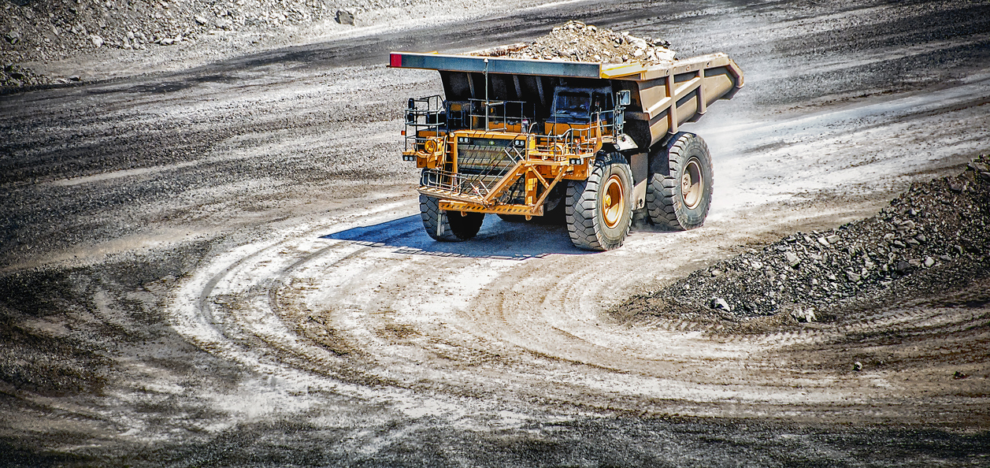
A large orange mining haul truck carries a load of rock in an open cut coal mine in Queensland’s coal basin.
Figure 1 shows annual global methane emissions from both natural and human sources. It also shows the natural processes that remove methane from the atmosphere (methane sinks) and the portion that remains in the atmosphere.
Figure 1: Global annual methane emissions sources and sinks for period 2010-2019
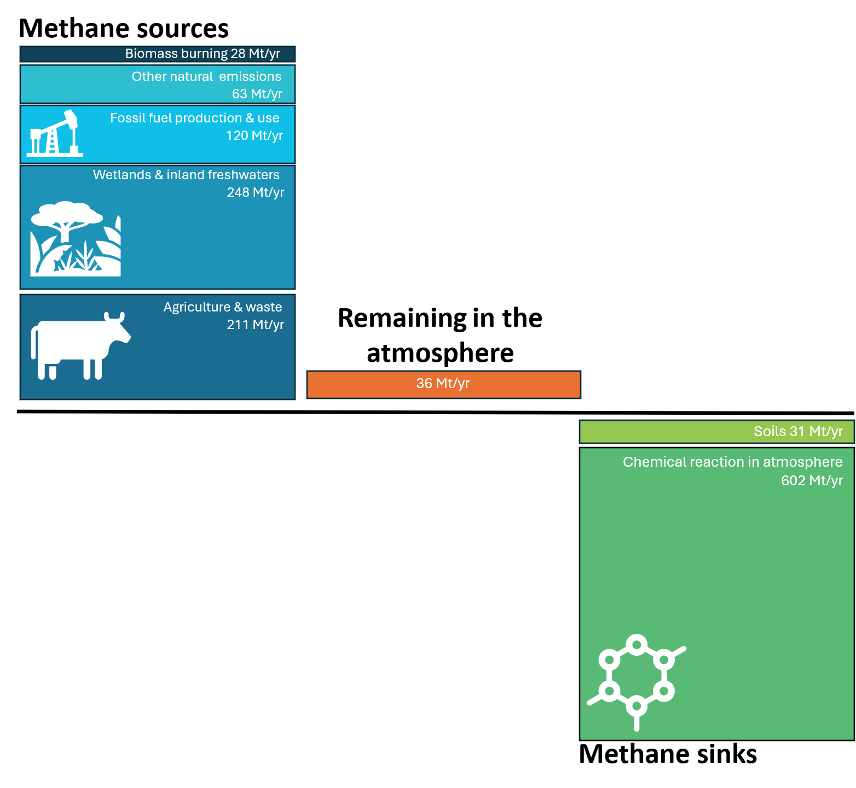
Source: (Saunois et al. 2025)
Note: units are megatonnes of methane, not carbon dioxide equivalent

Historically, there has been balance between the methane sinks and sources, meaning atmospheric methane concentrations remained relatively stable for most of the past 2000 years (CSIRO n.d.-a). Human activity, particularly since the industrial revolution, has disrupted this equilibrium, and methane is rapidly accumulating in the atmosphere (CSIRO n.d.-a; Figure 2). Over the last 200 years, the concentration of methane in the atmosphere has increased almost 2.7 times (IEA 2026b). Over the past 5 years, methane concentrations have increased at a record pace (Stanford Report 2024).

Figure 2: Change in atmospheric methane concentration over time
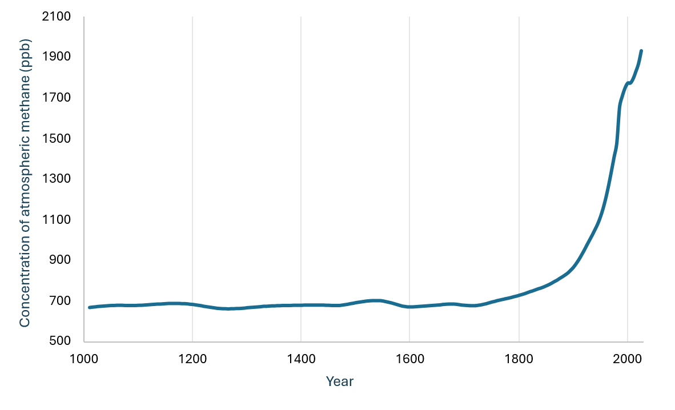
Source: (2 Degrees Institute 2026).

1.2 Methane has an outsized impact on warming in the near term
Methane is a greenhouse gas, like carbon dioxide, that traps heat in the atmosphere and drives climate change (CSIRO n.d.-b). After carbon dioxide, it is the second most abundant human-caused greenhouse gas, making up around 19% of global emissions and 29% of Australia’s emissions (WRI 2026; DCCEEW 2026b). Human-caused methane emissions are responsible for about 0.3 °C of warming since pre-industrial levels (OECD 2025).
Methane lasts for an average of 12 years in the atmosphere before naturally breaking down into carbon dioxide and water (WRI 2025). The resulting carbon dioxide, like direct carbon dioxide emissions, can remain in the atmosphere for hundreds to thousands of years (WRI 2025). While methane is in the atmosphere, it has a much higher ability than carbon dioxide to absorb energy, trapping more heat (IPCC 2021). It therefore has a higher ‘Global Warming Potential’ (GWP) than carbon dioxide over 100 years, and an even higher warming potential when considered over 20 years (Box 1).

Box 1: What is global warming potential?
Global warming potential (GWP) is a standard metric for comparing the warming impact of different greenhouse gases. It measures how much energy the emission of one tonne of a gas will absorb over a specified period, relative to one tonne of carbon dioxide. The larger the GWP, the higher the warming impact of the gas. The globally accepted time period for emissions reporting and policy is 100 years (IPCC 2021).
Because it is short-lived but powerful, methane’s warming impact is much higher over shorter timeframes. Methane is around 28 times more potent than carbon dioxide when averaged over 100 years (GWP-100), but around 86 times more potent over 20 years (GWP-20) (CCAC n.d.).
Because methane is short-lived but powerful, reducing emissions now can contribute to reducing the concentration of methane in the atmosphere in the near term (Copernicus 2022). That means cuts made today can have a measurable effect on warming within the next decade.
This is important for achieving the Paris Agreement temperature goal of holding warming well below 2 °C above pre-industrial levels, and pursuing efforts to limit it to 1.5 °C (Box 2). Rapid methane reductions can support this goal by slowing the pace of warming, limiting peak temperatures, and reducing the duration of any overshoot above 1.5 °C (OECD 2025; CCA 2025a). To limit warming to 1.5 °C with little or no overshoot, global studies suggest methane emissions would need to fall by an estimated 34% by 2030 and 44% by 2040, relative to 2019 levels (OECD 2025; IPCC 2023).
In addition to its warming impact, methane is also a precursor for ground level ozone, formed through oxidation in the presence of sunlight and other pollutants. Ground level ozone is a harmful air pollutant that can affect human health, reduce crop yields, and harm ecosystems. Methane emissions contribute to roughly half of the observed rise in global ozone levels. Reducing methane emissions is therefore not just important for climate change benefits but also air quality and for health and environmental outcomes (CCAC n.d.).
Box 2: What is temperature overshoot?
A decade ago, parties to the Paris Agreement, including Australia, committed to limiting the increase in global average temperature to well below 2 °C above pre-industrial levels, and to pursuing efforts to limit warming to 1.5 °C (UNFCCC 2015). These goals reflect scientific evidence that climate risks increase significantly beyond 1.5 °C (IPCC 2023).
Temperature overshoot occurs when global temperatures temporarily exceed these limits before falling back. Overshoot increases the risk of severe and, in some cases, irreversible impacts on human and natural systems (IPCC 2023).
Figure 3 shows how emissions levels shape temperature outcomes over time. Higher emissions lead to more warming, while lower emissions slow and eventually stop further warming. Temperature largely follows the total amount of emissions over time, so delayed or slower reductions result in higher cumulative emissions and higher peak temperatures (Climate Analytics 2021). Delayed reductions also increase reliance on carbon removals in the future (Drouet et al. 2021).
Figure 3: Relationship between emissions reduction and temperature overshoot. Illustration based on (Nature Geoscience 2023).
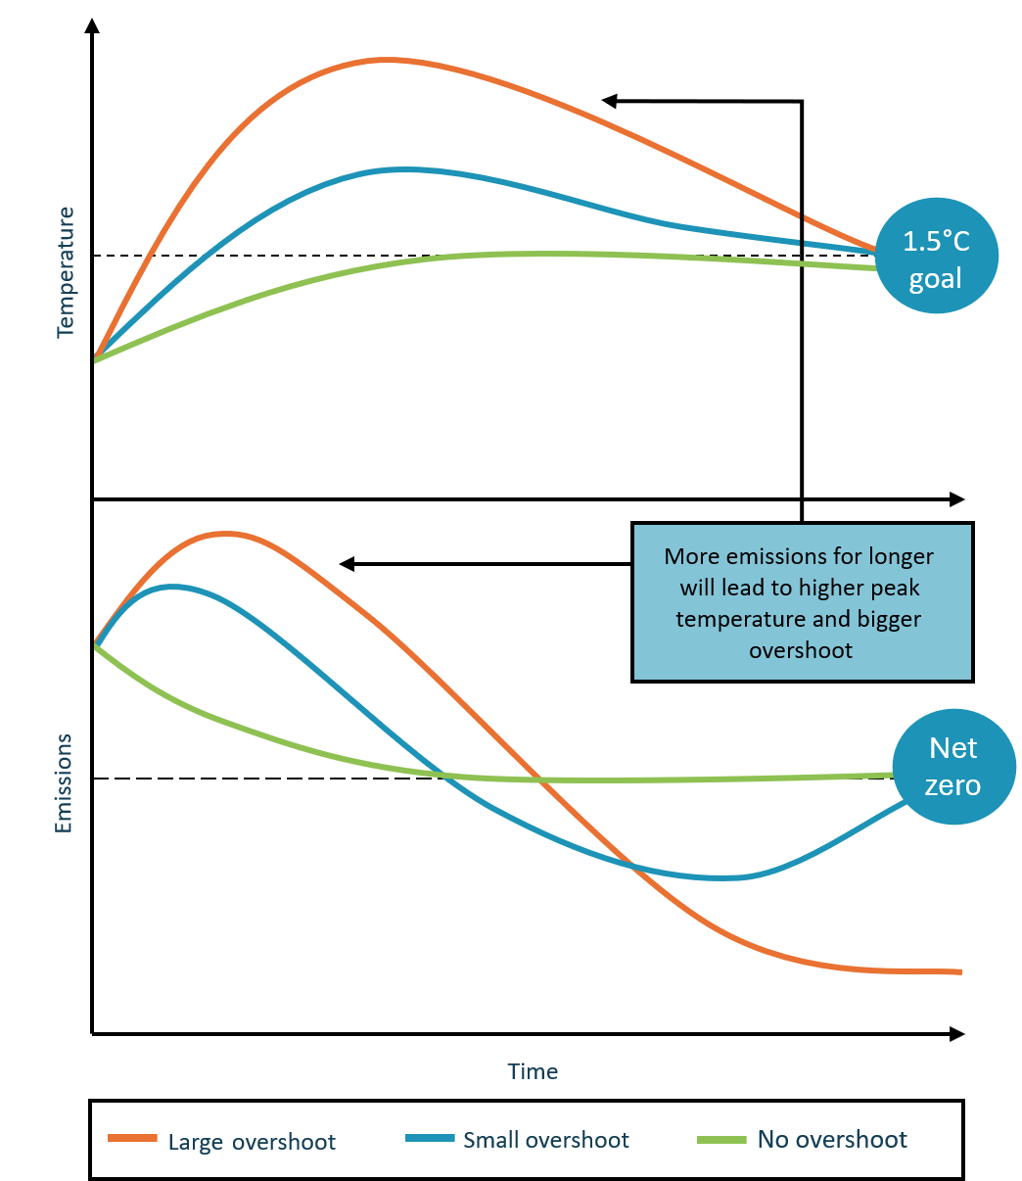

1.3 Agriculture is the largest source of methane emissions
In Australia, agriculture is the largest contributor to human caused methane emissions at an estimated 49% (Figure 4). Agricultural methane is produced as a result of biological processes from dispersed emissions sources, which can make it more difficult to manage (CCAG 2025). Some opportunities can be implemented now, such as changes to herd and manure management practices. Broadly, however, there are currently limited options commercially available to achieve significant abatement in the agriculture sector (DAFF 2025).
To overcome the barriers in the agriculture sector, existing programs are supporting research and development of abatement solutions such as feed supplements for livestock, including the Methane Emissions Reduction in Livestock Program (DCCEEW 2025a). Additional funding for early-stage commercialisation could further help address these challenges (CCA 2024).
While this important work progresses, it makes sense to look for near-term abatement opportunities in the next highest emitting sector—fossil fuel production and use.
Box 3: Australia’s international commitments on methane
Australia and the world have committed to reducing methane emissions. It forms part of our national targets and policies and is a focus of global collaboration. Australia’s public and private sectors have joined global initiatives to reduce methane emissions and improve measurement and reporting across key sectors, including the fossil fuel sector.
- Global Methane Pledge - Australia is a signatory to the Global Methane Pledge, in which 159 countries aim to collectively reduce global methane emissions by at least 30% by 2030 from 2020 levels. The pledge is voluntary and non‑binding (Global Methane Pledge 2026).
- Oil and Gas Decarbonisation Charter – participating firms, including firms based and/or operating in Australia, have committed to accelerate emissions reductions, including methane, and pursue near zero upstream methane emissions by 2030 (OGDC 2026).
- Oil & Gas Methane Partnership (OGMP) 2.0 - the United Nations Environment Programme’s (UNEP) OGMP 2.0 reporting framework aims to enhance transparency and accuracy in methane emissions reporting from the oil and gas sector. Globally, 150 companies, including many based or with operations in Australia, have voluntarily joined this initiative (UNEP 2026).
- Australia-UNEP IMEO Methane Measurement Study - Australia is collaborating with UNEP’s International Methane Emissions Observatory (IMEO) on a world‑first study testing ground, airborne and satellite measurement technologies. This work aims to improve understanding of the capability to detect and quantify fugitive methane emissions from open‑cut coal mines (UNEP 2025).
These international commitments and collaborations support stronger methane measurement, reporting and abatement outcomes. Countries and companies participate in different ways, with some drafting new regulations, improving leak detection programs and developing national action plans (CCAC 2025).

1.4 Fossil methane is a practical near-term abatement opportunity
The fossil fuel sectors that generate methane emissions are the coal, oil and gas sectors. In Australia, methane from fossil fuels makes up around 24% of Australia’s methane emissions. This is equivalent to 6% of Australia’s total greenhouse gas emissions.
In this paper, we focus on fugitive methane emissions from the coal and gas sectors in Australia, given oil generates a relatively small share (less than 1%) (DCCEEW 2026a). We refer to the methane fugitive emissions from the coal and gas sectors as 'fossil methane' in this paper. Appendix A provides detail about the sources of methane emissions in these sectors.
Figure 4: Proportion of Australian fossil methane emissions from the coal mining, natural gas and oil sectors in Australia
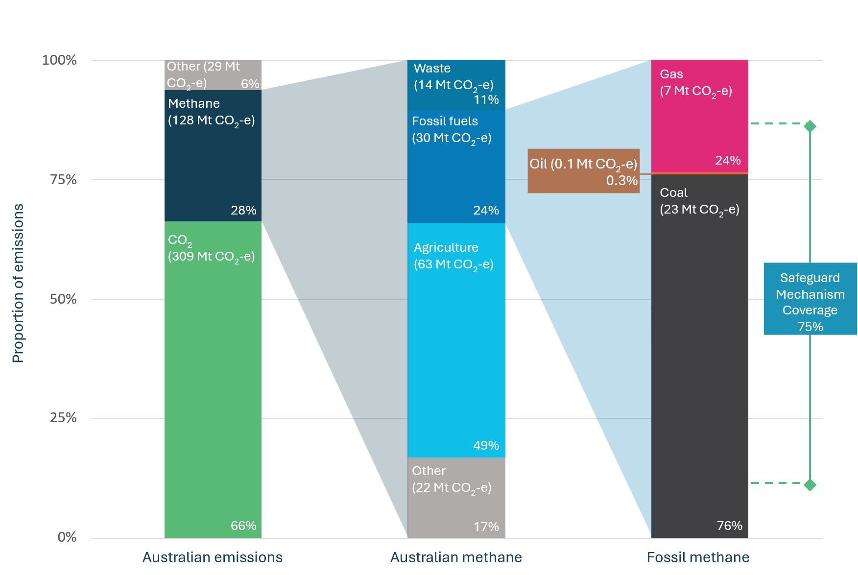
Source: (DCCEEW 2026a).

In the coal and gas sectors, a large share of emissions come from identifiable sources such as venting, leaks, and incomplete combustion (IEA 2026b). There are already proven technologies that can tackle these emissions. These include leak detection and repair (LDAR), improved maintenance and operational practices, and replacing high-emitting equipment (IEA 2026b). In coal mining, additional measures such as pre-drainage of methane from coal seams, capturing methane from ventilation air, and flaring or using drained gas can also reduce emissions (NSW Net Zero Commission 2025). Further information about fossil methane abatement technologies is described in Appendix B.
The IEA’s 2026 methane tracker identifies a range of methane abatement options in Australia at low or no net cost (IEA 2026b). In the gas sector, the captured methane can be sold or used onsite (IEEFA 2024). For the coal sector, the IEA’s tracker identified a smaller amount of low or no net cost options (IEA 2026a).
The fossil fuel sector has a high technical abatement capacity compared to other sectors that produce methane emissions. Fossil methane emissions are often concentrated at a relatively small number of sites, making them easier to detect and address at scale. In addition, coal and gas operators are typically large, well-capitalised companies with the ability to invest in abatement measures (IEA 2026b; CER 2026a; IEEFA 2024).
While there are still barriers to the uptake of abatement measures, there is strong potential to achieve substantial emissions reductions in the near-term using existing technologies. It should be noted, however, that methane abatement often involves converting the gas into carbon dioxide and waterShaw et. al, 2023. While this avoids the accelerated warming impacts of atmospheric methane, it does not eliminate the effect of the remaining carbon dioxide.
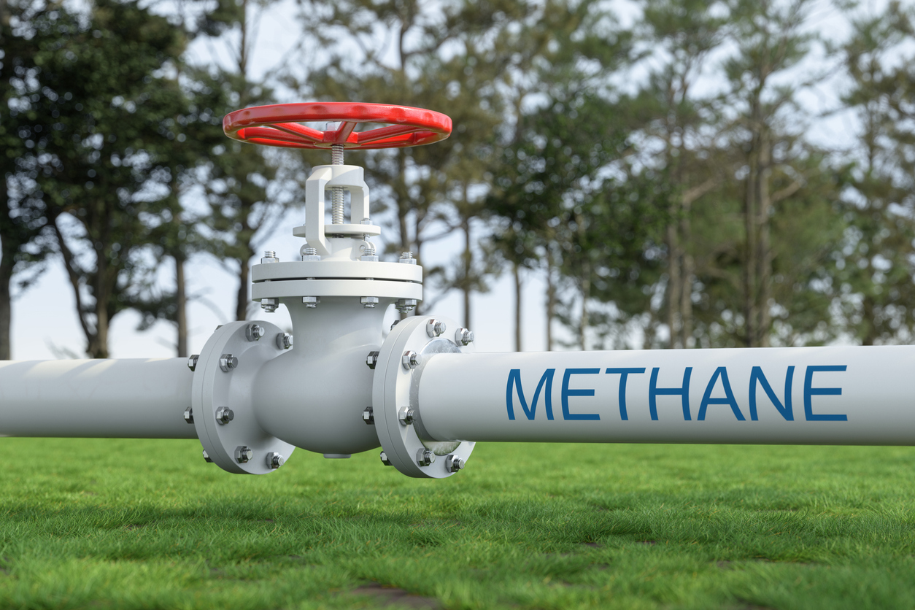
White industrial pipelines transport methane gas across a green field.

1.5 Australia’s fossil methane emissions have declined, but future trends will depend on domestic and global drivers
Australia’s reported methane emissions from coal mining peaked in 2007 and have fallen since then (Figure 5). This reflects reductions from underground mining activities, but it should be noted that over the same period, emissions from open cut mining have increased. In general, open cut mining is less emissions-intensive than underground, so the shift in composition of mining activity has contributed to lower overall emissions from the sector. Reported methane emissions from gas production rose during the liquefied natural gas (LNG) expansion of the 2010s, peaked in 2019, and have since declined.
Figure 5: Australian fossil methane emissions from coal mining and gas extraction
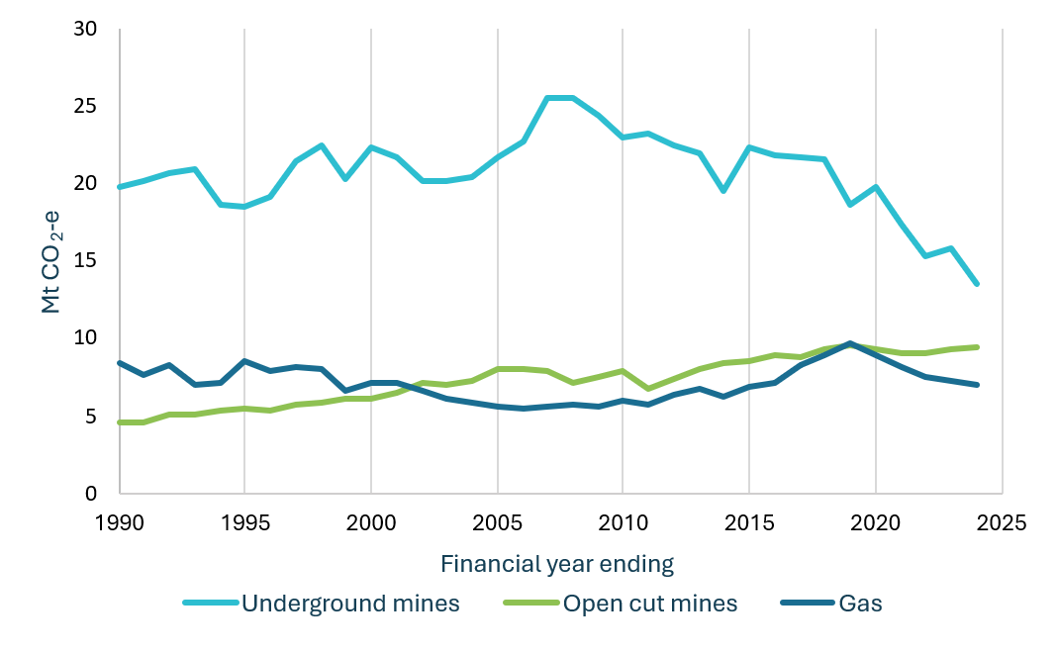
Source: (DCCEEW 2026a)
Whether this modest downward trajectory continues depends on domestic emissions reduction policies and on Australia’s fossil fuel production outlook. The Australian Government’s Emissions Projections show that under current policy settings, fugitive emissions — including fossil methane — decline modestly by 2% by 2030 from 2025 levels, and 25% by 2040 (DCCEEW 2025g). Australia’s policies and regulations are discussed further in Part 2.
Because Australia exports most of its coal and gas (DCCEEW 2025b), global demand and decisions by Australia’s trading partners will play a large role in shaping future production and, in turn, future fossil methane emissions. The remainder of this part of the paper explores whether trends in global fossil fuel production and demand will significantly reduce Australian fossil methane emissions.
Box 4: IEA scenarios and projections
The IEA conducts annual analyses of global energy pathways, based on global energy policies. These are then used to construct a series of scenarios illustrating possible energy supply and demand futures. The scenarios give an indication of the role of different energy sources in the coming decades and can illustrate how climate policy interacts with energy landscapes. Figures 6 and 7 show global coal and gas demand under each of the IEA scenarios, out to 2050, compared to demand in 2024.
International Energy Agency scenarios
Current Policies Scenario (CPS) | Includes policies and regulations that are already in place and takes a generally cautious perspective on the speed at which new energy technologies can be deployed in the energy system.
Stated Policies Scenario (STEPS) | Includes a broader range of policies, including those that have been announced but not yet adopted, as well as official government strategies. This scenario does not assume that aspirational targets are met.
Announced Pledges Scenario (APS) | A trajectory for the energy sector that assumes all national energy and climate pledges, including long-term net zero emissions goals, are met on time and in full.
Net Zero Emissions by 2050 (NZE) Scenario | A global pathway for the energy sector to achieve net zero carbon dioxide emissions by 2050, based on an overshoot of 1.5 °C and a return to 1.5 °C by 2100.
Figure 6: Global coal demand in 2035 and 2050 across IEA scenarios
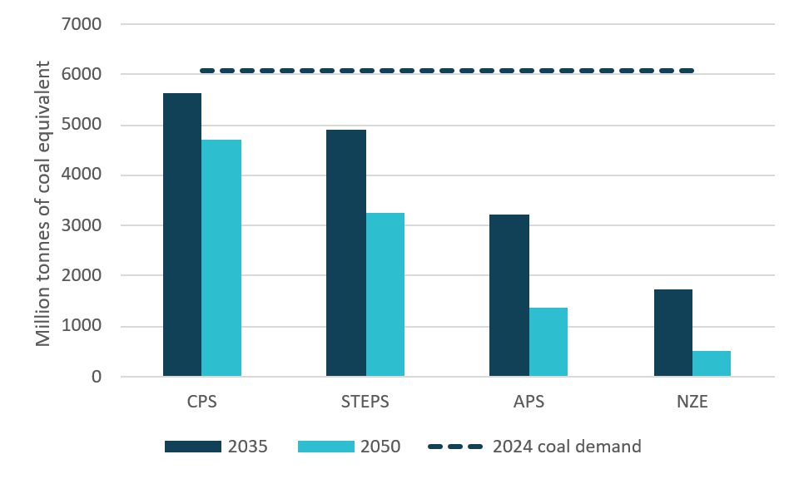
Source: (IEA 2025b, 2024).
Note: APS and NZE figures are not provided in WEO 2025, so figures from WEO 2024 are used. STEPS and CPS figures are from WEO 2025.
Figure 7: Global gas demand in 2035 and 2050 across IEA scenarios
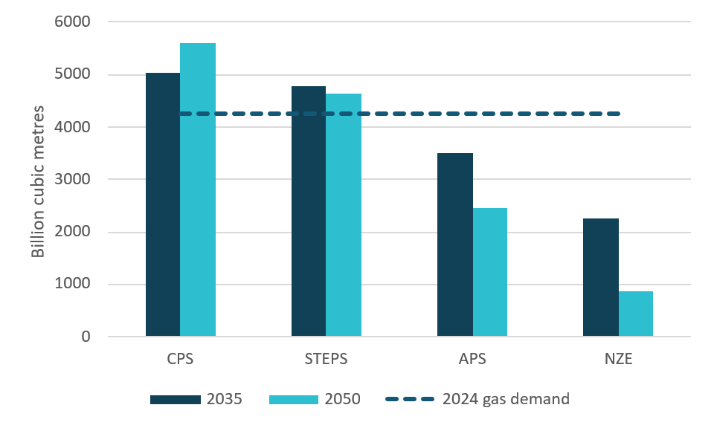
Source: (IEA 2024, 2025b)
Note: APS and NZE figures are not provided in WEO 2025, so figures from WEO 2024 are used. STEPS and CPS figures are from WEO 2025.

Current global policy settings do not point to significant reductions in fossil fuel production
The IEA’s Current Policies Scenario (Box 4) projects that under current settings, global demand for coal is likely to decline modestly, by around 8%, between 2024 and 2035. Gas demand is projected to rise by around 19% in the same period (IEA 2025b).
Australia’s Emissions Projections— which also assume current policies and measures—estimate total Australian production of black coal falls 15% between 2025 and 2035. Metallurgical coal production grows to 2030 and then declines, while thermal coal is flat to 2030 then declines. Brown coal production is estimated to decline 92% over the period, but accounts for only a small share of total production and is not exported. LNG production (gas for export) is projected to fall 5% between 2025 and 2035, peaking in 2028 and then declining (DCCEEW 2025g).

Box 5: Australia’s coal exports
Australia exports coal for 2 main uses:
Thermal coal (also known as steam coal) is burned to generate electricity. Demand for thermal coal from Australia’s trade partners is expected to decline gradually as these countries replace coal power generation with lower-carbon alternatives (DISR 2025a; IEA 2025b).
Metallurgical coal (also known as met coal or coking coal) is used in steelmaking and other industrial processes. Demand for Australian metallurgical coal is expected to be more stable in the medium term, in part because low-emissions alternatives are less commercially mature and more costly (IEA 2025c).
Australia currently exports around 350 Mt of coal each year—around 200 Mt per year of thermal coal and 150Mt of metallurgical coal (DISR 2025a).
Figure 8: Australian exports of thermal and met coal from 1990 to 2025
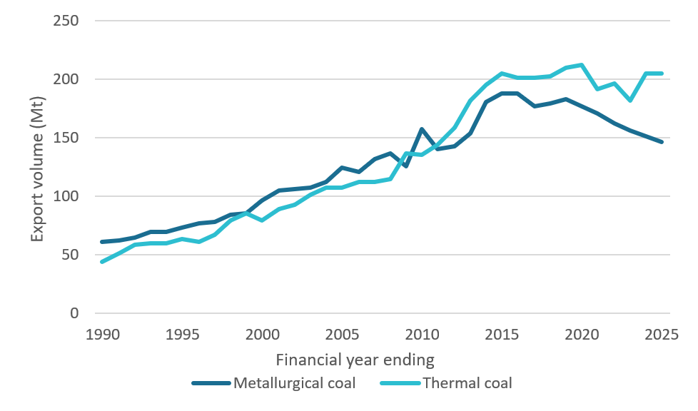
Source: (DISR 2025a)

Global climate action will reduce fossil fuel demand, but substantial demand will remain in coming decades
Over 84% of global GDP is covered by net zero commitments including Australia’s major trading partners China, Japan and South Korea (DCCEEW 2025c). As climate action strengthens in these countries, global demand for fossil fuels is expected to decline, in turn reducing fossil methane emissions over time. However, substantial fossil fuel production is still expected to continue for decades under all major scenarios (IEA 2025b). IEA scenarios (Box 4) show that coal demand falls most sharply under stronger climate action, especially for thermal coal (Figure 6). The outlook for gas is more mixed, and both gas and metallurgical coal are generally expected to persist longer than thermal coal because they are harder to replace with low emissions alternatives in some parts of the economy and in some markets (Figure 7) (IEA 2025b; DISR 2025a).
The Australian outlook is broadly consistent with this international picture. Because Australia supplies into a global coal and gas market, lower global demand is expected to translate into lower Australian production and exports over time (Australian Treasury 2025). Treasury’s 2025 modelling for the Australian Government’s Net Zero Plan points to coal declines under all modelled scenarios, largely driven by falls in thermal coal demand, while gas also declines but more gradually (Australian Treasury 2025). Even under stronger climate action scenarios, demand for coal and gas continues to 2050 (IEA 2025b).
It is therefore worth examining whether practical measures could accelerate fossil methane abatement beyond what existing market trends and policy settings would otherwise deliver.
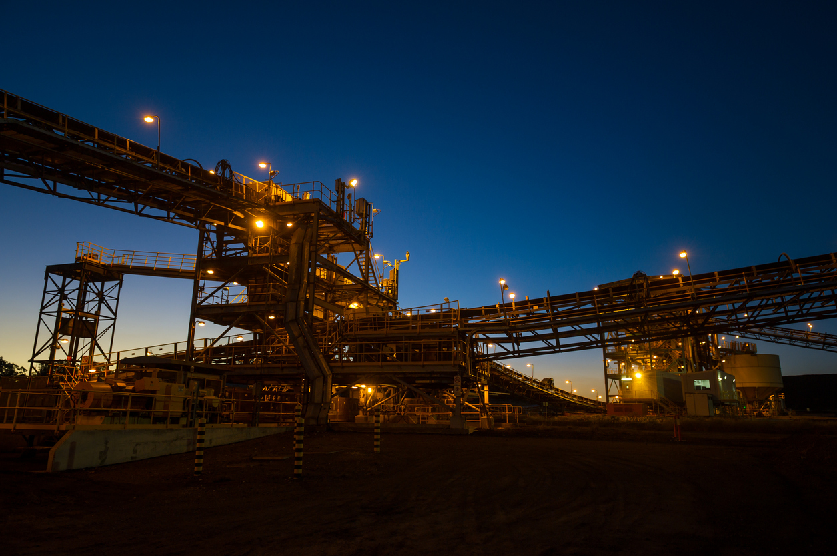
Mining processing plant with illuminated conveyor belts and steel structures at dawn.

Part 2: How Australia could accelerate fossil methane abatement
This section seeks input on practical options to accelerate methane abatement from coal mining, gas extraction and processing in the near term. The focus is on what current policy settings already do, where they may be falling short, and what else might bring forward additional abatement.

2.1 Existing policies already drive some fossil methane abatement

Commonwealth policies and regulations
The NGER scheme is a single national framework for reporting greenhouse gas emissions at the corporate and facility level (DCCEEW 2026g). It underpins the Safeguard Mechanism, which is the main Commonwealth policy to drive reductions in industrial emissions. The Safeguard Mechanism covers 75% of Australia’s fossil methane emissions (DCCEEW 2026a; CCA analysis of CER 2026b).
The Safeguard creates a general financial incentive for large industrial facilities to reduce their greenhouse gas emissions, including fossil methane emissions, by imposing binding limits on their net greenhouse gas emissions (DCCEEW 2026c).
The NGER scheme and Safeguard Mechanism aggregate emissions of different greenhouse gases using a common ‘carbon dioxide equivalent’ (CO₂-e) metric. This allows comparison of emissions from different sources. It also underpins consideration of the relative cost-effectiveness of different abatement options by Safeguard facilities. This accounting is done on a ‘GWP-100’ basis, which is the standard 100-year global warming potential metric used in national and international greenhouse gas emissions accounting (IPCC 2014). This is the same way methane is treated in Australia’s inventory and other domestic climate policy frameworks (DCCEEW 2025d).
For offshore petroleum facilities in Commonwealth waters, venting and flaring are regulated under the Offshore Petroleum and Greenhouse Gas Storage Act 2006 and associated safety, resource management and environmental regulations. The government’s 2024 Future Gas Strategy and complementary 2025 policy statement make clear that operators and regulators are expected to minimise venting and flaring and, where possible, eliminate them unless they are required for safety purposes (DISR 2025c).
The Commonwealth Government has made funding available for abatement technology, including for coal mine methane abatement through the Powering the Regions fund (DCCEEW 2024b).

State and territory policies and regulations
States and territories also influence methane outcomes through their regulation of onshore fossil fuel activities, including safety, planning and environmental requirements. This is particularly relevant in New South Wales and Queensland, which have the highest fossil methane emissions, mostly from coal mining (see Appendices A and C for detail).
In New South Wales, the Environment Protection Authority (EPA) recently introduced new climate change licence requirements, including specific requirements for major coal mines to reduce fossil methane emissions (NSW EPA 2026a). These include requirements for large underground mines to flare or use drained gas, minimise leakage from old workings, and install ventilation air methane abatement technology in certain circumstances, or achieve equivalent abatement (NSW EPA 2026a). The requirements will be phased in from 2027 and are expected to drive abatement once they take effect (NSW EPA 2026a; NSW Net Zero Commission 2025).
The NSW Government’s Coal Industry 2026–50 policy states that it will not consider proposals for new standalone greenfield coal mines. Applications to extend existing mines may still be considered, subject to environmental and emissions requirements (NSW Government 2026a). In relation to gas, however, the NSW Government has announced it will open new areas for exploration for the first time in more than a decade (NSW Government 2026b).
Queensland also has measures relevant to fossil methane. These include requirements under the Mineral Resources Act 1989 (Qld) that restrict the release of coal mine waste gas and, in practice, require the methane component to be combusted (such that the methane is converted into carbon dioxide and water vapour) or otherwise managed where this is feasible (DCCEEW 2025e; Queensland Government 1989). In addition, the Low Emissions Investment Partnerships program aims to reduce emissions from metallurgical coal mines covered by the Safeguard Mechanism. The program is intended to accelerate emissions reductions, with a preference for abatement that goes beyond Safeguard requirements and is delivered before 2030 (Queensland Treasury 2026).
Queensland oil and gas regulation only allows flaring if it is not commercially or technically feasible to use the gas (Queensland Government 2004; summarised by IEA 2022). It also states that, where it is safe to do so, waste gas must be preferentially flared over vented (which results in less methane being released into the atmosphere).
Appendix C provides more detail about existing state and Commonwealth policies.
Consultation questions on existing policies and measures
- Do current policies and measures adequately cover the material sources of fossil methane emissions in Australia? For example, are emissions from decommissioned and abandoned mines material, and are they adequately monitored and mitigated?
- To what extent will Australia’s current policy settings, including the Safeguard Mechanism and state regulations, drive near term fossil methane abatement? Please provide relevant analysis or evidence.

Consultation questions on abatement opportunities
- What fossil methane abatement technologies and practices are commercially ready, or likely to be viable in the near term in Australia? Where available, please provide indicative costs, timelines, and examples.
- What fossil methane abatement activities have Safeguard entities planned, started or completed since the commencement of the Safeguard Mechanism reforms?

Consultation questions on existing barriers and enablers
- What are the main barriers—whether commercial, regulatory, market or other— preventing the uptake of fossil methane abatement opportunities in Australia? How could those barriers be overcome?
- What factors are constraining broad deployment of ventilation air methane (VAM) abatement in underground coal mines in Australia? Where possible, please identify any relevant safety, technical, regulatory, commercial or site-specific barriers, and provide evidence or operational experience.
- Do current approaches to measuring, reporting and verifying fossil methane emissions create any practical barriers to the uptake of abatement options in Australia? Please identify the relevant issue and explain how it affects abatement decisions, incentives or compliance outcomes.

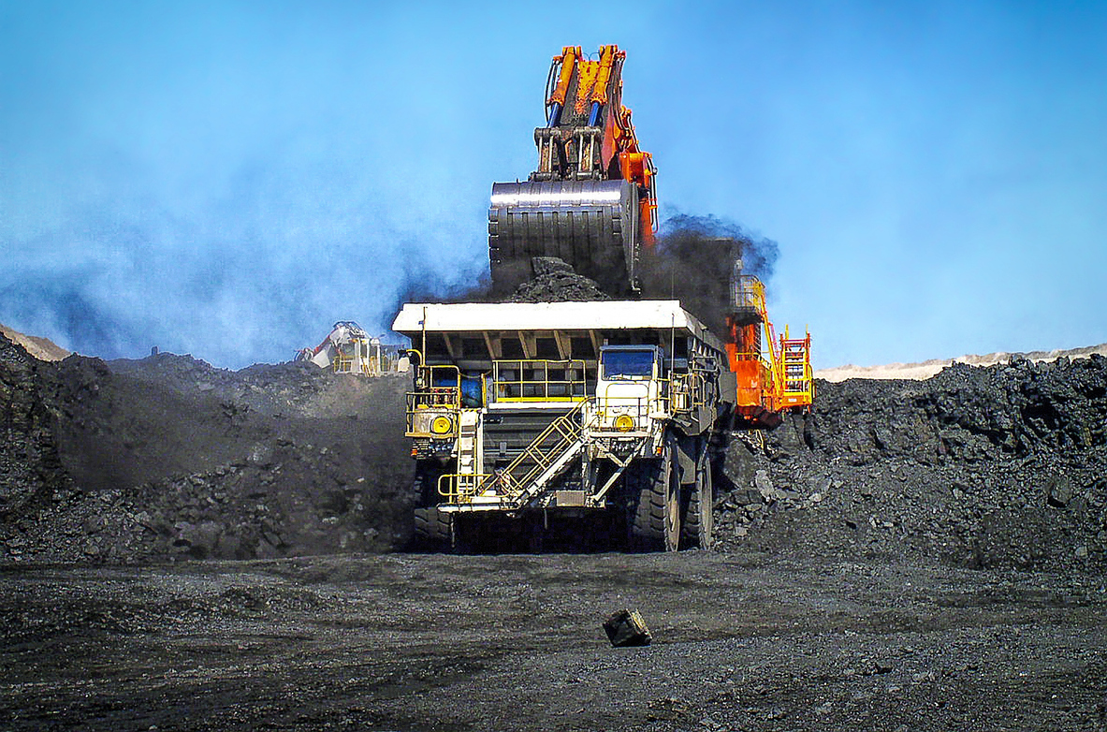
A large excavator loads black coal into a heavy dump truck at an open cut mine in Queensland.

2.2 The case for going further
While these policies and measures should drive some fossil methane abatement, there is a significant case for further action. Methane has a much stronger warming effect in the near term than is reflected in our standard (GWP-100) emissions accounting. As a result, under policies like the Safeguard Mechanism, methane abatement opportunities may appear less effective for reducing climate change than their near-term climate value would suggest.
This does not mean we need to change Australia’s established emissions accounting and policy architecture. GWP-100 is the basis for international reporting, national inventories and Australia’s facility-level emissions reporting scheme. The question for this project is whether practical measures within, or alongside, the existing framework could accelerate methane abatement in ways that better reflect its near-term climate benefits.

2.3 What kinds of policy response might accelerate methane abatement?
A central question for this project is understanding why companies aren’t taking up more methane abatement opportunities now. In some cases, practical barriers may be preventing investment in abatement options that should already be attractive even under current policy settings. In other cases, it may reflect a commercial judgement by companies that methane abatement is not sufficiently attractive under current market and policy settings, even if barriers were removed. This distinction is relevant because it points to two kinds of policy response.
The first is to identify and remove barriers that are preventing uptake of methane abatement opportunities that should already be commercially attractive. These barriers could be technical, regulatory, informational, coordination-related, or site-specific. There may also be cases where firms are not investing because uncertainty, transaction costs, measurement and reporting arrangements, or approval processes, weaken the incentive to act, even where abatement would otherwise compare favourably with alternative compliance options.
Policy responses to remove barriers could include better information, improved coordination between regulators, clearer approvals pathways, or targeted support to address specific implementation barriers.
The second response is to consider whether policy should go further than current settings and bring forward additional methane abatement opportunities that are not commercially attractive (in particular, not attractive on a GWP-100 basis). In these cases, the question is whether the near-term climate value of methane reduction justifies stronger intervention. Measures could include national goals, more direct regulation, targeted funding, or other complementary policy support.
Consultation questions on further policies and measures
- What practical policies and measures could drive more fossil methane abatement than existing policy settings would deliver? How would these interact with the Safeguard Mechanism, and how should those interactions be managed?

Targets and goals to set ambition
Establishing specific goals or commitments to limit emissions from specific source sectors can be a valuable part of the methane policymaking process (Global Methane Initiative n.d.), and many countries have done so (Climate Council 2024). Some country targets cover all methane sources (e.g. Mexico and Colombia), while others target specific sectors (Climate Analytics 2026). Some jurisdictions, including the UK and EU, have set methane intensity targets for imports and production of fossil fuels (European Commission n.d.; UK Government 2025).
Australia’s most recent Nationally Determined Contribution (NDC) sets a target to reach 62-70% reduction in net national greenhouse gas emissions by 2035 based on 2005 levels (Commonwealth of Australia 2025). It does not include a specific methane target. The Authority is not proposing to make changes to Australia’s NDC but is interested in the role that a specific methane goal could play in the Australian policy landscape, whether at a national, sub-national or sectoral level.
Consultation questions on targets or goals
- Should Australia set specific targets or goals for reductions in fossil methane emissions or the uptake of fossil methane abatement opportunities? What are the benefits and risks?

Regulation to reduce emissions
As outlined above, some Australian states and territories have implemented regulations specifically targeting fossil methane emissions. The Authority is interested in whether additional regulation may be warranted, and what form this could take, including the potential for more consistent or harmonised approaches. Some countries, such as Canada and the EU, have delivered tighter national regulations for the oil, gas and coal sectors (European Commission n.d.; Government of Canada n.d.) These include restrictions on venting and routine flaring, and requirements for industry to monitor, detect and repair methane leaks.
The EU has also set requirements for industry to address abandoned coal mines and inactive oil and gas wells (European Commission n.d.). By contrast, Australia lacks comprehensive monitoring and reporting systems for abandoned mine sites (NSW Net Zero Commission 2025).
Box 7: Any new measures should take account of the existing policy landscape
Any new or updated measures to reduce fossil methane should be designed to work with existing policy settings, so they do not create conflicting incentives or unnecessary complexity.

Safeguard Mechanism
If new regulations or incentives accelerate fossil methane abatement at Safeguard-covered facilities, but Safeguard settings otherwise remain unchanged, total net abatement (measured on a GWP-100 basis) will remain the same across the mechanism. The regulation or incentive will not deliver additional abatement (measured on a GWP-100 basis). Instead, it will shift the location or type of abatement towards methane. Even so, it would improve climate outcomes because methane reductions have a disproportionately large effect on near-term warming.
The Authority’s advice on fossil methane and its advice on the Safeguard Mechanism will be closely linked. One issue for both pieces of work is whether current settings are doing enough to drive onsite methane abatement, and whether any additional incentives or complementary measures may be warranted.

State and territory policies
Any variation to Commonwealth policies for fossil methane is likely to overlap with state and territory policies. Designing new or updated policies should involve careful consideration of, and coordination with. relevant jurisdictions. Aligning policy objectives and compliance requirements can increase the overall effectiveness of new or updated policies and should be a priority.

2.4 Using GWP-20 as an additional analytical lens
Emissions accounting using ‘GWP-20’ estimates the warming impact of greenhouse gases over 20 years and therefore gives greater weight to methane’s much stronger near-term warming effect.
The Authority is not proposing to replace GWP-100 as the basis for Australia’s accounting framework. However, it is interested in whether GWP-20 may be useful as an additional analytical lens when assessing methane-related policy options, investment choices or funding decisions. Using a GWP-20 lens highlights the much larger near-term climate value of methane abatement relative to the abatement of carbon dioxide and other more longer-lived greenhouse gases. This affects how policymakers and investors assess the case for stronger action on methane.
If methane emissions are assessed using a GWP-20 lens, the amount of carbon dioxide equivalent (CO₂-e) abatement attributed to a methane abatement activity increases for the same underlying methane reduction. As a result, the apparent cost per tonne of CO₂-e abated falls when compared with assessment on a GWP-100 basis.
Figure 9 illustrates this point using an illustrative marginal abatement cost curve for the same set of methane and carbon dioxide abatement activities assessed using GWP-100 and GWP-20. The figure does not show different physical abatement outcomes. Rather, it shows how the same methane reductions translate into different amounts of CO₂-e abatement, and therefore different apparent costs per tonne of abatement, when methane is assessed over 20 years rather than 100 years.
The figure shows that the carbon dioxide abatement options do not change when moving from GWP-100 to GWP-20. By contrast, the methane abatement options deliver a larger amount of CO₂-e abatement on a GWP-20 basis, so they appear larger on the horizontal axis and lower in cost per tonne on the vertical axis. Applying GWP-20 roughly triples the apparent volume of abatement from the methane options and reduces the apparent cost per tonne to around one-third of the GWP-100 result. The underlying methane reduced, and the cost of the technology, do not change. What changes is the amount of CO₂-e abatement attributed to that methane reduction.

Figure 9: Illustrative marginal abatement cost curves for the same methane abatement activities under GWP-100 and GWP-20
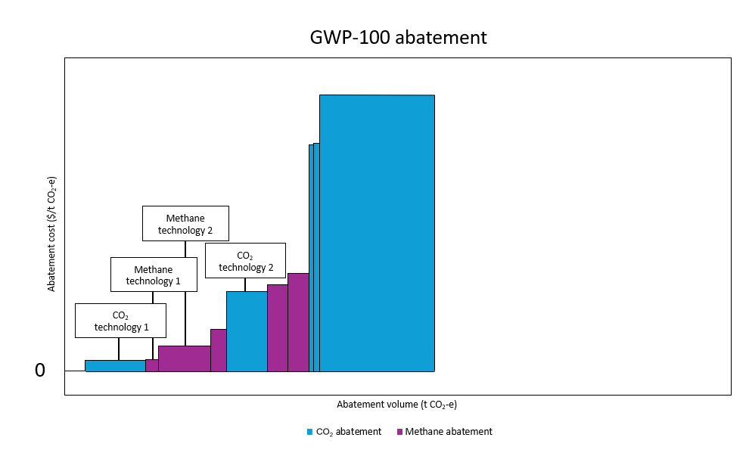
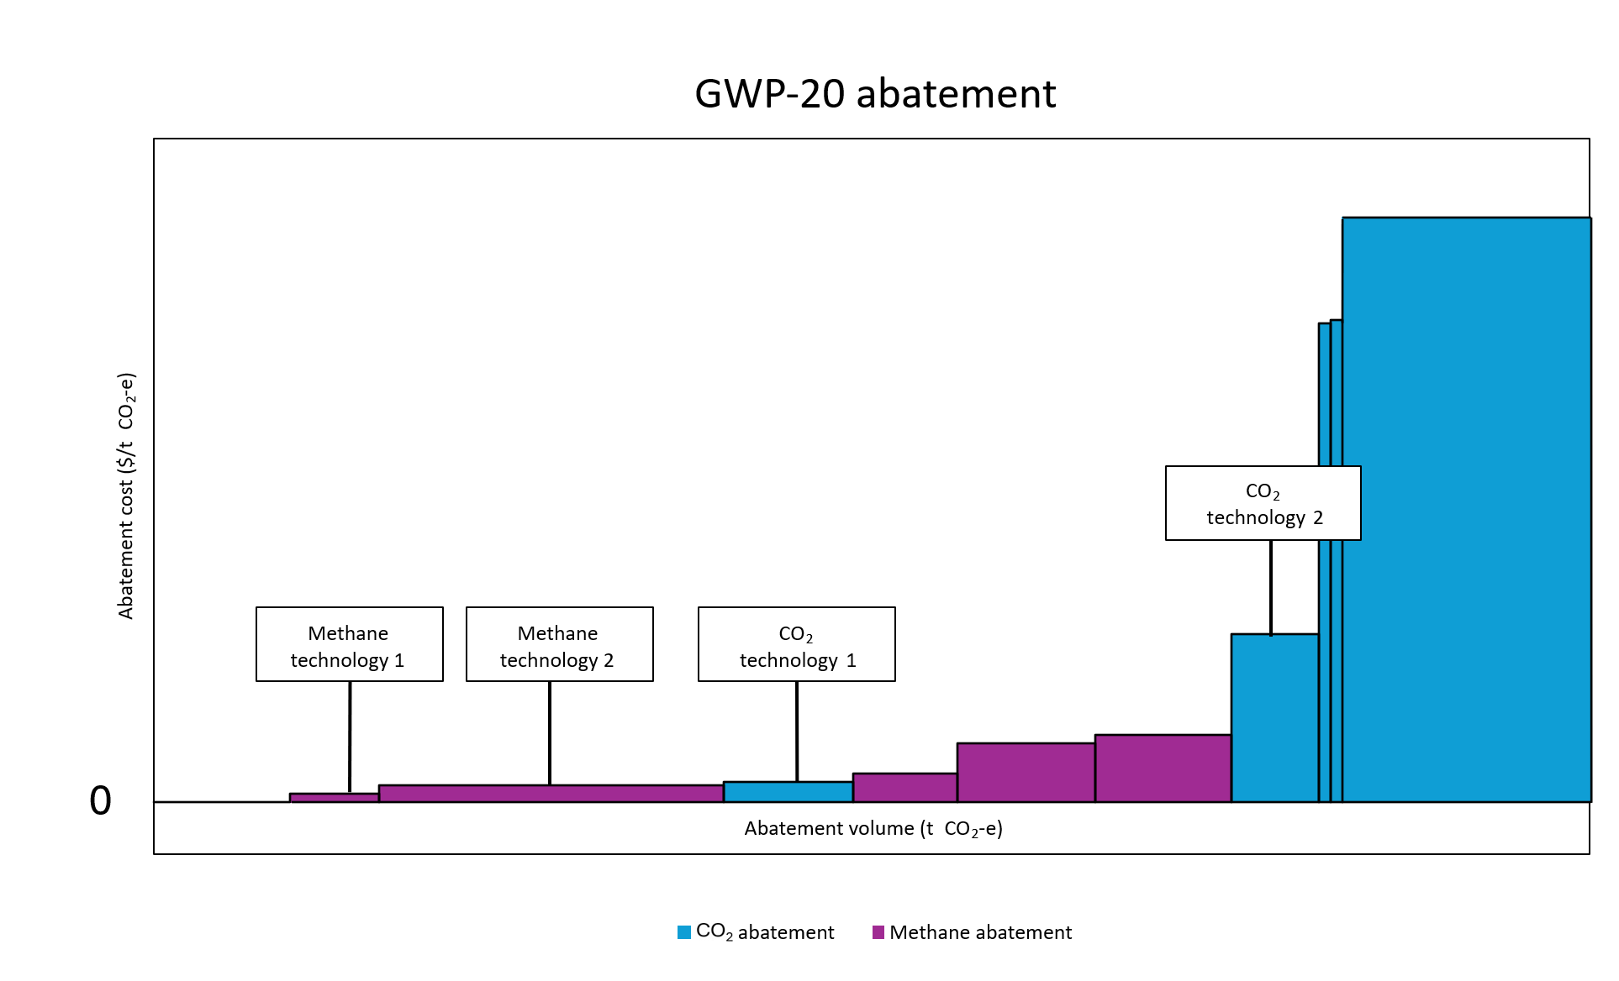
Consultation questions on accounting for near-term climate benefits of methane abatement
- Australia’s emissions accounting and reporting calculate methane emissions on a 100-year global warming potential (GWP-100) basis. Without changing that approach, should policy or investment decisions give more weight to the near-term climate benefits of methane abatement? How?

2.5 How the Authority will assess policy options
The Authority proposes assessing policy options using a framework tailored to the specific characteristics of fossil methane, while taking account of the Authority’s principles outlined in the Climate Change Authority Act 2011 (CCA Act).
Environmental effectiveness
Would the policy option reduce fossil methane emissions in the near term and improve climate outcomes? Policy options that contribute additional abatement towards meeting Australia’s targets, as well as options that do not make an additional contribution but shift effort from carbon dioxide towards methane abatement may have merit.
Cost effectiveness
Would the policy option deliver meaningful climate benefits at reasonable cost, taking account of existing incentives and market settings? In assessing cost effectiveness, the Authority will recognise that the near-term climate value of methane reductions may be better reflected using GWP-20 accounting than GWP-100 accounting. The Authority will take this into account when considering whether complementary measures may be justified.
Equity
Who would bear the costs and receive the benefits of the option, and are those impacts proportionate and transparent? In the fossil methane context, this includes considering impacts across industries and jurisdictions, across facilities with different abatement opportunities, and on workers and communities affected by the fossil fuel transition.
Simplicity and feasibility
Is the policy option administratively workable, compatible with existing institutions, and feasible to implement? In this project, that includes maintaining stability in existing market and regulatory frameworks, avoiding unnecessary duplication, and focusing on technologies and interventions that are viable now or in the near term. It also includes whether an option is feasible to monitor and enforce.

Appendices

Appendix A: Sources of fossil methane emissions
Australia’s fossil methane emissions almost entirely come from coal and gas, with a very small portion from the oil sector (Figure 4). The Authority is primarily focussed on opportunities for abatement from coal mining, and from gas extraction and processing.

Fossil methane emissions by state
Fossil methane emissions and sources vary across states and territories depending on their industrial base (Figure 10). Queensland, New South Wales and Western Australia account for most fossil methane emissions in Australia (CCA analysis of DCCEEW data 2026a). While emissions from the Northern Territory are currently low, they may increase if gas production expands.
Queensland and New South Wales emit the largest share of fossil methane emissions in Australia, with coal mining as the primary driver. In Western Australia, natural gas production is the dominant source.
All jurisdictions have committed to net zero emissions by 2050, and – other than Western Australia and the Northern Territory – have also set interim emissions reduction targets for 2030 or (CCA 2025b; Climateworks 2024). No jurisdiction has established specific targets for reducing fossil methane emissions.

Figure 10: Fossil methane emissions by state in 2023-24
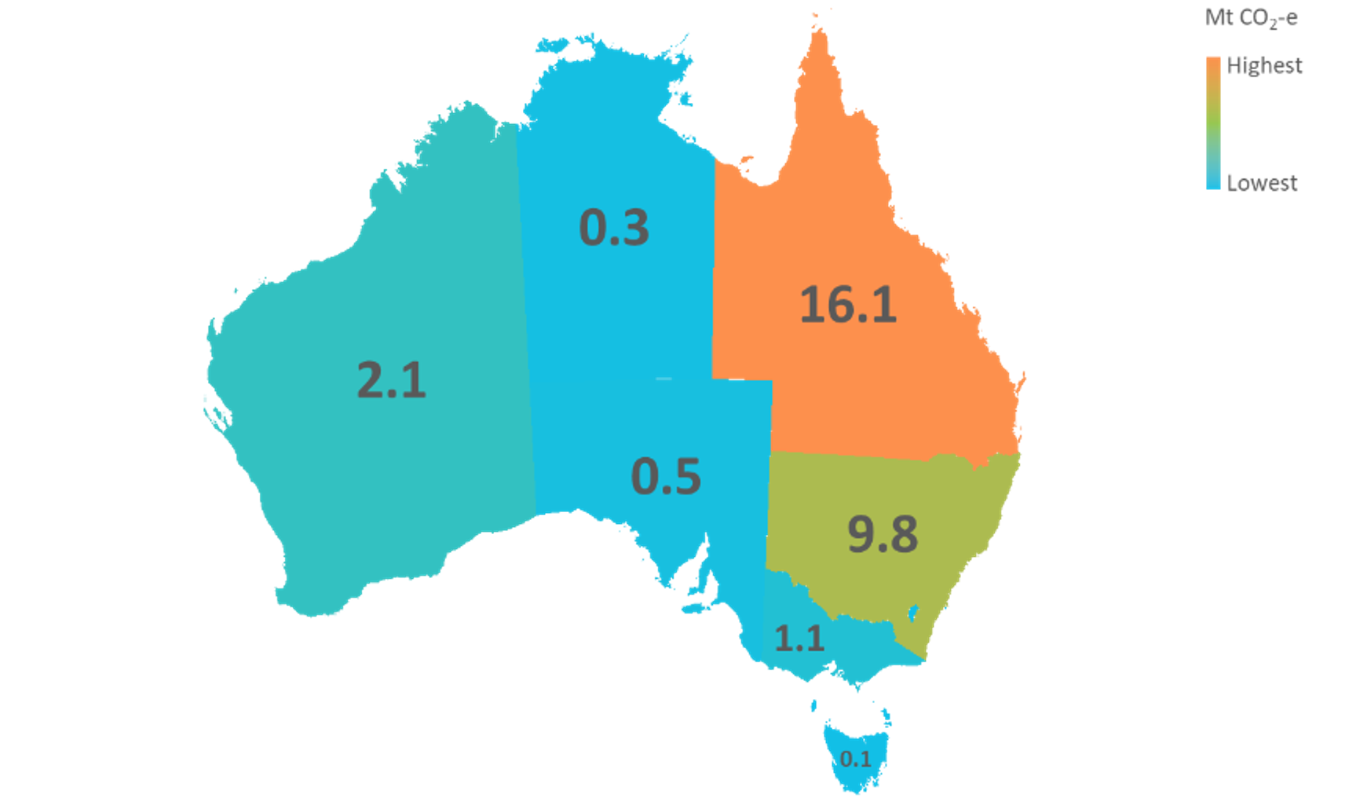
Source: (DCCEEW 2026a)

Fossil methane emissions from coal mining
Coal mining activities are the largest contributor to Australia’s fossil methane emissions. They are responsible for 18% of all of Australia’s methane and 76% of fugitive fossil methane emissions (DCCEEW 2026a).
Coal mining disturbs methane trapped within coal seams, leading to fossil methane emissions from (IEA 2023):
- Extraction - methane is released as coal seams are disturbed during underground and open cut mining.
- Processing - additional methane is emitted as coal is crushed, washed and moved onsite.
- Transport and storage - residual methane continues to escape during rail transport, stockpiling and port storage.
- Decommissioned mines - methane continues to be released from abandoned or closed mines over time unless these mines are effectively sealed.
Over 90% of Australia’s fossil methane emissions from coal mining occurs during the extraction stage (Figure 11). The Authority is therefore focusing on abatement opportunities at this source.
Coal is extracted using one of two methods – underground or open cut mining. Nearly 60% of Australia’s coal mining emissions come from underground mining, despite underground mine production volumes being lower than open cut mines (DCCEEW 2026a; Global Energy Monitor 2025). Underground mines typically have higher methane emissions than open cut mines because deeper coal seams tend to contain more gas and pressure, which is then released during mining (DCCEEW 2026d). In some cases, gas is extracted from the seam before mining to improve safety and reduce emissions (called ‘pre-drainage’). Pre-drainage is also an emerging opportunity to reduce methane emissions for open cut operations (NSW Net Zero Commission 2025).
Figure 11: Australia’s fossil methane emissions in the coal mining supply chain in 2023-24
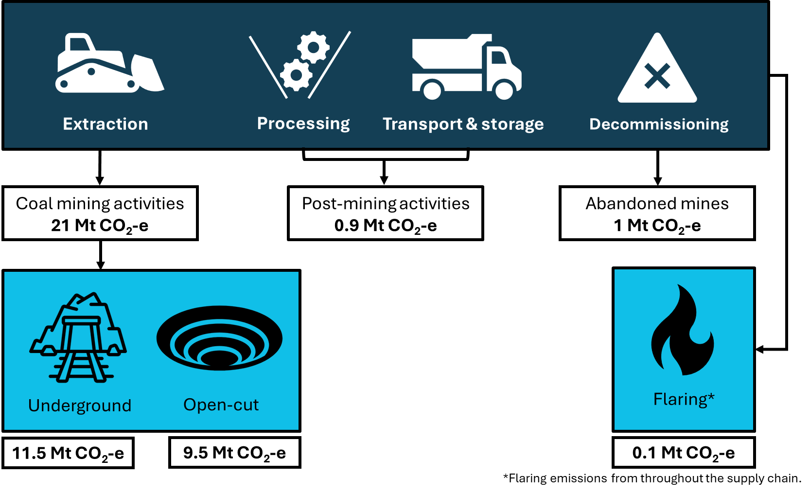
Source: DCCEEW 2026a

Fossil methane emissions from gas production
Gas production accounts for 24% of Australia’s fugitive fossil methane emissions. Gas is produced by drilling wells into underground reservoirs and bringing hydrocarbons to the surface. Methane is the main component of natural gas, making up 70-90% of the total gas (Gordon and Hughes 2023). Fossil methane emissions from oil production are relatively minor in Australia (DCCEEW 2026a).
The main stages of the natural gas supply chain where fossil methane emissions can occur are (IEA 2025a):
- Exploration - small amounts of methane may be released during drilling and well testing.
- Extraction - methane may be vented or flared to reduce pressure via safety systems.
- Processing - methane is emitted during the removal of impurities and handling at processing facilities.
- Post-processing - methane can leak during transmission, storage, distribution and export activities.
Venting and flaring occur at each stage of the production process as part of pressure relief and safety protocols. However, most of the venting and flaring emissions occur during the extraction and processing stages, which makes them the largest sources of methane emissions in natural gas production (Figure 12). The other source of fossil methane emissions is gas lost through leaks during initial handling (IEA 2025a).
Post-processing emissions include transmission, storage, distribution and abandoned gas wells (DCCEEW 2026a). While the largest source of emissions in this category is distribution, the dispersed nature of distribution networks and the different regulatory frameworks that apply means it warrants separate consideration. The Authority is focused primarily on extraction and processing.
Figure 12: Australia’s fossil methane emissions in the gas supply chain in 2023-24
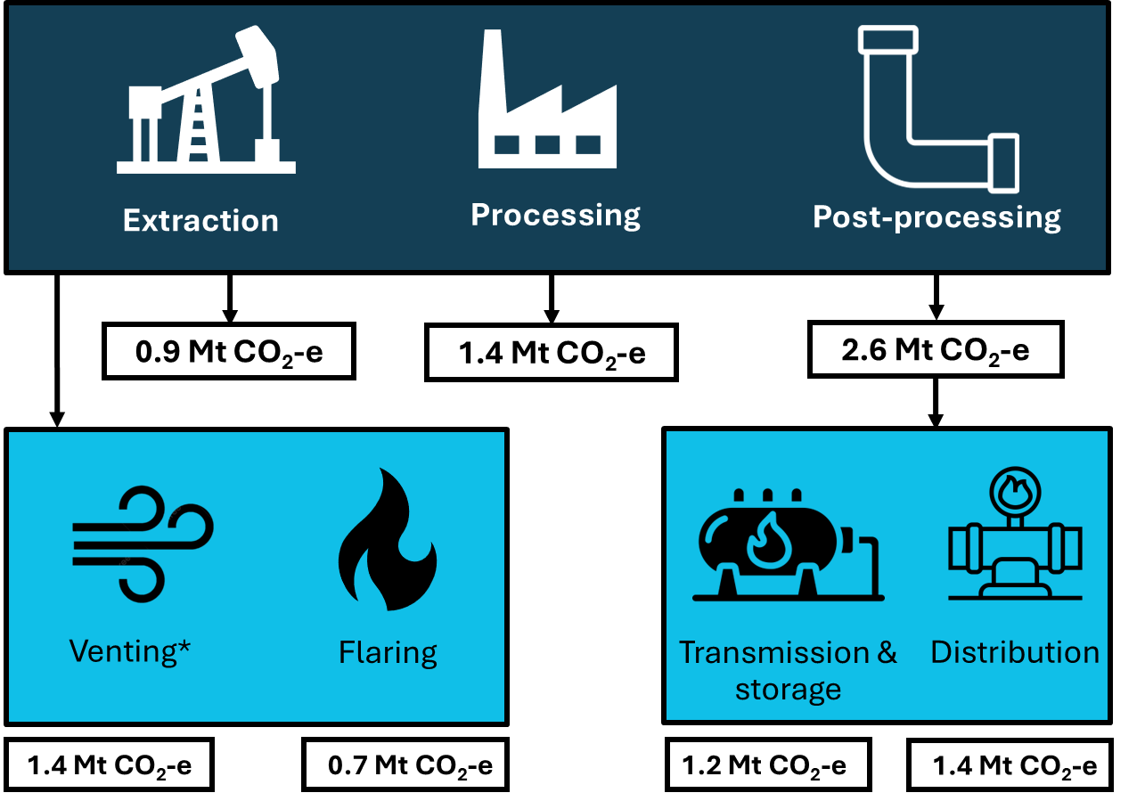
Source: (DCCEEW 2026a)
Note: venting emissions from both oil and gas production.

Appendix B: Fossil methane abatement technologies

Technologies for methane from coal mining
Pre-mining drainage of coal mine gas is already best practice for managing safety at underground mines (Queensland Government 2019). It also offers an opportunity to abate methane emissions. In Queensland, the Mineral Resources Act 1989 requires lease holders of coal mines to combust methane in coal mine waste gas (such that the methane is converted into carbon dioxide and water vapour) where it is technically and commercially feasible (Queensland Government 1989). Depending on the quality and composition of the drained gas it can be used in on-site electricity generation, transported to off-site generation facilities or flared. The ability to deploy these options varies site-to-site, and also varies within longwall panels at a single site. At underground coal mines, post-mining drainage can also be used to manage methane emissions, as with the pre-mining drainage methods.
Open-cut mines can also utilise pre-drainage prior to mining activities, with the same options to eliminate methane from the drained gas as with underground mines.
Any methane remaining in coal seams after drainage is managed via mine ventilation. Ventilation air methane (VAM) oxidation is the key technology available to abate this source of fossil methane. Following drainage, the concentration of methane in the air stream is low and the gas cannot be flared or used in electricity generation. VAM oxidation requires specialised equipment and capital investment. However, at gassy underground mines the technology can be deployed below the current Safeguard Mechanism Credit (SMC) unit cost (NSW Net Zero Commission 2025).
Trials of VAM oxidation technologies have demonstrated that it can provide meaningful abatement safely. However. there are still technical and economic barriers to broad adoption in more underground coal mines (CSIRO 2024). A commercial-scale project has been funded at the Kestrel mine in Queensland with 50% grant funding from the Powering the Regions Fund (DISR 2024a; DCCEEW 2024a).

Technologies for methane from gas extraction
In the gas sector the most effective method to reduce fossil methane is leak detection and repair. There are several leak detection methods that can be deployed at gas facilities, including infrared cameras for optical detection and ultrasonic gas detectors. Some equipment used in the gas extraction and processing chain emits methane emissions, either by venting or flaring, during their operation. Replacing equipment on site with electric or more efficient versions would reduce fossil methane emissions (IEA 2026a).
Other commercially ready options include ensuring that flaring is efficient, so that a higher proportion of the methane is converted into carbon dioxide and water vapour during combustion.

Appendix C: List of policies and regulations relevant to fossil methane

Federal policies
Policy | Description
Global Methane Pledge | Australia signed the Global Methane Pledge in 2022 (DCCEEW 2025c). It is one of 160 signatories working to reduce global methane emissions across all sectors by at least 30% below 2020 levels by 2030.
National Greenhouse and Energy Reporting (NGER) Scheme | The NGER scheme is Australia’s framework for reporting company information about greenhouse gas emissions, energy production and energy consumption (DCCEEW 2026c).
Safeguard Mechanism | The Safeguard Mechanism sets legislated limits on the greenhouse gas emissions of Australia’s largest industrial facilities (DCCEEW 2026c). These emissions limits are known as ‘baselines’. Baselines decline over time, driving net emissions reductions for these facilities.
Australian Carbon Credit Unit (ACCU) Scheme | The Australian Carbon Credit Unit (ACCU) Scheme supports projects that avoid the release of greenhouse gas emissions or remove and sequester carbon from the atmosphere (DCCEEW 2026e).
EPBC Act | The Environment Protection and Biodiversity Conservation Act 1999 (EPBC Act) is Australia’s primary environmental legislation. The Act aims to ensure actions on Commonwealth land do not cause significant impacts to ‘protected matters’ (DCCEEW 2026f).
OPGGSA Act | Offshore petroleum activities in Commonwealth waters must be undertaken in accordance with the Offshore Petroleum and Greenhouse Gas Storage Act 2006 (OPGGSA Act) and associated regulations including the Offshore Petroleum and Greenhouse Gas Storage (Environment) Regulations 2023 (DCCEEW 2023). In order to meet these regulations, offshore petroleum activities must be consistent with the principles of ecologically sustainable development, and have an acceptable level of environmental impact and risk that is reduced to acceptable and as low as reasonably practicable.
Net Zero Plan and Resources Sector Plan | The Net Zero Plan describes Australia’s clean energy transition and relevant policies to achieving net zero (DCCEEW 2025c). The Resources Sector Plan covers how the resources sector will transition to a net zero economy (DISR 2025b).
Future Gas Strategy | The Future Gas Strategy describes the government’s policies relating to natural gas, and the role of gas in Australia’s economy in coming years (DISR 2024b).

State and territory policies
State | Policy | Description
NSW | Environmental Planning and Assessment Act 1979 (NSW) No 203 | Coal mining can only be undertaken in NSW after a development consent is obtained. These are granted under the Environmental Planning and Assessment Act 1979 (NSW) No 203 and are subject to an environmental impact assessment. Air Quality and Greenhouse Gas Management Plans or Greenhouse Gas Mitigation Plans are approved under these consents (NSW Government 1979; NSW Net Zero Commission 2025).
 | Protection of the Environment Operations Act 1997 (NSW) No 156 | The NSW EPA issues environment protection licences under the Protection of the Environment Operations Act 1997 (NSW) No 156 (NSW Net Zero Commission 2025; NSW Government 1997) The EPA regulates ongoing mine operations through these licenses.
 | Climate Change Action Plan 2023–26 - new climate change requirements for licensees under the NSW EPA | In 2026, the NSW government introduced new rules to require major coal mines in NSW to directly reduce fossil methane pollution (NSW EPA 2026b). These requirements deliver on commitments in the EPA’s Climate Change Action Plan 2023–26. They apply to environment protection licensees under the POEO Act. The requirements will be phased in from 2027 (NSW EPA 2026a).
 | Coal Industry 2026–50 | This policy states that the NSW Government will not consider proposals for new standalone greenfield coal mines, while applications to extend existing mines may still be considered, subject to environmental and emissions requirements (NSW Government 2026a).
 | Gas Decarbonisation Roadmap (under development) | The NSW Government committed to deliver an NSW gas decarbonisation roadmap by late 2026 (NSW Government 2025).
VIC | Mineral Resources (Sustainable Development) Act 1990 (MRSDA) | The main law governing mineral resources in Victoria (Victorian Government 1990).
 | Gas Substitution Roadmap (2022) | The Gas Substitution Roadmap targets demand and gas usage. Measures include phasing out incentives under the Victorian Energy Upgrades (VEU) program for residential appliances that use fossil gas by the end of 2023 (Victorian Government 2025).
 | Gas and fracking bans | The development of unconventional gas, coal seam gas and the use of fracking are all banned in Victoria (Victorian Government 2021).
 | Commitment to end coal-burning power generation by 2035. | Victoria will end coal power generation in the state. This reduces the risk of fugitive emissions upstream in the supply chain (Victorian Government 2024).
QLD | Clean Economy Jobs Act (2004)  Environmental Protection Act (1994) | These Acts contain measures to limit greenhouse gas emissions/pollution. They do not specifically target methane or fugitive emissions.
 | Mineral Resources Act 1989 (Qld) | The Act restricts the release of coal mine waste gas and, in practice, requires the methane component to be combusted (such that the methane is converted into carbon dioxide and water vapour) or otherwise managed where this is feasible.
 | Low Emissions Investment Partnerships | The fund focuses on reducing emissions from metallurgical coal mines that are covered by the Australian Government’s Safeguard Mechanism (Queensland Treasury 2026).
SA | South Australia’s Net Zero Strategy 2024-2030 | This strategy contains policy priorities for transitioning the manufacturing and resources sector to low emissions technologies (South Australian Government 2024). This includes 3 million tonnes of carbon capture and storage by 2030.
 | 2025 SA Gas Initiative | The 2025 SA Gas Initiative is a $17.5 million initiative, designed to accelerate investment in a portfolio of gas projects in South Australia (South Australian Government 2025). This could include projects for natural gas supply, storage and infrastructure.
 | 10 Year Moratorium on Fracture Stimulation in the Limestone Coast Region | This moratorium bans fracking across the Limestone Coast Region of South-East South Australia until 2028. Fracking is still permitted in other parts of the state (South Australian Government n.d., 2025).
WA | World Bank's Zero Routine Flaring by 2030 initiative | WA endorsed the World Bank's Zero Routine Flaring by 2030 initiative. It has committed to end routine wellhead flaring during production and at oil refineries (Western Australian Government 2019; World Bank n.d.).

Appendix D: Status of the Authority’s 2023 NGER Review recommendations (numbers 15-22)
The Department of Climate Change, Energy, the Environment and Water (DCCEEW) provided the following update to the Authority for inclusion in this consultation paper.
Climate Change Authority recommendation | Government response
Phase out Method 1 estimation methodologies for fugitive methane emissions, including as a matter of urgency for the extraction of coal in open cut coal mining. | Agreed-in-principle
Resource the Department to establish higher order estimation methods for all fugitive methane emission sources included in the Measurement Determination. | Agreed-in-principle
As a matter of urgency, review Method 2 for extraction of coal in open cut coal mining with respect to sampling requirements and standards. | Agreed
Review the requirement for integrated gas facilities to use the same method across activities to allow for flexibility to use higher order methods for larger emission sources, while ensuring integrity of estimated emissions. | Agreed
Commission a panel of Australian and international experts to establish a best practice process to document the standards and requirements for making transparent, repeatable and credible top-down measurements of fugitive methane emissions from Australian facilities. This panel should evaluate whether any further research studies are needed and should be resourced to conduct required studies. The panel of experts should be commissioned in the first quarter of 2024, and the guidelines for making top-down verification measurements published as soon as practicable. | Agreed
Develop a top-down verification policy framework for the verification of bottom-up estimates of fugitive methane emissions reported under the NGER scheme. This should be phased in on a trial basis as soon as practicable, with mandatory verification using top-down measurements commencing the year after. If any discrepancies are found between bottom-up estimates obtained using an NGER method and the top-down verification measurement, the bottom-up measurement approach should be refined by the reporting entity to reconcile the emission estimates. | Agreed-in-principle
Determine the appropriate requirements to be met for future use of satellite technology in detection of fugitive methane emissions, and for verification of estimated fugitive methane emissions. | Agreed-in-principle
Prioritise and support the development of Australia’s sovereign capability in methane emissions measurement and quantification, by building on existing expertise and leveraging international partnerships where appropriate. | Agreed
The Australian Government is implementing its response to the 2023 Climate Change Authority review of the NGER scheme. This includes further enhancing the transparency and accuracy of fugitive methane emissions estimation through reforms to the Safeguard Mechanism and the regular NGER scheme review and update. Improvements include:
- phasing out the use of Method 1 (least technically sophisticated method with minimal facility-specific data) for estimating fugitive methane emissions from coal extraction from open cut mines covered by the Safeguard Mechanism (consistent with the government’s response to recommendation 15 of the 2023 CCA review)
- introducing an additional Method 2 (more technically sophisticated method with more facility-specific data) to enable more accurate estimation of fugitive methane emissions from flaring of gas in natural gas production, transmission and distribution
- improving Method 2 for estimating fugitive methane emissions from produced water from oil or gas operations to better reflect on-site operations and incentivise on-site abatement
- improving completeness by reinstating a method for estimating fugitive methane emissions from oil or gas exploration and development mud de-gassing activities
- improving the accuracy of emission factors for estimating fugitive methane emissions from flaring during oil and gas operations
- requiring publication of the methods used by Safeguard Mechanism facilities to estimate fugitive methane emissions
- requiring publication of methane, carbon dioxide and nitrous oxide, emissions reported by Safeguard Mechanism facilities.
In parallel, DCCEEW has established 3 workstreams to support further improvements to fugitive methane emission estimation in the medium to longer-term.

Review of Method 2 for estimating fugitive emissions from open cut coal mine extraction
Consistent with the government’s response to recommendation 17 of the 2023 CCA review, review of Method 2 has commenced. The government is reviewing Method 2 to ensure it remains fit for purpose and based on the best available science, technologies and practices. The review will cover issues including the timing and location of gas sampling relative to mining activity, the minimum number of boreholes required to classify a gas domain, lateral gas movement, transparency and peer review processes, and emission estimation when pre-mining drainage occurs.
DCCEEW will lead the review in consultation with the Clean Energy Regulator, and engage with scientific and technical experts, industry and other stakeholders. DCCEEW will work closely with Australian Coal Industry’s Research Program, which is responsible for the Guidelines that form a core component of Method 2. The scope of the review was informed by stakeholder consultation, including through the 2025 NGER scheme public consultation (DCCEEW 2025f).
The review is expected to conclude by June 2028. Where appropriate, incremental improvements to Method 2 will be implemented during the review. Implementation arrangements will consider the situations of those facilities that are transitioning to, or already using, Method 2. Legislative amendments to the NGER Regulations and Determinations arising from the review will undergo public consultation as part of the annual NGER scheme consultation cycle.
The Terms of Reference for the review of Method 2 are published on the Department’s website (DCCEEW 2026g).

Expert Panel on Atmospheric Measurement of Fugitive Methane
Consistent with the government’s response to recommendations 19-21 of the 2023 CCA review, it has established a Fugitive Methane Expert Panel. The Panel, chaired by Australia’s former Chief Scientist Dr Cathy Foley, was established to provide advice to government on atmospheric (‘top-down’) estimation of fugitive methane emissions in Australia. The Panel held a public webinar on 29 August 2025 to introduce members and provide information on its mandate and progress to date. The webinar is available on the Panel website (DCCEEW 2026g).
The Panel has developed a comprehensive work program and scoped the information needed to support its work, including the detailed technical information required on each component of top-down approaches for detecting or quantifying fugitive methane emissions. A CSIRO research team has finished compiling the information scoped by the Panel through an extensive scientific literature review and engagement with over 150 suppliers and developers.
The Panel plans to prepare an interim report providing more detail on its work to date and early insights, for release mid-2026. In accordance with its Terms of Reference, interim reports will be published on the Department’s website. The Panel will provide its final advice to government and the public at the end of its term in mid-2027.

Government-funded fugitive methane emissions science
Consistent with the government’s response to recommendation 19 and 22, government is also funding science to help fill information gaps regarding the application of satellite and other ‘top-down’ approaches in detecting and estimating fugitive methane emissions. This work will support the Panel, build scientific capacity in Australia and contribute to global efforts to better understand, monitor and manage fugitive methane emissions.
Australia and the United Nations Environment Programme’s International Methane Emissions Observatory are collaborating on a world-first study in Australia to test the capability of a range of atmospheric approaches, including ground-based, airborne and satellite-based sensors, in detecting and estimating fugitive methane emissions at a site simulating open cut coal mine operation.
The study will be undertaken by internationally recognised experts in the field of controlled methane release science from FluxLab research group at St. Francis Xavier University and Stanford University’s Environmental Assessment and Optimization Group (EREF, 2025). The science team is progressing design and logistical arrangements, including selection of a suitable site and engagement with Australian and international scientists, academics and industry. The study is expected to be completed by the end of 2027, with its findings published in early 2028. The science team will seek to provide early insights to the Panel as they emerge.

References

2 Degrees Institute (2026) Atmospheric CH4 Levels Graph, https://www.methanelevels.org/.
Australian Treasury (2025) Australia’s Net Zero Transformation: Treasury Modelling and Analysis, Canberra, https://treasury.gov.au/publication/p2025-700922.
Climate Change Authority (CCA) (2024) Sector Pathways Review, https://www.climatechangeauthority.gov.au/sites/default/files/documents/2024-09/2024SectorPathwaysReview.pdf.
CCA (2025a) 2035 Emissions Reduction Targets Report, Canberra, https://www.climatechangeauthority.gov.au/2035-emissions-reduction-targets-advice.
CCA (2025b) 2025 Annual Progress Report, Canberra, https://www.climatechangeauthority.gov.au/2025-annual-progress-report.
Climate and Clean Air Coalition (CCAC) (2025) National Methane Roadmaps and Action Plans, https://www.ccacoalition.org/resources/national-methane-action-plans.
CCAC (n.d.) Methane, https://www.ccacoalition.org/short-lived-climate-pollutants/methane.
Climate Crisis Advisory Group (CCAG) (2025) Methane: the emergency brake for climate heating, https://www.ccag.earth/reports/methane-the-emergency-brake-for-climate-heating.

Clean Energy Regulator (CER) (2026a) 2024–25 baselines and emissions data, Canberra, https://cer.gov.au/markets/reports-and-data/safeguard-data/2024-25-baselines-and-emissions-data.
CER (2026b) 2023–24 baselines and emissions data, Canberra, https://cer.gov.au/markets/reports-and-data/safeguard-data/2023-24-baselines-and-emissions-data.
Climate Analytics (2021) The science of temperature overshoots, https://ca1-clm.edcdn.com/assets/temperature-overshoots_ar6.pdf.
Climate Analytics (2026) National methane reduction targets, Global Methane Explorer.
Climate Council (2024) Dangerously Overlooked: Why we need to talk about methane, https://www.climatecouncil.org.au/resources/dangerously-overlooked-why-we-need-to-talk-about-methane/.
Climateworks (2024) Leading climate policies from Australia’s states and territories, Melbourne, https://climateworkscentre.org/resource/leading-climate-policies-from-australias-states-and-territories/.
Commonwealth of Australia (2006) Offshore Petroleum and Greenhouse Gas Storage Act 2006 (Cth), https://www.legislation.gov.au/C2006A00014/2008-11-22/text.

Commonwealth of Australia (2024) Australian Government response to the Climate Change Authority’s 2023 Review of the National Greenhouse and Energy Reporting legislation, Canberra, https://www.dcceew.gov.au/sites/default/files/documents/government-response-cca-nger-review.pdf.
Commonwealth of Australia (2025) Australia’s 2035 Nationally Determined Contribution, Canberra, https://unfccc.int/sites/default/files/2025-09/Australias%20Second%20NDC.pdf.
Copernicus (2022) Methane, the omnipresent and elusive “second” greenhouse gas, https://atmosphere.copernicus.eu/methane-omnipresent-and-elusive-second-greenhouse-gas.
Commonwealth Scientific and Industrial Research Organisation (CSIRO) (2024) Catalytic VAMMIT trials: tackling methane emissions in mining, https://www.csiro.au/en/news/All/Articles/2024/October/VAMMIT-methane-emissions.
CSIRO (n.d.-a) Global Methane Budget, https://www.csiro.au/en/research/environmental-impacts/emissions/Global-greenhouse-gas-budgets/Global-methane-budget.
CSIRO (n.d.-b) How do greenhouse gases warm the planet?, https://www.csiro.au/en/research/environmental-impacts/climate-change/climate-change-qa/how-do-greenhouse-gases-warm-the-planet.
CSIRO (n.d.-c) Fugitive emissions abatement, https://www.csiro.au/en/work-with-us/industries/mining-resources/Mining/Fugitive-emissions-abatement.

Department of Agriculture, Fisheries and Forestry (DAFF) (2025) Agriculture and Land Sector Plan, Canberra, https://www.agriculture.gov.au/agriculture-land/farm-food-drought/climatechange/ag-and-land-sector-plan.
Department of Climate Change, Energy, the Environment and Water (DCCEEW) (2023) Offshore Petroleum and Greenhouse Gas Storage (Environment) Regulations 2023 (Cth), https://www.legislation.gov.au/F2023L00998/latest/text
DCCEEW (2024a) Powering the Regions Fund - STS Batch 2 - Grant funding decision, https://www.dcceew.gov.au/sites/default/files/documents/77677.pdf.
DCCEEW (2024b) Joint media release: $91 million to drive down emissions in heavy industry, https://minister.dcceew.gov.au/bowen/media-releases/joint-release-powering-the-regions-20240712.
DCCEEW (2024c) Emissions reporting, https://www.dcceew.gov.au/climate-change/emissions-reporting.
DCCEEW (2025a) Reducing methane from livestock, https://www.dcceew.gov.au/climate-change/emissions-reduction/agricultural-land-sectors/livestock.
DCCEEW (2025b) Energy trade, https://www.energy.gov.au/energy-data/australian-energy-statistics/energy-trade.
DCCEEW (2025c) Australia’s Net Zero Plan, https://www.dcceew.gov.au/sites/default/files/documents/net-zero-report.pdf.
DCCEEW (2025d) National Greenhouse Accounts Factors: 2025, Canberra, https://www.dcceew.gov.au/climate-change/publications/national-greenhouse-accounts-factors-2025.
DCCEEW (2025e) Coal Mine Waste Gas method 2015 Periodic review report, https://www.dcceew.gov.au/sites/default/files/documents/coal-mine-waste-gas-method-periodic-review-report-2025.pdf.
DCCEEW (2025f) National Greenhouse and Energy Reporting (NGER) Scheme, https://consult.dcceew.gov.au/national-greenhouse-and-energy-reporting-nger-scheme.
DCCEEW (2025g) Australia’s emissions projections 2025: November 2025, Canberra, https://www.dcceew.gov.au/sites/default/files/documents/australias-emissions-projections-2025.pdf.
DCCEEW (2026a) Australia’s National Greenhouse Accounts, https://www.greenhouseaccounts.climatechange.gov.au/.
DCCEEW (2026b) National Greenhouse Gas Inventory Quarterly Update: December 2025,
https://www.dcceew.gov.au/climate-change/publications/national-greenhouse-gas-inventory-quarterly-update-december-2025.
DCCEEW (2026c) Safeguard Mechanism, https://www.dcceew.gov.au/climate-change/emissions-reporting/national-greenhouse-energy-reporting-scheme/safeguard-mechanism.
DCCEEW (2026d) National Inventory Report 2024, Volume I, Canberra, https://www.dcceew.gov.au/sites/default/files/documents/national-inventory-report-2024-vol-1.pdf.
DCCEEW (2026e) Australian Carbon Credit Unit (ACCU) Scheme, https://www.dcceew.gov.au/climate-change/emissions-reduction/accu-scheme.
DCCEEW (2026f) Environment Protection and Biodiversity Conservation Act 1999 (EPBC Act), https://www.dcceew.gov.au/environment/epbc.
DCCEEW (2026g) Expert Panel on Atmospheric Measurement of Fugitive Methane Emissions in Australia, https://www.dcceew.gov.au/climate-change/emissions-reporting/national-greenhouse-energy-reporting-scheme/expert-panel-atmospheric-measurement-fugitive-methane-emissions-au.
Department of Industry Science and Resources (DISR) (2024a) $91 million to drive down emissions in heavy industry, https://www.minister.industry.gov.au/ministers/husic/media-releases/91-million-drive-down-emissions-heavy-industry.
DISR (2024b) Future Gas Strategy, https://www.industry.gov.au/publications/future-gas-strategy.
DISR (2025a) Resources and Energy Quarterly: December 2025, https://www.industry.gov.au/sites/default/files/2025-12/resources-and-energy-quarterly-december-2025.pdf.
DISR (2025b) Resources Sector Plan, https://www.industry.gov.au/publications/resources-sector-plan
DISR (2025c) Policy statement: Venting and flaring from offshore petroleum facilities, https://www.industry.gov.au/publications/policy-statement-venting-and-flaring-offshore-petroleum-facilities.

Drouet L, Bosetti V, Padoan SA, Aleluia Reis L, Bertram C, Dalla Longa F, Després J, Emmerling J, Fosse F, Fragkiadakis K, Frank S, Fricko O, Fujimori S, Harmsen M, Krey V, Oshiro K, Nogueira LP, Paroussos L, Piontek F, Riahi K, Rochedo PRR, Schaeffer R, Takakura J, van der Wijst K-I, van der Zwaan B, van Vuuren D, Vrontisi Z, Weitzel M, Zakeri B and Tavoni M (2021) ‘Net zero-emission pathways reduce the physical and economic risks of climate change’, Nature Climate Change, 11(12):1070–1076, doi:10.1038/s41558-021-01218-z.
Encyclopædia Britannica (2026) hydrocarbon, Britannica, https://www.britannica.com/science/hydrocarbon.
Environmental Research & Education Foundation (EREF) (2025) EREF Launches Third Controlled Release Study to Improve Methane Detection at Landfills, https://erefdn.org/eref-launches-third-controlled-release-study-to-improve-methane-detection-at-landfills/.
European Commission (n.d.) Methane emissions, https://energy.ec.europa.eu/topics/carbon-management-and-fossil-fuels/methane-emissions_en.
Global Energy Monitor (2025) Global Coal Mine Tracker, https://globalenergymonitor.org/projects/global-coal-mine-tracker.
Global Methane Initiative (n.d.) Global Methane Initiative (GMI) Policymaker Framework for Addressing Methane Emissions, https://globalmethane.org/pmf.
Global Methane Pledge (2026) Global Methane Pledge, https://www.globalmethanepledge.org.
Gordon D and Hughes S (2023) Reality Check: Natural Gas’s True Climate Risk, RMI, https://www.ccacoalition.org/short-lived-climate-pollutants/methane.
Government of Canada (n.d.) Reducing methane emissions, https://www.canada.ca/en/services/environment/weather/climatechange/climate-plan/reducing-methane-emissions.html.
International Energy Agency (IEA) (2022) (Queensland) Petroleum and Gas (Production and Safety) Act 2004, https://www.iea.org/policies/8620-queensland-petroleum-and-gas-production-and-safety-act-2004.
IEA (2023) Driving Down Coal Mine Methane Emissions, Paris, https://www.iea.org/reports/driving-down-coal-mine-methane-emissions.
IEA (2024) World Energy Outlook 2024, Paris, https://www.iea.org/reports/world-energy-outlook-2024.
IEA (2025a) Assessing emissions from LNG supply and abatement options, Paris, https://www.iea.org/reports/assessing-emissions-from-lng-supply-and-abatement-options.
IEA (2025b) World Energy Outlook 2025, Paris, https://www.iea.org/reports/world-energy-outlook-2025.
IEA (2025c) Coal 2025, Paris, https://www.iea.org/reports/coal-2025.
IEA (2026a) Methane Tracker, https://www.iea.org/data-and-statistics/data-tools/methane-tracker.
IEA (2026b) Global Methane Tracker 2026, Paris, https://www.iea.org/reports/global-methane-tracker-2026.
Institute for Energy Economics and Financial Analysis (IEEFA) (2024) Prioritising methane abatement makes economic sense, https://ieefa.org/resources/prioritising-methane-abatement-makes-economic-sense.

Intergovernmental Panel on Climate Change (IPCC) (2014) Climate Change 2014: Synthesis Report, https://www.ipcc.ch/report/ar5/syr/.
IPCC (2019) ‘2019 Refinement to the 2006 IPCC Guidelines for National Greenhouse Gas Inventories’, in 2019 Refinement to the 2006 IPCC Guidelines for National Greenhouse Gas Inventories, Geneva, https://www.ipcc-nggip.iges.or.jp/public/2006gl/vol2.html.
IPCC (2021) Climate Change 2021 – The Physical Science Basis Contribution of Working Group I to the Sixth Assessment Report of the Intergovernmental Panel on Climate Change, Geneva, doi:10.1017/9781009157896.
IPCC (2023) Climate Change 2023: Synthesis Report. Contribution of Working Groups I, II and III to the Sixth Assessment Report of the Intergovernmental Panel on Climate Change, P Arias, M Bustamante, I Elgizouli, G Flato, M Howden, C Méndez-Vallejo, JJ Pereira, R Pichs-Madruga, SK Rose, Y Saheb, R Sánchez Rodríguez, D Ürge-Vorsatz, C Xiao, N Yassaa, J Romero, J Kim, EF Haites, Y Jung, R Stavins, A Birt, M Ha, DJA Orendain, L Ignon, S Park, Y Park, A Reisinger, D Cammaramo, A Fischlin, JS Fuglestvedt, G Hansen, C Ludden, V Masson-Delmotte, JBR Matthews, K Mintenbeck, A Pirani, E Poloczanska, N Leprince-Ringuet, and C Péan (eds), Geneva, Switzerland, doi:10.59327/IPCC/AR6-9789291691647.
Nature Geoscience (2023) ‘Reversing climate overshoot’ 16(6):467–467, doi:10.1038/s41561-023-01213-3.

NSW Environment Protection Agency (EPA) (2026a) Climate change requirements for licensees, https://www.epa.nsw.gov.au/Your-environment/Climate-change/climate-change-requirements-licensees.
NSW EPA (2026b) NSW to regulate reduction of coal mine emissions, https://www.epa.nsw.gov.au/news/epamedia/260319-nsw-to-regulate-reduction-of-coal-mine-emissions.
NSW Government (1979) Environmental Planning and Assessment Act 1979 No 203, https://legislation.nsw.gov.au/view/html/inforce/current/act-1979-203.
NSW Government (1997) Protection of the Environment Operations Act 1997 No 156, https://legislation.nsw.gov.au/view/html/inforce/current/act-1997-156.
NSW Government (2025) Delivering a Gas Decarbonisation Roadmap, NSW Climate and Energy Action, https://www.energy.nsw.gov.au/nsw-plans-and-progress/regulation-and-policy/delivering-gas-decarbonisation-roadmap.
NSW Government (2026a) NSW Coal Industry 2026–50, https://www.nsw.gov.au/regional-and-primary-industries/nsw-coal-industry-2026-50
NSW Government (2026b) Minns Labor Government securing gas supply for NSW homes and industry, https://www.nsw.gov.au/ministerial-releases/new-areas-open-gas-exploration.
NSW Net Zero Commission (2025) Coal Mining Emissions Spotlight Report, https://www.netzerocommission.nsw.gov.au/sites/default/files/2025-12/NZC_Coal_Spotlight_Report_2025.pdf.

Organisation for Economic Co-operation and Development (OECD) (2025) Targeting methane emissions to mitigate the risk of climate overshoot, Paris, https://www.oecd.org/en/about/programmes/net-zero-building-climate-and-economic-resilience.html.
Oil and Gas Decarbonization Charter (OGDC) (2026) The Oil and Gas Decarbonization Charter, https://www.ogdc.org/.
Queensland Government (1989) Mineral Resources Act 1989, Australia, https://www.legislation.qld.gov.au/view/html/inforce/current/act-1989-110.
Queensland Government (1994) Environmental Protection Act 1994 (Qld), https://www.legislation.qld.gov.au/view/html/inforce/current/act-1994-062.
Queensland Government (2004) Petroleum and Gas (Production and Safety) Act 2004, Australia, https://www.legislation.qld.gov.au/view/html/inforce/current/act-2004-025.
Queensland Government (2019) Methane management in underground coal mines: Best practice and recommendations, https://www.resources.qld.gov.au/__data/assets/pdf_file/0004/1449121/methane-management-in-underground-coal-mines.pdf
Queensland Government (2024) Clean Economy Jobs Act 2024 (Qld), https://www.legislation.qld.gov.au/view/html/inforce/current/act-2024-016
Queensland Treasury (2026) Low Emissions Investment Partnerships, https://www.treasury.qld.gov.au/policies-and-programs/investment/leip/.

Saunois M, Martinez A, Poulter B, Zhang Z, Raymond PA, Regnier P, Canadell JG, Jackson RB, Patra PK, Bousquet P, Ciais P, Dlugokencky EJ, Lan X, Allen GH, Bastviken D, Beerling DJ, Belikov DA, Blake DR, Castaldi S, Crippa M, Deemer BR, Dennison F, Etiope G, Gedney N, Höglund-Isaksson L, Holgerson MA, Hopcroft PO, Hugelius G, Ito A, Jain AK, Janardanan R, Johnson MS, Kleinen T, Krummel PB, Lauerwald R, Li T, Liu X, McDonald KC, Melton JR, Mühle J, Müller J, Murguia-Flores F, Niwa Y, Noce S, Pan S, Parker RJ, Peng C, Ramonet M, Riley WJ, Rocher-Ros G, Rosentreter JA, Sasakawa M, Segers A, Smith SJ, Stanley EH, Thanwerdas J, Tian H, Tsuruta A, Tubiello FN, Weber TS, van der Werf GR, Worthy DEJ, Xi Y, Yoshida Y, Zhang W, Zheng B, Zhu Qing, Zhu Qiuan and Zhuang Q (2025) ‘Global Methane Budget 2000–2020’, Earth System Science Data, 17(5):1873–1958, doi:10.5194/essd-17-1873-2025.
South Australian Government (2024) South Australia’s Net Zero Strategy, https://cdn.environment.sa.gov.au/environment/docs/SA-Net-Zero-Strategy-WEB.pdf.
South Australian Government (2025) 2025 SA Gas Initiative Grant Scheme, Energy & Mining, https://energymining.sa.gov.au/industry/energy-resources/industry-activity/2025-sa-gas-initiative-grant-scheme.
South Australian Government (n.d.) 10 Year Moratorium on Fracture Stimulation in the Limestone Coast Region of South Australia, https://energymining.sa.gov.au/industry/energy-resources/regulation/policies-and-guidelines/policies/10_year_moratorium_on_fracture_stimulation_in_limestone_coast_region_sa.
Stanford Report (2024) Methane emissions are rising faster than ever, https://news.stanford.edu/stories/2024/09/methane-emissions-are-rising-faster-than-ever.
UK Government (2025) UK methane action plan, https://www.gov.uk/government/publications/uk-methane-action-plan/uk-methane-action-plan-accessible-webpage.
United Nations Environment Programme (UNEP) (2024) Facts about Methane, https://www.unep.org/explore-topics/energy/facts-about-methane.
UNEP (2025) Australia announces landmark study to improve understanding of coal and steel sector methane emissions, https://www.unep.org/news-and-stories/press-release/unep-australia-announce-landmark-study-improve-understanding-coal.
UNEP (2026) The Oil & Gas Methane Partnership 2.0, https://www.ogmpartnership.org/.
United Nations Framework Convention on Climate Change (UNFCCC) (2015) The Paris Agreement, https://unfccc.int/process-and-meetings/the-paris-agreement?gad_source=1&gclid=https://unfccc.int/process-and-meetings/the-paris-agreement.
Victorian Government (1990) Mineral Resources (Sustainable Development) Act 1990, Australia, https://www.legislation.vic.gov.au/in-force/acts/mineral-resources-sustainable-development-act-1990/132.

Victorian Government (2021) Enshrining Victoria’s Ban On Fracking Forever, https://www.premier.vic.gov.au/enshrining-victorias-ban-fracking-forever.
Victorian Government (2024) Cheaper, Cleaner, Renewable: Our Plan for Victoria’s Electricity Future, https://www.energy.vic.gov.au/__data/assets/pdf_file/0014/715010/our-plan-for-victorias-electricity-future.pdf.
Victorian Government (2025) Victoria’s Gas Substitution Roadmap, https://www.energy.vic.gov.au/renewable-energy/victorias-gas-substitution-roadmap.
Western Australian Government (2019) WA first State to sign up to cut flaring in petroleum industry, https://www.wa.gov.au/government/media-statements/McGowan%20Labor%20Government/WA-first-State-to-sign-up-to-cut-flaring-in-petroleum-industry-20190207.
World Bank (n.d.) Zero Routine Flaring by 2030 (ZRF) Initiative, https://www.worldbank.org/en/programs/zero-routine-flaring-by-2030/about.
World Resources Institute (WRI) (2026) Historical GHG Emissions, ClimateWatch, https://www.climatewatchdata.org/.
WRI (2025) 5 Things to Know About Atmospheric Methane Removal, https://www.wri.org/insights/atmospheric-methane-removal.




Fugitive emissions are the intentional or unintentional release of greenhouse gases that occur during the extraction, processing and delivery of fossil fuels to the point of final use (CSIRO n.d-c.; IPCC 2019). These emissions can be carbon dioxide, methane or other gases.
Methane emissions from fossil fuel combustion are not discussed in this report. Emissions data for fossil methane are taken from sector '1.B Fugitive Emissions From Fuels' in the in Australia's National Greenhouse Accounts (DCCEEW, 2026)
Hydrocarbons are organic compounds made up of carbon and hydrogen. Hydrocarbons are the main component of fossil fuels (Encyclopædia Britannica, 2026).
"Agreed in principle" means the government supports the overall policy idea or goal of the recommendation but has not yet committed to the specific implementation details, timing, or resourcing (DCCEEW, 2023).

