
2026 Annual Progress Advice

Consultation paper
July 2026


The Authority recognises the First Nations people of this land and their ongoing connection to culture and country. We acknowledge First Nations people as the Traditional Owners, Custodians and Lore Keepers of the world’s oldest living cultures, and pay our respects to their Elders.

2026 Annual Progress Advice consultation paper

About consultation papers from the Authority
The Authority provides independent, expert advice to the Australian Government and Parliament on the response to climate change.
We engage the Australian community because better conversations lead to better climate policy. We see consultation as an opportunity to bring different perspectives into the preparation of our expert advice.

We want to hear from you
We welcome submissions responding to the questions in this paper. Answer as many or as few questions as you like. You can refer us to relevant submissions to other consultation processes, or other related research and data.
Make a submission through our Consultation Hub until 11.00pm, Sunday 9 August 2026.

Contacts
For more information about making a submission, please contact the Authority on free call 1800 475 869 or via email at consultation@cca.gov.au.

Table of contents
Introduction 5
The Annual Progress Advice and legislative requirements 5
Our principles 5
Purpose of this consultation paper 6
Next steps following the consultation paper 8
Structure of this consultation paper 8
Questions for stakeholder input 8
1. Strategic context 11
1.1 Scope of the 2026 Annual Progress Advice 11
2. Assessing progress and what comes next 12
2.1 Our proposed approach to tracking progress – reference pathways 12
2.2 Major drivers of this year’s progress – preliminary analysis 17
2.3 Priority policy opportunities 22
3. The Authority’s 2026 advice on the Safeguard Mechanism 27
3.1 Role and scope of our advice 27
3.2 About the Safeguard Mechanism 28
3.3 The Safeguard Mechanism’s contribution to national targets 30
3.4 Onsite abatement 36
3.5 Potential adjustments to Safeguard Mechanism settings 40
References 43

Introduction

The Annual Progress Advice and legislative requirements
The Climate Change Act 2022 requires us to provide independent, evidence-based advice on how Australia can meet its emission reduction targets and achieve a prosperous, resilient net zero future.
Each year, we publish our Annual Progress Advice with recommendations the Minister for Climate Change and Energy must address in the Annual Climate Change Statement to Parliament. Our advice strengthens accountability and makes sure policies remain effective and responsive.
This year, our Annual Progress Advice will include:
- an assessment of how Australia is progressing toward its emissions reduction targets
- input to the government’s 2026–27 review of the Safeguard Mechanism and analysis of opportunities to reduce fossil methane emissions.

Our principles
As set out in Section 12 of the Climate Change Authority Act 2011, we must have regard to the following principles in developing our advice:
- the principle that any measures to respond to climate change should:
- be economically efficient
- be environmentally effective
- be equitable
- be in the public interest
- take account of impacts on households, businesses, workers and communities
- support an effective global response to climate change
- be consistent with Australia’s foreign policy and trade objectives
- take account of Article 2 of the Paris Agreement
- boost economic, employment and social benefits, including for rural and regional Australia.
- such other principles (if any) as the Authority considers relevant.
To complement these principles, we will also have regard to the principle of ‘simplicity’. That is, measures should enable clear and efficient administration and reporting, while still achieving their intended objectives.
The principle of ‘equity’ includes consideration of the impact of climate policy across socio-economic groups, regions, nations, sectors of the economy and future generations. In the Safeguard Mechanism section, we consider how the abatement task is shared between covered and uncovered sectors of the economy (Section 3.3) and between covered facilities and industries (Section 3.5).

Purpose of this consultation paper
This consultation paper is seeking input to inform our 2026 Annual Progress Advice. Consultation is a critical component of our advice (Figure 1 overleaf).
You can find more information about our work on our website: www.climatechangeauthority.gov.au.
Subscribe to our newsletter On Good Authority for updates about our consultation papers and final reports: https://consult.to/cca/u/subscribe.

Figure 1: Annual Progress Advice consultation paper in the context of the broader ecosystem
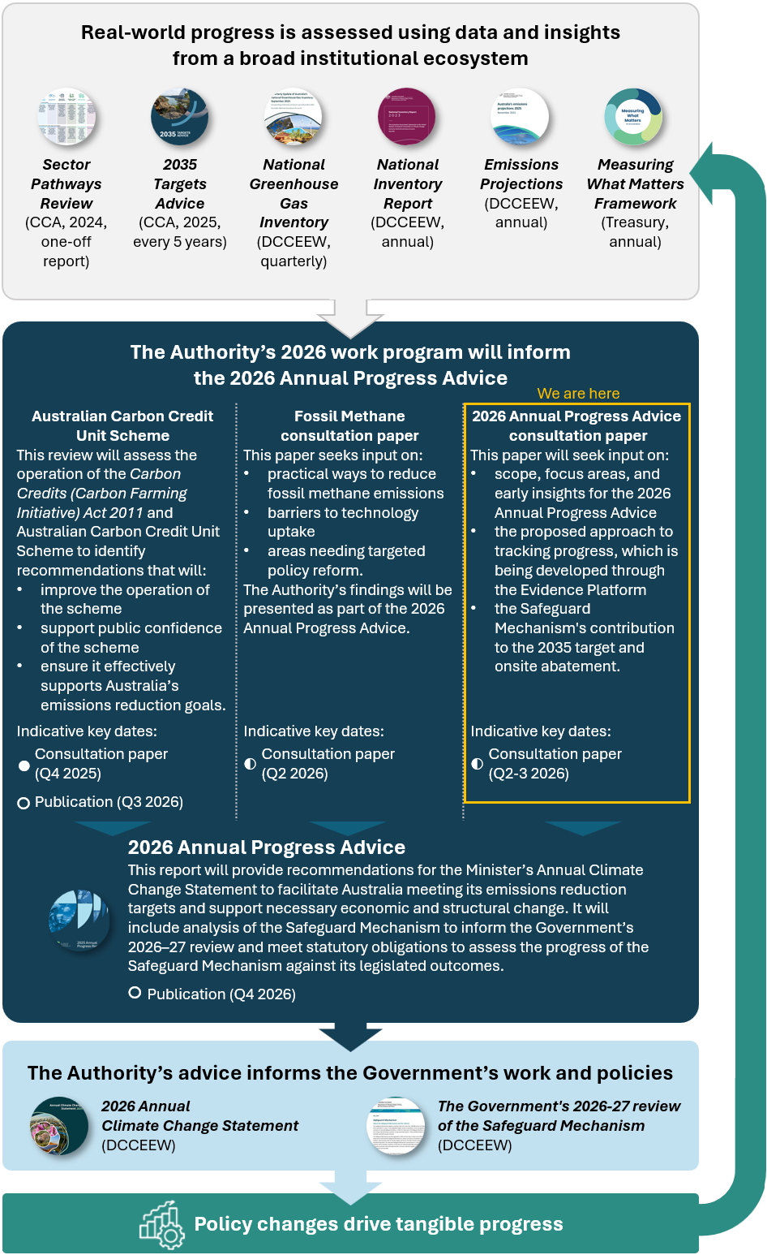

Next steps following the consultation paper
Submissions for the consultation paper are open until Sunday 9 August 2026. We will continue our analysis in parallel to this consultation period.
Once the consultation period closes, we will consider all submissions and refine our analysis.
We will provide our final advice to the government by the end of the calendar year.

Structure of this consultation paper
This consultation paper is structured in 3 parts:
Part 1: Strategic context
Outlines the scope of our 2026 Annual Progress Advice, and how it builds on our previous work and lays the foundation for future advice.
Part 2: Assessing progress and what comes next
Describes ‘reference pathways’ against which we will assess annual progress; and highlights emerging insights on how Australia’s transition is tracking towards a prosperous, resilient, net zero future.
Part 3: The Authority’s 2026 advice on the Safeguard Mechanism
Discusses what we intend to assess for the Safeguard Mechanism, and potential areas where we may develop advice for government. This includes:
- input to the government’s 2026–27 review of the Safeguard Mechanism, focused on its contribution to the 2035 target and onsite abatement
- annual advice as part of our regular statutory assessment of the performance of the Safeguard Mechanism to inform the Minister’s Annual Climate Change Statement.

Questions for stakeholder input

2.1 Our proposed approach to tracking progress – reference pathways
Question 1
What are your views on the proposed approach for setting reference pathways to assess progress, including strengths, limitations and any alternative approaches that should be considered?

2.2 Major drivers of this year’s progress – preliminary analysis
Question 2
What signs are you seeing of emissions reductions across industries, businesses, households or investors? What barriers or delays to abatement are you observing?

2.3 Priority policy opportunities
Question 3
What do you see as the top priorities for climate policy reform and why?

Question 4
What actions could help households adopt solar, batteries, electric vehicles and home electrification?

Question 5
What are the key barriers to the growth of low-emissions industries in Australia? What government policies or initiatives could most effectively strengthen demand for Australian low-emissions products and services, including low-carbon liquid fuels?
Please provide evidence or analysis to support your views.

3.3 The Safeguard Mechanism’s contribution to national targets
Question 6
6A) The Safeguard Mechanism’s current baseline decline rate is calibrated so the scheme delivers a proportional share of Australia’s 2030 emissions reduction target.
- What are the advantages and disadvantages of continuing this approach beyond 2030?
- If the proportional share approach should be maintained, how should it take account of Australia’s 2035 target range?

6B) If a different approach to setting the baseline decline rate should be used (instead of the proportional share approach), what should it be and why?

Question 7
Should decline rates differ across facilities or sectors beyond existing arrangements for trade exposed, baseline adjusted (TEBA) facilities? What evidence would support differentiation, and what principles should guide how any differentiation is applied?

3.4 Onsite abatement
Question 8
How should we assess the extent to which the Safeguard Mechanism is driving onsite abatement? What metrics, data sources or methods should we use, and how should we account for changes in production, operational conditions and emissions variability?

Question 9
What evidence is available on onsite abatement activities at Safeguard facilities, including for activities planned, underway or completed since the reforms commenced? Where possible, please provide information on emissions impacts, timing, costs and barriers.

Question 10
Should the Safeguard Mechanism play a stronger role in encouraging onsite abatement, relative to allowing flexibility through Australian Carbon Credit Unit Scheme (ACCU) use?
- What objectives should guide this assessment?
- Are additional incentives or constraints warranted?
- If so, what options should be considered and why?

Strategic context
Following the Australian Government’s adoption of a 2035 emissions reduction target of 62–70% below 2005 levels last September, this year’s Annual Progress Advice will present evidence of progress, identify challenges, gaps and opportunities, and provide policy advice to help Australia achieve its climate goals.
Australia experienced another year of severe climate impacts in 2025. Extreme weather has continued to intensify with increasingly dangerous fire seasons, and more extreme rainfall and heat (BOM & CSIRO, 2024). Growing pressures on Australia’s ecosystems, communities and economy highlight the urgent need for rapid and substantial emissions reduction (ANU, 2025). The recent tensions overseas are increasing fuel risks and costs, which also adds to cost-of-living pressures and reinforces the importance of accelerating more reliable, low-cost clean energy at home.
Meeting Australia’s emissions reduction targets requires faster, coordinated action across all sectors, with Australia needing to substantially increase its average annual abatement from 8 Mt CO₂-e (the average rate from 2020–2025) to 20–25 Mt CO₂-e over the next decade (CCA, 2025). Our Annual Progress Advice will look at how Australia is tracking against its targets using 2025–26 data which will be available later in the year.

Scope of the 2026 Annual Progress Advice
In this context, our 2026 Annual Progress Advice will identify timely and feasible adjustments to policy settings to accelerate emissions reductions and keep Australia on track to meet its 2035 target.
This year’s Annual Progress Advice will explore how strengthening key policy levers, such as the Safeguard Mechanism, can accelerate abatement. We are considering other policy areas where targeted reform can accelerate emissions reductions, resilience and economic growth.
We are also planning ahead. In future years, we intend to focus on adaptation and other key issues identified through our analysis and stakeholder consultation. Your responses to this consultation paper will help shape this ongoing work program.
We thank you for your valuable contributions to date, including through the Evidence Platform, ACCU and other consultations. We welcome your feedback on this consultation paper as a key input to our 2026 Annual Progress Advice.

Assessing progress and what comes next
Our 2026 Annual Progress Advice will highlight how Australia’s transition is tracking towards a prosperous, resilient, net zero future. This part of the consultation paper provides updates since we consulted on our new Evidence Platform earlier this year. We are now seeking input on our proposed approaches and some of our initial findings to help refine our analysis and advice to the government on next steps.

Our proposed approach to tracking progress – reference pathways
All sectors need to reduce emissions as fast as possible to give Australia the best chance of achieving its targets. We track progress by using metrics to detect early signs of change or delays as Australia transitions to net zero. This helps us give timely advice to the government to keep Australia on track and enable informed policy and investment decisions.
For 2026, we will focus on a small set of metrics for:
- emissions reductions
- economic transformation through critical abatement technologies, green industry development, and social equity.
We will continue to build and refine our metrics in future years for these focus areas, and to include other priority areas such as community acceptance, green jobs in a decarbonising economy, and adaptation and resilience.

Challenges with determining and using reference pathways
Our Evidence Platform Issues Paper (released March 2026) discussed how each metric would have a ‘benchmark’ to measure progress each year. We have now developed our approach further and plan to use ‘reference pathways’.
Setting a reference pathway for each metric, aligned to meeting national targets, is challenging. There are different pathways to achieve targets, and progress is rarely linear; it may involve step changes (e.g. as large assets enter or exit the market), acceleration (e.g. as new technologies move from early adoption to widescale take-up), or volatility (e.g. for activities affected by climate or global market disruptions).
It is important to note that a single metric deviating from its reference pathway does not, in itself, mean that Australia is off track overall. Rather, it signals the need for closer examination to understand the underlying drivers and whether targeted action is required. Given the inherent uncertainty in technology development, market conditions and behavioural change, Australia’s approach must remain adaptive. Regular monitoring, analysis and timely policy advice will be essential to ensure settings can be adjusted where needed, keeping Australia on track to meet its climate goals.
For these reasons, some reference pathways may be qualitative, directional (e.g. simply ‘increase’ or ‘decrease’), ranges, or approximate (e.g. assume a linear rate of change, in the absence of better information). Even where a more specific reference pathway is available, it will generally be indicative (what we might expect) rather than prescriptive (what we must achieve). Nonetheless, metrics and reference pathways – considered separately and as a full set – are a powerful tool to support planning and investment decisions and to build a good understanding of Australia’s overall progress.

Determining reference pathways for emissions reductions
This year’s Annual Progress Advice will pilot emissions reduction reference pathways. While these pathways indicate target-consistent emissions levels for 2025–26, it is important to recognise that alternative pathways could achieve the same outcome. This approach helps us see where sectors are exceeding expectations and where they’re falling behind, and in turn see where policy intervention may be required. It may also indicate a need to reconsider decarbonisation pathways – accelerating action in some sectors while allowing more gradual progress in others.
Our reference pathways are informed by analysis for our 2035 Targets advice. This analysis has been updated to a 2025 starting point (see Table 1 for more context).
For example, Figure 2 shows how we would apply the reference pathway for the built environment sector for the 2025–26 financial year. The reference pathway for this sector (i.e. the level at which we will assess this sector to be on track) is approximately 25–26 Mt CO₂-e.
Figure 2: How annual reference pathways for sector emissions are derived from our 2035 Targets Advice, 2005–2035
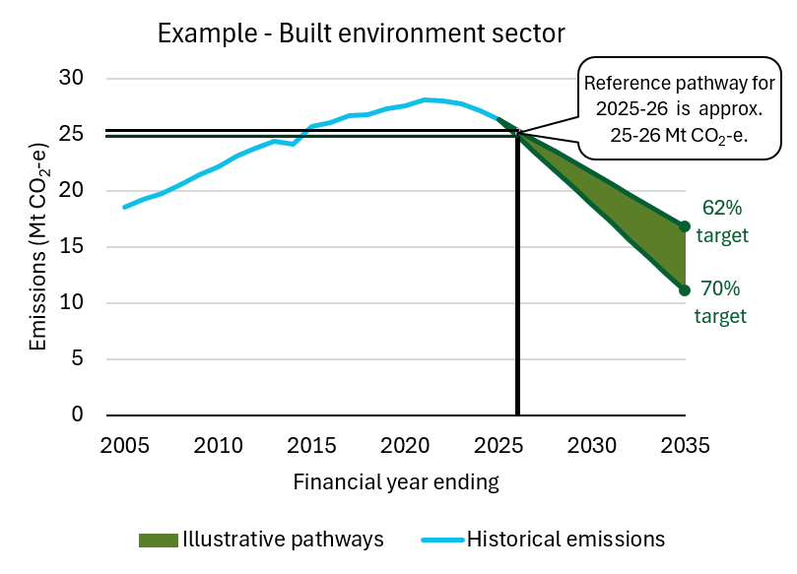
We will calculate emissions reference pathways for 2025–26 once emissions data for the period are published later this year by the Department of Climate Change, Energy, the Environment and Water (DCCEEW). Table 1 sets out draft reference pathways – using existing data – as well as our estimation approaches and assumptions. Where a sector is expected to be a net ‘sink’ each year (that is, removing emissions from the atmosphere), the range may be negative.

Table 1: Draft reference pathways for emissions levels for 2025–26
Sector | Draft reference pathways for emissions levels in 2025–26  (Mt CO₂-e) | Estimation approach and key assumptions
Electricity and energy | 128 to 130 | Applies a non-linear abatement pathway informed by Australian Energy Market Operator’s (AEMO) 2024 and 2026 Integrated System Plan (ISP) Step Change scenario for electricity, adjusted to start from actual 2025 sectoral emissions and reaching 20 Mt CO₂-e in 2035 (AEMO, 2024, 2026a)
Industry and waste | 56 to 57 | Applies a linear abatement pathway from actual 2025 emissions to reach 35 to 44 Mt CO₂-e in 2035
Transport | 103 to 104 | Applies a non-linear abatement pathway based on our modelling of plausible fleet transition for road vehicles and for sustainable aviation fuel (SAF) uptake, adjusted to start from actual 2025 emissions and reaching 79 to 86 Mt CO₂-e in 2035
Agriculture | 82 to 83 | Applies a linear abatement pathway from actual 2025 emissions to reach 77 to 83 Mt CO₂-e in 2035
Resources | 97 to 98 | Applies a linear abatement pathway from actual 2025 emissions to reach 61 to 73 Mt CO₂-e in 2035
Built environment | 25 to 26 | Applies a linear abatement pathway from actual 2025 emissions to reach 11 to 17 Mt CO₂-e in 2035
Land | -56 to -55 | Applies a linear abatement pathway from actual 2025 emissions to reach -86 to -90 Mt CO₂-e in 2035  NB: Land sector is affected by changing weather patterns. This can lead to high variability in emission levels.
Engineered removals | -1 to 0 | Applies a linear abatement pathway from zero in 2025 to reach -3 to -10 Mt CO₂-e in 2035
National | 435 to 441 | Sum of all component ranges, aligned to reach 185 to 234 Mt CO₂-e in 2035
Note: These pathways are consistent with sectoral analysis informing our 2035 Targets Advice. Draft numbers are aligned to estimated 2025 emissions using the 2024 National Inventory Report (DCCEEW, 2026c) and the June 2025 Quarterly Update of Australia’s National Greenhouse Gas Inventory (DCCEEW, 2025d). We will update reference pathways and report on the full financial year of sectoral emissions data to June 2026 in the final 2026 Annual Progress Advice.

Determining reference pathways for metrics tracking economic transformation
We are developing reference pathways to track progress across the economy and highlight areas which may need further policy effort. These metrics track uptake of critical abatement technologies, green industry development, and social equity. A select list of draft metrics is set out in Table 2.
Table 2: Reference pathways for metrics tracking economic transformation
Metric | Draft reference pathways | Estimation approach and assumptions
Share of on-grid electricity provided from renewables | 44–49% in 2025–26 | The central estimate is the average of actual data for 2024–25 and projected data for 2026–27 in AEMO’s 2026 ISP Step Change scenario (AEMO, 2026a). We make a simplifying assumption that this applies to all on-grid electricity, noting the ISP is limited to the National Electricity Market (NEM).  A range is then applied to allow for year-to-year variations in renewable generation, based on past variability in wind, solar and hydro generation, and the expected future energy generation mix (per AEMO’s ISP).
Rooftop solar | Under development: we may develop reference pathways for these metrics drawing on the 2026 ISP Step Change scenario.
Battery storage
Electric vehicle (EV) sales share (light vehicles) | - 15% Battery electric vehicles (BEVs) in 2026 calendar year  - 20% Battery electric vehicles AND plug-in hybrids in 2026 calendar year | This draws on our analysis for the 2035 Targets Advice. The analysis assumes the New Vehicle Efficiency Standard is the main driver of light vehicle decarbonisation until 2029. The mix of technologies may vary.
Change in residential energy consumption by fuel type | - Upwards trend in the % share of residential energy from electricity  - Downwards trend in the % share and total consumption for residential energy from gas | This indicator monitors how households are transitioning to lower-emissions energy sources over time.

Question 1
What are your views on the proposed approach for setting reference pathways to assess progress, including strengths, limitations and any alternative approaches that should be considered?

Major drivers of this year’s progress – preliminary analysis
This section highlights selected emissions reduction drivers (including policy) and identifies where more policy may be needed. Our preliminary analysis has found:
- Electricity continues to deliver the largest emissions reduction of any sector (5.7 Mt CO₂-e in the 2025 calendar year), driven by the rollout of renewables and batteries (CCA Analysis of DCCEEW, 2026a). Greater investment in generation and storage – alongside addressing linked barriers such as approvals times and transmission delays – is needed to accelerate capacity growth and generation.
- Passenger EV uptake is increasing, driven by the government’s New Vehicle Efficiency Standard (NVES), high fuel prices and shifting consumer preferences. The light vehicle fleet is currently tracking ahead of (that is, better than) the NVES limit. Further policies are needed to electrify Australia’s heavy vehicle fleet.
We consider these valuable areas to monitor in this year’s Annual Progress Advice, aligning with the first 2 priorities of the government’s Net Zero Plan: clean energy across the economy and lowering emissions through electrification and efficiency improvements (DCCEEW, 2025c).

Renewables and batteries are reshaping electricity supply and prices
Preliminary analysis shows that renewable energy generation and battery storage are increasingly shaping Australia’s electricity system, lowering wholesale prices and meeting rising demand. Renewable generation has been growing steadily and reached around 43% in 2025 (CEC, 2026a). A large contributor to this rise is growth in rooftop solar and national battery storage capacity at the household and grid level (Figure 3). These changes have started to transform the energy market and electricity prices in the last 12 months (AEMO, 2026b).
Figure 3: Renewable energy and investment share
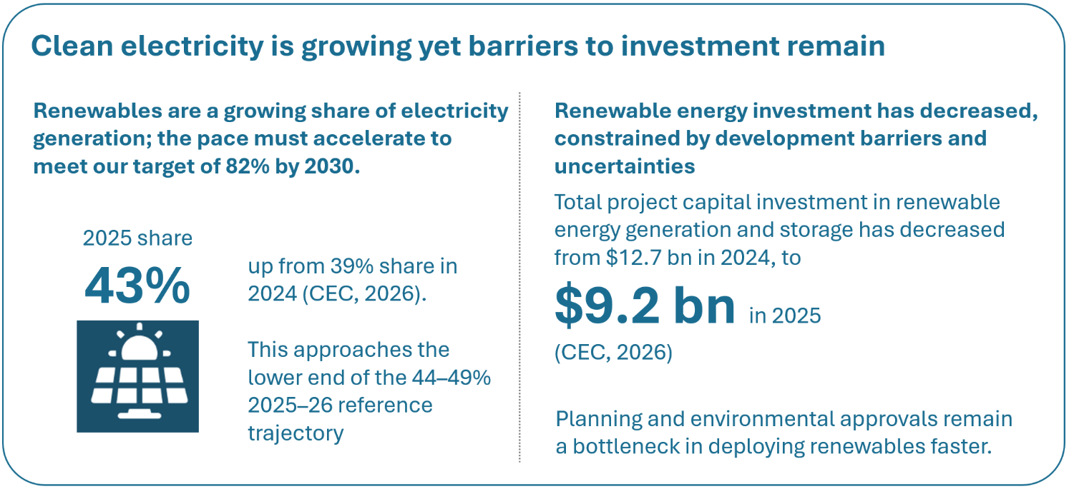
Source: CCA analysis of CEC (2026a).
Wholesale electricity prices have fallen despite higher demand, reflecting the growing role of battery storage in shifting and supplying low‑cost renewable energy. Despite higher demand in Australia’s largest grid during summer heatwaves, distributed solar kept average demand in Q1 2026 comparable to previous years and Q1 prices were at their lowest level in 4 years (Figure 4). Batteries are displacing gas-fired generation during peak periods at lower cost (AEMO, 2026b), storing excess daytime solar energy for evening use. Installed battery capacity in the NEM doubled over the past year, with 4 GW / 11 GWh of large-scale capacity added (AEMO, 2026b).
Figure 4: NEM average spot prices, Q1 2023–Q1 2026
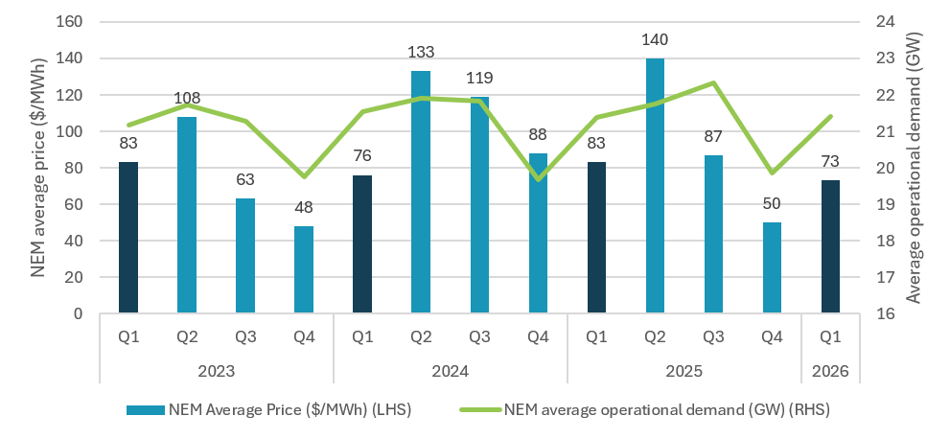
Sources: Rimrod & Manfield (2026); AEMO (2026b).
Note: Based on AEMO’s Quarterly Energy Dynamics. NEM operational demand excludes electricity demand met by rooftop solar.

Accelerating renewable energy investment and capacity additions will be critical to achieving Australia’s decarbonisation objectives
Despite recent improvements, more investment in renewables is needed to achieve Australia’s renewable energy and decarbonisation goals. Investment in large-scale renewable energy generation and storage declined from $12.7 bn in 2024 to $9.2 bn in 2025 (CEC, 2026a).
There are encouraging signs of renewed momentum in 2026. Projects reaching final investment decision (FID) totalled 2.4 GW from January to the beginning of June 2026, exceeding the 2.1 GW in FID achieved in the entire 2025 calendar year (CER, 2026b). Maintaining this momentum will be important to build the pipeline of projects in coming years.
Yet, recent capacity additions and investment in renewable energy are not yet at the scale of deployment needed to meet Australia’s decarbonisation targets. In 2025, 3.4 GW of new large-scale renewable generation was commissioned, down from the 4.4 GW in 2024. Both years were well below the average annual addition of around 7.7 GW of large-scale variable renewable energy capacity estimated to be required to meet the 2030 target (CEC, 2026a; AEMO, 2026a).
Development barriers and market uncertainties continue to constrain investment and project delivery by increasing project risk (Guthrie, 2026). Rather than withdrawing from the market, lenders are re-pricing risk by applying more stringent due diligence, particularly where projects have weak offtake arrangements or unresolved grid and connection risks. This is contributing to a widening gap between projects that are technically viable and those that are commercially financeable.
Key challenges to overcome include lengthy planning and approval durations, transmission delays, grid congestion, curtailment risks, and complex connection processes (CEIG, 2025). These challenges are compounded by social licence considerations; workforce shortages; supply chain limitations; data gaps; and research, development and demonstration capacity – all of which are increasing project costs and delaying deployment (CCA, 2024).
Private demand-side signals have also weakened, with corporate power purchase agreements of large-scale renewable energy decreasing from 4 GW in 2024 to 2.4 GW in 2025 (BNEF, 2026). Increased size and volume of these agreements would better support the commercial viability of renewable energy projects.
The incoming COP31 Presidency, Türkiye, has announced a global electrification target to increase the share of final energy demand met by electricity from just over 20% today to 35% by 2035 (UNFCCC, 2026). Achieving this target would require significant international acceleration in the electrification of transport, buildings and industry. We will further assess next year what this ambition could mean for Australia’s energy transition.
We will continue to monitor domestic policy developments in the electricity sector. Our final Annual Progress Advice will include a short update on the Capacity Investment Scheme (CIS) and plans for the Electricity Services Entry Mechanism (ESEM).

EV adoption is rising rapidly amid evolving market, policy and consumer dynamics
Figure 5: EV sales progress
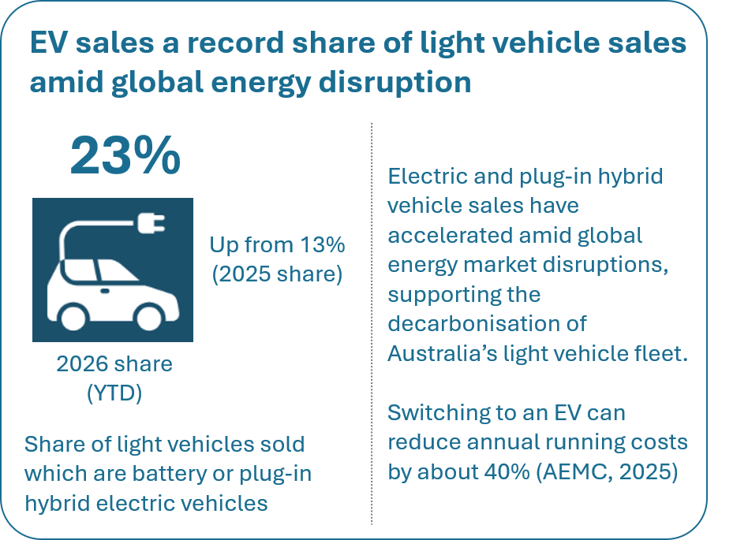
Sources: AEMC (2025b); CCA analysis of Federal Chamber of Automotive Industries (VFACTS) and Electric Vehicle Council data (via AAA (2026); CarExpert (2026); Andrew (2026)).
Our preliminary assessment shows EV uptake in Australia has strengthened significantly in the year-to-date. EVs accounted for 23% of new vehicle sales in the first 5 months of 2026, an increase from 13% over the 12 months of 2025 (Figure 5). This occurred alongside a gradual decline in the share of petrol and diesel vehicles (Figure 6).
This growth in EV sales reflects a combination of market, policy and behavioural factors, including increasing model availability and affordability, consumer preferences and the growing social normalisation of EV ownership. Policies such as the NVES are designed to support the uptake of lower‑emissions vehicles, while higher fuel prices increase the relative attractiveness of EVs (FCAI, 2026).
Figure 6: Monthly Australian new light vehicle sales by type, July 2020–May 2026
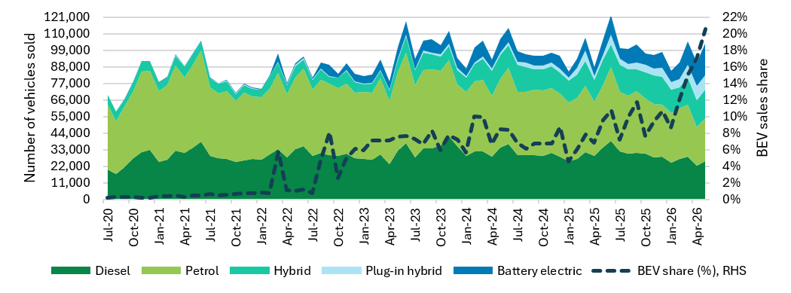
Sources: CCA analysis of VFACTS and Electric Vehicle Council data (via AAA (2026); CarExpert (2026); Andrew (2026)).
While emissions reduction progress has been encouraging for light passenger vehicles, electrification of Australia’s heavy vehicle fleet is still at a very early stage, with less than 1% of trucks and buses electrified (CCA analysis of DITRDCSA, 2025). Trials to test electric trucks and chargers in real-world conditions are underway across multiple road freight companies (ARENA, 2025).
Question 2
What signs are you seeing of emissions reductions across industries, businesses, households or investors? What barriers or delays to abatement are you observing?

Priority policy opportunities
Our Annual Progress Advice informs the Minister’s annual Climate Statement to Parliament. Having assessed progress, we will advise priority actions to keep Australia on track towards a prosperous, resilient and decarbonised future.
Question 3
What do you see as the top priorities for climate policy reform and why?

This section outlines 2 areas where targeted reform could accelerate emissions reduction and support economic prosperity:
- improving household access to low-emissions technologies
- supporting clean industry projects progress from concept to final investment decision.
These 2 areas were identified through early insights from our Evidence Platform, and they are particularly relevant in the context of geopolitical tensions, cost-of-living pressures, and the need for industries to remain competitive. Both areas are also high-impact, near-term opportunities that do not face significant technical barriers.

Enabling households to adopt more lower emissions technologies can reduce energy bills and deliver cost-effective emissions reductions
Households can substantially reduce their energy bills by adopting more low-emissions technologies including rooftop solar, home batteries, EVs, and swapping gas appliances for electric ones (Figure 7). Energy bills are a major cost-of-living pressure, with one in 5 Australian households vulnerable to, or experiencing, some form of energy hardship, according to survey data from Energy Consumers Australia (2025). Global energy market volatility is adding further strain. Enabling households to adopt solar, batteries, an electric vehicle and electric appliances can unlock savings of up to 90% on energy bills – around $4,400–4,900 per year (AEMC, 2025a).
Figure 7: Household energy hardship and cost‑saving, low‑emissions technologies
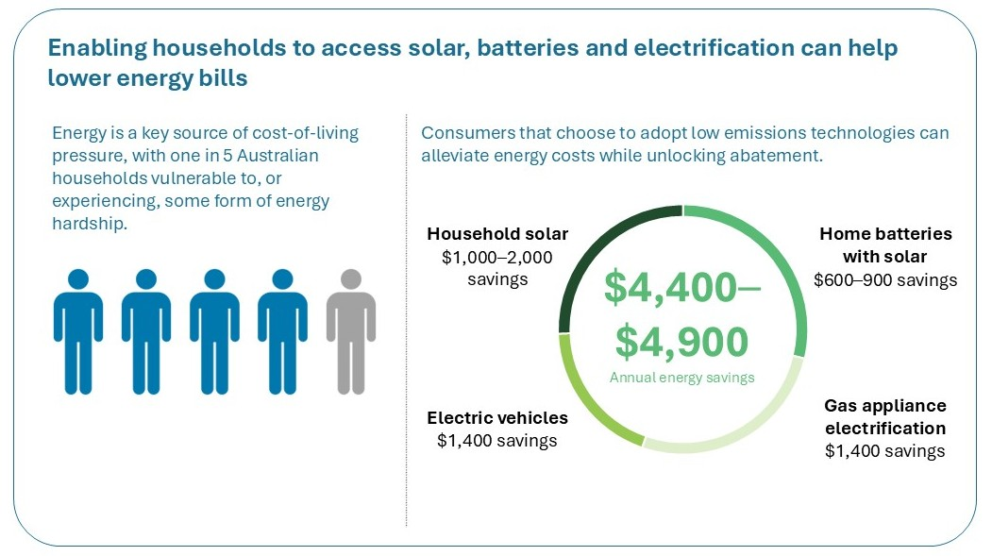
Sources: ECA (2025); AEMC (2025b).
Household uptake of low-emissions technologies also makes an important contribution to Australia’s whole-of-economy transition to net zero. Household solar and batteries help to reduce peak electricity demand, moderating wholesale prices in peak periods and reducing spending on grid infrastructure. The latest ISP shows that under a least-cost pathway, consumer energy resources such as rooftop solar and small-scale batteries make up roughly 40% of generation capacity in 2050 (AEMO, 2026a). Switching from gas to electric appliances frees up gas supply for industrial uses where electrification is not yet feasible.
There are strong signs of progress. More than 4.3 million Australian households have installed rooftop solar, while more than 450,000 battery systems have been deployed (CEC, 2026b). Gas’s share of residential energy consumption fell by 4 percentage points to 29% between 2022 and 2024, while electricity’s share grew by 3 percentage points to 53%. This suggests households are beginning to switch from gas to electric appliances (CCA analysis of DCCEEW, 2025a).
However, not all households are accessing these cost-saving technologies. For example, many Australian households continue to use gas for a range of reasons. Household gas connections on Australia’s east coast have increased by over 3% since 2022 (CCA analysis of AER, 2026). Fully electrifying these additional households could have reduced cumulative emissions since 2022 by around one million tonnes of emissions.
Realising the financial and emissions benefits of household electrification will require action to address persistent barriers to uptake. These include upfront costs, limited incentives for landlords to invest in energy upgrades, and low awareness of electrification options (The Senate, 2025).
These barriers are often structural and mutually reinforcing. Upfront costs can deter households even where electrification would deliver long-term savings, particularly where access to finance is limited. Split incentives between landlords and tenants constrain uptake in rental properties, while long appliance lifetimes can lock in gas use. Limited access to clear, trusted information further reduces confidence and uptake.
We will examine policy options to address these barriers in the 2026 Annual Progress Advice.
Question 4
What actions could help households adopt solar, batteries, electric vehicles and home electrification?

Clean industry projects are struggling to progress from concept to final investment decision
Australia has a significant opportunity to leverage its comparative advantage in low-emissions exports, such as green iron, low carbon liquid fuels (LCLF) and refined critical minerals. Realising this opportunity will require stronger, more predictable demand signals, alongside progress on technology maturity and firmed energy supply, to enable projects to reach FID. While Australia has one of the world’s largest pipelines of clean industrial projects – valued at around $264 billion – many are yet to secure finance or progress to FID (Figure 8; ITA & MPP, 2026). Unlike renewable energy deployment (as discussed in 2.2), which is primarily constrained by planning delays, transmission constraints and connection complexities, clean industry projects are more exposed to technology risk premiums and demand uncertainty.
Offtake agreements are a key mechanism for creating demand, providing revenue certainty, and supporting project viability (Reem, 2025). These mechanisms are most effective where technologies are sufficiently mature, allowing demand certainty to unlock investment and drive scale. In contrast, more nascent technologies typically require further supply-side progress – such as technological development, cost reductions, and the build-out of enabling infrastructure – before demand-side mechanisms can be fully effective.
Even for relatively more mature technologies, clean industry projects remain capital intensive and require further commercial scaling, which increases risk. In these cases, stronger and more predictable demand signals can play a critical role in reducing commercial uncertainty and giving investors the confidence needed to commit capital. Governments can help increase and accelerate offtake agreements through policies such as public procurement and product mandates. These policies create differentiated markets for low‑emissions goods and provide the demand certainty needed to support investment in low‑carbon production capacity (ITA & MPP, 2024).
International demand will also be critical. Australia’s 2035 Targets Advice identified an opportunity to transition from a net exporter of emissions to a net exporter of abatement. Decarbonisation deals could support this by strengthening international demand for Australia’s clean exports and enabling regional emissions reduction (CCA, 2026).

Figure 8: Australia’s clean industry opportunity and investment challenges
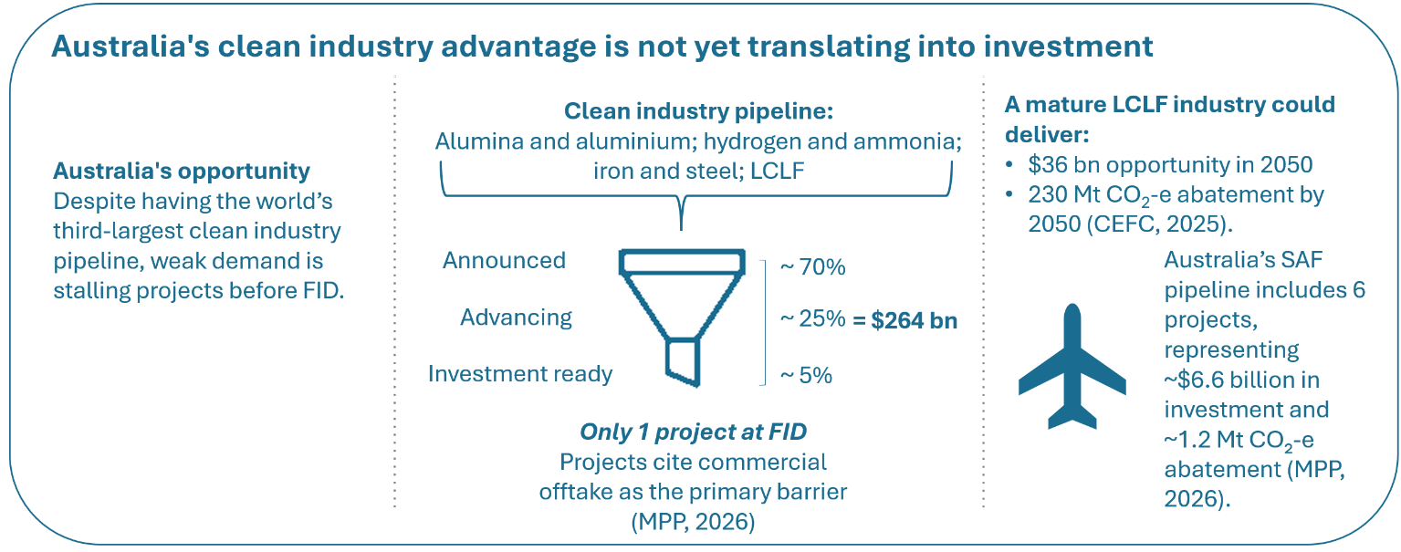
Sources: MPP (2026); CEFC (2025).
Regional coordination can strengthen demand in key markets. For example, the Republic of Korea – Australia’s third largest export market – relies heavily on emissions-intensive imports such as coal, gas and iron ore. Decarbonisation deals could support the transition of shared supply chains (e.g., steel and aluminium), while generating sustained demand for low-emissions products and supporting energy security and competitiveness in both countries (CCA, 2026).
Australia is well placed given its abundant renewable energy resources, critical mineral deposits, and skilled workforce. Strengthening demand will be increasingly important as global markets shift away from emissions-intensive goods (CCA, 2021).
Emerging sectors such as LCLF highlight this opportunity. A mature Australian LCLF sector could reach up to $36 billion by 2050 (CEFC, 2025). Across Asia, governments are introducing sustainable aviation fuel mandates and considering policies to support supply (NRF, 2025). Recent budget measures are a step towards building Australia’s domestic capability and reducing reliance on imports (Budget, 2026). We will examine options to strengthen demand for low-emissions products in the 2026 Annual Progress Advice.
Question 5
What are the key barriers to the growth of low-emissions industries in Australia? What government policies or initiatives could most effectively strengthen demand for Australian low-emissions products and services, including low-carbon liquid fuels?
Please provide evidence or analysis to support your views.

3. The Authority’s 2026 advice on the Safeguard Mechanism
We will provide advice on 2 aspects of the Safeguard Mechanism (the Scheme) in 2026:
- input to the government’s 2026–27 review of the Scheme, focused on the Scheme’s contribution to the 2035 target and onsite abatement
- annual advice as part of our regular statutory assessment of the performance of the Scheme to inform the Minister’s Annual Climate Change Statement.
Figure 1 in the introduction of this consultation paper shows how our advice on the Scheme, our 2026 Annual Progress Advice and the government’s review relate.
We will consider the principles outlined in the Introduction and the Safeguard outcomes legislated in the National Greenhouse and Energy Reporting Act 2007 (NGER Act) in preparing our advice.

3.1 Role and scope of our advice

Our advice is an input to the government’s 2026–27 review of the Scheme
The government will undertake a review of the Scheme over the 2026–27 financial year. Consistent with the Minister’s request, the Authority will contribute advice for the review, focusing on 2 key elements:
- the post-2030 decline rate, following Australia’s commitment to a 2035 emissions reduction target of 62–70% below 2005 levels in its updated Nationally Determined Contribution under the Paris Agreement (Section 3.3)
- the extent to which onsite abatement is being driven by the reforms, and whether additional incentives are required (Section 3.4).
These elements go to the core of the Scheme’s performance: how much abatement it delivers, where the abatement occurs, and the level and distribution of costs.
There are strong interactions between these elements and other Scheme settings, including coverage, credit use, flexibility mechanisms and competitiveness arrangements. While our advice is focused on the Scheme’s contribution to national targets and onsite abatement, we will take these broader interactions into account.

We will be fulfilling our statutory obligation to assess the Scheme
This is our third year assessing whether Safeguard emissions are declining consistently with the legislated outcomes. These outcomes include limits on net Safeguard emissions to 2030 and 2050, and a requirement for gross Safeguard emissions to decline over time.

3.2 About the Safeguard Mechanism
The Scheme is the key policy for reducing emissions from Australia’s largest industrial facilities.
The Scheme sets emissions limits, known as baselines, for Safeguard facilities. Baselines are determined on an ‘emissions intensity’ basis, which means they are adjusted for the facility’s production each year (so facilities are not ‘rewarded’ for reducing production, or ‘penalised’ for growth). Baselines are generally calculated each year by multiplying actual production by an emissions intensity value, with an annual baseline reduction then applied. This places downward pressure on both emissions intensity and aggregate emissions over time.
Facilities can meet their obligations by reducing emissions onsite, surrendering ACCUs, surrendering Safeguard Mechanism Credits (SMCs), or using other flexibility mechanisms where eligible. ACCUs represent emissions sequestered or avoided by eligible offsets projects, while SMCs are generated when a Safeguard facility’s emissions are below its baseline.
Table 3 outlines the central policy settings of the Scheme.
Table 3: Safeguard Mechanism – current policy settings
Policy setting | Description
Proportional share | Current settings are based on the Scheme delivering 28.14% of Australia’s 2030 target, reflecting its coverage of national emissions when the reforms were developed.
Coverage | The Scheme covers facilities that emit more than 100,000 t CO₂-e annually. In 2024–25, there were 208 facilities across resources, industry, transport and waste sectors that exceeded this threshold.
Baseline decline rate | The Scheme is designed to reduce net emissions from Safeguard facilities predictably and gradually over time, determined by the baseline decline rate. The 4.9 percentage point annual decline for 2024–2030 is calibrated to deliver the Scheme’s proportional share of the 2030 emissions target, in light of anticipated production levels.  The Safeguard Rules include an indicative decline rate of 3.285% per year from 2030–31wards. This rate was included to support planning toward net zero by 2050. Post-2030 decline rates are intended to be set in predictable 5-year blocks, consistent with updates to Australia’s Nationally Determined Contribution under the Paris Agreement.  Australia has now set a 2035 emissions reduction target under the Paris Agreement, so the first post-2030 decline-rate setting process will determine how the Scheme contributes to that target. The rates for 2030–31 to 2034–35 are to be set by 1 July 2027, following advice from the Authority and the government’s 2026–27 review.
Use of carbon units | The Scheme allows facilities unrestricted use of ACCUs and SMCs for compliance purposes. International and voluntary carbon units are excluded. If a facility surrenders ACCUs equal to or more than 30% of its baseline, it must provide a statement to the Clean Energy Regulator (CER) that details why more onsite abatement hasn’t been undertaken.
Other flexibility and competitiveness measures | The Scheme includes measures to moderate compliance costs for facilities and mitigates risks of carbon leakage. These measures include TEBA determinations, banking, borrowing and multi-year monitoring periods.
Baseline emissions intensity settings | Baselines for existing Safeguard facilities are set using a hybrid approach, initially weighted towards a facility-specific emissions intensity value, gradually transitioning to a full industry average value by 2030. Baselines for new Safeguard facilities are set using emissions intensity values based on international best-practice levels, adapted for an Australian context.
Note: Policy settings that we are focusing on in our contribution to the Safeguard review are shaded in green. Others are within scope of the review to be led by DCCEEW.

These policy settings interact and changes to one setting can affect outcomes elsewhere. For example, a higher baseline decline rate may increase carbon unit demand, while restrictions on ACCU use may increase onsite abatement incentives but also raise costs for facilities with limited near-term abatement options.

The Scheme incentivises economically efficient emissions reductions
Under the Scheme’s design, declining baselines increase the incentive to reduce emissions over time. Facilities that reduce gross emissions below their baselines may be eligible to receive SMCs, which can be banked for future use or sold to other Safeguard facilities.
The Scheme also encourages production to occur where it is least emissions intensive. Over time, baseline settings transition toward industry-average emissions intensity values, strengthening incentives for lower-emissions production within industries.
At the same time, the Scheme provides flexibility. Facilities can use offsets (ACCUs and/or SMCs) to manage excess emissions. This allows abatement to occur across Safeguard facilities and eligible ACCU projects, rather than requiring every tonne of abatement to occur at the facility with excess emissions.
Use of offsets under the Scheme improves economic efficiency because they allow emissions reductions to occur where and when they are cheapest.
In practice, this means:
- Lower-cost abatement happens first – Some emissions reductions (for example, some land sector projects) can be delivered at relatively low cost today. Using offsets enables firms to access these cheaper options, rather than undertaking more expensive onsite abatement immediately.
- More emissions reductions can be delivered in the near-term – Offsets allow emissions to be reduced now, rather than delaying action while waiting for emerging or capital-intensive technologies to become viable.
- Australia’s emissions reduction pathway is more efficient – Facilities can pursue the mix of onsite and offsite abatement, over the short and long term, leading to a smoother and less costly transition overall.
Facilities with firm and credible onsite abatement projects planned may also access multi-year monitoring periods, allowing them to ‘smooth out’ their emissions trajectories over a period of up to 5 years whilst they implement these projects. Support for onsite abatement is also available through the Powering the Regions Fund.
Facilities that surrender ACCUs equal to 30% or more of their baseline must provide a statement explaining why they have not undertaken more onsite abatement. In 2024–25, 23 facilities triggered this requirement. The CER reports these statements often cite low availability of affordable decarbonisation technologies and facility operational circumstances (CER, 2026a).
For readers seeking a more detailed overview of the Scheme, the government’s Safeguard Mechanism overview provides a useful introduction to coverage, baseline setting, crediting, flexibility arrangements and compliance (DCCEEW, 2026d).

3.3 The Scheme’s contribution to national targets
Our advice will consider the extent to which the Scheme should contribute to achieving the 2035 target.

The Scheme’s baseline decline rate is a central policy lever
The baseline decline rate determines the scale of emissions reductions the Scheme contributes to achieving Australia’s targets. It is, therefore, directly relevant to the environmental effectiveness of the policy.
It also shapes equity, in 2 ways.
First, at the aggregate level, the decline rate reflects how much Safeguard-covered sectors contribute to Australia’s emissions reduction targets relative to sectors outside the Scheme.
Second, where decline rates or other baseline settings differ between facilities, those settings influence how costs and abatement effort are distributed within the Scheme.
Other settings that influence the emissions reduction contribution of the Scheme to the target are discussed in the next section.

The current decline rate reflects the Scheme’s proportional share
The Scheme’s 4.9% annual percentage point reduction in baselines to 2030 was set so that Safeguard facilities deliver their proportional share of Australia’s emissions budget and the 2030-point target. This proportional share was based on Safeguard facilities accounting for around 28% of national emissions in 2020–21, the latest available national emissions data when the reforms were designed.
This proportional share approach is transparent and predictable. It also provides a stable basis for aligning the Scheme with national emissions reduction targets over time. Continuing this approach could support investment certainty for Safeguard facilities planning decarbonisation projects and provide a predictable basis for ACCU market participants estimating future demand.
We note the proportional share approach for the Scheme does not require sectors outside the Safeguard to cut emissions at the same rate. Our Sector Pathways Review and 2035 Targets Advice note abatement potential to 2035 varies across sectors – electricity can decarbonise more rapidly, while agriculture faces more challenges. Existing policy settings, including the Scheme (largely industry and resources), CIS (electricity) and NVES (transport), recognise the different abatement opportunities and constraints rather than enforcing uniform reduction rates across all sectors. The current approach to emissions reduction in the Scheme also does not require facilities to achieve all emissions reductions onsite. Recognising that some industries and facilities are more difficult to decarbonise than others, the Scheme allows trading of carbon credits and other flexibility mechanisms to meet compliance obligations. This allows facilities to make a net emissions reduction contribution to the national target.
We are interested in stakeholder views on whether this approach should continue beyond 2030 (Figure 9), or whether there is evidence to support an updated proportion or different approach.

Our advice on a post-2030 decline rate will consider multiple factors
We will consider:
- the extent to which the Scheme should contribute to Australia’s 2035 target,
whether to maintain a proportional share approach and, if so, how it should be applied beyond 2030
- whether to apply a uniform or differentiated decline rate across industries or facilities.

Different approaches can be taken to determine the Scheme’s post‑2030 proportional share
Two potential approaches to setting the post-2030 decline rate, based on the Scheme’s proportional share are:
- Static approach – the Scheme retains, for example, the 28% share of national emissions it represented in 2020–21, and this fixed share is applied to future emissions reduction targets (Figure 9).
- Dynamic approach – the Scheme’s share is updated every 5 years using the latest national inventory data to reflect changes in the share of Safeguard emissions relative to total national emissions. The updated share determines the Scheme’s contribution to future emissions reduction targets.
Figure 9: Illustrative scenario – Static proportional share of 28%
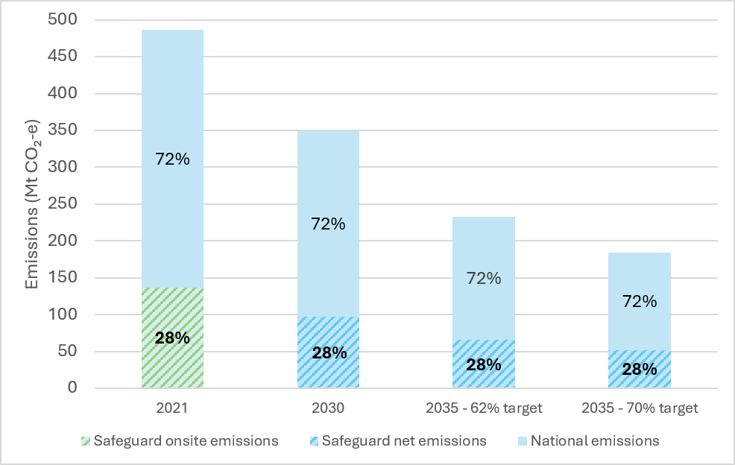
Source: Authority analysis based on data from DCCEEW (2023).
Notes: This figure presents national emissions in 2020–21 as 487 Mt CO₂-e, consistent with the value used in DCCEEW’s 2023 position paper to calculate the proportion of Safeguard emissions as a share of national emissions. 2020–21 emissions have since been through multiple revisions and were estimated at 440 Mt CO₂-e in the 2024 National Inventory Report (DCCEEW, 2026c).
If the Scheme’s coverage expands to bring in more facilities or sectors, it would be reasonable to update the share (as, without amendment, 28% would then involve Safeguard facilities making a more-than-proportionate contribution). However, in the absence of material changes to coverage, we propose retaining a static 28% proportional share approach, because it is simple and predictable. As the Scheme contributes 28% of 2030 target emissions in net terms, and Safeguard facilities obligations are set in net terms, maintaining this share enables a significant contribution to national emission reductions without disproportionate costs.
While we note the national inventory for 2020–21 has been through multiple revisions since the reformed Scheme commenced, we do not propose recalibrating the Scheme’s 2020–21 proportional share after each revision.

Assuming a static proportional share approach, preliminary analysis suggests a decline rate of 4.5–7% per year aligns with Australia’s 2035 target
Because Australia’s 2035 target is expressed as a range, we have estimated illustrative decline rates across that range. Based on a static 28% proportional share, our initial analysis indicates that a decline rate of around 4.5% per year would align with 62% (lower bound), and a decline rate of around 7% per year would align with 70% (upper).
Figure 10 illustrates how these decline rates would lower aggregate Safeguard baselines. Because facilities must keep net emissions at or below their baselines, lower aggregate baselines represent a tighter net emissions constraint for the Scheme. The 70%-aligned trajectory would tighten that constraint by around 17 Mt CO₂-e in 2035 relative to DCCEEW’s 2025 projections, which assume the indicative post-2030 decline rate of 3.285% applies.
These estimates are preliminary. They apply a 28% proportional share approach and involve assumptions about future production levels, use of TEBA arrangements, new entrants and facilities falling below the coverage threshold. They do not account for other possible changes to Scheme settings, including changes to coverage, flexibility mechanisms or credit use.
Setting a decline rate consistent with the Scheme contributing less than a proportional share of achieving Australia’s 2035 target would require other sectors of the economy to contribute more abatement to achieve the same target.
Figure 10: Illustrative decline rate scenarios under a static proportional share, 2026–2035

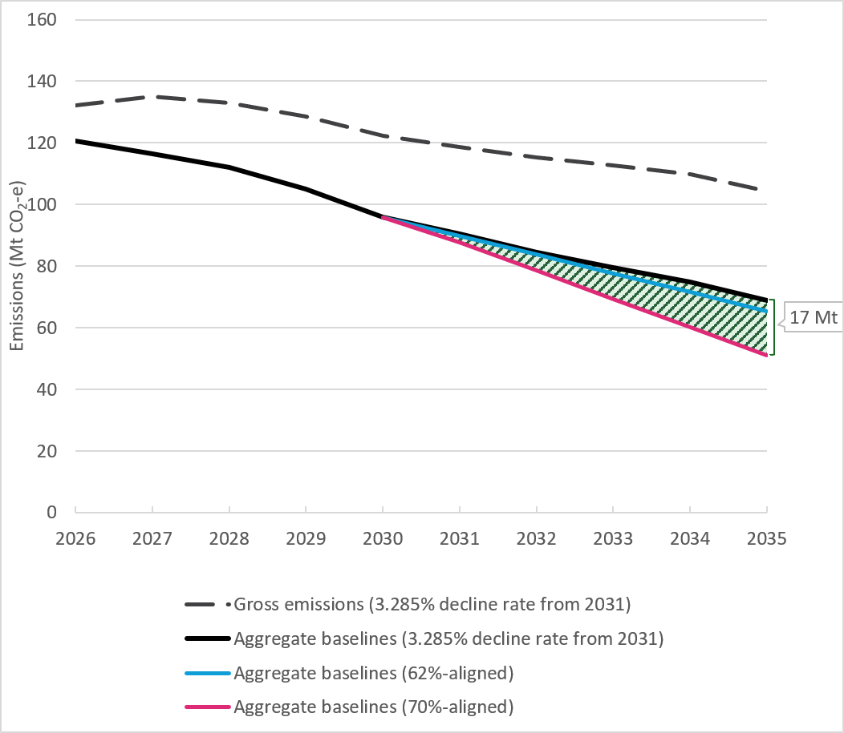
Sources: Authority analysis based on data from Australia’s emissions projections 2025 (DCCEEW, 2025b).
Notes: Aggregate baselines are shown as an indication of the Safeguard Mechanism’s net emissions constraint under different decline-rate settings. Actual net emissions will depend on facility emissions, ACCU and SMC surrender, below-baseline performance and use of flexibility mechanisms. ‘Gross emissions’ and ‘Aggregate baselines (3.285% decline rate from 2031)’ are based on Australia’s emissions projections 2025. Projections reflect policy settings at the time of publication, including the 4.9% decline rate to 2030, and the indicative post-2030 decline rate of 3.285%. The 62% and 70%-aligned aggregate baseline declines are based on our internal analysis.
Question 6
6A) The Safeguard Mechanism’s current baseline decline rate is calibrated so the scheme delivers a proportional share of Australia’s 2030 emissions reduction target.
- What are the advantages and disadvantages of continuing this approach beyond 2030?
- If the proportional share approach should be maintained, how should it take account of Australia’s 2035 target range?
6B) If a different approach to setting the baseline decline rate should be used (instead of the proportional share approach), what should it be and why?

Further differentiating decline rates across covered subsectors could better reflect abatement opportunities, but adds complexity
Flexibility mechanisms – including the use of ACCUs and SMCs and those described in Table 3 – moderate cost impacts to Safeguard facilities and reduce the risk of carbon leakage while maintaining the Scheme’s contribution to Australia’s emissions reduction targets. In particular, TEBA is a flexibility mechanism that provides trade-exposed facilities differentiated treatment by applying a lower baseline decline rates to address carbon leakage risks.
Some stakeholders have proposed broader differentiation across sectors or activities. For example, the Australian Conservation Foundation and the Climate Council have examined the implications of coal and gas emissions for the Safeguard Mechanism and found that stronger decline rates for coal and gas could reduce the decarbonisation required from other industries, such as manufacturing and minerals processing, while maintaining the same overall emissions outcome (RepuTex Energy, 2026).
More extensive differentiation could better reflect differences in abatement opportunities, costs or competitiveness risks. It could also increase complexity and make the Scheme less predictable, particularly where differentiated settings rely on facility-specific or commercially sensitive information.
Question 7
Should decline rates differ across facilities or sectors beyond existing arrangements for TEBA facilities? What evidence would support differentiation, and what principles should guide how any differentiation is applied?

3.4 Onsite abatement
To comply with the Scheme, facilities can either reduce their gross emissions through onsite abatement or surrender units to lower their net emissions. Opportunities for onsite abatement vary across Safeguard facilities and include shifting to low-emissions technologies, shifting to low-emissions fuels, operational changes or making efficiency improvements.
The government has indicated that as part of the 2026–27 review, the Authority will advise on:
- the extent to which onsite abatement is being driven by the reforms
- whether additional incentives are required, such as discounting the abatement value of ACCUs (so more than one ACCU must be used to offset one tonne of emissions) when used above a certain percentage of a baseline, or circumstances where limits on ACCU use may be appropriate.
This section sets out how we propose to approach those questions.

We will use a range of indicators to measure onsite abatement
Measuring onsite abatement is not straightforward. For this work, we are interested in emissions reductions that occur at Safeguard facilities, rather than through the surrender of ACCUs.
There is no single metric that can definitively attribute observed emissions reductions to onsite abatement driven by the Safeguard reforms. While declines in gross emissions (that is, emissions before the surrender of ACCUs and SMCs) may suggest onsite abatement, they can also reflect a range of other factors. These include changes in production levels, shifts in the location of activity, variations in operational conditions, facility openings or closures, and temporary outages or disruptions.
Changes in emissions intensity provide another useful indicator because they show whether facilities are producing fewer emissions per unit of output. This can help distinguish changes in production from changes in emissions performance. However, emissions intensity is also affected by a range of factors. These include changes in input quality, resource characteristics and operating conditions. Conversely, a facility may undertake abatement activities but still report a higher emissions intensity because of other factors.
These challenges are particularly important for sectors with variable fugitive emissions. For example, the CER notes that increases in coal mining emissions intensity in 2024–25 reflected factors including mining gassier areas, decommissioning activities and disruptions to production (CER, 2026c). The CER also noted some coal mines reduced emissions intensity by capturing and combusting coal mine waste gas.
For these reasons, we will examine a range of indicators, including changes in gross emissions and emissions intensity at the Scheme and sector level. We will interpret these indicators alongside facility-level evidence, including case studies and information from stakeholders about onsite abatement activities that have been planned, commenced or completed.
We are seeking 2 types of input to refine our approach:
- evidence from Safeguard facilities on onsite abatement activities they have planned, commenced or completed
- views from stakeholders on how we should measure onsite abatement, including whether deliberate emissions reductions need to be isolated from changes in production, operational conditions or emissions variability, and how this can be robustly and practically done.
Question 8
How should we assess the extent to which the Safeguard Mechanism is driving onsite abatement? What metrics, data sources or methods should we use, and how should we account for changes in production, operational conditions and emissions variability?

Question 9
What evidence is available on onsite abatement activities at Safeguard facilities, including for activities planned, underway or completed since the reforms commenced? Where possible, please provide information on emissions impacts, timing, costs and barriers.

Gross Safeguard emissions have fallen since the reformed Scheme commenced
The reformed Scheme has completed only 2 compliance years, and our 2026 Annual Progress Advice will assess preliminary data for the third.
Gross emissions (before credit use) rose modestly in the years immediately before the 2023 reforms. Across the 2 completed years since reform, gross emissions have fallen by 5.8 Mt CO₂-e (4%), and net emissions (after credit use) have fallen by 17.5 Mt CO₂-e (13%) (Figure 11 and Figure 12). Whilst results from the first 2 compliance years show Safeguard emissions tracking downwards, it is too early to draw firm conclusions about the precise impact of the reforms on onsite abatement. Changes in gross emissions reflect a range of factors – some unrelated to the Scheme – including production levels, operational conditions and emissions intensity.
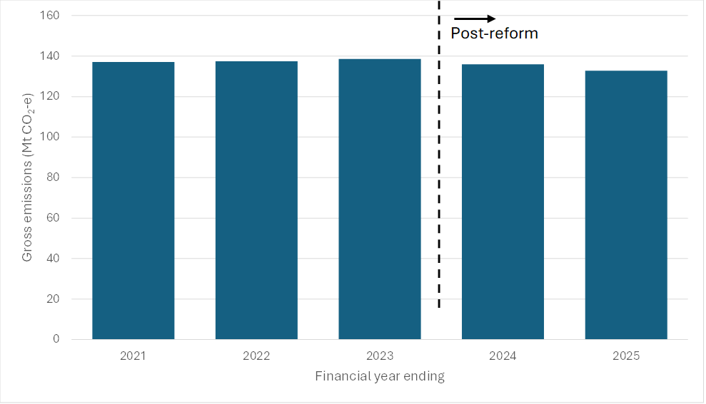 Source: CER (2026c).
Figure 11: Gross Safeguard emissions pre- and post-reforms, 2021–2025
Source: CER (2026c).
Figure 12: Net Safeguard emissions pre- and post-reforms with indicative trajectory, 2021–2030
Since the reforms, the gap between total facility baselines and total facility emissions before credit use has been eliminated. Total (net) baselines are now below total (gross) facility emissions. As baselines continue to decline, the incentive to reduce emissions will increase. Early examples of onsite abatement include catalytic systems that reduce nitrous oxide emissions from chemical manufacturing, carbon capture and storage in oil and gas, electrification trials, and capture and combustion of coal mine waste gas.
To date, material onsite abatement appears limited to a few facilities. Many industrial decarbonisation projects require major capital investment with long lead times. For that reason, the full effect of the reforms on onsite abatement will only be observable over time.
As baselines continue to decline, more facilities will need to reduce onsite emissions, or purchase and surrender SMCs or ACCUs to meet their compliance obligations. This strengthens the incentive to identify and implement onsite abatement. Allowing the use of ACCUs and SMCs enables the Scheme to achieve more ambitious emissions reductions more quickly, and to ensure facilities that currently lack feasible or cost-effective options still contribute to the abatement task.

Preferencing onsite abatement involves trade-offs
A key question for the review is whether (and if so, to what extent) the Scheme should preference onsite abatement, relative to allowing flexibility through ACCU and SMC use. The current design prioritises net emissions reductions and provides flexibility for facilities to meet obligations through a mix of onsite abatement, SMCs and ACCUs. One of the Scheme’s legislated outcomes requires the 5-year-rolling-average of gross emissions declines over time but does not require a specific quantity of reductions. Accordingly, the extent of onsite emissions reductions largely reflects individual facilities’ decisions in light of market conditions.
Some stakeholders argue the Scheme should place greater emphasis on onsite abatement and reduce reliance on ACCUs for several reasons.
For example, some raise concerns that offset use could delay or displace industrial decarbonisation. Others argue that given industrial CO₂ emissions remain in the atmosphere for hundreds or thousands of years, offsetting them with biological carbon sequestration (that may be at risk of reversal over shorter timeframes) raises issues of equivalence and durability. On this view, temporary or reversible sequestration may not be fully equivalent to avoiding or reducing long-lived industrial emissions at source.

On the other hand, some emphasise that restricting ACCU use could increase compliance costs and reduce flexibility, particularly for facilities with limited near-term onsite abatement options. If restrictions are set too tightly, some facilities may find it difficult or impossible to meet their baselines. On this view, access to trading is a key counterpart to the ‘proportional share’ approach discussed in section 3.3. Restricting trade could lead to pressure to make other design changes, such as less stringent baseline decline rates (i.e. fewer emission reductions overall) or introduction of additional flexibility mechanisms (adding complexity and potentially reducing near term abatement).
The Authority is considering issues relating to ACCU integrity, permanence and reversal risk in its current review of the ACCU Scheme. However, Scheme settings determine how ACCUs can be used for compliance. The Authority is, therefore, considering whether additional incentives or constraints on the use of ACCUs are warranted, and will analyse how different approaches could affect emissions outcomes, compliance costs and how those costs are distributed.

3.5 Potential adjustments to Scheme settings
Stakeholders have proposed a range of possible adjustments to Scheme settings that are relevant to the 2 core issues considered in this paper: the baseline decline rate and onsite abatement. Some of these are presented in Table 4.
We have not yet formed a view on these options and are open to other options. We are seeking evidence on how they would affect emissions, costs, investment, competitiveness, carbon markets and administrative complexity. Some options would increase the Scheme’s overall emissions reduction task, while others would mainly affect where abatement occurs – at Safeguard facilities or through ACCU projects.
We note changing settings to further incentivise onsite abatement could, if implemented in isolation, reduce scheme-driven demand for ACCUs. There may be a role for government to support long-term ACCU demand stability.
Many other policy options, including expanding the Scheme coverage (e.g. by lowering the 100 kt threshold or broadening sector coverage) and allowing the use of international offsets are outside the scope of our work, but will be considered as part of the government’s review.

Table 4: Potential adjustments to Safeguard Mechanism settings and issues for assessment
Potential adjustment | Main effect | Likely effects to test | Key issues for assessment
- Increase the baseline decline rate | Increases the emissions reduction task under the Scheme by requiring lower net emissions over time. | Likely to increase onsite abatement, demand for ACCUs and SMCs, and increase land-sector abatement through higher ACCU demand. | - Efficiency – Compliance costs  - Equity – Safeguard-covered sectors’ emissions reduction contribution relative to sectors outside the Scheme; and treatment of trade exposure and competitiveness
- Apply steeper decline rates to coal and gas sectors | Differentiates the emissions reduction task by requiring coal and gas facilities to reduce net emissions faster than other Safeguard facilities. | Could increase net abatement from coal and gas facilities and reduce abatement required from other Safeguard sectors for a given Scheme-wide outcome. May see similar patterns of abatement, but greater SMC and ACCU purchase by coal and gas facilities and less by others. | - Effectiveness – Lower near-term warming effects  - Equity – distribution of abatement costs across industries
- Discount the abatement value of ACCUs for Safeguard compliance | Requires facilities surrender more than one ACCU to offset one tonne of emissions above baseline or above a certain level of ACCU use. | Could increase net emissions reductions for a given baseline decline rate, increase ACCU demand, and strengthen incentives for onsite abatement. | - Effectiveness – scale of extra abatement  - Efficiency –compliance costs
- Limit ACCU use in some circumstances | Caps extent facilities can rely on ACCUs to meet Safeguard obligations.  Limits could be applied to all, or limited to facilities in subsectors with cost-effective abatement opportunities. | Likely shifts abatement from ACCU projects to onsite at Safeguard facilities but would not increase total net abatement unless other settings change. Could reduce ACCU demand and increase compliance costs. | - Efficiency – compliance costs  - Equity – feasibility and costs for facilities with limited near-term onsite options
- Transition existing coal mines to fully industry-average baselines by 2035 | Most existing Safeguard facilities transition to baselines based on industry-average emissions intensity values by 2030. Existing coal mines are treated differently: by 2030, their baselines will still use a 50:50 mix of facility-specific and industry-average emissions intensity values. This adjustment would continue the coal mine transition after 2030, so that existing coal mines also move to fully industry-average baselines by 2035. | Could increase costs for coal mines with higher emissions intensity and strengthen incentives to reduce emissions or shift production towards lower-emissions mines. | - Equity – distributional impacts across coal mines with different fugitive emissions profiles
- Targeted regulation, funding or support for onsite abatement | Directly encourages or requires particular abatement activities or technologies at Safeguard facilities. | Likely to increase Safeguard-sector onsite abatement. May not increase national abatement unless baselines or other settings are adjusted, but could reduce future compliance costs or accelerate technology deployment. | - Efficiency –system-wide abatement costs  - Equity – technology neutrality; public support for public good spillovers
Note: ‘Likely effects’ assumes no other changes to Scheme settings or complementary measures.
Our assessment of potential scheme adjustments is preliminary. We will undertake further analysis, including economic modelling of some options, to better understand:
- how different decline rates affect emissions outcomes and credit demand
- how changes to ACCU use affect onsite abatement incentives
- system-wide abatement costs and how compliance costs vary across sectors and facility types
- how Safeguard settings interact with ACCU markets and other policies.
Question 10
Should the Safeguard Mechanism play a stronger role in encouraging onsite abatement, relative to allowing flexibility through ACCU use?
- What objectives should guide this assessment?
- Are additional incentives or constraints warranted?
- If so, what options should be considered and why?

References
Australian Automobile Association (AAA). (2026). Electric Vehicle Index. https://www.aaa.asn.au/research-data/electric-vehicle/
Australian Energy Market Commission (AEMC). (2025a). Faster renewable buildout and electrification key to affordable energy transition. https://www.aemc.gov.au/news-centre/media-releases/faster-renewable-buildout-and-electrification-key-affordable-energy-transition
AEMC. (2025b). Residential Electricity Price Trends 2025. https://www.aemc.gov.au/market-reviews-advice/residential-electricity-price-trends-2025
Australian Energy Market Operator (AEMO). (2024). 2024 Integrated System Plan For the National Electricity Market: A roadmap for the energy transition. https://www.aemo.com.au/-/media/files/major-publications/isp/2024/2024-integrated-system-plan-isp.pdf?rev=b811f5d66df24e0a980ce0df8eaa5687&sc_lang=en
AEMO. (2026a). 2026 Integrated System Plan. https://www.aemo.com.au/energy-systems/major-publications/integrated-system-plan-isp/2026-integrated-system-plan-isp
AEMO. (2026b). Quarterly Energy Dynamics Q1 2026. https://www.aemo.com.au/-/media/files/major-publications/qed/2026/qed-q1-2026.pdf
Australian Energy Regulator (AER). (2026). Gas quarterly disconnection reporting. https://www.aer.gov.au/publications/reports/performance/gas-quarterly-disconnection-reporting
Andrew, R. (2026). Collected vehicle registration data. https://robbieandrew.github.io/carsales/?lang=en&freq=monthly&type=relative&sort=alphabetical&country=all
Australian National University (ANU). (2025). Australia’s Environment 2025 Report. https://ausenv.tern.org.au/wp-content/uploads/2026/03/2025_Aus-Env-Report_FINAL_web.pdf?utm_medium=referral&utm_source=tern-website&utm_campaign=ausenv-report-2025
Australian Renewable Energy Agency (ARENA). (2025). Electrifying Road Freight: Australia’s Blueprint for a Cleaner Transport Future. https://arena.gov.au/blog/electrifying-road-freight-australias-blueprint-for-a-cleaner-transport-future/
Ausnet. (2025). Household Energy Cost Analysis. https://www.aer.gov.au/system/files/2025-02/ASD%20-%20Household%20energy%20cost%20analysis%20-%2031%20Jan%202025%20-%20PUBLIC.pdf
BloombergNEF (BNEF). (2026). Power Purchase Agreements dataset (unpublished).
Bureau of Meteorology & Commonwealth Scientific and Industrial Research Organisation (BOM & CSIRO). (2024). State of the Climate 2024. https://www.csiro.au/en/research/environmental-impacts/climate-change/state-of-the-climate
Budget. (2026). Budget 2026-27. https://budget.gov.au/content/01-fuel-supply-and-security.htm
CarExpert. (2026). VFACTS vehicle sales data. https://www.carexpert.com.au/category/vfacts
Climate Change Authority (CCA). (2021). Trade and investment trends in a decarbonising world. https://www.climatechangeauthority.gov.au/publications/paris-plus-trade-and-investment-trends-decarbonising-world
CCA. (2024). Sector Pathways Review 2024. https://www.climatechangeauthority.gov.au/sector-pathways-review
CCA. (2025). 2025 Annual Progress Report. https://www.climatechangeauthority.gov.au/2025-annual-progress-report
CCA. (2026). Decarbonisation deals: A proposed COP Negotiations Presidency initiative. https://www.climatechangeauthority.gov.au/decarbonisation-deals-proposed-cop-negotiations-presidency-initiative
Clean Energy Council (CEC). (2026a). Clean Energy Australia 2026. https://cleanenergycouncil.org.au/news-resources/clean-energy-australia-report-2026
CEC. (2026b). Rooftop solar and storage report: July-December 2025. https://cleanenergycouncil.org.au/news-resources/record-home-battery-surge-charges-up-australia-s-biggest-power-station-on-aussie-rooftops
Clean Energy Finance Corporation (CEFC). (2025). Exploring Australia’s Low Carbon Liquid Fuel Potential . https://www.cefc.com.au/document?file=/media/knuirzzl/cefc_refined_ambitions_lclf_opportunities_investment_insight.pdf
Clean Energy Investor Group (CEIG). (2025). 2025 Clean Energy Outlook: CEIG Annual Member Survey Results. https://www.ceig.org.au/wp-content/uploads/2025/07/2025-Clean-Energy-Outlook_CEIG-Annual-Member-Survey-Results-2.pdf
Clean Energy Regulator (CER). (2026a). 2024–25 baselines and emissions data. https://cer.gov.au/markets/reports-and-data/safeguard-data/2024-25-baselines-and-emissions-data#accu-surrender-statements
CER. (2026b). Quarterly Carbon Market Report March quarter 2026. https://cer.gov.au/markets/reports-and-data/quarterly-carbon-market-reports/quarterly-carbon-market-report-march-quarter-2026
CER. (2026c). Safeguard data. https://cer.gov.au/markets/reports-and-data/safeguard-data
Department of Climate Change, Energy, the Environment and Water (DCCEEW). (2023). Safeguard Mechanism Reforms: Position Paper. https://consult.dcceew.gov.au/safeguard-mechanism-reform-consult-on-design
DCCEEW. (2024). Safeguard Mechanism: About the Safeguard Mechanism and the reforms. https://www.dcceew.gov.au/sites/default/files/documents/safeguard-mechanism-reforms-factsheet-2023.pdf
DCCEEW. (2025a). Australian Energy Update 2025. https://www.energy.gov.au/publications/australian-energy-update-2025
DCCEEW. (2025b). Australia’s emissions projections 2025. https://www.dcceew.gov.au/climate-change/publications/australias-emissions-projections-2025
DCCEEW. (2025c). Australia’s Net Zero Plan. https://www.dcceew.gov.au/climate-change/publications/net-zero-plan
DCCEEW. (2025d). National Greenhouse Gas Inventory Quarterly Update: June 2025. https://www.dcceew.gov.au/climate-change/publications/national-greenhouse-gas-inventory-quarterly-update-june-2025
DCCEEW. (2026a). Cheaper Home Batteries Program. https://www.dcceew.gov.au/energy/programs/cheaper-home-batteries
DCCEEW. (2026b). National Greenhouse Gas Inventory Quarterly Update: December 2025. https://www.dcceew.gov.au/climate-change/publications/national-greenhouse-gas-inventory-quarterly-update-december-2025
DCCEEW. (2026c). National Inventory Report 2024. https://www.dcceew.gov.au/climate-change/publications/national-inventory-report-2024
DCCEEW. (2026d). Safeguard Mechanism overview. https://www.dcceew.gov.au/climate-change/emissions-reporting/national-greenhouse-energy-reporting-scheme/safeguard-mechanism/overview
Department of Infrastructure, Transport, Regional Development, Communications, Sport and the Arts (DITRDCSA). (2025). Road vehicles Australia, January 2025. https://www.bitre.gov.au/publications/2025/road-vehicles-australia-january-2025
Energy Consumers Australia (ECA). (2025). Understanding and measuring energy hardship in Australia. https://energyconsumersaustralia.com.au/our-work/surveys/consumer-energy-report-card-understanding-measuring-energy-hardship-australia
Federal Chamber of Automotive Industries (FCAI). (2026). EVs surge as buyers respond to fuel uncertainty. https://www.fcai.com.au/evs-surge-as-buyers-respond-to-fuel-uncertainty/
Guthrie, J. (2026). Banks are no longer financing the energy transition on faith. Gilbert + Tobin. https://www.gtlaw.com.au/insights/key-topics/beyond-transition/banks-are-no-longer-financing-the-energy-transition-on-faith
Hon Chris Bowen MP. (2026). Joint media release: Cheaper Home Batteries are powering the suburbs, rural and regional Australia. https://minister.dcceew.gov.au/bowen/media-releases/joint-media-release-cheaper-home-batteries-are-powering-suburbs-rural-and-regional-australia
Industrial Transition Accelerator & Mission Possible Partnership (ITA & MPP). (2024). Green Demand Policy Playbook: Simulating Demand for Low and Near-Zero Carbon Materials, Fuels and Chemicals Through Government Policies. https://ita.missionpossiblepartnership.org/green-demand-policy-playbook/
ITA & MPP. (2026). Clean Industry Spotlight: Turning Australia’s natural advantage into industrial leadership. https://ita.missionpossiblepartnership.org/news/entry/australia-poised-to-unlock-aud300-billion-clean-industrial-opportunity-if-it-takes-action-to-boost-demand/
Mission Possible Partnership (MPP). (2026). Project pipeline status by sector. https://tracker.missionpossiblepartnership.org/mpp-global-projects-map/pipeline
Norton Rose Fulbright (NRF). (2025). Taking flight: sustainable aviation fuels in Asia. https://www.nortonrosefulbright.com/en/knowledge/publications/916218d2/taking-flight-sustainable-aviation-fuels-in-asia
Reem, Y. (2025). 4 winning offtake agreement strategies to scale climate tech. WEF. https://www.weforum.org/stories/2025/03/4-winning-offtake-agreement-strategies-to-scale-climate-tech/
RepuTex Energy. (2026). Safeguard Mechanism emissions sensitivities & baseline implications. https://www.reputex.com/research-insights/report-safeguard-mechanism-emissions-sensitivities-baseline-implications-2026-27-policy-review/
Rimrod, F., & Manfield, E. (2026). Renewables and batteries drive down fossil fuel use despite record electricity demand. ABC News. https://www.abc.net.au/news/2026-04-30/renewables-batteries-drive-down-fossil-fuel-use-/106622772
The Senate. (2025). Economics References Committee: Residential electrification. https://www.aph.gov.au/Parliamentary_Business/Committees/Senate/Economics/ResElectrification/Report
United Nations Framework Convention on Climate Change (UNFCCC). (2026). COP31 Presidency announces new targets on global electrification, cutting waste, resilient cities; press conference transcript. https://unfccc.int/news/cop31-presidency-announces-new-targets-on-global-electrification-cutting-waste-resilient-cities



Previously referred to as the Annual Progress Report (APR)
This is because updated emissions inventory estimation methods and data can lead to revisions to historical data as well as sector emissions changing over time, both affecting how reference pathways are calculated.
Australia is a global leader in rooftop solar uptake. As of February 2026, more than 4.3 million households and small businesses have installed photovoltaic systems (CEC, 2026). The Small-scale Renewable Energy Scheme and state and territory government rooftop solar incentives contribute to strong uptake of rooftop solar across Australia.
More than 350,000 home batteries have been installed since July 2025 under the Cheaper Home Batteries Program, equivalent to over 10 GWh of capacity (Hon Chris Bowen MP, 2026). The scheme is expected to support more than 2 million Australians install a battery by 2030, delivering around 40 gigawatt hours of additional storage capacity (DCCEEW, 2026).
East coast refers to jurisdictions that are part of the Australian Energy Regulator’s regulated gas networks, which covers ACT, NSW, SA and VIC.
Potential emissions savings are cumulative from 2022 onwards, based on an assumed average household gas consumption of 49,900 MJ per year (Ausnet, 2025).
The proportional share is referred to later in this paper as a rounded value of 28%.
Coal mines retain their hybrid baselines, with the weighting between facility specific and industry average emissions intensity transitioning to a 50:50 split in 2030. The government adopted this approach to mitigate distributional impacts arising from large variances in emissions intensities between coal facilities.
This policy setting was adopted to mitigate distributional impacts in the coal sector arising from differences in emissions intensity across coal mines (DCCEEW, 2024).

