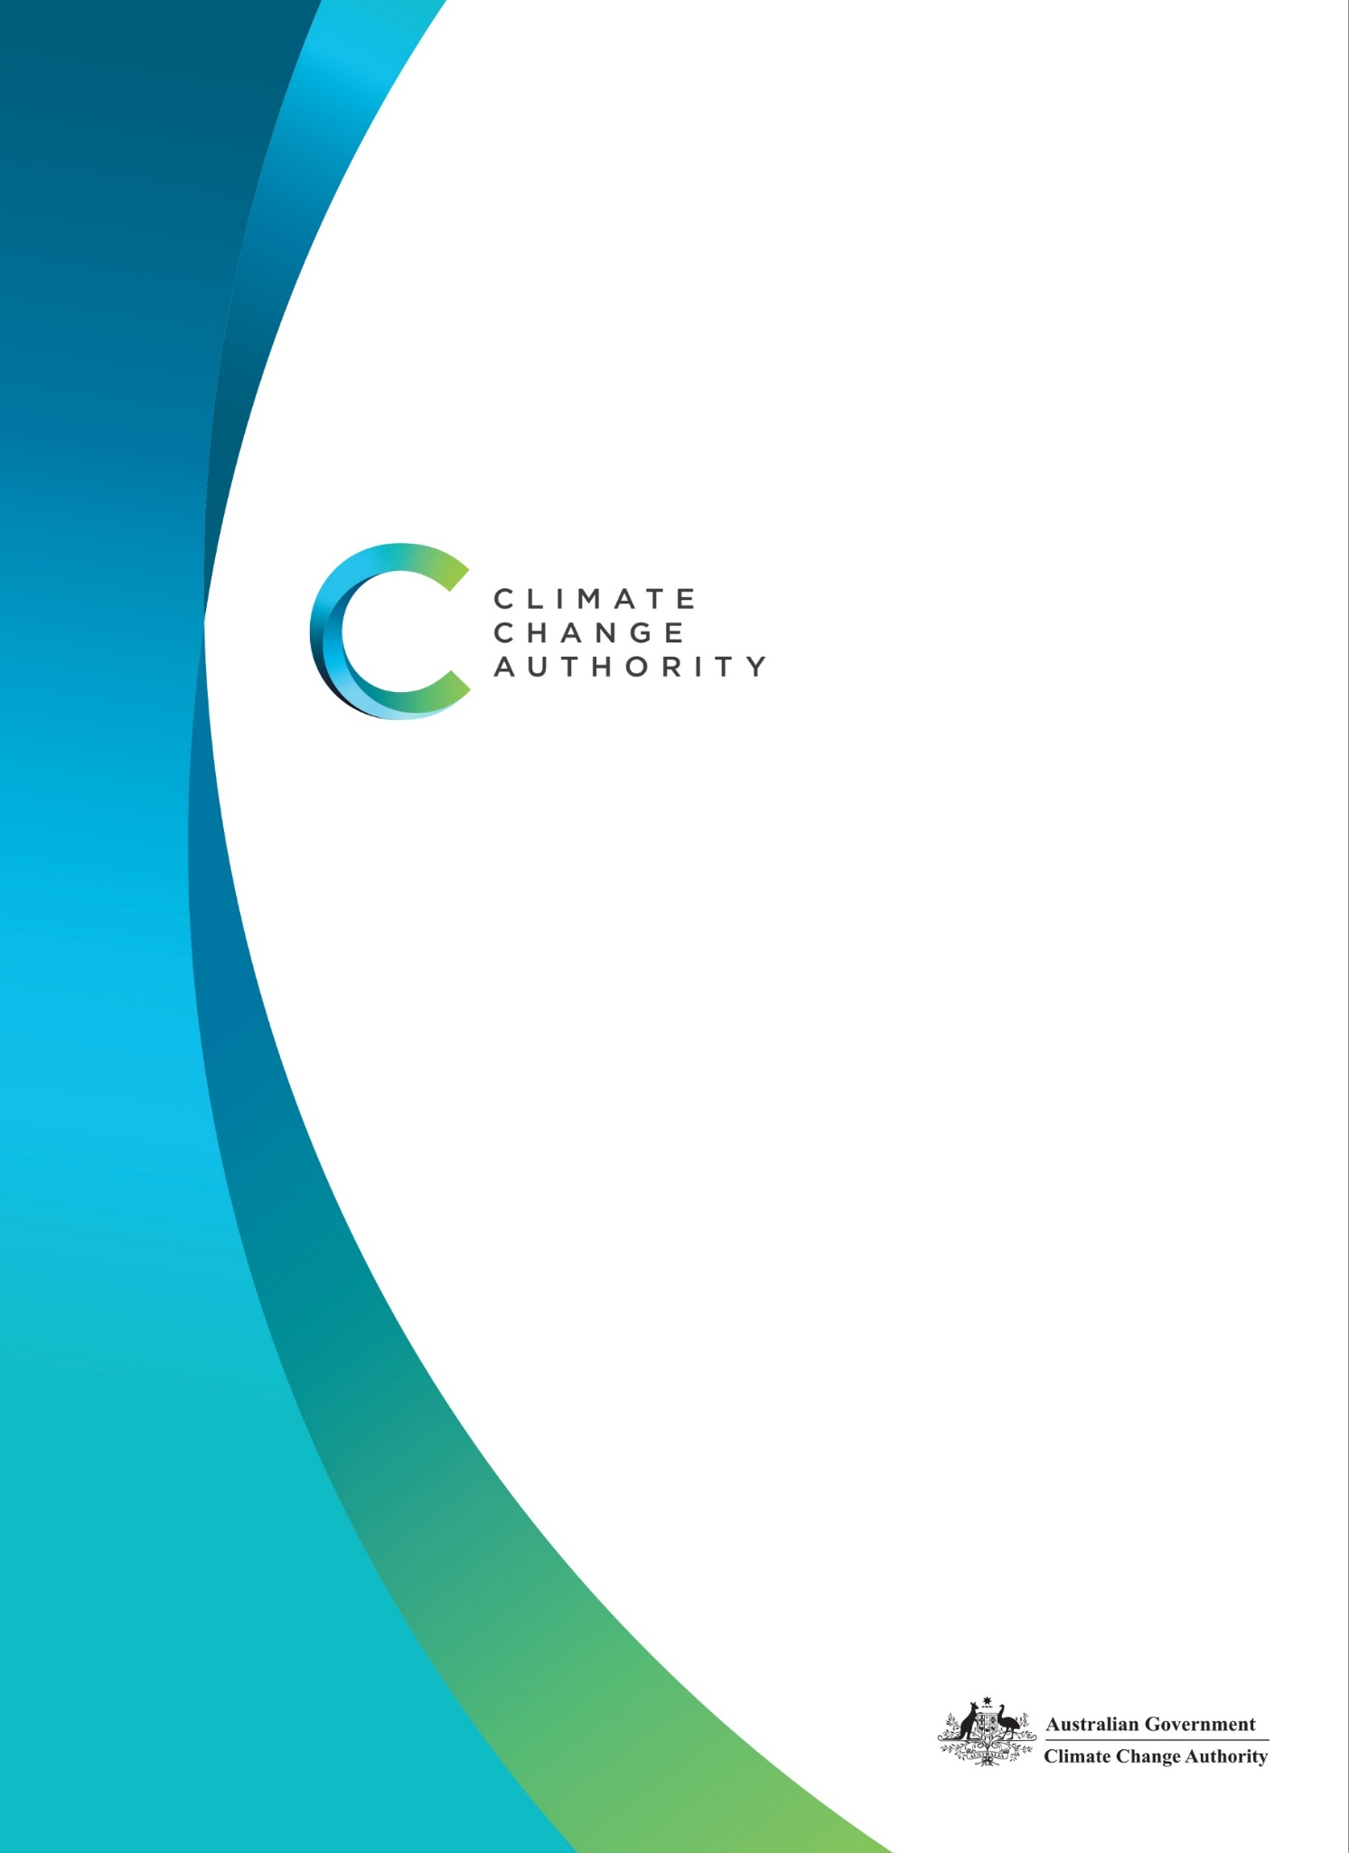
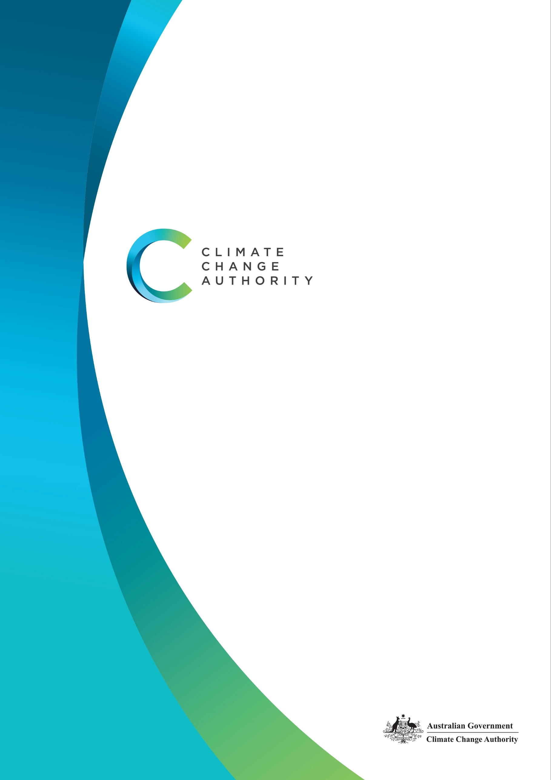
CLIMATE CHANGE AUTHORITY
CORPORATE PLAN 2026–27
AUGUST 2026

Ownership
Published by the Climate Change Authority
www.climatechangeauthority.gov.au
Copyright © Commonwealth of Australia 2026
ISBN: 978-1-7641783-6-5
Unless otherwise stated and except for the Authority’s logo, all photographs, graphics and trademarks, this publication is licensed under a Creative Commons 4.0 International licence.
Creative commons licence

With the exception of content supplied by third parties and content otherwise labelled, copyright in this publication is licensed under a Creative Commons BY Attribution 4.0 International licence.
Attribution
Use of material contained in this publication under a Creative Commons BY Attribution 4.0 International licence requires you to attribute the work (but not in any way that suggests that the Commonwealth endorses you or your use of the work). Provided you have not modified or transformed the publication in any way including, by changing text; calculating percentage changes; graphing or charting data; or deriving new statistics from published Commonwealth statistics – then the Commonwealth prefers the following attribution: Commonwealth of Australia (Climate Change Authority) 2026.
Further information on the licence terms is available from https://creativecommons.org/licenses/by/4.0.
Third party copyright
Wherever a third party holds copyright in material presented in this publication, the copyright remains with that party.
Accessibility
The Authority makes its documents and information available in accessible formats. If you have problems accessing the document, please contact us at Climate Change Authority, enquiries@cca.gov.au or phone 1800 475 869.
IMPORTANT NOTICE – PLEASE READ
This document is produced for general information only. The Commonwealth of Australia and all persons acting for the Commonwealth preparing this plan accept no liability for the accuracy of or inferences from the material contained in this publication, or for any action as a result of any person’s or group’s interpretations, deductions, conclusions or actions in relying on this material.

Image overleaf: Natalie L. Simmons (2023) Birrang (Wiradjuri for journey) [Acrylic on linen], Australia

The Authority recognises the First Nations people of this land and their ongoing connection to culture and country. We acknowledge First Nations people as the Traditional Owners, Custodians and Lore Keepers of the world’s oldest living cultures, and pay our respects to their Elders.

Statement of Preparation
I, Kath Rowley, as the accountable authority of the Climate Change Authority, present the Authority’s Corporate Plan 2026-27, which covers reporting periods 2026-27 to 2029-30 as required under s.35(1)(b) of the Public Governance, Performance and Accountability Act 2013. The plan is prepared in accordance with the Public Governance, Performance and Accountability Rule 2014 and s.55 of the Climate Change Authority Act 2011.
Kath Rowley
Chief Executive Officer
Signed by Kath Rowley
Date: 28 August 2026

Contents
Chair’s opening statement 6
Chief executive’s foreword 8
Purpose and strategy 10
Our purpose 10
Our functions 10
Who we are 11
Our guiding principles 12
Our values 13
Our strategy 14
Our strategic priorities 14
Our operating context 15
Operating environment 15
Resources and capability 17
Workforce 18
Cooperation: Partnerships 18
Corporate governance 21
Corporate governance framework 21
Our activities and performance 26
Activities 2026–27 26
Performance framework 28
Key performance indicators 30
Performance reporting 32


Chair’s opening statement

Matt Kean

Chair

It gives me great pleasure to introduce the Climate Change Authority’s 2026-27 Corporate Plan.
At a time of global disruption, it can be easy to lose sight of the imperative and the opportunities for Australia to act on climate change. But disruption should sharpen our focus. A faster, well-managed transition can make Australia stronger, more self-reliant and more resilient in an uncertain world.
Certainly 2025-26 was a busy one for the Authority. The highlight was providing our 2035 emissions target advice for Australia to the Government – and that advice being accepted. Australia is now committed to reducing emissions to 62 to 70 per cent below 2005 levels by 2035, as part of global climate action under the Paris Agreement.
This coming year’s agenda will help define how Australia can meet that target. Priorities include our triennial review of the Australian Carbon Credit Unit scheme, contributing to the Government’s review of the Safeguard Mechanism, and assessing opportunities to radically reduce fossil methane emissions.
The urgency of tackling the climate challenge to ensure the future prosperity of Australia, of course, requires ongoing efforts at all levels of government, here and abroad.

Australians, as individuals, families, businesses or members of community groups, have so much riding on the successful stabilisation of our climate.
As we enter an El Niño year, possibly an extreme one, Australians may be reminded our relative exposure to the perils generated by a hotter world.
Past El Niños have been associated with some of Australia’s worst droughts, heatwaves and bushfires. The breaking of heat records, here and abroad, may be increasingly common but the effects – now exacerbated by climate change – are anything but commonplace.
Humans can mitigate some of their impacts if they have access to cooling systems, but we have limits. So, too, do many species in our environment that we have barely studied. What are their thresholds of tolerance, and how will the ecosystems they make up affect us when they no longer function as they did?

Our choices do matter and fortunately, those choices are becoming easier to make.
The remarkable advances of solar panels and now low-cost batteries are transforming how we generate and store electricity in Australia, both at the household and grid-scale. Smart investors are increasingly combining with smart investors to make the low-carbon choice not just good for the environment but good for household budgets.
Nobody can tell how the war in the Middle East, which erupted at the end of February 2026, will play out. Will there be further disruptions to the fossil fuel trade?
The signal this sent globally has been received loud and clear: localise your energy supplies.
More than one-third (over 4.4 million) of Australian households have solar panels and more than one-tenth of them now have their own battery. Increasing numbers of Aussies are also driving an electric vehicle, some of which are powered from their own rooftops.
The benefits include quieter streets, cleaner air, and the satisfaction of taking more control of our finances and our energy supply.
The range of processes that now use fossil fuels that can be converted to electricity grows by the day. The era of the electron is replacing the age of flame, factory by factory, home by home.
The Authority is here to help ensure that Australians make the best possible choices, informed by evidence, designed through cooperation and driven by our national interests. We do have agency. Let’s share the word, share the benefits, and stay the decarbonising course.


Chief Executive’s foreword

Kath Rowley

Chief Executive Officer
I am pleased to present the Climate Change Authority’s 2026–27 Corporate Plan.
This plan sets out the Authority’s priorities for the year ahead and how we will deliver on our purpose over the next four years. It explains who we are, what we do, the environment we operate in, and how we will measure our performance.
The past year has been significant for the Authority. In 2025–26, we delivered our 2035 Targets Advice. This reflected the Authority’s collective judgement on what is ambitious, achievable and in Australia’s national interest.
The next phase is about delivery. Achieving Australia’s climate goals will require sustained effort across governments, the private sector and the community. The Authority plays an important role by providing independent, evidence-based advice on the policies, pathways and practical choices needed to support an orderly and effective transition.
In the coming year, this will include releasing our statutory review of the Australian Carbon Credit Unit Scheme, providing advice on the Safeguard Mechanism’s policy settings and opportunities to reduce fossil methane emissions. We will examine the role these policies should play in helping accelerate emission reductions across the economy.
A strong evidence base is central to good advice. We need to understand where Australia is making progress, where further effort is needed and how policy can best support Australia’s emissions reduction commitments. That is why we will be strengthening our Annual Progress Advice. In 2026–27, we will leverage the analysis underpinning our 2035 target advice to assess progress on reducing emissions, at a national and sectoral level. Over the next four years, we intend to expand this view, including tracking how Australia’s adaptation measures are advancing.
Engagement will remain central to the Authority’s work. It helps us understand how climate policies operate in practice, identify emerging challenges and opportunities and ensure our advice is informed by diverse experience alongside evidence and analysis. We will continue to strengthen our communications so our work is accessible, practical and useful to decision-makers, stakeholders and the broader community.
We will continue to invest in the Authority’s capability as a trusted source of climate policy advice. This means supporting our people, strengthening our analytical tools and methods, and continuing to engage widely across government, industry, experts and the community.
Since I commenced as Chief Executive Officer in December 2025, I have benefited greatly from the support of the Authority’s Chair and members. I am grateful for their unwavering commitment to the Authority’s work.
I would also like to acknowledge the work of the previous CEO, Brad Archer, in rebuilding the Authority and strengthening its role as an independent source of climate policy advice. I look forward to building on that foundation as we continue to support Australia’s transition to a net zero, climate-resilient future.
Finally, I would like to thank the Authority’s staff, whose passion, commitment and expertise make this work possible.

Purpose and strategy

Our purpose
The Climate Change Authority’s purpose is to provide evidence-based advice, and engage with the community, on the response to climate change, to:
- accelerate emissions reductions and position Australia as a leader in the global effort to limit temperature increases
- guide Australia to new opportunities and new ways of doing things, to sustain Australia’s prosperity as the world transitions to net zero emissions
- help Australia prepare for, and adapt to, the current and increasing impacts of climate change, which have already begun and will continue to increase.

Our functions
The Authority’s functions are set out in its enabling legislation, the Climate Change Authority Act 2011, and can be summarised as follows:
- providing advice to the Minister for Climate Change and Energy, as required by the Climate Change Act 2022, on greenhouse gas emissions reduction targets for Australia’s Nationally Determined Contributions under the Paris Agreement
- providing advice on progress towards Australia’s emissions reduction targets and the effectiveness of climate change policies, to inform the Minister’s annual statement to the Parliament under the Climate Change Act 2022
- conducting reviews of the Carbon Credits (Carbon Farming Initiative) Act 2011 (which creates the Australian Carbon Credit Unit (ACCU) Scheme) and the National Greenhouse and Energy Reporting Act 2007 (which creates the National Greenhouse and Energy Reporting Scheme and the Safeguard Mechanism)
- conducting special reviews of matters relating to climate change as requested by the Minister for Climate Change and Energy or the Parliament
- undertaking research into matters relating to climate change and other matters relating to the performance of our functions.

Who we are

Authority members
The Climate Change Authority is an independent statutory body established under the Climate Change Authority Act 2011.
The Authority is made up of a Chair, Australia’s Chief Scientist, and up to 7 other members. The current membership comprises:
Chair: Mr Matt Kean
Member: Professor Tony Haymet (Chief Scientist of Australia) (ex officio)
Member: Dr Virginia Marshall
Member: Professor Lesley Hughes
Member: Mr Richard Bolt
Member: Ms Fiona Simson
Member: Ms Patty Akopiantz
Member: Ms Gretta Theobald Stephens
Member: Mr Tim Reed
Our members have substantial experience, knowledge and standing in the fields that underpin our work, as required by the Climate Change Authority Act 2011. These include economics, public administration, energy systems, industrial decarbonisation, land resource and environment management, Indigenous knowledge systems, technology development and adoption, greenhouse gas emissions measurement and reporting, financial markets and investment.
This experience, knowledge and standing means potential conflicts are expected to arise from time to time. Our members recognise that management of conflicts of interest is vital to maintaining the Authority’s position as a trusted source of advice on climate change issues.
We do this by following:
- all legislated requirements in disclosure of interests
- good governance practices outlined in the Authority Charter, which ensure disclosures are actively managed
- a best practice approach to keep the Minister for Climate Change and Energy apprised of any changes.
Details of members’ qualifications and expertise can be found at https://www.climatechangeauthority.gov.au/about-authority/who-we-are

Authority staff
The Authority’s policy branches perform our core advisory, analysis, modelling, communications and engagement roles. The corporate branch manages the Authority’s financial, human resources, procurement, property, security, risk, governance and information technology functions.
Our staff have expertise and qualifications in a wide range of fields, including climate science, economics, law, international relations, human relations, accounting and communications.

Our guiding principles
In carrying out our functions, the Climate Change Authority Act 2011 requires us to consider the principle that any actions taken to address climate change should:
- be economically efficient
- be environmentally effective
- be equitable
- be in the public interest
- take account of the impact on households, business, workers and communities
- support the development of an effective global response to climate change
- be consistent with Australia’s foreign policy and trade objectives
- consider the matters set out in Article 2 of the Paris Agreement
- boost economic, employment and social benefits, including for rural and regional Australia.

Our values

Independence
The Authority operates independently under its own legislation, budget allocation and staff, as a non-corporate statutory body located in the Climate Change, Energy, Environment and Water portfolio. We are committed to independence and impartiality when undertaking research and reviews and providing advice based on our own research and judgements.

Transparency
The Authority operates in an open and transparent manner. We have a statutory obligation to publish our research, advice and review reports. Where possible, we publish submissions to our public consultations. Our advice and reports are the result of reviewing and synthesising existing materials, engaging with stakeholders and undertaking independent research to generate analysis and advice.

Good governance and accountability
The Authority maintains high standards of accountability and governance. As a government agency, the Authority is subject to the Public Governance, Performance and Accountability Act 2013 and Public Service Act 1999, and has specific additional governance requirements under the Climate Change Authority Act 2011.

Broad and positive stakeholder engagement
The Authority considers available inputs and perspectives by engaging with a wide range of people and organisations with an interest in climate change policy and related matters. We consult the public on every review, as well as in preparing our advice, consistent with the requirements set out in the legislation.

Excellence in research and analysis
The credibility of the Authority relies on the quality of its research, analysis and reporting. We undertake detailed planning and thorough research and analysis, drawing on the best available knowledge, and we seek input from expert advisers. We also have a skilled workforce with a broad range of experience and established links to relevant national and international expert organisations.

Valuing our most valuable asset – our staff
The Authority’s professional, capable and committed workforce is its most valuable resource. Continued investment in our staff, in an inclusive way that respects and reflects the diversity of our skills, knowledge and backgrounds, is vital for maintaining and enhancing the Authority’s performance. We provide all staff with the opportunity to develop their skills and knowledge. We treat their growth and wellbeing as a fundamental priority.

Our strategy
We will engage with the community and deliver influential, independent and expert advice by:
- undertaking rigorous research, analysis and policy development
- commissioning other analytical work (for example, economic modelling) where required
- engaging with stakeholders to understand issues, explore options, and develop our advice
- building networks with expert, local and international organisations
- presenting insightful and practical information and reports
- operating within a strong governance and accountability framework.

Our strategic priorities
Our strategic priorities are underpinned by our enabling legislation, purpose, guiding principles and values. The strategic priorities represent 5 focus areas that will guide us in our activities and shape our performance framework.
Our strategic priorities are to:
- deliver on our legislated tasks and functions
- engage with the community
- produce independent, rigorous, high-quality advice, reviews and research
- be recognised as a trusted voice and influential leader in climate policy advice
- maintain a capable workforce and thriving, inclusive culture.

Our operating context

Operating environment
The Authority’s activities are shaped by:
- accelerating climate impacts
- evolving domestic policy settings
- international geopolitical, technological and market developments
- public expectations about the quality of climate policy and implementation.
Australia has established strong foundations for emissions reduction and building climate resilience. Progress is under way across the economy, but action needs to accelerate and broaden if we are to achieve Australia’s 2035 target and net zero by 2050. The Authority’s independent, evidence-based advice will continue to help government accelerate progress toward a prosperous, resilient, decarbonised future for Australia.

Domestic policy landscape and opportunities
Australia’s emissions are falling, but are not yet falling at the rate required to meet the 2030 or 2035 targets. Relative to recent trends, the annual rate of emissions reduction would need to more than double to meet the 2030 target and increase further still to meet the 2035 target. The Authority’s view is that these outcomes remain achievable but will require strong and sustained policy effort across the economy.
This year, the Authority will advise on the role existing policies should play in accelerating progress. The Authority is currently undertaking its review of the ACCU Scheme. Integrity, policy certainty and the role of the scheme in supporting Australia’s targets emerged as key themes throughout the review’s public consultation.
The Authority will also contribute to the Government’s 2026–27 review of the Safeguard Mechanism, which applies to more than 200 of Australia’s largest industrial facilities and accounts for around 30% of national emissions. The review will consider whether the mechanism is aligned with Australia’s 2035 emissions reduction target and is operating efficiently and equitably.
The Authority also expects to contribute to the review of the New Vehicle Efficiency Standard, including to inform emissions limits for new vehicles beyond 2029, recognising the vital role reducing transport sector emissions will play in achieving national targets.
As the Authority has previously highlighted, the electricity transition is a crucial driver of emissions reduction and a key opportunity to deliver more reliable, affordable and secure energy for Australian households and businesses over time. Whilst renewable generation is expanding and electricity emissions are falling, deployment of generation, storage and transmission must continue to accelerate. It is important that timely transmission development, streamlined approvals, system security investments and meaningful community benefit-sharing support this rollout. The Government’s response to the Authority’s 2025 Annual Progress Report indicated that some of these recommendations are being progressed. The Authority will continue to monitor whether reforms translate into faster and more durable delivery on the ground.

International policy landscape and opportunities
The international policy environment remains affected by conflict, trade fragmentation and volatility in global energy and supply chains. These disruptions reinforce the economic case for decarbonisation, electrification and domestic clean energy capability. They also strengthen the case for developing local industries that reduce Australia’s exposure to imported fossil fuels and fragile global supply chains. The Authority continues to analyse how policy can help reduce Australia’s transition risks and bolster our competitiveness and energy security.
Scientific foundations and urgency
The Authority’s work is grounded in the best available science and in a practical assessment of what that science means for Australia’s economy, communities and policy choices.
Australia’s first National Climate Risk Assessment, released in 2025, highlighted how climate change is amplifying existing risks and can create cascading impacts across health, infrastructure and the economy. Climate-related financial reporting rules under the Corporations Act provide a maturing and systematic response, requiring major corporate entities to assess transition and physical risks to their operations – and to set out how they are responding.
The Government’s own adaptation agenda is also evolving. The Government agreed to Authority recommendations in our 2025 Annual Progress Report on climate adaptation, including working with states and territories to make sure future climate risks are considered in planning and decision-making. The Authority will continue to monitor issues such as climate risk in land-use planning and planned relocation. This is important because climate change is making some areas increasingly difficult to insure, live in or rebuild after extreme events. While mitigation remains central, adaptation and resilience are becoming more visibly important to the public. The Authority will continue elevating scientific evidence, highlighting the seriousness of climate impacts and identifying where mitigation and adaptation policy increasingly intersect.
Economic and social considerations
Our growing understanding of the physical risks of climate change, and the opportunities the global transition to net zero create for Australia, make it clear that the cost of climate inaction would far exceed the cost of transition. A delayed or disorderly transition would bring significant costs for productivity, investment and national income. Australia can strengthen its competitiveness by using its abundant renewable energy, expanding domestic value-adding and growing lower-emissions industries. These opportunities are in Australia’s national interest and investment in them depends on stable and predictable policy settings.
The transition will affect regions, industries, communities and households unevenly, and community confidence will remain critical to durable policy progress. The Authority’s advice has already highlighted the importance of community engagement, benefit-sharing and a just and orderly transition. The Authority will continue to support better public understanding of climate policy, climate risk and the practical conditions needed for successful implementation. Our analytical independence, public consultation processes and diverse membership remain important strengths in performing that role.

Resources and capability
The Authority’s budgeted departmental funding for 2026–27 is $13.987 million, with an average staffing level of 65 employees.
The appointment of a CEO on a 5-year term provides leadership continuity to support delivery of the Authority's long-term strategic priorities. Over the life of this plan, the Authority will strengthen organisational capability, maintain a high-performing culture and ensure it remains well positioned to respond to emerging challenges and opportunities in Australia's dynamic climate policy landscape.
The Authority recognises that organisational performance depends on the wellbeing, engagement and capability of its people. The Authority will continue to support flexible ways of working, employee wellbeing and professional development to attract, retain and develop a highly capable workforce. This includes investing in learning and development and knowledge management to ensure it maintains the specialist expertise required to deliver its legislated functions and strategic priorities.
The Authority’s corporate function supports operational delivery through fit-for-purpose systems, sound governance, information management and strategic workforce planning.

Information management
The Authority will strengthen its digital, data and information management capability to support efficient operations, high-quality analysis and secure, accessible ways of working. Cooperative arrangements with other agencies will continue to provide scalable support where fully in-house delivery is not practical or cost-effective.
The Authority will also take a careful, practical and proportionate approach to adopting Artificial Intelligence (AI). This will include building staff capability, supporting responsible use of approved tools for research, drafting, analysis and knowledge management, and ensuring AI-assisted work remains human-supervised, secure and subject to appropriate review.

Workforce
Our people underpin the Authority’s ability to deliver credible, high-quality and evidence-based advice, reviews and reports. The Authority is committed to maintaining a capable, engaged and adaptable workforce that is equipped for the future and supports the achievement of our strategic objectives.
The Authority operates in line with the APS Strategic Commissioning Framework and is committed to retaining the capability required to undertake its core work. Where external providers are engaged, they complement rather than replace the Authority's core workforce capability.
Workforce planning is a key strategic priority for the Authority. During 2026–27, the Authority is building a clear, evidence-based understanding of its current workforce and future capability needs. The project will consider capability, capacity, organisational culture, workforce risks and operating model effectiveness, and will inform the development of a Capability Framework and 3-year Strategic Workforce Plan. The Authority will use these outputs to guide capability development, succession planning, workforce priorities and future organisational design.
Staff are supported through access to learning and development opportunities, including an annual learning and development allocation and conference funding that supports the ongoing development of industry knowledge and technical capability.
The Authority will continue to use staff feedback, workforce data and employee insights to inform initiatives that support a positive, inclusive and psychologically safe workplace culture. We will continue to monitor workforce wellbeing and engagement, including through the annual APS Census, to ensure our approaches remain responsive and effective.

Cooperation: Partnerships
Shared services arrangements
As a small agency, the Authority leverages shared service arrangements to support efficient and effective delivery of corporate services while maintaining focus on its core functions. The Department of Climate Change, Energy, the Environment and Water (DCCEEW) provides the Authority with information and communications technology (ICT), cyber security, learning and development system support and office accommodation for Authority staff based in Adelaide, Sydney and Melbourne. The Department of Industry, Science and Resources provides system support for the Authority’s financial and payroll systems.
These arrangements provide scalable and cost-effective access to specialist capability and systems that would not be practical to maintain in-house. The Authority will work with its service providers to support reliable service delivery and meet evolving organisational needs.
The Authority will continue to support capability development across the APS through participation in graduate programs and other collaborative initiatives with partner agencies. The Authority will strengthen in-house capability in key enabling functions, including governance and information management.
Climate science advice
Science is a core capability of the Authority and underpins the quality and credibility of our advice. Australia’s Chief Scientist is an ex officio member of the Authority, and other members also bring significant scientific expertise, which is complemented by the Authority’s strong internal analytical capability. The Authority regularly engages in knowledge exchange with government agencies, science institutions and leading university research groups. These organisations include the Bureau of Meteorology, the CSIRO, the Australian Antarctic Division and the Australian Bureau of Statistics. These relationships and shared activities ensure our advice is based on world-leading science, information and expertise.
First Nations
Reconciliation has a crucial role to play in Australia’s climate response. Building national resilience and decarbonising the economy provides an opportunity to work in partnership with First Nations peoples, so that policy is informed by Indigenous knowledges and enables equitable participation and benefit sharing.
In 2026–27, the Authority is seeking to deliver its first ‘Innovate’ Reconciliation Action Plan (RAP). This will guide our efforts to deepen, diversify and enrich the Authority's understanding of First Nations priorities and the ongoing impacts of colonisation, building on the progress made under the Authority’s first 2 ‘Reflect’ RAPs. Our next RAP will focus on strengthening our relationships and working to create new opportunities with First Nations peoples.
International partnerships
The Authority is a founding member of the International Climate Councils Network (ICCN). Established in 2021, the ICCN brings together independent climate change agencies from around the world to share experiences, discuss common challenges and support one another’s work.
The Authority draws on the ICCN’s technical working groups, international expertise and regional networks to inform its advice and better understand emerging climate policy challenges and opportunities. Through its participation in the ICCN, the Authority will continue to engage with international counterparts and contribute to knowledge-sharing activities, including COP31 to help ensure its advice reflects global developments and practical experience from other jurisdictions.
The Authority engages with government organisations across 6 continents to promote the role of independent climate councils. This engagement enables the Authority to access international expertise and experience. It also contributes to the Authority’s recognition as an internationally trusted source of information on climate change.
National climate council partnerships
The Authority founded the Australian Climate Councils Network (ACCN) in December 2025. The network is a voluntary collaboration among state, territory and Commonwealth climate bodies who provide independent expert advice to governments on reducing greenhouse gas emissions and climate adaptation. The ACCN enables members to share knowledge and resources, elevate public communication and promote evidence-based climate policy. In 2026-27, the ACCN will meet regularly to identify opportunities for collaboration, address shared challenges and strengthen the impact of independent climate advice across Australia.

Corporate governance
The Authority is an independent statutory body established under the Climate Change Authority Act 2011 and is a non-corporate Commonwealth entity within the Climate Change, Energy, the Environment and Water portfolio. Authority members are appointed by the Minister for Climate Change and Energy and include the Chair, Australia’s Chief Scientist and up to 7 other members.
The Authority is supported by a CEO, who is also a statutory office holder. As the accountable authority under the Public Governance, Performance and Accountability Act 2013 (PGPA Act), the CEO is responsible for the Authority’s day-to-day operations. The members and CEO are further supported by staff employed under the Public Service Act 1999.
The Authority is governed by the requirements of the PGPA Act, the Public Service Act 1999, as well as specific governance obligations under the Climate Change Authority Act 2011.

Corporate governance framework
The Authority maintains a governance framework that supports effective decision-making, accountability, risk management and delivery of its statutory functions. The framework is designed to ensure integrity, transparency and the appropriate stewardship of public resources.
To support these outcomes, the Authority will continue to:
- maintain effective systems for the management and oversight of projects, procurement, finances and human resources
- apply a comprehensive Risk Management Framework, supported by oversight from the independent Audit Committee
- uphold high standards of probity and integrity, including robust arrangements to identify and manage conflicts of interest for Authority members and staff
- provide governance, integrity and capability-building opportunities for Authority members and staff, including onboarding for new starters
- embed governance and risk considerations into decision making processes
- undertake assurance activities, including internal audit and management reporting, to support continuous improvement and compliance with legislative obligations.

Risk management
The Authority is maturing its risk management culture to support informed decision-making, accountability and organisational resilience. The Authority adopts a positive approach to risk management, encouraging collaboration in the identification, assessment and management of risks and opportunities. The Authority’s Risk Management Framework outlines the key strategic risks that could affect delivery of its purpose and functions. The framework is reviewed regularly and updated as required, with oversight provided by the independent Audit Committee. The framework is aligned with the Commonwealth Risk Management Policy 2023 and the PGPA Act.
The Authority’s strategic risks and key mitigation strategies are set out in Table 1. Risk treatments and owners are documented in the Strategic Risk Register, which is reviewed at least quarterly by the Executive Committee. Risk treatments are tested as part of an annual controls testing program. The results are reported to the Executive Committee quarterly. All staff complete annual training relating to integrity, risk, fraud and other governance obligations.

Climate risk management and the Australian Public Service net zero target
The Authority recognises that climate-related risks and opportunities affect its operations and ability to achieve its objectives. The Authority incorporates climate considerations into its enterprise risk management arrangements and will continue to strengthen its approach to climate risk governance. The Authority has limited physical assets and low direct exposure to climate-related physical risks, beyond that experienced by all Australians.
The Authority's most material climate-related risks and opportunities arise through its statutory advisory role, including its ability to deliver trusted, timely and evidence-based advice in a rapidly evolving climate policy environment. Oversight of climate risk management is provided by the Executive Committee, supported by the Chief Sustainability Officer and broader risk management framework. Climate-related risks are considered as part of the Strategic Risk Register.
The Authority will continue to identify opportunities to reduce operational emissions and improve environmental sustainability. Further information on planned initiatives is available in the Authority's Emissions Reduction Plan.

Table 1: Strategic Risks
RISK DESCRIPTION | MITIGATION STRATEGIES
Medium  The Authority is unable to maintain the confidence and trust of the Government, industry and the public | - The Authority operates in a transparent and accountable way and stakeholder opinions are valued and considered.  - Outputs are reviewed for quality assurance – both internally and externally – and accuracy and conclusions are supported by evidence-based advice.  - Maintain a constructive working relationship with the Minister, Minister’s Office and the Portfolio Department.  - Maintain good lines of communication with relevant government policy and regulatory agencies, including during design and implementation of work plans.  - Conflicts of interest are declared by employees and Authority members, and are managed in keeping with legislative requirements, relevant guidance and expectations of the APS.
Medium  The Authority fails to deliver high quality, independent, evidence-based advice. | - Adequate scoping of tasks, problem definition, and review methodologies is undertaken.  - Outputs are reviewed for quality assurance and accuracy.  - Knowledge resources are available to staff (e.g., policies, standard operating procedures, fact sheets and guidance).  - Learning and development for staff to build and develop knowledge.  - External expertise accessed/procured as required and as resourcing allows.  - Scheduling tools and progress reporting are implemented.  - Open and ongoing communication and collaboration with staff and the Authority members.  - Ongoing liaison with the Portfolio Department on the workload and allocated resources.  - AI-assisted analytical and drafting activities are subject to appropriate guidance, human review and quality assurance before use in advice, analysis or publications.
Medium  The Authority is unable to attract, develop and retain the people capability it needs. | - Professional career development and training opportunities are available to all staff, including mandatory training on APS values, Code of Conduct and fraud and corruption.  - Recruitment material and engagement strategies attract appropriately skilled people.  - Staff have appropriate access to leave and downtime that promotes wellbeing.  - Project Steering Committee takes an active role in project scoping to reflect current staff resources.  - Established Consultative Committee and established Health and Safety Representatives , warden and first aid officer roles.
Medium  The Authority fails to ensure the data integrity, security, reliability and availability of its information and information systems. | - Staff complete mandatory training for information management, security, AI, privacy, integrity and fraud & corruption.  - Formal process for release of information and data.  - Confirm new personnel suitability through required checks and clearance, monitor ongoing suitability, and remove access while reinforcing obligations when personnel leave.  - Established Information and Data Governance Framework and supporting policies.  - Established Security policies and processes including Insider Threat Program & Security Committee.  - Established AI guidelines and protocols.  - PSPF controls and Security Improvement Action Plan.  - Business continuity policy and plan.  - ICT Shared Service Letter of Agreement with DCCEEW.  - Compliance with the Archives Act 1983 and ongoing information management assurance activities, including Data Maturity Assessment and Check-up reporting.
Medium  The Authority's system of governance fails to ensure strong levels of compliance with statutory obligations. | - Internal audit program is undertaken and delivered on time.  - Appropriately experienced staff are engaged to perform roles across the Authority.  - Appropriate guidance, documentation and training is available, including for activity-specific risks (e.g. procurement, HR).  - Review of compliance activities e.g. Annual compliance assurance survey.  - Climate-related risks and opportunities are identified, assessed, governed and reported through enterprise risk management, corporate planning and annual reporting processes.
Low  The Authority is unable to sustainably manage financial resources, assets, procurement and budgets to support delivery of its work program and statutory functions. | - Budget expenditure is monitored closely and any under/overspends are communicated and addressed.  - Support ANAO financial statement audit program.  - Review of financial delegations.  - Staff with financial, procurement or contract management responsibilities have access to relevant guidance, support and training to perform their roles in accordance with financial delegations, procurement requirements and PGPA obligations.
The risk rating is a composite of the likelihood of the risk occurring and its consequences, assessed using generally accepted standards.

Our activities and performance

Activities 2026–27
Our core statutory functions are:
- Advice under the Climate Change Act 2022:
  - on emissions reductions targets to be included in Australia’s Nationally Determined Contribution under the Paris Agreement.
  - relating to the Minister’s annual climate change statement.
- Statutory reviews outlined in the:
  - Carbon Credits (Carbon Farming Initiative) Act 2011
  - National Greenhouse and Energy Reporting Act 2007
- Special reviews outlined in Climate Change Authority Act 2011
- Self-initiated research and analysis as outlined in Climate Change Authority Act 2011.
Our activities under these functions over the 2026–27 and 2027-30 reporting period are mapped in Table 2.
The Authority will also support Australia’s co-presidency of COP31. We will also conduct a range of other engagement activities relevant to our work, and share insights from them.

Table 2: Activities
 | 2026-27 | 2027-30
1 | Deliver its Annual Progress Advice 2026, which will inform the Minister’s 5th annual climate change statement. | Deliver its Annual Progress Advice each year, informing the Minister’s corresponding annual climate change statements.  Provide advice to the Government on the 2040 emissions reduction targets to be included in Australia’s next Nationally Determined Contribution.
2 | Deliver its 2026 Review of the ACCU Scheme, which is due to be provided to the Minister by 31 December 2026. | Deliver the next review of the National Greenhouse and Energy Reporting Act 2007 in 2028 and a review of Carbon Credits (Carbon Farming Initiative) Act 2011 in 2029.
3 | No special reviews have been requested at the time of publication. | No special reviews have been requested at the time of publication.
4 | Take a deep look at opportunities to radically reduce fossil methane emissions. This was a recommendation in the 2025 Annual Progress Report, which the Government agreed to.  Publish a misinformation insights paper. The insights paper will draw on a literature review commissioned by the Authority from 89 Degrees East.  The Authority will identify and undertake further self-initiated research and provide input to other government reviews (eg, the 2026-27 review of the New Vehicle Efficiency Standard Act 2024), as opportunities arise. | Identify and undertake further self-initiated research and provide input to other government reviews as opportunities arise.

Performance framework
This plan covers 4 financial years, from July 2026 to June 2030. Our Performance Framework is outlined in Table 3 and will be used to measure our effectiveness in delivering on our activities during the term of this plan.
Table 5 outlines the activities over the life of this plan, along with the key performance indicators for those activities.
As set out in the Government’s Portfolio Budget Statements, the Authority is responsible for the following outcome:
Provide expert advice to the Australian Government and engage with the community on Australia’s climate change targets, policies and progress, including through conducting, consulting on and communicating regular and specifically commissioned reviews and reports and sharing insights from research.
The Authority’s objective is to provide independent, expert advice to the Minister for Climate Change and Energy. The Authority also assists the Department of Climate Change, Energy, the Environment and Water and the Australian Parliament on climate change policy, to improve the quality of life for all Australians.
The key elements of our performance framework are set out below.

Table 3: Performance Framework
Our purpose | The Climate Change Authority’s purpose is to provide evidence-based advice and engage with the community on the response to climate change, to:  - accelerate emissions reductions and position Australia as a leader in the global effort to limit temperature increases  - guide Australia to new opportunities and new ways of doing things, to sustain Australia’s prosperity as the world transitions to net zero emissions  - help Australia prepare for and adapt to the current and increasing impacts of climate change, which have already begun and will continue to increase.
Our values |   Independence |   Transparency |   Broad and positive stakeholder engagement
 |   Good governance and accountability |   Excellence in research and analysis |   Valuing our most valuable asset – our staff

Table 3: Performance Framework (cont.)
Functions | Provide advice on:  - progress towards targets and on related policies to support the Government’s annual climate change statement  - Australia’s Nationally Determined Contribution.  Conduct reviews of:  - the Carbon Credits (Carbon Farming Initiative) Act 2011 and National Greenhouse and Energy Reporting Act 2007  - other matters as requested by the Minister or Parliament.  Undertake independent research and analysis on matters related to climate change.
Strategic priorities | Our strategic priorities are to:  - deliver on our legislated tasks and functions  - engage with the community  - produce independent, rigorous, high-quality advice, reviews and research  - be recognised as a trusted voice and influential leader in climate policy advice  - maintain a capable workforce and thriving, inclusive culture.

Key performance indicators
The Authority measures its performance against 5 strategic priorities using 8 key performance indicators (KPIs), with 2 types of measures – ‘delivery’ and ‘impact’ – as demonstrated in Table 4.
- Delivery KPIs measure the way in which the Authority conducts and delivers its legislated functions and responsibilities.
- Impact KPIs measure the impact of the Authority’s work beyond its legislated functions and responsibilities.
In 2024–25 the Authority substantially revised its performance reporting process, establishing a range of new KPIs. The Authority will review these in 2026–27 to ensure they effectively measure our outcomes and impact.

Table 4: Strategic priorities and key performance indicators
Strategic priority |  | Key performance indicator (KPI) | Type
Delivering on our legislated tasks and functions | 1 | The Authority’s advice, reviews and research are delivered and published on time and in accordance with other statutory requirements | Delivery
Delivering on our legislated tasks and functions | 2 | The Authority’s advice, reviews and research lead to policy implementation that supports the achievement of Australia’s emissions reduction targets | Impact
Engage with the community | 3 | The Authority’s engagement processes are inclusive, transparent, accountable and accessible | Delivery
Engage with the community | 4 | The Authority’s advice, reviews and research take account of the views, experiences and expertise of stakeholders | Delivery
Produce independent and rigorous advice, reviews and research | 5 | The Authority’s advice, reviews and research are independent, timely, rigorous, high quality, follow best-practice and are based on the latest findings in climate science research and policy developments | Delivery
Be recognised as a trusted voice and influential leader in climate policy advice | 6 | The Authority is recognised and trusted by stakeholders and the wider Australian public as an expert body and leading voice on climate change policy influencing public debate and conversations | Impact
 | 7 | The Authority’s advice, reviews and research are communicated clearly, effectively and accessibly in a way that builds public understanding | Delivery
Maintaining a capable workforce and a thriving and inclusive culture | 8 | The Authority maintains a good culture aligned with the APS values, attracting and investing in a high calibre, diverse workforce | Impact

Performance reporting

Table 5: Key performance indicators, 2026–2029
 | Indicator | Target | Assessment
1 | The Authority’s advice, reviews and research are delivered and published on time and in accordance with other statutory requirements. | Advice, reviews and research are submitted by the due date. | Share of projects submitted by the due date.
2 | The Authority’s advice, reviews and research lead to policy implementation that supports the achievement of Australia’s emissions reduction targets. | Government considers the Authority’s findings and advice. | Share of recommendations that have been implemented.
3 | The Authority’s engagement processes are inclusive, transparent, accountable and accessible. | Stakeholders perceive the Authority’s engagement processes to be inclusive, transparent, accountable and accessible. | Stakeholder survey.
4 | The Authority’s advice, reviews and research take account of the views, experiences and expertise of stakeholders. | The Authority uses stakeholder submissions and other contributions in formulating its advice, reviews and research. | Number of submissions received and referenced.  Engagement data.
5 | The Authority’s advice, reviews and research are independent, timely, rigorous, high quality, follow best-practice and are based on the latest findings in climate science research and policy developments. | All advice, reviews and research reports are subjected to a robust fact checking process. | Number of errors identified after publishing.  Number of references used and share of projects subjected to APS fact check.

 | Indicator | Target | Assessment
6 | The Authority is recognised and trusted by stakeholders and the wider Australian public as an expert body and leading voice on climate change policy influencing public debate and conversations. | Stakeholders perceive the Authority as a leading voice on climate change policy. The Authority’s work receives a consistent volume of positive coverage across traditional and social media platforms.  The Authority continuously grows its social media followership across key outreach channels. | Positive stakeholder survey outcomes of perception the Authority’s influence.  Monthly data on media and subscriber activity.
7 | The Authority’s advice, reviews and research are communicated clearly, effectively and accessibly in a way that builds public understanding. | All public facing communications meet government standards for accessibility and readability. All public facing reports are supported by tailored communication plans and audience-appropriate communications activities. | Readability score of published reports.  Tailored communications plans developed and implemented for all published reports.  Post-release evaluation of delivered communications plans.
8 | The Authority maintains a good culture aligned with the APS values, attracting and investing in a high calibre, diverse workforce. | The Authority’s APS census results demonstrate a positive culture and a high calibre, capable workforce.  The Authority workforce demographic data shows a diverse workforce. The Authority invests in its workforce. | Employee Engagement Index score (APS Census).  Enabling Innovation Index score (APS Census).  Percentage of total budget allocated to capability building.

