


Misinformation:
A climate policy risk
Insights paper
August 2026

Ownership
Published by the Climate Change Authority www.climatechangeauthority.gov.au
Copyright © Commonwealth of Australia 2026 ISBN: 978-1-7641783-7-2

Creative commons licence

With the exception of (a) the Climate Change Authority photos and graphics; (b) content supplied by third parties; (c) content otherwise labelled, copyright in this publication is licensed under a Creative ommons BY Attribution 4.0 International licence.

Attribution
Use of material contained in this publication under a Creative Commons BY Attribution 4.0 International licence requires you to attribute the work (but not in any way that suggests that the Commonwealth endorses you or your use of the work). Provided you have not modifi ed or transformed the publication
in any way including, by changing text; calculating percentage changes; graphing or charting data; or deriving new statistics from published Commonwealth statistics – then the Commonwealth prefers the
following attribution: Commonwealth of Australia (Climate Change Authority) 2025. Further information on the licence terms is available from https://creativecommons.org/licenses/by/4.0.

Derivative material
If you have modifi ed or transformed material contained in this publication, or derived new material from that material in any way, then the Commonwealth prefers the inclusion of the phrase ‘This work is a derivative of’ prior to the attribution.

Third party copyright
Wherever a third party holds copyright in material presented in this publication, the copyright remains
with that party.

Accessibility
The Climate Change Authority makes its documents and information available in accessible formats. If you or someone you know has trouble accessing this document, please contact us at: enquiries@climatechangeauthority.gov.au or phone 1800 475 869.

IMPORTANT NOTICE – PLEASE READ
This document is produced to fulfi l the Climate Change Authority’s statutory role and is otherwise made available for general information only. It does not represent a statement of the policy of the Commonwealth of Australia. This report does not constitute personal fi nancial, legal or other professional advice. Users should obtain any appropriate independent professional advice relevant to their particular circumstances. The Commonwealth and all persons acting for it preparing this report accept no liability for the accuracy of, or inferences from, the material contained in this publication, or for any action or omission as a result of any person’s or group’s interpretations, deductions, conclusions or actions in relying on this material. The Commonwealth is not liable for any loss caused, howsoever arising, from the use of, or reliance on, the information provided through this report.



The Authority recognises the First Nations people of this land and their ongoing connection to culture and country. We acknowledge First Nations people as the Traditional Owners, Custodians and Lore Keepers of the world’s oldest living cultures, and pay our respects to their Elders.

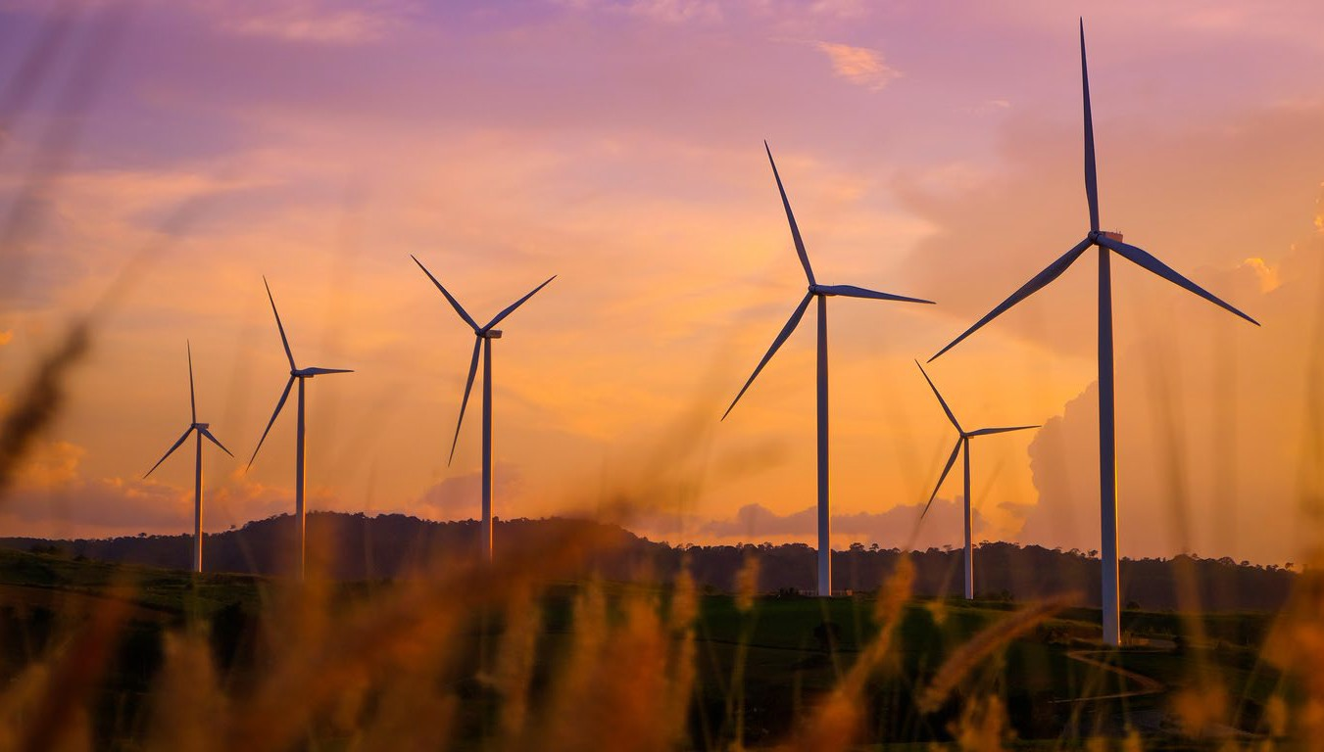
Table of Contents
Purpose 3
Climate and energy misinformation state of play 3
Misinformation narratives now focus on disruption, not denial 3
Misinformation narratives come from well-resourced actors 1
Misinformation thrives when people don’t have strong views 2
Many government agencies have roles addressing climate misinformation 3
The Authority’s role goes beyond expert advice to supporting a healthy information ecosystem 4
What we’re already doing 4
Building on our role as climate policy experts 4

Purpose
This paper explains how misinformation affects climate policy and what it means for the Climate Change Authority’s (the Authority’s) work.
This paper draws on evidence from the findings of the Select Committee on Information Integrity on

Climate Change and Energy1, independent research and engagement with misinformation experts in government, academia, industry, and the community sector.

Defining misinformation
For this paper, ‘misinformation’ is used as an umbrella term for misinformation (unintentionally false), disinformation (intentionally false) and malinformation (true information used with the intent to mislead).2 We have chosen misinformation as it is in common use. Experts often distinguish between the different terms.
While freedom of expression and debate are fundamental to democracy, these forms of information disorder can undermine informed public discussion and confidence in climate and energy policy.

Climate and energy misinformation state of play
Climate misinformation is already affecting how climate policy is delivered in Australia. It’s contributing to project delays, higher costs and community division.
Globally, misinformation is a recognised risk to policy delivery in complex transitions. It can distort public debate, amplify mistrust, create confusion and affect how people respond to change.3 Misinformation is a real delivery risk that can distort the policy environment before evidence is presented. It affects both policy on emissions reduction and preparedness for climate impacts.

1 Select Committee on Information Integrity on Climate Change and Energy, The Integrity Gap: Restoring Trust in the Climate and Energy Debate, 2026, accessed 22 July 2026.
2 D Balog-Way and K McComas, ‘Unpacking the Risk of Misinformation: A Communication-Based Critique’, 2025, accessed 28 July 2026, doi: 10.1111/risa.70093.

Misinformation narratives now focus on disruption, not denial
Climate misinformation in Australia has changed. Recent research1 shows it is increasingly focused on delaying or disrupting climate and energy action rather than denying climate change.
Common narratives seek to increase uncertainty about climate policies, technologies and solutions, focusing on:
- cost of living
- energy prices and reliability
- jobs
- regional impacts
- biodiversity and environmental impacts
- whether Australia’s action matters.

3 OECD, Facts not Fakes: Tackling Disinformation, Strengthening Information Integrity, OECD, 2024, accessed 22 July 2026.

This shift is consistent with international evidence.4 Simple, emotionally engaging and well-funded messages spread faster than detailed policy evidence. The result is an uneven playing field.
Misinformation is increasingly delivered through channels and formats designed to maximise reach and engagement. Short-form video, online influencers, coordinated social media activity and AI-generated content can communicate simple messages quickly and at scale. Emerging AI-powered search and chatbot tools are further growing exposure to inaccurate or misleading information where underlying sources are unreliable. Climate misinformation is increasingly intersecting with broader online communities built
around distrust of government and institutions. This expands the audience beyond people with a direct interest in climate, energy or specific projects.
The recent Senate inquiry heard that social media platforms can amplify misleading information because recommendation algorithms prioritise engagement rather than accuracy. Evidence presented to the inquiry also highlighted the use of coordinated online activity, including automated or inauthentic accounts, to spread misleading and false climate narratives. Together, these trends suggest climate misinformation is becoming more coordinated, more sophisticated and more capable of influencing public debate than in the past.

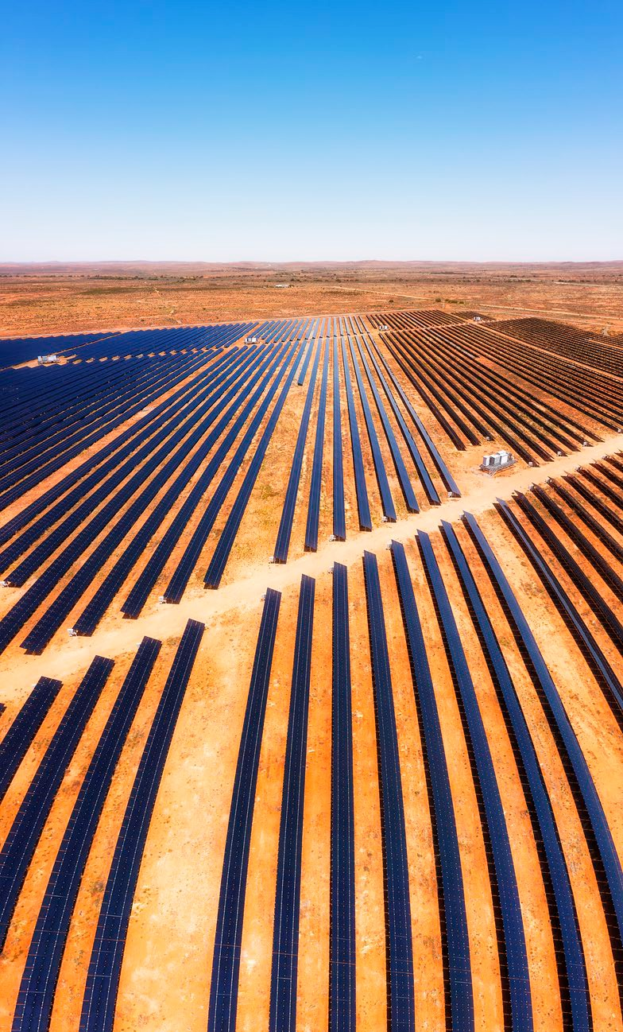

4 Center for Countering Digital Hate, The New Climate Denial, Center for Countering Digital Hate, 2024.

There’s more support for the energy transition than most people think
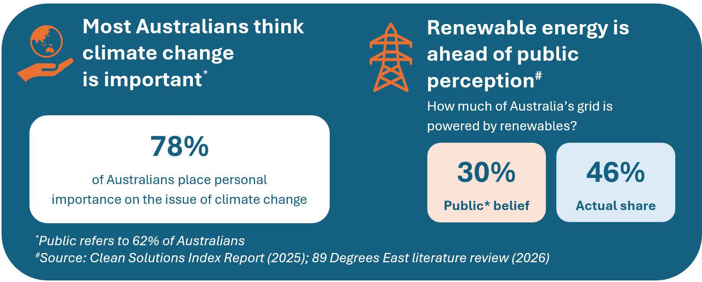

Misinformation narratives come from well-resourced actors
Some actors have more resources to shape public narratives than others. Recent research identified a diverse set of sources for climate and energy misinformation narratives1, including:
- industry and advocacy organisations
- think tanks
- online influencers
- campaign groups
- community-based opposition movements.
The Senate inquiry highlighted concerns about unclear funding sources, third party campaigns and the influence of well-resourced networks operating across multiple communication channels.

* 89 Degrees East, Misinformation audience literature review, report commissioned by the Climate Change Authority, 2026
# Clean Energy Solutions Index, ‘Bridging the "Perception Gap"’, 2025, Clean Energy Solutions Index, accessed 27 July 2026.

Misinformation thrives when people don’t have strong views
Misinformation often works by exploiting uncertainty. Many Australians accept climate change but are unsure about specific policies, technologies and local impacts.5 This uncertainty creates opportunities for misinformation to influence public opinion and policy debates. Roundtable participants noted that misinformation may reflect deeper community concerns around livelihoods, identity, values, regional development, visual impacts, trust and perceptions of fairness, rather than being the primary issue itself.
Reliable information is important, however, is rarely enough to change views or build support6. The Authority identified social acceptance as critical to achieving Australia’s climate targets.7
Evidence presented to the Senate inquiry suggests misinformation can exploit existing mistrust in institutions, increase community conflict and contribute to opposition to climate and energy projects. It can also contribute to delays, increased costs and reduced confidence in climate policy. Experts consulted for this paper reported growing concern that hostile rhetoric surrounding the energy transition is contributing to threats and intimidation directed at individuals and organisations involved in climate and energy issues.
Misinformation can also increase vulnerability to climate-related disasters by undermining preparedness, disrupting emergency response efforts and eroding trust in official sources of information during crises.
Following extreme weather events, misinformation can also hinder community recovery, resilience and social cohesion, amplifying the broader impacts of climate change.⁸

5 Australian attitudes toward the renewable energy transition, CSIRO, 2024
6 E Ebrahimi, ‘Climate Change Denial as Identity Defence: Understanding Resistance Beyond Ignorance’,
Environmental Management, 2025, 76(54), doi: 10.1007/s00267-025-02353-5; 89 Degrees East, Misinformation
audience literature review, report commissioned by the Climate Change Authority, 2026; Climate Change Authority (CCA), 2035 Targets Advice, Commonwealth Government, 2025, accessed 22 July 2026.
7 CCA, ‘Sector Pathways Review’, Commonwealth Government, 2024, accessed 22 July 2026; CCA, ‘Annual Progress Report’, Commonwealth Government, 2025, accessed 22 July 2026.
8 S Hilberts, M Govers, E Petelos, S Evers, ‘The Impact of Misinformation on Social Media in the Context of Natural Disasters: Narrative Review’, JMIR Infodemiology, 2025, 5, doi: 10.2196/70413; I Trijsburg and J Richardson, Australia
isn’t immune to disaster disinformation, The University of Melbourne website, 2024, accessed 27 July 2026.

Many government agencies have roles addressing climate misinformation
Climate misinformation is part of a broader challenge around information integrity that affects many policy areas. Effective responses require coordination across government, with different agencies contributing expertise, insights and actions within their respective mandates.

Multiple government agencies play an important role in responding to climate misinformation challenges, including the Department of Climate Change, Energy, the Environment and Water (DCCEEW), Net Zero Economy Authority (NZEA), Australian Energy Market Operator (AEMO), and the Australian Energy Infrastructure Commissioner. The Department of Infrastructure, Transport, Regional Development, Communications and the Arts also has a role in addressing broader misinformation and information integrity issues through its responsibilities for communications policy, the digital environment and media regulation. Addressing climate misinformation more broadly also extends beyond government, including universities, fact-checkers, researchers, civil society groups, community organisations, and climate-focused non-government organisations.

While existing efforts are significant, they are not always heard by the public as a clear, consistent story. This gap creates space for misinformation to spread.
Government is already investing in communication and engagement. Coordination is also improving. DCCEEW has formed a cross-agency communications and stakeholder engagement working group to support a more collaborative approach to addressing climate misinformation.
Focus areas for a more collaborative approach could include:
- developing a shared message framework across agencies
- linking national messaging with local engagement
- translating technical policy into practical explanations
- using audience insight and monitoring misinformation to identify risks
- resourcing further research into effective strategies for addressing misinformation
- establishing a whole-of-government rapid-response approach to climate and energy misinformation.
Better alignment would reduce uncertainty and limit the space for misinformation. Government also needs to embed engagement, communication and explanation into policy design and implementation, rather than treating them as a later or separate function.
Government could consider partnering with trusted local voices to provide clear information and resources, tailor messages to the needs and concerns of different communities, and to make local benefits more visible.
Greater investment is also needed in the social infrastructure of the transition alongside new energy infrastructure. Involving communities in decisions, sharing benefits fairly and supporting co-ownership models can increase local support and reduce the influence of misinformation.

The Authority’s role goes beyond expert advice to supporting a healthy information ecosystem

What we’re already doing
The Authority’s chief role is to provide independent expert advice to the Australian Government on setting and tracking Australia’s climate targets, fast-tracking emissions reduction, and helping Australia prepare for and adapt to climate change impacts. Through our legislated reviews of major climate policies and independent research, we are already contributing to the evidence base to support the climate information ecosystem. Our nuclear pathway report9 is an example of how independent, evidence-based analysis can help improve information integrity by clarifying complex issues, testing competing claims and supporting informed public discussion about contested policy choices.

Building on our role as climate policy experts

Advise the Australian Government on climate policy threats
The Authority will use its Annual Progress Advice as a flagship mechanism for identifying climate misinformation risks and assessing how they may affect climate policy delivery. This approach builds on the social license recommendation from our 2025 advice, 10 and may include:
- perceptions of opposition being greater than reality
- debunking top climate myths
- case studies on how climate misinformation threatening policy delivery has been overcome
- mapping Australia's climate information ecosystem to identify emerging risks, gaps and opportunities for collaboration.

Act as wholesaler of climate policy information
Our independence sets us apart. It is particularly important given low public trust in government and institutions compared to greater confidence in scientific experts.11 The Authority does not run public campaigns. However, we can support and empower others by providing high-quality information, including to the media and trusted local messengers.
Experts consulted for this paper identified a demand for clear, trusted and reusable climate information that they could draw on in conversation and engagement with their communities.

9 CCA, ‘Assessing the impact of a nuclear pathway on Australia’s emissions’, Commonwealth of Australia, 2025, accessed 22 July 2026.
10 CCA, ‘Annual Progress Report’, Commonwealth of Australia, 2025, accessed 22 July 2026.
11 Ipsos, ‘IPSOS Climate Change Report 2024’, Ipsos, 2024, accessed 27 July 2026.

As “wholesalers” of reliable information, we could provide clear, plain-English explainers of complex issues on system reliability, costs and trade-offs, supported by practical and positive examples. In focusing on the broader energy transition and climate impacts, we would complement rather than duplicate community and project-level engagement undertaken by others.

Supporting a healthier climate information ecosystem
Building on our Engagement Strategy, we are improving climate information integrity through:
- Speaking opportunities including conferences, media appearances and industry forums. These platforms provide opportunities to raise awareness of climate misinformation, share evidence and insights, connect stakeholders, and support informed discussion on solutions that strengthen understanding of the climate and energy transition.
- Network coordination, leveraging our role in the Australian Climate Councils Network (ACCN) and membership of the International Climate Councils Network (ICCN). These relationships give us further opportunities to share evidence, monitor emerging misinformation trends and identify international and local best practice on information integrity and climate communication.
- Engagement with intermediaries to determine what kind of information, formats and channels are useful for explaining the evidence behind climate policy to different communities.
- Targeted digital content, using an audience-first approach to translate complex climate and energy issues into accessible and shareable content. This could include explainers, myth-busting content, short-form videos12 and other formats designed to help intermediaries communicate evidence-based information through their own networks and channels.
- Research and monitoring, drawing on our analytical capabilities and stakeholder networks to identify emerging misinformation narratives, information gaps and areas of public uncertainty that may affect climate policy delivery, adaptation efforts and community preparedness.
Looking ahead, the Authority will seek to play an active role in strengthening Australia's climate information ecosystem. Through our advice, research, engagement and networks, we will continue to identify emerging risks and opportunities for practical action to support informed decision-making and effective climate policy delivery. We will also regularly review and refine our approach to ensure it remains responsive to emerging evidence, stakeholder needs and changes in the information environment.

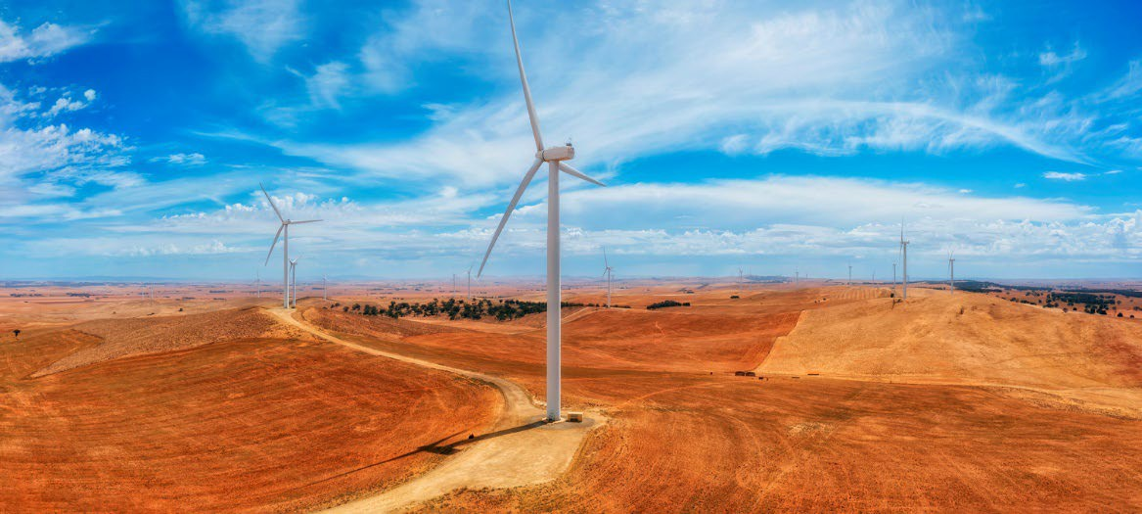

12 The Authority trialled 2 short-form videos on the energy transition earlier this year that received higher engagement than other posts: https://www.instagram.com/p/DZMVv_go1sU/ and https://www.instagram.com/p/DXaoCPECC4x/




