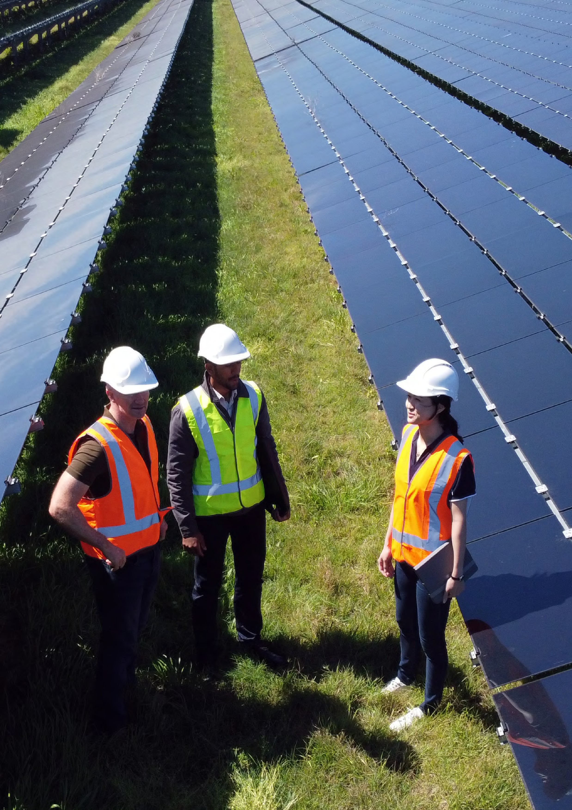

Engagement
Strategy

2026-29

Ownership
Published by the Climate Change Authority www.climatechangeauthority.gov.au
Copyright © Commonwealth of Australia 2026
ISBN: 978-0-6486349-5-9

Creative commons licence

With the exception of (a) the Climate Change Authority photos and graphics; (b) content supplied by third parties; (c) content otherwise labelled copyright in this publication is licensed under a Creative Commons BY Attribution 4.0 International licence.

Attribution
Use of material contained in this publication under a Creative Commons BY Attribution 4.0 International licence requires you to attribute the work (but not in any way that suggests that the Commonwealth endorses you or your use of the work). Provided you have not modified or transformed the publication in any way including, by changing text; calculating percentage changes; graphing or charting data; or deriving new statistics from published Commonwealth statistics – then the Commonwealth prefers the following attribution: Commonwealth of Australia (Climate Change Authority) 2024.
Further information on the licence terms is available from https://creativecommons.org/licenses/by/4.0.

Derivative material
If you have modified or transformed material contained in this publication, or derived new material from that material in any way, then the Commonwealth prefers the inclusion of the phrase
“This work is a derivative of” prior to the attribution.

Third party copyright
Wherever a third party holds copyright in material presented in this publication, the copyright remains with that party.

Accessibility
The authority makes its documents and information available in accessible formats. If you have problems accessing the document, please contact us at Climate Change Authority or phone 1800 475 869.

IMPORTANT NOTICE – PLEASE READ
This strategy sets the Authority’s engagement purpose. It explains our goal, priorities, how we approach engagement, who we engage and what people can expect when engaging with us.
Climate change affects every community, region and sector across Australia – and policy responses are often debated and contested. This strategy reflects the Authority’s new outcome statement to provide expert advice to the Australian Government and engage with the community on Australia’s climate change targets, policies and progress.


The Authority recognises the First Nations people
of this land and their ongoing connection to culture
and country. We acknowledge First Nations people
as the Traditional Owners, Custodians and

Lore Keepers of the world’s oldest living cultures,
and pay our respects to their Elders.

Who we are
The Climate Change Authority is an independent statutory body established under the Climate Change Authority Act 2011. Our role is to provide expert advice to the Australian Government and engage with the community to guide Australia towards a prosperous, resilient and decarbonised future.
The Authority is made up of a Chair, Australia’s Chief Scientist, and up to 7 other members. The Authority’s work is supported by a dedicated secretariat, with expertise in science, economics, policy and community engagement.

What we do
- Advice to the Government on setting and tracking Australia’s climate targets, fast-tracking emissions reduction, and helping Australia prepare for and adapt to climate change impacts.
- Legislated reviews of major climate policies, like the Australia Carbon Credit Unit Scheme, and the National Greenhouse and Energy Reporting Scheme, which includes the Safeguard Mechanism.

- Independent research that supports our advice and highlights areas where action could help Australia move toward a more successful, cleaner, low-emissions future.

Why we engage
We engage stakeholders because better conversations lead to better climate policy.
Our goal is to be a trusted voice and an influential leader in climate policy. To get there, we will focus on 2 priorities:
- Sharper climate policy advice – Engaging with stakeholders to strengthen the quality, relevance and credibility of what we bring to government
- Broader influence – Helping shape Australia’s climate policy conversation towards a prosperous, resilient, net-zero future.
The Authority is required by legislation to consult publicly on all legislated advice it provides to the Australian Government. Stakeholder engagement and participation in the Authority’s work is fundamental to earning trust and navigating complexity.

Engagement to strengthen the quality, relevance and credibility of our climate policy advice
Engagement builds a shared understanding of the challenges and opportunities of responding to climate risk. It provides insight into how specific policy options are likely to operate in practice, strengthening the quality and relevance of our recommendations to Government. Insights gathered through engagement are:
- reflected in our reviews, reports and recommendations
- used to test assumptions and stress test policy options
- drawn on to highlight regional, sectoral and community experiences and opportunities.
We will continue to communicate how engagement has informed our work, where stakeholder input has been considered and where it has influenced outcomes.

Engagement to assist in shaping Australia’s climate policy conversation towards a prosperous, resilient, net-zero future
Ambitious climate action is increasingly limited by social licence, not technological or economic feasibility. We are operating in an increasingly fragmented information environment, where misinformation and conflicting claims are more common.
The Authority plays a critical role in providing independent, credible evidence of the facts about Australia’s transition to a prosperous, resilient, net-zero future. We will engage to provide reliable information about the challenges and opportunities, and the progress Australia is making. We are committed to strengthening public understanding and supporting informed discussion on climate policy, with a focus on policy areas that are critical to achieving emissions reduction targets.

Who we engage
The Authority engages widely to reflect the full range of experiences, knowledge and perspectives across Australia, supporting well informed and credible advice to the Australian Government. We engage with communities, industry, advocacy groups, experts and research institutions, to ensure our advice is informed by lived experience, regional realities and diverse perspectives, alongside robust evidence and expert analysis.
We also engage with governments at the federal, state and territory, and local levels, and with international counterparts. This supports stronger coordination across jurisdictions and improves shared understanding of how our work fits within broader domestic and global climate policy efforts.

First Nations engagement
We shine a light on First Nations voices in our
climate policy advice. We are committed to
engaging with First Nations peoples in ways
that strengthen Australia’s response to climate
change and support policy that advances
prosperity, resilience and equity for First
Nations communities. Our approach is guided
by the principles of free, prior and informed
consent (FPIC), respectful and meaningful
participation, and self-determination, with a
focus on building lasting trust.
We recognise that respectful and effective
engagement with First Nations peoples
requires ongoing learning, accountability and
improvement, and a deep appreciation of the
diversity of First Nations communities. We
are committed to reflecting on our approach,
listening to feedback, and strengthening how
engagement informs advice.
CLIMATE CHANGE AUTHORITY
|
ENGAGEMENT STRATEGY 2026-29

|
6

How we engage
We recognise that meaningful engagement goes beyond consultation. It involves listening, learning, sharing information, being genuine, being open and maintaining relationships over time.
We engage at all levels across the Authority. Authority members leverage their significant experience, knowledge and standing to engage stakeholders and contribute to shaping national climate policy.
We apply best-practice engagement principles, aligned with the APS framework for engagement and participation and the Climate Change Authority’s values.

Our stakeholder engagement theory of change
The connection between the Authority’s outcome and stakeholder engagement enablers, activities, products and goal is set out in the Authority’s stakeholder engagement theory of change at Figure 1.


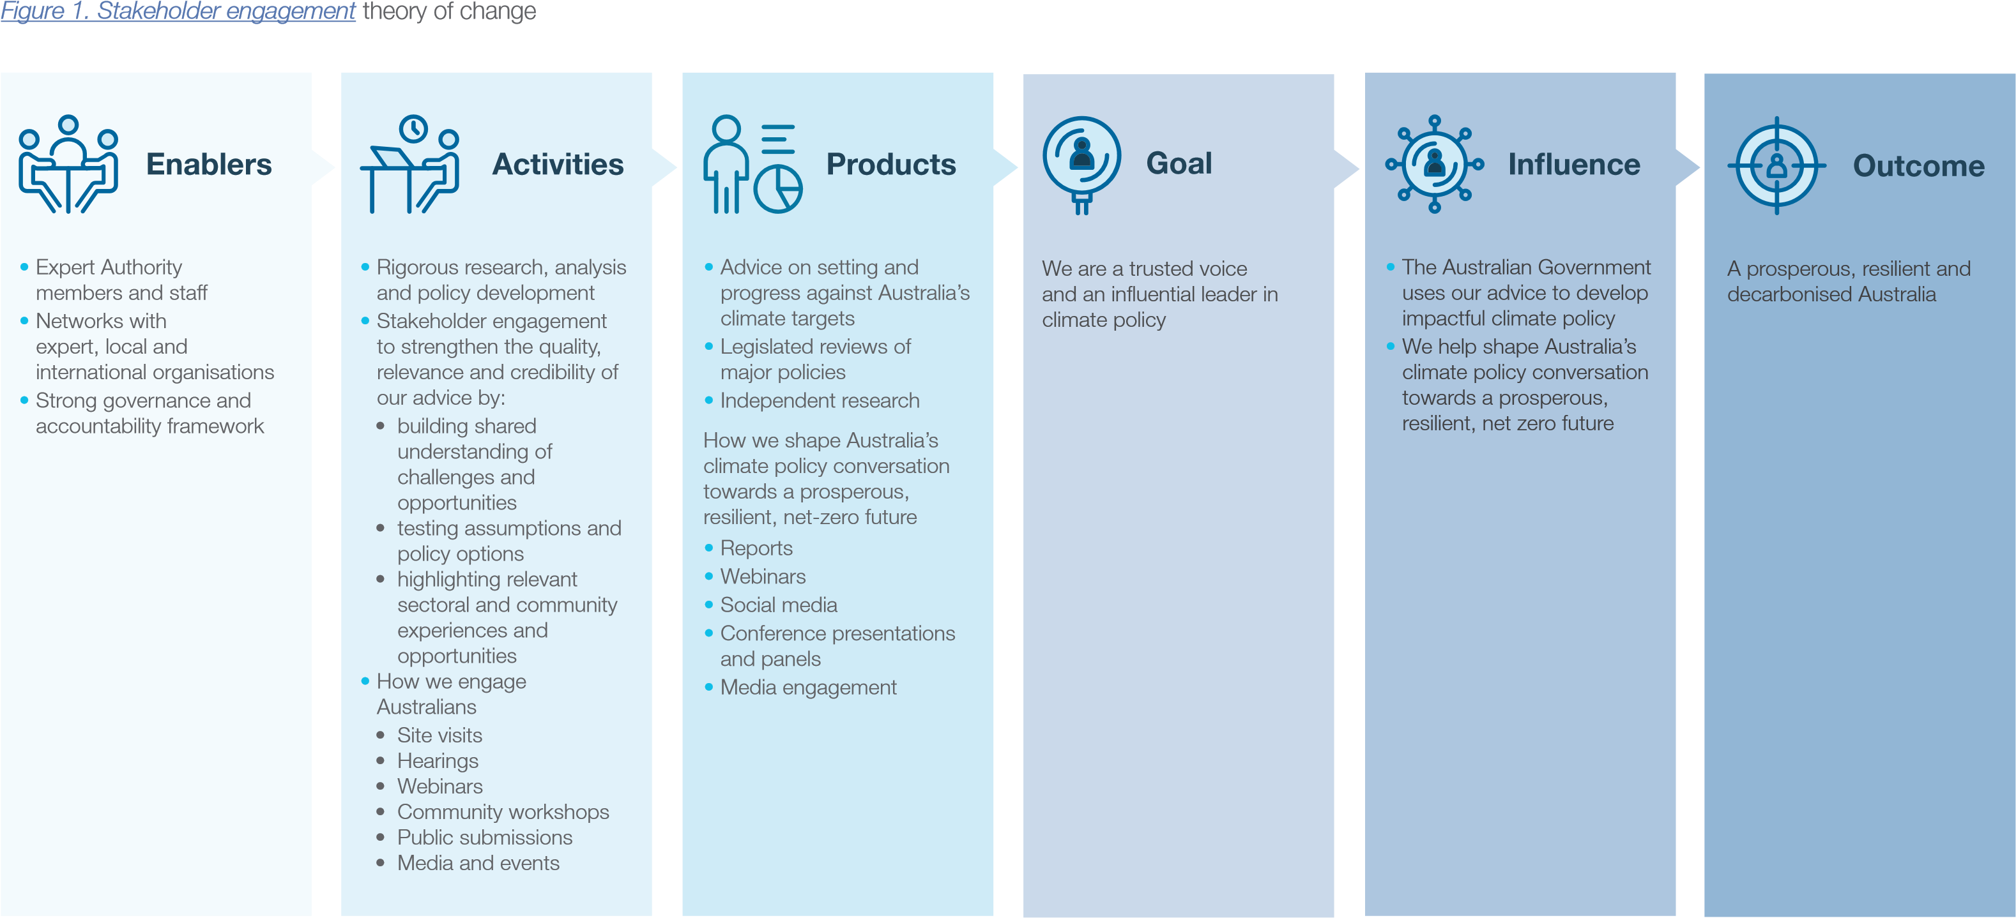
CLIMATE CHANGE AUTHORITY | ENGAGEMENT STRATEGY 2026-29 | 8

Measuring progress
We are committed to learning and continually improving our engagement approach. Measuring engagement progress is embedded in the Authority’s performance framework, with results included in our annual report.

Opportunities to engage
To learn more about our work and explore ways to get involved, visit our website, get in touch with us directly, or take part in our consultations.
- Website: Homepage | Climate Change Authority
- Consultation Hub: Have your say
- Email: enquiries@cca.gov.au
- Phone: 1800 475 869
You can also subscribe to our newsletter, On Good Authority, to receive the latest climate news and updates on our work.
Follow us on LinkedIn, Instagram and Facebook for Authority updates.

The Authority recognises the First Nations people of this land and their ongoing connection to culture and country. We acknowledge First Nations people as the Traditional Owners, Custodians and Lore Keepers of the world’s oldest living cultures, and pay our respects to their Elders—past and present.

CLIMATE CHANGE AUTHORITY
|
ENGAGEMENT STRATEGY 2026-29

|
10

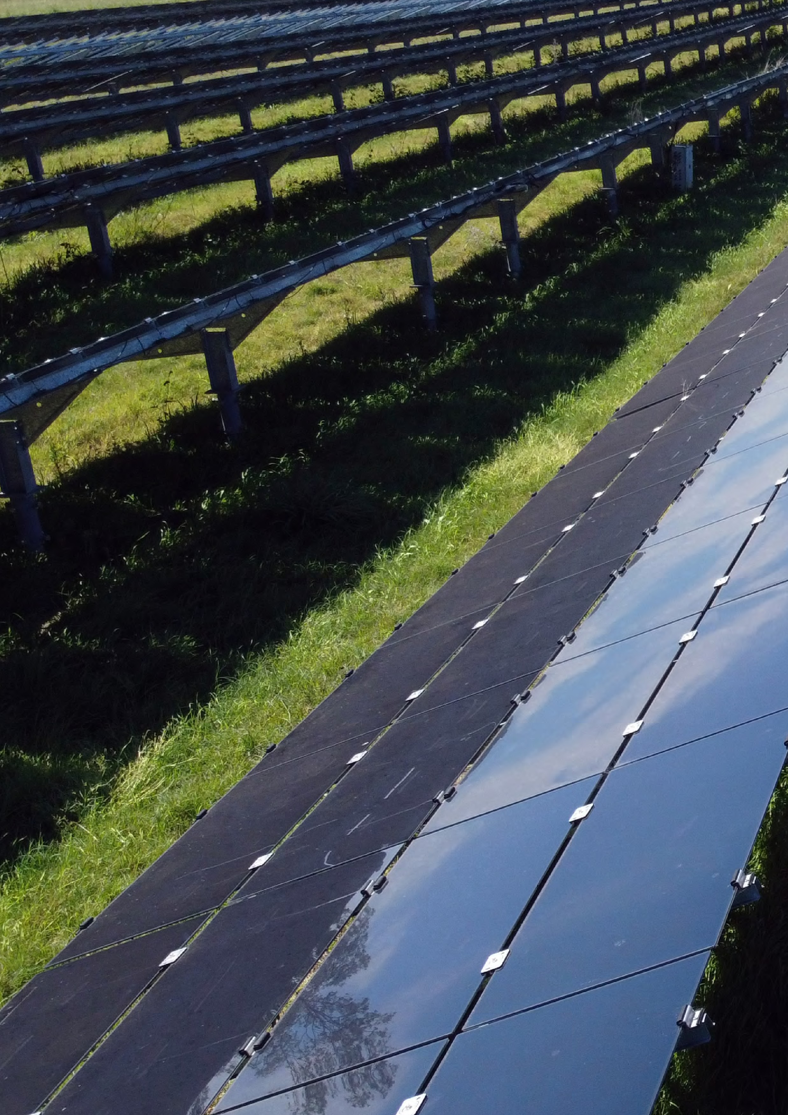

CLIMATE CHANGE AUTHORITY
|
ENGAGEMENT STRATEGY 2026-29

|
11

