2026
Review of the Carbon Credits
(Carbon Farming Initiative) Act 2011
Enhancing the stability and integrity of the Australian Carbon Credit Unit Scheme







September 2026

Ownership
Published by the Climate Change Authority www.climatechangeauthority.gov.au
Copyright © Commonwealth of Australia 2026 ISBN: 978-1-7641783-8-9
Creative commons licence


With the exception of (a) the Climate Change Authority photos and graphics; (b) content supplied by third parties; (c) content otherwise labelled, copyright in this publication is licensed under a Creative Commons BY Attribution 4.0 International licence.
Attribution
Use of material contained in this publication under a Creative Commons BY Attribution 4.0 International licence requires you to attribute the work (but not in any way that suggests that the Commonwealth endorses you or your use of the work). Provided you have not modified or
transformed the publication in any way including, by changing text; calculating percentage changes; graphing or charting data; or deriving new statistics from published Commonwealth statistics – then the Commonwealth prefers the following attribution: Commonwealth of Australia (Climate Change Authority) 2026.
Further information on the licence terms is available from https://creativecommons.org/ licenses/by/4.0.
Derivative material
If you have modified or transformed material contained in this publication, or derived new material from that material in any way, then the Commonwealth prefers the inclusion of the phrase ‘This work is a derivative of’ prior to the attribution.
Third party copyright
Wherever a third party holds copyright in material presented in this publication, the copyright remains with that party.
Accessibility
The Authority makes its documents and information available in accessible formats.
If you or someone you know has trouble accessing this document, please contact us at: enquiries@cca.gov.au or phone 1800 475 869.
Artificial intelligence
Artificial intelligence was used to assist in preparing this report in accordance with the Climate Change Authority’s Artificial Intelligence Transparency Statement. All AI-assisted content was subject to human review and verification.
IMPORTANT NOTICE – PLEASE READ
This document is produced to fulfil the Climate Change Authority’s statutory role and is otherwise made available for general information only. It does not represent a statement of the policy of the Commonwealth of Australia. This report does not constitute personal financial, legal or other professional advice. Users should obtain any appropriate independent professional advice relevant to their particular circumstances. The Commonwealth and all persons acting for it preparing this report accept no liability for the accuracy of, or inferences from, the material contained in this publication, or for any action or omission as a result of any person’s or group’s interpretations, deductions, conclusions or actions in relying on this material. The Commonwealth is not liable for any loss caused, howsoever arising, from the use of, or reliance on, the information provided through this report.

Version | Date | Changes
1.0 | 01/09/2026 | Initial publication
2.0 | 07/09/2026 | Small correction to page 42

Artwork on opposite page
Natalie L. Simmons (2023) Birrang (Wiradjuri for journey)



The Authority recognises the First Nations people of this land and their ongoing connection to culture and Country.

We acknowledge First Nations people as the Traditional Owners, Custodians and Lore Keepers of the world’s oldest living cultures, and pay our respects to their Elders.



The Hon Chris Bowen MP
Minister for Climate Change and Energy House of Representatives
Parliament House CANBERRA ACT 2600

Dear Minister
GPO Box 3090, Canberra ACT 2601
1800 475 869
Climatechangeauthority.gov.au

In accordance with section 306 of the Carbon Credits (Carbon Farming Initiative) Act 2011 (the Act), I am pleased to provide to you the report of the Climate Change Authority’s 2026 review of the Australian Carbon Credit Unit (ACCU) Scheme on behalf of Authority members.

The ACCU Scheme remains an integral part of Australia’s policy response to climate change. It supports emissions reduction and carbon storage across the economy, and helps Australian industry contribute to the national mitigation effort by providing flexibility in the Safeguard Mechanism. Our public consultation clearly indicated that stable and predictable policy settings are essential to encourage the large-scale, long-term investment needed for the scheme to operate well.

The Authority finds the scheme remains fundamentally sound. The report makes six targeted recommendations to further strengthen confidence in and the operation of the scheme. These complement the reforms the Government is currently progressing in response to our previous reviews.


As required by section 306(3) of the Act, the Authority will publish a copy of this report on its website. Yours sincerely

Kath Rowley
Chief Executive Officer 27 August 2026



Acknowledgements
The Climate Change Authority would like to thank the many individuals and organisations who contributed time and expertise to this review, including those who provided formal submissions and participated in consultation. The Authority received public submissions related to the ACCU Scheme Review from:

AgriProve Alinta Energy ANU
ANZ Biochar Industry Group Ltd Australian Academy of Technological Sciences & Engineering
Australian Climate and Biodiversity Foundation Australian Dairy Farmers Australian Energy Producers Australian Financial Markets Association
Australian Industrial Hemp Alliance
Australian Industry Greenhouse Network
Australian Land Conservation Alliance
Australian Pork Limited BeZero Carbon
Biocare Projects Pty Ltd BP Australia
Business Council of Australia Carbon Asset Solutions Carbon Market Institute Cattle Australia
Carbon Capture Utilisation and Storage Network Australia
Chamber of Minerals and Energy WA
Chevron Australia
Citizens’ Climate Lobby, Australia Climate Energy Finance
Climate Friendly Climate Integrity Climateworks Centre Corporate Carbon CS Energy Limited Dac Labs
Environmental Defenders Office Environmental Defense Fund FarmN
Fortescue
Future Energy Exports CRC Future Group
Future Smart Strategies GHG Offset Services GreenCollar
Greenpeace Australia Pacific International Emissions Trading Association
Indigenous Carbon Industry Network
INPEX
Kimberley Land Council LGI Ltd
Macdoch Australia
Nature Solutions Consultancy NextFarm Pty Ltd, NSW NRM Regions Australia Orange New Energy and Oil Mallee Association Australia Origin Energy
Private Forests Tasmania Rumin8
Shell Energy
Smart Energy Council
South Australian Dairyfarmers Association
South Pole Australia
The Australasian Railway Association
The Carbon Store Pty Ltd The Nature Conservancy The Superpower Institute Viridios Capital
Waste Management and Resource Recovery Association of Australia
Woodside Energy

Andrew Pitman Peter Jansson Tim Kelly

The Authority also received 19 confidential submissions.

We are grateful to the First Nations people and organisations that took the time to speak with us and share their knowledge and perspectives, and to IPS Management Consulting for providing guidance. These contributions have improved the quality of the review and provided evidence to help inform our recommendations.

The Department of Climate Change, Energy, the Environment and Water, the Clean Energy Regulator and other Government agencies also provided valuable input. The views expressed in the review are the Authority’s own and should not be taken as the views or positions of any of the entities listed.

Table of contents

Legislative references 8
Summary 9
Recommendations 14
Introduction 17
Previous reviews and reforms underway 17
Approach to this review 17
Scope of this review 17
How this report is structured 18
Theme 1: ACCU Scheme’s role in achieving Australia’s target 20
  - The ACCU Scheme is now part of a suite of policies 21
  - Activities well suited to the ACCU Scheme 22
  - How the ACCU Scheme interacts with the Safeguard Mechanism 24
  - What ACCU supply means for Australia’s targets 24
  - Land sector abatement potential is greater than likely safeguard demand for ACCUs 26
  - Avoiding double counting and supporting credible carbon claims 26
Theme 2: Permanence, durability and scheme confidence 28
  - Assessing current permanence settings 29
  - ACCUs from 25-year projects are used for safeguard compliance 30
  - Project proponents’ obligations end after permanence period is complete 32
  - Permanence settings warrant consideration 34
Theme 3: Participation, equity and public benefits 36
  - ACCU projects can deliver broader public benefits 38
  - First Nations participation is central to the scheme’s public value 40
  - Regional and rural participation depends on trusted advice and capability 43
  - Regional planning can help align ACCU projects with local priorities 44
  - Nature Repair Market interaction creates opportunities and integrity questions 45
Theme 4: Market settings and investment confidence 46
  - The ACCU market is shaped by policy 47
  - Supply, demand and price outlooks are uncertain and contested 48
  - Policy settings involve trade-offs 52
  - Better transparency and registry functionality would support confidence 54
  - Land-use trade-offs need monitoring beyond the ACCU Scheme 55
Theme 5: Method development 60
  - Method development as a supply-side lever 62
  - Risk-based triggers for method reviews 65
  - A roadmap would provide clearer strategic visibility 66
  - Improving method development capacity and delivery 67
References 69
Appendix A: Assessment of costs and benefits 73
Appendix B: Background on the ACCU Scheme 76
Appendix C: Status of recommendations from recent ACCU Scheme reviews 81
Appendix D: ACCU Scheme methods 86

List of figures
Figure 1.1: Evolution of the ACCU Scheme 21
Figure 1.2: Illustrative sector contributions to a 70% reduction on 2005 levels by 2035 21
Figure 2.1: ACCU sequestration project registrations 30
Figure 2.2: ACCUs issued to sequestration projects 30
Figure 2.3: Permanence periods for ACCUs surrendered and in holdings 31
Figure 4.1: ACCU surrenders, cancellations and delivery to Government 47
Figure 4.2: ACCU supply, demand and private holdings 48
Figure 4.3: Projected ACCU issuance from registered and new projects 49
Figure 4.4: ACCU holdings by participant type 50
Figure 4.5: ACCU project registrations and issuance by method 50
Figure 4.6: ACCU project areas overlaid on land-use type 57
Figure 4.7: Project areas and carbon estimation areas in northwest NSW 58
Figure 5.1: Existing, recently expired and anticipated new ACCU methods 63
Figure B.1: ACCU legislative framework 77
Figure B.2: Governance structure and roles 78

List of boxes
Box 1.1: ACCU Scheme suitability characteristics: illustrative application 23
Box 1.2: How the Safeguard Mechanism and ACCU Scheme contribute towards the national target 25
Box 2.1: Permanence and durability under the ACCU Scheme 29
Box 2.2: Interaction between the ACCU Scheme, the Safeguard Mechanism and permanence 33
Box 3.1: Case study: Queensland’s Land Restoration Fund 39
Box 3.2: Case study: First Nations traditional knowledge, savanna fire management and carbon 41
Box 3.3: Case study: Bonnie Doone Soil Carbon Project 43
Box 5.1: How ACCU methods are developed 61
Box 5.2: Why some engineered removals are not yet eligible under the ACCU Scheme 64
Box B.1: Objects of the CFI Act 76
Box B.2: Integrity measures in the scheme 80
List of tables
Table 4.1: Policy options and potential market effects 47
Table 4.2: Proportion of current ACCU project area by land-use type 48
Table A.1: Potential costs and benefits of recommendations 73

Glossary

Acronym/term | Meaning
Abatement | A reduction in atmospheric greenhouse gases through emissions avoidance or removal and sequestration of carbon from the atmosphere.
ABARES | Australian Bureau of Agricultural and Resource Economics and Sciences The research arm of the Australian Government Department of Agriculture, Fisheries and Forestry.
ACCU | Australian Carbon Credit Unit  One Australian carbon credit unit represents one tonne of verified carbon dioxide equivalent abatement. ACCUs are created from eligible offsets projects and issued by the Clean Energy Regulator in accordance with section 147 of the Carbon Credits (Carbon Farming Initiative) Act 2011 (CFI Act).
ACCU project | Eligible offsets project registered under the ACCU Scheme.
Baseline | An annual limit on the net amount of greenhouse gases a safeguard facility can emit without incurring a compliance obligation.
CAIC | Carbon Abatement Integrity Committee  The replacement for the Emissions Reduction Assurance Committee under proposed legislative amendments (Carbon Credits and Other Legislation Amendment [Integrity and Transparency] Bill 2026).
CER | Clean Energy Regulator  Commonwealth statutory authority that administers regulatory schemes relating to climate and clean energy, including the Renewable Energy Target, the National Greenhouse and Energy Reporting scheme, and the ACCU Scheme.
CFI | Carbon Farming Initiative  The Australian carbon credit unit scheme first created by the Carbon Credits (Carbon Farming Initiative) Act 2011, also called the ACCU Scheme.
CFOP | Carbon Farming Outreach Program  Australian Government program that supports Australian farmers and land managers, including First Nations land managers, to explore options for managing emissions and storing carbon, and participate in carbon markets.
Chubb Review | Independent Review of ACCUs (2022) commissioned by the Australian Government and led by Professor Ian Chubb.
CO2-e | Carbon dioxide equivalent  The amount of carbon dioxide emissions that would have an equivalent effect on a specified key measure of climate change, over a specified time horizon, as an amount of another greenhouse gas or a mixture of other greenhouse gases.
Crediting period | In relation to an ACCU project, the length of time the project is eligible to be issued ACCUs.

Acronym/term | Meaning
DCCEEW | Department of Climate Change, Energy, the Environment and Water Australian Government department leading Australia’s response to climate change and sustainable energy use, and protecting Australia’s environment, heritage and water.
Double counting | Counting or claiming the same emissions reduction, removal or environmental outcome more than once (for an equivalent purpose).
Eligible interest holder | A person or body with legally recognised interests in land whose consent may be required before certain ACCU projects can proceed.
ERAC | Emissions Reduction Assurance Committee  The independent statutory committee that assesses whether ACCU methods meet the Offsets Integrity Standards and advises the Minister.
Environmental offset | An action or credit used to compensate for environmental impacts other than greenhouse gas emissions, such as biodiversity loss from development.
ERF | Emissions Reduction Fund  A scheme resulting from the expansion of, streamlining and other changes to the Carbon Credits (Carbon Farming Initiative) Act 2011, in December 2014. The ERF involved purchases of ACCUs by the Government. It transitioned to the ACCU Scheme in 2022.
EOI | Expression of interest  A formal initial submission proposing a new or varied ACCU method for assessment and possible prioritisation.
FPIC | Free, Prior and Informed Consent  A process for obtaining consent that involves genuine inclusion, disclosure and respect for First Nations peoples. The three elements (free, prior and informed) are the requirements for this consent.
HIR | Human-induced regeneration  A method to regenerate native forests by introducing new land management practices, expired in 2023.
IFLM | Integrated Farm and Land Management  Proposed method to allow multiple activities that store carbon in the land to occur on a single property.
Insetting | Undertaking emissions reduction or sequestration projects or activities to compensate for emissions within an entity’s own value chain or operations.
kt | Kilotonne or thousand tonnes.
Method | The detailed rules for an ACCU project type, including eligible activities, how abatement is calculated, and monitoring and reporting requirements.
Mt | Mega or million tonnes.
Nature Repair Market | National, legislated biodiversity market designed to deliver high-integrity biodiversity outcomes and increase investment in nature.
NRM | Natural Resource Management  The coordinated stewardship of environmental assets like land, water, soil, plants and animals.

Acronym/term | Meaning
OIS | Offsets Integrity Standards  Legislated criteria under the Carbon Credits (Carbon Farming Initiative) Act 2011 that all ACCU methods must meet.
Permanence period | Legislated requirement to maintain stored carbon for a specified period of either 25 or 100 years under the ACCU Scheme.
Permanence period discount | A reduction in ACCUs issued from projects with a 25-year permanence period, typically 20%.
Project proponent | The person or organisation responsible for running an ACCU project and meeting scheme obligations.
QCMR | Quarterly Carbon Market Report  Source of data on Australia’s carbon markets providing a view of supply and demand across the schemes administered by CER.
Relinquishment | The surrender and cancellation of ACCUs by a person to meet a requirement or obligation under the CFI Act, including in circumstances where ACCUs have been issued through provision of false or misleading information, a sequestration project that has been issued ACCUs is being revoked, carbon stores have not been restored after a natural disturbance, or there has been a deliberate reversal of carbon stores.
Risk of reversal buffer | The portion of a project’s carbon credits that is held back in case some of the stored carbon is later released, for example, because of fire, clearing or damage to vegetation.
SFM | Savanna fire management  Land management practice based on First Nations knowledge and modern science that reintroduces early-season controlled fire burning and reduces the frequency and severity of fires in the late dry season.
SMC | Safeguard Mechanism credit  An SMC represents one tonne of carbon dioxide equivalent (t CO2-e) emissions below a facility’s baseline.
Stacking | Generating more than one type of environmental product or claim from related activities on the same land, such as ACCUs and nature repair certificates.
Surrender | The surrender of ACCUs and SMCs is an option available to a facility covered by the Safeguard Mechanism to manage excess emissions. When units are surrendered in a period, the facility’s net emissions number for that period is reduced by the number of ACCUs and SMCs surrendered.
Voluntary cancellation | The act of cancelling an ACCU in the Unit and Certificate Registry on a voluntary basis, typically to offset greenhouse gas emissions.

Legislative references
All legislation cited in this report is Commonwealth legislation unless otherwise indicated. Commonwealth legislation can be found on the Federal Register of Legislation: www.legislation.gov.au.

The following Commonwealth Acts and related instruments are cited in this report:
Australian National Registry of Emissions Units Act 2011
- Australian National Registry of Emissions Units Regulations 2011
- Australian National Registry of Emissions Units Rules 2023
Carbon Credits (Carbon Farming Initiative) Act 2011 (CFI Act)
- Carbon Credits (Carbon Farming Initiative) (Audit Thresholds) Instrument 2015
- Carbon Credits (Carbon Farming Initiative) Rule 2015
Clean Energy Regulator Act 2011
- Clean Energy Regulator Regulations 2018
Climate Change Authority Act 2011
Environment Protection and Biodiversity Conservation Act 1999 (EPBC Act)
National Greenhouse and Energy Reporting Act 2007 (NGER Act)
- National Greenhouse and Energy Reporting (Measurement) Determination 2008
- National Greenhouse and Energy Reporting (Safeguard Mechanism) Rule 2015




Summary

Summary

The ACCU Scheme is robust and helps deliver Australia’s emissions targets
The Australian Carbon Credit Unit (ACCU) Scheme remains an important and valuable part of Australia’s climate policy framework. The Climate Change Authority completed its last review of
the scheme in 2023, finding it was fundamentally well designed. This followed the Chubb Review, completed in 2022, which found the scheme was essentially sound. Both reviews recommended improvements to governance, transparency and integrity arrangements. Consequent reforms have strengthened the scheme, and further legislative reforms are underway. The Authority believes these reforms should be given time to mature.
This 2026 review therefore does not recommend major changes. Policy stability and predictability will improve the operation of the scheme. The Authority has instead focused on residual
gaps and practical improvements. The recommendations address permanence, public value, transparency and method development. While the scheme remains fundamentally sound, the shift from Government purchasing to safeguard compliance as the main source of
ACCU demand makes permanence a significant strategic issue warranting further assessment.
The permanence recommendations propose the Government assess whether current settings remain appropriate given this changing context and increasing risks from climate and reversal events. The remaining recommendations aim
to strengthen participation, transparency and confidence in the scheme.
The scheme’s role has changed significantly. From 2014 to 2022, it was Australia’s main emissions reduction policy, underpinned by large-scale Government purchasing through the Emissions Reduction Fund. With the major policy reforms
of the past 4 years, it now operates as part of a portfolio of measures, targeting emissions reduction and sequestration opportunities not
effectively covered by the Safeguard Mechanism, efficiency standards and other policies. Safeguard facilities have replaced Government as the main source of ACCU demand. These facilities can surrender ACCUs to help meet their baselines, alongside reducing their onsite emissions and other options. This makes ACCUs important for compliance flexibility, cost containment and

private investment in emissions reductions and removals. A robust, credible offset market allows Australia to set and meet ambitious emissions reduction targets.

ACCUs support targets in different ways
The ACCU Scheme contributes to meeting Australia’s emissions reduction targets in several ways. Voluntary and government demand for ACCUs makes a direct contribution towards meeting Australia’s national targets, over and above the reductions driven by the Safeguard Mechanism. Further, by stimulating innovation and take-up of cleaner technologies, the scheme can help make some low-emission practices ‘business as usual’ over time, delivering emissions reductions long after crediting for early adopters ends.
The scheme also makes an indirect contribution by allowing safeguard facilities to draw on abatement beyond their own operations. This flexibility can reduce compliance costs, help facilities manage the timing and availability of onsite abatement,
and make ambitious baseline decline rates more feasible. For any given safeguard setting, ACCU supply to safeguard facilities does not by itself increase national abatement. Instead, it shapes where abatement occurs – that is, the mix of offsite abatement through ACCU projects and onsite reductions at safeguard facilities.
Nevertheless, stronger ACCU supply can help meet Australia’s targets where it supports stronger safeguard baseline settings.
The Authority believes the ACCU Scheme should play a targeted role in meeting Australia’s 2035 target. By subsidising eligible emissions reduction and sequestration activities, the scheme unlocks abatement that would not otherwise occur.
However, project-based crediting is not well suited to all abatement opportunities. Further, achieving net zero will require direct contributions from most or all emissions sources. Over time, Australia will need to rely more on measures that drive down emissions from all sources, including stronger Safeguard Mechanism settings, clean technology standards and other policies, and less on ACCU subsidies. Sequestration and carbon removal technology may remain well suited to crediting over the longer term with appropriate controls for risk of reversal.

While ACCU demand from the Safeguard Mechanism can support land sector abatement, anticipated safeguard demand falls well short of the land sector contribution identified in modelled net zero pathways. Additional policies are, therefore, likely to be needed to realise more of Australia’s land sector abatement potential.

Permanence should be reassessed in the current market context
The Authority has assessed the permanence settings of the ACCU Scheme, and recommends this as a key area for further Government review. The ACCU Scheme allows eligible sequestration projects to choose a 25-year or 100-year permanence period. Projects with
25-year permanence periods receive fewer ACCUs, generally through a 20% permanence period discount. This option was introduced in 2014 to encourage participation, particularly for landholders and others unable or unwilling to take on 100-year obligations.
The market context has changed since these settings were introduced. Safeguard compliance is now the main source of ACCU demand, and ACCUs are increasingly used to offset industrial emissions. Projects with 25-year permanence periods are increasing, and ACCUs from these projects are being used for safeguard compliance.
Project proponents are not required to maintain carbon stores beyond the nominated permanence period. This does not mean projects with 25-year permanence periods lack integrity. Removing and storing more carbon now helps slow warming sooner and lowers future climate risks. Where sequestration supports, rather than replaces, rapid emissions cuts it helps reduce the risk of reaching dangerous climate tipping points. However the Authority believes the growing role of ACCUs
from projects with 25-year permanence periods in safeguard compliance raises questions about durability that warrant further assessment.
The Authority reiterates its 2023 recommendation that the Government assess the risk of reversal buffer and permanence period discount, and complete and publish this assessment by the end of 2027. The Authority also recommends that, through its 2026-27 Safeguard Mechanism review, the Government assess whether ACCUs from projects with 25-year permanence periods provide sufficient durability for safeguard compliance.
The appropriate specific changes to the treatment of ACCUs from projects with 25-year permanence periods depend on an assessment of the discount and risk buffer, and the implications for
participation, ACCU supply, safeguard compliance costs and existing investments. These issues
are best considered through an assessment of the permanence settings and the Safeguard Mechanism review. As a result, the Authority has not recommended specific changes at this time.

Participation and public benefits matter for long-term public value
ACCU projects deliver benefits beyond emissions reductions. These benefits support First
Nations communities, biodiversity, soil health, landscape resilience, cultural outcomes, regional employment and community resilience. The broader advantages are not explicitly recognised or rewarded by the ACCU Scheme, although some buyers preference units from these projects and pay a premium for them.
First Nations participation is particularly important. The review finds that First Nations rights, interests and participation should be central to the ongoing design and evolution of the ACCU Scheme. First Nations organisations and communities have played a leading role in savanna fire management, demonstrating how ACCU projects can support cultural, environmental, social and economic outcomes. Recent Australian Government funding to support participation, and proposed reforms including stronger consent requirements, are important. However stakeholders continue to identify barriers, including information asymmetry, capability gaps, consent processes, benefit-sharing and access to trusted advice.
There are many areas in which government funding could accelerate decarbonisation, including through purchasing ACCUs. If the Government decides to purchase ACCUs, the Authority recommends prioritising projects which demonstrate strong public and First Nations benefits. Clear purchasing criteria and protections would be needed to ensure public benefits are genuine, verifiable, and not double counted, particularly where ACCU projects interact with
the Nature Repair Market or other natural capital initiatives.

Market confidence depends on transparency and predictable policy settings
Government policy creates and shapes the ACCU market. Supply depends on approved methods, project registration, crediting rules, permanence settings and issuance. Demand is increasingly shaped by safeguard settings, including baseline decline rates and rules for ACCU use.
Forecasts of ACCU supply, demand and prices are uncertain. Government projections provide an important reference case under current policy settings, but market participants and analysts
contend that future demand may be higher, supply may be slower to materialise, and existing ACCU holdings may not be readily available to the market. The Authority does not seek to provide its own forecast in this review. The relevant point is that divergent views of future market conditions are material for investment confidence and policy design. The Authority will continue to engage stakeholders on this issue to build a better shared understanding of the market.
Better information is a practical response. The Clean Energy Regulator (CER) and Department of Climate Change, Energy, the Environment and Water (DCCEEW) have already made important improvements to ACCU Scheme transparency, including additional project register information, and certificate and unit registry reforms. However, stakeholders continue to seek more accessible, comparable and reusable information on project performance, unit attributes, issuance, holdings
and transactions. Better information would support due diligence, price discovery, independent analysis and confidence in ACCU integrity.
The Authority recommends improving transparency by providing more information and making it more accessible. This includes clearer project-level and unit-level information, more usable data, and consideration of registry interoperability where this can be done while protecting privacy, commercial confidentiality, account integrity and fit-and-proper-person requirements.

Land-use concerns should be monitored in a broader transition context
Some stakeholders raised concerns that increasing ACCU demand could lead to excess conversion of agricultural land to carbon projects, with potential effects on food production,
regional employment and community identity. The Authority’s analysis of the current evidence does not indicate the ACCU Scheme has caused material conversion of high-value agricultural land at the national scale to date. As demand
for ACCUs grows, monitoring land-use change at national and regional levels will become increasingly important.
Australia’s land use continues to evolve in response to changing economic, policy,
technological and environmental conditions. Landholders respond to these changes by adapting land-use practices to maintain productivity and maximise land value. Climate change is expected to play an increasingly significant role in shaping future land-use decisions and patterns of land use across Australia.
Demand for land extends beyond carbon sequestration under the ACCU Scheme and includes renewable energy, transmission and storage infrastructure, nature repair, low-emissions fuel production and new industries, in addition
to the wide variety of existing uses. Effective monitoring can help identify emerging pressures, risks and opportunities, and inform Government and market decisions. The Authority will consider these broader land-use trade-offs through its Annual Progress Advice.

Method development needs clearer forward planning
Method development is the main supply-side lever in the ACCU Scheme. Only activities covered
by an approved method can generate ACCUs. Recent reforms have improved the process, including moving to a proponent-led model, Emissions Reduction Assurance Committee (ERAC) triage criteria, published Expression of Interest (EOI) assessment summaries, method tracking and DCCEEW guidance for proponents on methods development.
For this review, the Authority has not sought to identify or assess specific method gaps or priorities. The evidence does not indicate an
immediate need to expand the method portfolio. However, there is a compelling case for better forward planning. Method development takes time, and decisions made now will shape ACCU supply later this decade and beyond.
The Authority recommends the Government publish a forward method development and review roadmap. The roadmap would not replace or limit ERAC’s triage role or the proponent-led process. It would provide a strategic planning layer to signal the characteristics of activities best suited to the ACCU scheme, key dependencies, timing
of known decisions and processes, and risk-based triggers for review of methods over time.
A roadmap would help governments, proponents and investors identify emerging opportunities and where further evidence, policy development or technical work may be needed. It would also help distinguish activities that may be ready for ACCU method development from those that may be better supported through research, demonstration, funding programs, regulatory reform or other policy measures.
The roadmap should be supported by practical delivery improvements. The Authority recommends improving the efficiency, capacity and predictability of method development while retaining their integrity and legislative status. This includes stronger project management and oversight, earlier identification of factors that may delay method development, and improved coordination across agencies and with proponents. Where appropriate, additional sources of qualified external legal drafting support could also be considered to help improve timeliness while maintaining integrity, accountability, independent assurance and parliamentary scrutiny.

Targeted improvements can strengthen confidence without redesigning the scheme
The recommendations in this review are targeted. They seek timely Government consideration of permanence settings, and address residual gaps where further action is warranted, while allowing recent reforms to mature and avoid changes
that would unnecessarily disrupt investment or duplicate work underway.
Our overall judgement is that the ACCU Scheme remains fundamentally sound and important
to Australia’s climate policy framework. With clearer signals, better information and targeted improvements, the scheme can continue to support credible domestic abatement and Australia’s transition to net zero. We will continue to monitor and provide feedback on the scheme’s operations, including through our Annual Progress Advice.

Recommendations
The recommendations are grouped below into permanence, public value and transparency, and method development. Recommendations 1 and 2 address the strategic question of whether permanence settings remain appropriate in the scheme’s changed market context. The remaining recommendations target practical improvements to the scheme’s public value, transparency and operation.
The detailed analysis supporting each recommendation appears in the relevant theme, as indicated in the table. Appendix C outlines the Government’s response to, and implementation status of, recommendations from previous ACCU Scheme reviews.

Recommendation | Rationale | Supported by
Permanence
1. Complete and publish the first assessment of the risk of reversal buffer and permanence period discount by the end of 2027.  Examine whether the buffer and discount remain appropriate in light of climate risks and reversal events. Specifically consider  appropriate discounts for projects with 25-year permanence periods. | The permanence period discount and risk of reversal buffer are key integrity settings for sequestration ACCUs. The Authority’s 2023 ACCU Scheme review recommended regular assessments of the risk of reversal buffer and permanence period discount to ensure they remain well-calibrated, and that those assessments be published. The Government accepted this recommendation but has not yet conducted the first assessment.  25-year permanence periods were introduced in 2014 as an option to lower participation barriers for landholders, leaseholders and others unable or unwilling to take on  100-year obligations for sequestration projects. The changes were made as part of the Emissions Reduction Fund  (ERF) reforms, when ACCUs were primarily purchased by Government to help meet national emissions targets.  As climate change is increasing the risk of reversal in some regions, and ACCUs are increasingly used by safeguard facilities as offsets for industrial emissions, it is timely to reassess the discount rate. | Theme 2
2. Through the 2026-27 Safeguard Mechanism review, assess whether ACCUs from 25-year permanence projects provide sufficient durability to be used for Safeguard Mechanism compliance.  Consider options to better align compliance use with the durability of the emissions being offset, with appropriate transition arrangements. | ACCUs used for Safeguard Mechanism compliance can substitute for reductions in industrial emissions. The environmental effectiveness of this substitution depends on the durability of the underlying abatement.  Projects with 25-year permanence periods have no obligation to store carbon beyond that period. Future land use decisions will be driven by prevailing economic and regulatory settings. This creates a risk that credited abatement will be reversed.  This uncertainty does not mean 25-year projects lack integrity. However, it raises a potential misalignment between the duration of abatement and the emissions being offset when these units are used for compliance.  The Safeguard Mechanism review is an opportunity to evaluate this alignment, complementing the assessment of the calibration of permanence discounts and risk buffers (Recommendation 1).  The Government has proposed legislative changes to allow projects to move from 25-year to 100-year permanence periods. This will provide greater flexibility and may support longer-term carbon maintenance if implemented. Any changes to permanence settings or the use of units would need to carefully consider market impacts and facilitate a fair transition for participants. | Theme 2

Recommendation | Rationale | Supported by
Public value and transparency
3. Prioritise credible public benefits in any future Government purchasing.  Any future Government purchasing of ACCUs should prioritise projects with credible public and First Nations benefits, supported by clear criteria and guardrails. | If the Government decides to purchase more ACCUs, it should prioritise units with broader benefits.  Future Government purchasing could create targeted demand for ACCUs from projects with credible public and First Nations benefits without redesigning the ACCU market or providing broad price support. The Government has proposed legislative updates to remove the requirement for least-cost Government purchasing and enable value-for-money purchasing instead.  Clear and transparent purchasing criteria will be needed. Criteria could include First Nations participation and benefit-sharing, biodiversity and threatened species outcomes, soil, wetland, coastal and ocean health, landscape resilience, regional employment and community benefits.  Public benefit claims will need appropriate guidelines to ensure they are real, verifiable and not double counted, particularly where ACCU projects interact with the Nature Repair Market or other biodiversity and natural capital initiatives. | Theme 3
- Give buyers clearer information about the carbon credits they are buying.  Build on CER register, Data Services and registry reforms by improving access to detailed, standardised and reusable project, unit and market information by:  - improving visibility of material ACCU attributes and project-level information relevant to due diligence and valuation across the Project Registry and the Unit and Certificate Registry  - improving the accessibility, comparability and reusability of project, unit, holdings and transaction information  - progressing any legislative, regulatory or system changes needed to support modern registry interoperability and secure system-to-system functionality. | Information availability, usability and transparency are essential to a well-functioning ACCU market. Stakeholders continue to raise concerns about market confidence, project-level information, registry usability and the need for clearer information about ACCU attributes. These characteristics include permanence period, reporting or abatement period and others relevant to due diligence and valuation.  The Government has already made important transparency and registry improvements. By building on those reforms, information would be easier to access, compare and reuse across the project register, the Unit and Certificate Registry, and market systems.  Implementing this recommendation would improve price discovery, support due diligence by ACCU buyers, enable independent assessment of project and unit attributes, reduce information asymmetry, and strengthen confidence in the integrity and functioning of the ACCU market. | Theme 4

Recommendation | Rationale | Supported by
Method development
- Publish and maintain a forward method development and review roadmap.  This would:  - provide guidance on the characteristics of activities likely to be suited to ACCU crediting and, without limiting the proponent-led process, signal where future proposals could support the role of the scheme, projected demand and broader policy objectives  - provide a forward view of development timelines, key dependencies and decision points across the method work program  - include risk-based triggers for reviewing existing methods, including evidence of eroding additionality, measurement issues, climate-related risks, market leakage risks or changes in relevant laws, standards or common practice  - support timely consideration of whether methods need to be varied, suspended or revoked to maintain integrity. | There is currently no clear, strategic forward view of method development priorities, timeframes and review processes beyond methods already in train. This limits the ability  of project proponents and investors to plan for future opportunities and contributes to uncertainty about the scale and timing of ACCU supply.  Stakeholders have called for greater visibility of which methods are likely to progress, why they have been prioritised and when key decisions are expected.  Providing a clearer forward view would improve investment certainty, strengthen confidence in the program of method development, and support a more timely and strategic supply response. It would strengthen integrity by ensuring existing methods are reviewed and updated in response to emerging risks and changing conditions.  Implementing this recommendation would complement reforms already underway to improve method development processes by adding a clearer, more strategic forward view of priorities, timing and review triggers. | Theme 5
- Improve the efficiency, capacity and predictability of the ACCU method development process.  This would involve:  - monitoring and reporting progress against method development project plans and indicative timeframes  - addressing process, resourcing and coordination constraints in method development, variation and remake as early as possible  - improving coordination across agencies and proponents involved in the method development process  - ensuring method development functions are adequately resourced, including considering the use of additional sources of qualified external legal drafting support where appropriate. | Method development determines which activities can generate ACCUs and how abatement is measured. It is a key supply-side lever for the ACCU Scheme.  Stakeholders continue to raise concerns about long development timeframes, resourcing constraints and limited visibility of progress. Recent reforms, including the proponent-led process, ERAC triage criteria, published EOI summaries, the method tracker and DCCEEW’s process guide, have improved transparency and clarity; but there is further scope for improvement.  Implementing this recommendation would improve method delivery capacity, reduce risks of future supply gaps, support investor confidence and strengthen the resilience of ACCU supply. It would allow recent reforms to mature while maintaining the legislative status of methods and the  governance features that underpin integrity and confidence in the scheme. | Theme 5

Introduction
The ACCU Scheme remains an important part of Australia’s climate policy framework. The Authority reaffirms its 2023 finding that the scheme is fundamentally well-designed and notes the 2022 Independent Review of ACCUs (the Chubb Review) also found the scheme to be essentially sound (DCCEEW, 2022). Recent reforms have strengthened governance, transparency and integrity, and further legislative reforms are underway.
This review therefore does not recommend major change. It focuses on targeted improvements
to strengthen confidence, support investment and ensure the scheme remains fit for purpose as Australia works towards its 2035 target and net zero.

Previous reviews and reforms underway
In developing this review, the Authority considered the findings of recent ACCU Scheme reviews, including our 2023 review, the 2022 Chubb Review, our 2020 review and the 2020 King Review.
The Government has progressed significant work to implement its response to these reviews, as summarised in Reforming the ACCU Scheme: progress report 2023–2025 (DCCEEW, 2026c). Many of these reforms are relevant to issues considered in this report.
This context is important. Many reforms have only recently commenced or are still being implemented. The Authority has taken a targeted approach in this review, focused on completing previous recommendations, addressing residual gaps and improving confidence in the scheme, rather than proposing major change or wholesale redesign.

Approach to this review
This report is the Authority’s fifth review of the ACCU Scheme. In undertaking this review, we have followed the principles in the Climate Change Authority Act 2011, including that measures to respond to climate change should be economically efficient, environmentally effective, equitable, in the public interest, and take account of impacts
on households, businesses, workers and communities.
Public consultation was central to the review. The Authority received submissions in response to our issues paper, Enhancing the ACCU Scheme to support Australia’s 2035 emissions reduction target, and engaged with stakeholders through events, webinars and roundtables (CCA, 2026a). ACCU Scheme participants, carbon market investors, environmental organisations, industry groups, First Nations organisations and members of the public contributed to the review. We also engaged with First Nations organisations involved in the carbon market to understand their views
on the ACCU Scheme, including participation opportunities, barriers, rights and interests, and benefit-sharing issues.
We appreciate the valuable feedback received.

Scope of this review
This review focuses on how the ACCU Scheme can continue to support credible domestic abatement while maintaining scheme integrity and market confidence. It does not assess the design of emissions reduction policies outside the ACCU Scheme or make recommendations about sectors better addressed through other policy tools. It considers those policies only where they affect the role, demand, supply, integrity or investment settings of the ACCU Scheme.

Domestic focus
This review focuses on domestic abatement generated under the ACCU Scheme. Australia’s 2035 Nationally Determined Contribution
does not currently anticipate participation in international carbon markets under Article 6 of the Paris Agreement. For that reason, this review does not examine international cooperative approaches in detail.

Relationship with the Safeguard Mechanism
The review considers the Safeguard Mechanism because it is now the main source of ACCU demand. Changes to safeguard settings can affect ACCU demand, prices and investment decisions, while ACCU supply can affect compliance costs for covered facilities. This review discusses that relationship where it is directly relevant to the ACCU Scheme. Broader Safeguard Mechanism design issues will be considered through the Authority's 2026 Annual Progress Advice and the Government’s 2026–27 review.

Method development
Stakeholders raised significant concerns about the pace, transparency and predictability of ACCU method development. This review considers how method development can better support the role of the ACCU Scheme, future ACCU supply and scheme integrity.
The Authority has not sought to identify or assess specific method gaps, rank individual method proposals, or determine which activities should be prioritised for method development. Those decisions sit primarily with the Government and ERAC, including through the proponent-led
method development process. Instead, this review focuses on whether the method development process provides enough strategic visibility, clear prioritisation signals, risk-based review triggers and delivery accountability.

Ongoing evaluation
Statutory ACCU Scheme reviews occur at set intervals. Between reviews, new evidence may emerge about land sector abatement opportunities, market conditions, method performance or interactions with other climate
policies. The Authority’s Annual Progress Advice provides a way to monitor these developments and, where appropriate, identify issues that may warrant further analysis before the next statutory ACCU Scheme review.

How this report is structured
This report is structured around 5 themes under the umbrella of the Authority’s overall finding that the ACCU Scheme remains fundamentally sound and important to Australia’s climate policyframework. It identifies targeted improvements to strengthen permanence, confidence, transparency, method development and participation. These improvements reflect the ACCU Scheme’s evolving role within Australia’s climate policy framework, including the Safeguard Mechanism becoming the primary source of ACCU demand.

Theme 1: Role of the ACCU Scheme in achieving Australia’s target
Theme 1 explains how the role of the ACCU Scheme has changed. The scheme has evolved from being Australia’s main emissions reduction policy, underpinned by Government purchasing, into a more targeted crediting scheme operating alongside the Safeguard Mechanism and
sector-specific policies. This theme explains the interaction between ACCUs and the Safeguard Mechanism, how ACCUs contribute to Australia’s targets, why ACCU supply alone cannot deliver the full emissions reduction task, and why safeguard-driven ACCU demand is unlikely to realise Australia’s full potential for land sector sequestration. It also explains characteristics of activities best suited to project-based crediting and why clear accounting and claims guidance is needed.

Theme 2: Permanence, durability and scheme confidence
Theme 2 considers whether the scheme’s permanence settings remain fit for purpose in the current policy context. It explains how 25-year and 100-year permanence periods work, the growth in 25-year projects, the use of ACCUs from projects with 25-year permanence periods for safeguard compliance, and uncertainty about what happens when permanence obligations end. It distinguishes between the integrity of ACCUs under current scheme rules and the separate question of whether ACCUs from shorter permanence
projects provide sufficient durability for industrial compliance use.
Theme 2 supports recommendations 1 and 2 on permanence and durability.

Theme 3: Participation, equity and public benefits
Theme 3 considers who can participate in and benefit from the ACCU Scheme. It examines First Nations participation, regional and rural participation, non-carbon benefits, the interaction with the Nature Repair Market, and demand
for ACCUs from projects with broader public benefits. It explains reforms already underway and remaining issues raised by stakeholders, including consent, capability, advice, benefit sharing and access to trusted information.
Theme 3 supports recommendation 3 on Government purchasing for credible public benefits.

Theme 4: Market settings and investment confidence
Theme 4 examines how market settings affect ACCU supply, demand, prices and investment confidence. The ACCU market is created and shaped by policy, and Safeguard Mechanism compliance is now the main source of demand.
This theme explains why supply, demand and price forecasts differ, why that matters
for investment, and how better transparency, project information, unit attributes and registry interoperability would support confidence. It also addresses land-use concerns and explains why broader land-use trade-offs should be considered further, including through the Authority’s Annual Progress Advice.
Theme 4 supports recommendation 4 on transparency and registry functionality.

Theme 5: Method development
Theme 5 examines method development as the main supply-side lever in the ACCU Scheme. Only activities covered by an approved method can generate ACCUs. Recent reforms have improved method development, but there is still no clear forward roadmap showing priority method areas, timing, dependencies and review triggers beyond methods already in train. This theme explains why strategic forward planning matters, how risk-based review triggers could help maintain integrity, and why practical delivery improvements are needed within the current framework.
Theme 5 supports recommendations 5 and 6 on method development.



Theme 1: ACCU Scheme’s role in achieving Australia’s target

Key points
- The ACCU Scheme is no longer Australia’s primary economy-wide emissions reduction policy, but it remains an important part of the climate policy framework. It now operates alongside the Safeguard Mechanism and sector-specific policies.
- ACCUs used for safeguard compliance provide flexibility and reduce compliance costs. They contribute indirectly to meeting Australia’s emissions reduction goals by supporting more ambitious Safeguard Mechanism settings.
- Voluntary and government purchase of ACCUs contribute directly towards meeting Australia’s national targets beyond the reductions driven by the Safeguard Mechanism.
- The scheme is best suited to activities that clearly demonstrate the Offsets Integrity Standards (OIS), and are scalable, technologically ready and durable, and where regulatory or other policy tools are not suitable.
- Safeguard-driven ACCU demand will drive some land sector sequestration, but other land sector policies will be needed to unlock the full potential identified in analysis of Australia’s net zero pathways.
- As Australia moves towards net zero, policy settings should place greater weight on durable removals and clearer alignment between the emissions being offset and the abatement used to offset them.

The role of the ACCU Scheme in Australia’s current climate policy framework has evolved from being Australia’s main emissions reduction policy, underpinned by large-scale Government purchasing through the ERF, into a more targeted carbon crediting scheme that now operates alongside the Safeguard Mechanism and sector-specific policies (Figure 1.1). A robust, credible offset market enables Australia to set ambitious emissions reductions targets and stronger Safeguard Mechanism decline rates.
Safeguard facilities are now the main source of ACCU demand. They can surrender ACCUs to help manage emissions above their baselines, alongside reducing their onsite emissions or using Safeguard Mechanism Credits (SMCs). This means ACCUs now play an important role in providing compliance flexibility and reducing costs
for industrial facilities, while also mobilising private investment in emissions reductions and removals.

Figure 1.1: Evolution of the ACCU Scheme
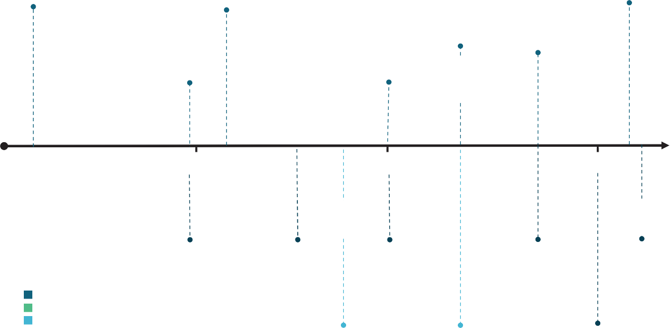
2011
Introduction of a price on carbon emissions
2016
Commencement of the Safeguard Rule
Permanent contract exit arrangements
2026
2022
2023
Introduction of CFI Act
2014
2020
Carbon price repealed, Emissions Reduction Fund (ERF) introduced
Optional delivery contracts within ERF
ERF Contract exit arrangements – 1st pilot window
Reforms to the Safeguard Mechanism
2010
2015
2020
2025
Authority’s 1st
review
Authority’s 2nd Authority’s 3rd
review
review
Authority’s 4th
review
Authority’s 5th review
2014
2017
2020
2023
2026
Legend: Legislation/policy change Authority review
Other independent review
King Review
2020
Chubb Review
2022
CCA 2035
Targets advice
2025
Source: Authority analysis, 2026.

The ACCU Scheme is now part of a suite of policies
Meeting Australia’s targets will require deeper, faster emissions reductions across all sectors (Figure 1.2). The ACCU Scheme is no longer the primary policy to drive economy-wide emissions reductions, but plays a complementary role within a broader policy framework.

Figure 1.2: Illustrative sector contributions to a 70% reduction on 2005 levels by 2035
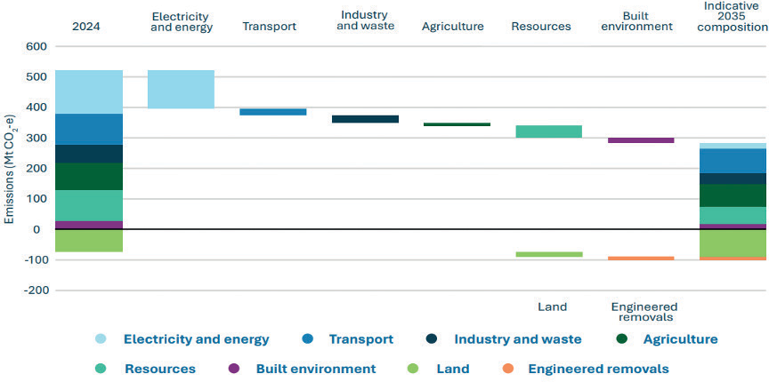
Source: Authority 2035 Targets Advice (CCA, 2025)1.

1 All graphs and charts show years as financial year ending 30 June, unless otherwise specified.

ACCU Methods are predominantly focused in the agriculture and land sectors but also include some coverage of waste and industrial energy efficiency.
The Safeguard Mechanism covers around 30% of national emissions and applies to facilities that emit over 100,000 tonnes of CO₂-e per year (Authority analysis of CER, 2026a). It applies to
large industrial facilities, particularly in the industry and resources sectors. Facility-level emission baselines decline each year in line with the national emissions reduction task. The Safeguard Mechanism does not cover most transport, built environment or agriculture emissions. It does cover grid-connected electricity generators, but only through a single sectoral baseline rather than facility-level baselines. This sectoral baseline is well above actual emissions and does not decline, so the Safeguard Mechanism is not driving grid-connected electricity-sector abatement.
Safeguard-covered facilities are now the primary source of demand for ACCUs. This helps provide an incentive for projects that sequester carbon or avoid emissions. The ACCU Scheme and Safeguard Mechanism are insufficient,
by themselves, to achieve all the emissions reductions needed to meet Australia’s targets. The reforms to the Safeguard Mechanism were designed to deliver a proportional share of the national task to 2030, based on total safeguard emissions in 2020-21 (DCCEEW, 2025e), when safeguard-covered facilities accounted for approximately 28% of Australia’s emissions (PM&C, 2023).
Policies driving emissions reductions in other sectors include the Capacity Investment Scheme in the electricity sector, the New Vehicle
Efficiency Standard for transport, and the National Construction Code and Greenhouse and Energy Minimum Standards for the built environment.
The ACCU Scheme is now best suited to filling gaps where other policy tools are not suitable.

Activities well suited to the ACCU Scheme
As Australia’s emissions reduction task grows, it will become increasingly important to focus the ACCU Scheme on activities that warrant direct payment for the abatement being delivered.
Reductions that can be more effectively or efficiently driven through other policies should be supported through those mechanisms instead.
Not all emissions reduction or sequestration activities are well suited to the ACCU Scheme. As a project-based crediting mechanism, the scheme is most relevant where emissions reduction activities clearly meet OIS requirements and provide credible, lasting abatement. Many current ACCU projects are concentrated in land, agriculture and waste activities, but the scheme’s suitability depends on the characteristics of the activity rather than the sector alone.
The Authority considers the ACCU Scheme generally suited to activities with the following characteristics:
    - Strong additionality- the activity would not occur under prevailing conditions without the incentive provided by the scheme, including because it faces clear financial or non-financial barriers.
    - Technological readiness - the technology or practice is sufficiently mature to support timely uptake and credible implementation.
    - Scalability - the activity can be scaled to deliver a material amount of abatement, so necessary project-level crediting and transaction costs are justified.
    - Quantifiable emissions reductions - abatement is able to be measured and verified at reasonable cost.
    - Permanence - abatement is durable, and supported by permanence, crediting period and reversal-risk settings that maintain integrity.

Box 1.1 illustrates how these characteristics can be applied.
Activities that do not meet these characteristics need not be excluded from climate policy support – but that support may sit outside the ACCU Scheme, at least initially. They may be better suited to regulation, grants, innovation funding, pilots, research and development, or commercialisation support. Future consideration
under the ACCU Scheme may be warranted once evidence and technological readiness improve.
For example, activities with poorly defined project boundaries, high monitoring costs or very small abatement volumes may be poorly suited to project-based crediting because of the high transaction costs. Activities that face upfront capital barriers may be better addressed through concessional finance. Split incentives, where the costs and benefits accrue to different parties, may be better addressed through disclosure requirements, standards, or regulation.

Box 1.1: ACCU Scheme suitability characteristics: illustrative application
Biochar and direct air capture (DAC) are both carbon dioxide removal approaches, but they differ in how they remove and store carbon, their technological readiness, current costs and suitability for ACCU crediting. Biochar stores carbon from biomass in a stable carbon-rich product capable of storing carbon for long periods, while direct air capture uses engineered systems to remove carbon dioxide directly from the atmosphere for storage.
Biochar is a relatively mature approach compared with many engineered removal technologies. It may be able to deliver additional, measurable and scalable abatement, depending on feedstock, production processes, lifecycle emissions, end use and monitoring arrangements. It may also provide non-carbon benefits, such as improved soil health and resilience. While costs remain higher than many existing ACCU project types, biochar may become increasingly suitable for ACCU crediting as activity, evidence and measurement approaches mature.
DAC offers highly durable carbon removal but is at an earlier stage of commercialisation and remains significantly more expensive than many other abatement opportunities. DAC may play an important longer-term role in achieving net zero, particularly for offsetting residual emissions, but is unlikely to be deployed at scale in the near term. It may also require further policy, accounting, monitoring and legislative development before it can be considered for ACCU crediting. Theme 5 discusses these method development and eligibility issues in more detail.
This illustrates why ACCU Scheme suitability is not determined by abatement potential alone.

How the ACCU Scheme interacts with the Safeguard Mechanism
The Safeguard Mechanism sets mandatory declining baselines for covered facilities. Facilities can meet their baselines by reducing emissions onsite or surrendering SMCs or ACCUs. This makes ACCUs an important flexibility mechanism within the safeguard framework. Box 1.2 illustrates how the ACCU Scheme and Safeguard Mechanism interact to deliver a proportionate share of the national emissions reduction task.
ACCU availability can reduce compliance costs for covered facilities and help smooth the transition while onsite abatement options are developed (DCCEEW, 2025e). Analysis by the EY Net
Zero Centre suggests that use of ACCUs in the Safeguard Mechanism can reduce total system-wide abatement costs by more than 60%, under the assumptions used in its 2026 Australian carbon market outlook. This flexibility can also support more ambitious safeguard settings by reducing the risk of excessive costs for industry (EY, 2026).
Changes to safeguard settings can have significant effects on ACCU demand, prices and investment incentives. Similarly, ACCU supply influences incentives for investment in onsite abatement at safeguard facilities. Future baseline decline rates, rules for ACCU use and the availability of SMCs will all influence how much abatement occurs onsite at safeguard facilities and how much occurs through ACCU projects. The Authority will examine these interactions as part of our 2026 Annual Progress Advice.

What ACCU supply means for Australia’s targets
ACCU projects contribute to progress towards Australia’s emissions reduction targets because the underlying emissions reductions or removals are reflected in the national greenhouse gas inventory. Therefore, ACCU project activities contribute to Australia’s national abatement effort.
From a policy perspective, ACCUs contribute to meeting Australia’s targets primarily through helping meet the baseline settings of the
Safeguard Mechanism. Under any given baseline decline rate, increasing ACCU supply will tend
to reduce the quantum of onsite abatement at safeguard facilities and increase the quantum happening offsite at an ACCU project. It will not necessarily lead to greater overall progress towards Australia’s targets. However, stronger
ACCU supply can indirectly contribute to greater overall progress where it enables stronger safeguard baseline settings.
ACCU supply contributes directly to achieving Australia’s targets, over and above its role in the Safeguard Mechanism, where ACCUs are purchased and cancelled by government or voluntary buyers (Box 1.2).

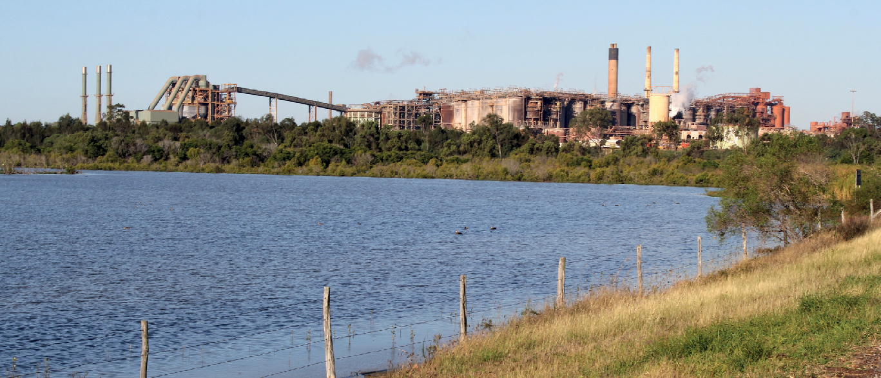

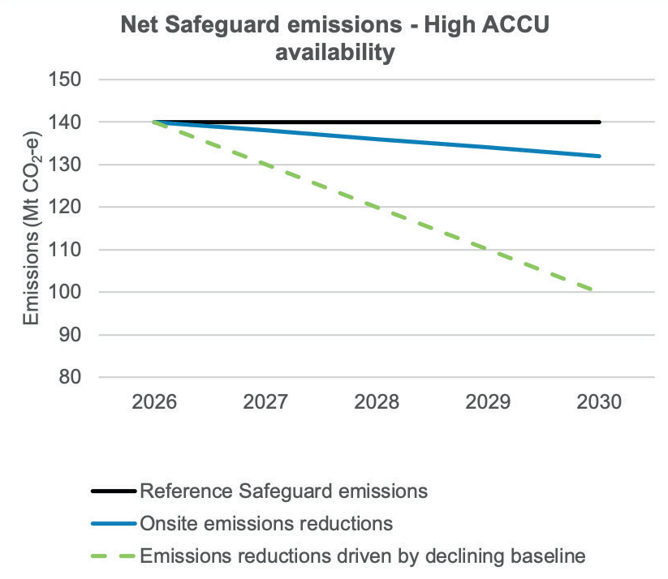
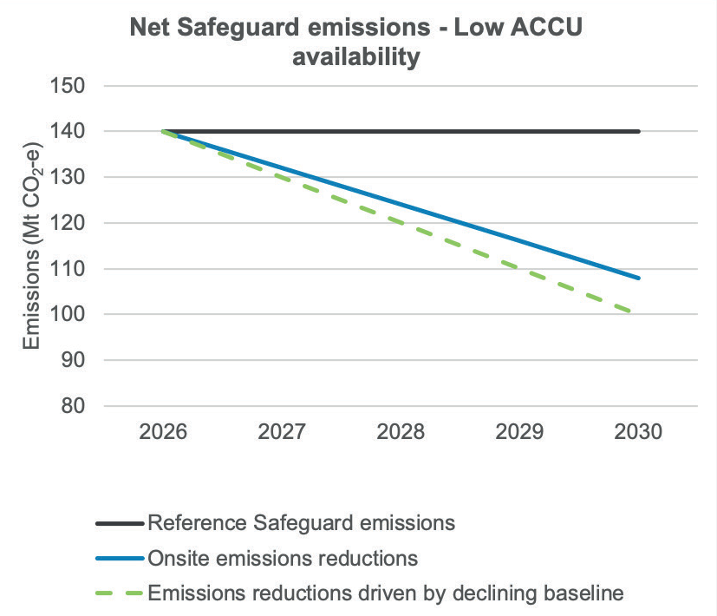
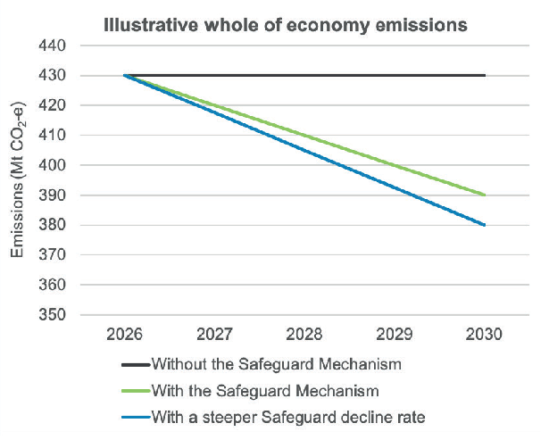
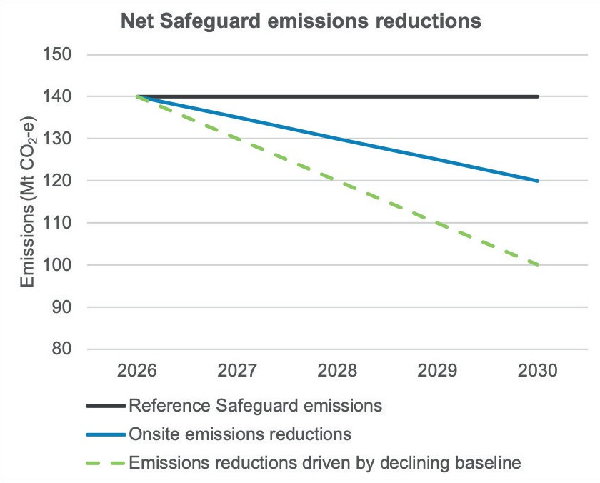

Box 1.2: How the Safeguard Mechanism and ACCU Scheme contribute towards the national target
The following graphs provide a simplified representation of national emissions, the Safeguard Mechanism and the ACCU Scheme.
The declining baseline of the Safeguard Mechanism requires facilities to reduce emissions or surrender ACCUs, leading to lower national emissions. The Safeguard Mechanism sets the declining baseline that facilities must meet. Net emissions from safeguard facilities decline in line with the legislated baseline trajectory.

Onsite emissions reductions

ACCU
surrenders
Total abatement outcome is largely determined by the decline rate

A steeper baseline decine rate will achieve more emissions reductions

A proportion of emissions will be met through onsite emissions reductions. The rest will be achieved through ACCU surrender. If ACCU availability is low, the price will increase and more abatement is likely to occur onsite. Where ACCU availability is high, a greater proportion of safeguard compliance is likely to be met with ACCUs. Either way, the overall abatement outcome does not change.

Higher ACCU availability drives more abatement through ACCU Scheme
Overall abatement achieved doesn’t change with changing ACCU supply

Lower ACCU availability drives more onsite abatement

Use of ACCUs shifts emissions reduction activity from safeguard facilities to those areas of the economy in which ACCUs can be generated. The volume of ACCUs surrendered may understate the total abatement achieved in these sectors, due to factors such as conservative method settings.
Voluntary and government cancellation of ACCUs drives emissions reductions beyond those required under the Safeguard Mechanism, directly accelerating progress towards Australia’s targets.

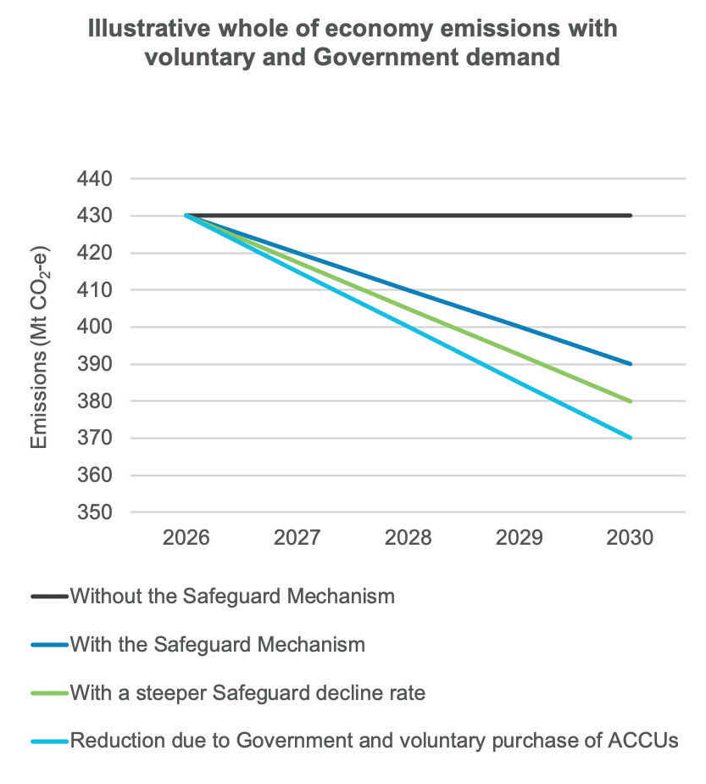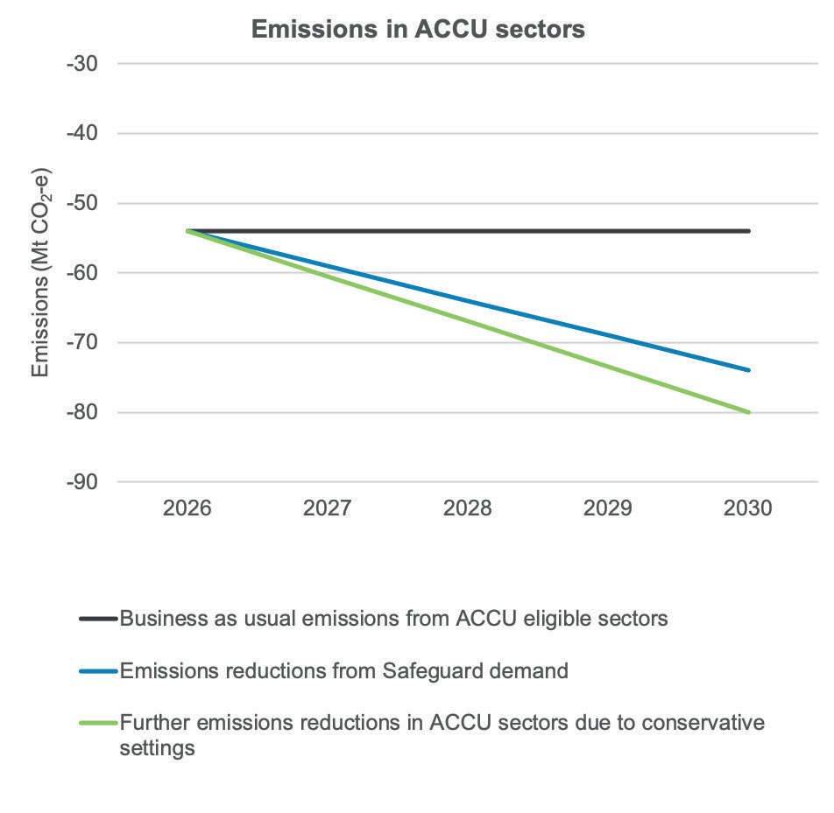
Safeguard contributes towards targets
Government and voluntary purchase of ACCUs can drive reductions beyond Safeguard
Steeper decline rate achieves more emissions reduction

Source: (DCCEEW, 2025a) and Authority analysis

Safeguard demand drives emissions reduction in ACCU sectors

Conservative settings may deliver extra abatement
This distinction is important for the role of the ACCU Scheme. Increased ACCU supply can reduce safeguard compliance costs and support investment in abatement projects, but it is not a substitute for policy settings that reduce emissions across the economy. Meeting Australia’s targets will require the Safeguard Mechanism, the ACCU Scheme and sector-specific policies to work together and ratchet up aggregate emission reduction over time.

Land sector abatement potential is greater than likely safeguard demand for ACCUs
Land sector sequestration is expected to make an important contribution to Australia’s pathway to net zero. The Authority’s 2035 Targets Advice and Treasury’s net zero modelling both anticipate a substantial land sector sink by 2035 and beyond. The existing land sector sink is projected to ease over time, so additional policy effort is likely to
be needed to maintain and increase land sector sequestration (DCCEEW, 2025a).
Safeguard-driven ACCU demand can help fund land sector abatement and sequestration. As safeguard baselines decline, facilities that cannot reduce enough emissions onsite may purchase ACCUs, including from land sector projects. This directs private finance towards sequestration and emission reduction activities in the land sector, helping boost regional economies.
However, safeguard-driven ACCU demand
is likely to fall well short of the full land sector abatement potential identified in Australia’s net zero pathways. The Safeguard Mechanism covers only around 30% of Australia’s greenhouse gas emissions (DCCEEW, 2025f). By 2050, all residual emissions will need to be balanced by carbon sequestration and removals, not just the residual emissions from safeguard facilities.
Stronger safeguard settings can play a role, but further sources of demand for ACCUs, and further policies and measures beyond the ACCU Scheme are likely to be required to realise the land sector sink implied by net zero-consistent pathways.
These could include government or voluntary ACCU cancellation, stronger economy-wide incentives for carbon removal, and targeted land sector policies that directly support sequestration and emissions reduction activities.

Avoiding double counting and supporting credible carbon claims
Emissions reduction activities onsite at safeguard facilities are better recognised through the Safeguard Mechanism than through the ACCU Scheme. These activities can help a facility meet its baseline and, where the facility performs better than its baseline, may allow it to generate SMCs.
The ACCU Scheme and Safeguard Mechanism already include rules to prevent the same abatement being counted twice. Where ACCUs are issued for abatement attributable to a safeguard facility’s covered emissions, those ACCUs are added back in the facility’s safeguard calculation (DCCEEW, 2025e). These rules address the risk of double counting between ACCUs and Safeguard Mechanism compliance. However, clear accounting and claims guidance

remains important for project proponents, safeguard facilities and ACCU buyers, particularly as market participants seek to understand how different units, emissions reductions and claims interact.

Emerging trade-offs between selling ACCUs and using abatement within a supply chain
As demand grows for low-emissions products, some ACCU Scheme participants may have a stronger incentive to keep and use the carbon benefit from their projects rather than sell ACCUs into the market. This is particularly relevant in the agriculture and land sectors.
For example, a grazier who develops an eligible ACCU project can generate ACCUs and sell them into the carbon market, adding a new revenue stream to their farm income. Once those ACCUs are sold, the grazier needs to be careful about relying on that same abatement to support emissions-intensity or carbon-neutrality claims for their products. Australian Competition and Consumer Commission guidance on
environmental claims notes that businesses using offsets should verify the emissions benefit has not already been claimed elsewhere (ACCC, 2023). Using the same emissions reduction to support claims by multiple parties may create
a risk of double counting and could mislead consumers about who is entitled to claim the environmental benefit.
The alternative is often described as ‘insetting’. Under this approach, the grazier would generate, retain and use abatement within the emissions boundary of the farm, business or supply chain. If they are undertaking an ACCU project to generate the abatement, then instead of selling the resulting units, they would retain and cancel them to support claims about the lower emissions-intensity of their own livestock production or along their product supply chain.
This creates a strategic choice for producers. Selling ACCUs can provide an immediate financial return. Retaining and using the abatement
may support longer-term competitiveness in markets that increasingly value low-emissions commodities, including through price premiums or preferential market access.
Stakeholders have also raised interest in sharing carbon-related benefits across supply chains.
This highlights the opportunity and the complexity of recognising emissions reductions across supply chains.
The key accounting issue is ensuring emissions benefits are clearly attributed, so the same abatement is not double counted or used by multiple parties to support the same claim. As in the example above, care is needed where a
landholder or other participant in the supply chain relies on an emissions benefit already transferred through the sale of ACCUs to support claims of lower emissions intensity or carbon neutrality.
Clear accounting and claims frameworks help avoid double counting and provide clarity about who is entitled to claim the environmental benefit.
Similar accounting and claims issues may arise where ACCU projects interact with the Nature Repair Market and future environmental offset obligations under reforms to the Environment Protection and Biodiversity Conservation Act 1999 (EPBC Act). Current Nature Repair Market rules allow projects to be registered on the same land as an ACCU project where each scheme’s requirements are met, but the use of biodiversity
certificates for regulatory offsets is still developing. Where the same activity is used to support carbon, biodiversity and regulatory offset claims, clear rules are needed to ensure the same outcome
is not claimed twice and that ACCU additionality is maintained. This issue is discussed further in Theme 3.
Stakeholder feedback indicates there is still confusion about these distinctions at the producer and supply-chain level. The ACCU Scheme and Safeguard Mechanism contain protections to prevent double counting within the formal scheme rules. However, additional guidance delivered through a trusted source, such as the Carbon Farming Outreach Program (CFOP), could help producers and buyers make more informed, consistent and credible decisions about offsetting, insetting, supply-chain claims and interactions with biodiversity or environmental offset claims.

Theme 2: Permanence, durability and scheme confidence
Key points
- Permanence settings should be revisited due to the shift from Government purchasing of ACCUs to safeguard facility purchasing for compliance.
- Project proponents are increasingly nominating a 25-year permanence period. ACCUs from these projects are being used in growing volumes for safeguard compliance, including 19% of surrenders for compliance in 2023–24 and 22% in 2024–25.
- Project proponents have no obligation to maintain sequestered carbon beyond the nominated permanence period. Outcomes after that point will depend on factors such as market opportunities, land use economics, regulatory settings (including land clearing controls), and availability of incentives or pathways to continue carbon storage.
- The Government has already progressed reforms relevant to permanence, including making permanence information available to buyers and consulting on legislative changes to allow projects to move from 25-year to 100-year permanence periods.
- The Government should assess whether current permanence settings remain appropriately calibrated and whether ACCUs from projects with 25-year permanence periods provide a sufficiently durable outcome for Safeguard Mechanism compliance.

Integrity is central to confidence in the ACCU Scheme and its role in supporting Australia’s emissions reduction targets. The Authority reaffirms its 2023 finding that the scheme is fundamentally well designed and notes the 2022 Chubb Review also found the scheme to be essentially sound. Since those reviews, the Government has made progress implementing reforms to strengthen governance, transparency
and integrity, with further legislative changes under consideration.
The Authority does not consider wholesale review of the scheme’s integrity framework is
warranted. Many reforms have only recently been implemented or are still in progress. This theme therefore focuses on 2 related issues where further assessment is needed in the near term due to the scheme’s changed market context:
    - whether the ACCU Scheme’s permanence settings remain well calibrated
    - whether the use of ACCUs from 25-year permanence projects for Safeguard Mechanism compliance is appropriate.

Central to both issues is that proponents with
year permanence projects are not required to maintain carbon stocks beyond the nominated permanence period. The Authority’s 2023 review of the ACCU Scheme covered the risk of reversal buffer, and this review focuses on the permanence period discount (CCA, 2023).

Box 2.1: Permanence and durability under the ACCU Scheme
For sequestration ACCUs, to offset emissions credibly, carbon storage should be maintained for a duration sufficiently comparable to the persistence of the emissions being offset. Internationally,
most carbon markets have a 100-year storage requirement (CCA, 2023; Cornell Law School, 2024; UNFCCC, 2025). European Union legislation adopted in 2024 creates differentiated units for long-lasting carbon storage, carbon stored in products, and carbon farming (EU, 2024).
Under the ACCU Scheme, permanence obligations are the period for which a project proponent must maintain the stored carbon. For eligible sequestration projects, proponents can generally choose either a 25-year or 100-year permanence period (CER, 2026d).2 Project proponents are not required to maintain carbon stocks beyond the nominated permanence period.
Projects with a 25-year permanence period receive fewer ACCUs than projects with a 100-year permanence period. A 20% permanence discount applies to most 25 year projects.3 In addition, sequestration projects are subject to reversal obligations and a scheme level risk of reversal buffer designed to manage the risk that stored carbon is released before the permanence obligation ends.4
The 25-year option was introduced in 2014 to reduce participation barriers, particularly for landholders and others unable or unwilling to take on 100-year obligations (CCA, 2023).

2.1 Assessing current permanence settings
In recent years, there has been a substantial increase in sequestration projects with 25-year permanence periods (CCA analysis of (CER, 2026a), Figure 2.1). Over the last 5 years, 87% of new sequestration projects have nominated a 25-year permanence period. Soil carbon projects have led this trend (Figure 2.1). Many of these projects have not yet been credited with any ACCUs (Figure 2.2).
Vegetation projects have been the main source of ACCUs, delivering 54% in 2024-25, and 55% of all ACCUs issued to date (Figure 2.2). Since the 2022 Chubb Review, there has been a small increase
in vegetation projects with 100-year permanence periods. From 2018, project proponents for the savanna fire management (SFM) method have been able to apply for credits for sequestration as well as avoidance. There has been a limited uptake of SFM sequestration projects (5 projects with a
25-year permanence period, and one with a 100-year permanence period, see Theme 3 for more discussion of SFM).

2 Sequestration projects include vegetation, soil carbon, blue carbon and savanna fire management.
3 The permanence period discount applies to ACCUs issued from most projects with 25-year permanence periods. 20% fewer ACCUs are granted to these projects (CER, 2026d). A few selected projects have different discounts. For example, certain plantation forestry projects have a 25% discount, while tidal restoration, savanna fire management sequestration and certain forestry projects do not have a discount rate. This discount helps manage the scheme-wide risk if carbon stores are not maintained after 25-year projects conclude (DAFF, 2026).
4 The risk of reversal buffer is a 5% discount that applies to ACCUs issued from sequestration projects. This protects against risks not managed by permanence arrangements (CER, 2026d). For 25-year projects, a permanence discount also applies. For example, a 25-year project that abates 10,000 t CO2-e will receive 7,500 ACCUs, due to the 20% permanence period discount and the 5% risk of reversal buffer.

Figure 2.1: ACCU sequestration project registrations
100-year permanence period
400

350

300

250

200

150
Soil
Vegetation
100

50

0
25-year permanence period
400

350

300
250

200

150

100
50

0

Source: Authority analysis of (CER, 2026a).
ACCUs issued (millions)
2013
2014
2015
2016
2017
2018
2019
2020
2021
2022
2023
2024
2025
2026
2013
2014
2015
2016
2017
2018
2019
2020
2021
2022
2023
2024
2025
2026

Figure 2.2: ACCUs issued to sequestration projects
25-year permanence period
8
7
6
5
4
3
2
1
0
100-year permanence period
8
7
6
5
4
3
2
1
0
Soil
Vegetation
ACCUs issued (millions)

Source: Authority analysis of (CER, 2026a).
2013
2014
2015
2016
2017
2018
2019
2020
2021
2022
2023
2024
2025
2026
2013
2014
2015
2016
2017
2018
2019
2020
2021
2022
2023
2024
2025
2026

The increasing adoption of shorter permanence periods means they now make up a significant share of the scheme overall.

2.2 ACCUs from 25-year projects are used for safeguard compliance
At the same time as the increase in projects with shorter permanence periods, demand for ACCUs from safeguard entities has increased in terms
of purchase and cancellation, and in holdings (see Theme 4). Units from projects with 25-year permanence periods made up 19% of safeguard surrenders for compliance in 2023-24, and 22% in 2024-25 (Figure 2.3). These units now make up 26% of ACCUs held by safeguard entities. Across the first 2 years of declining safeguard baselines,
3.8 million ACCUs with a 25-year permanence period were used to offset 3.8 Mt CO2-e of industrial emissions.
The Authority has previously suggested requiring 4 credits from projects with 25-year permanence periods could be used to equate to one 100-year credit (CCA, 2023). Requiring 4 ACCUs from projects with 25-year permanence periods, instead
of one, would have meant those 3.8 million ACCUs could have only been used to offset 0.95 Mt
CO2-e of industrial emissions. To fully meet their obligations these facilities would need to surrender an additional 2.8 million ACCUs from projects
with 100-year permanence periods or avoidance projects, or a further 11.4 million ACCUs from projects with 25-year permanence periods.
Demand for ACCUs for safeguard compliance purposes is forecast to significantly increase in coming years (Theme 4). Any reversal of sequestration after project completion, which
could occur as early as 2039, may make reaching Australia’s long term emissions reduction targets even more challenging.

Figure 2.3: Permanence periods for ACCUs surrendered and in holdings
ACCUs surrendered for Safeguard compliance
40
35
30
25
20
15
10
5
0
ACCUs in holdings
40
35
30
25
20
15
10
5
0
Avoidance
25-year 100-year
ACCUs (millions)

Source: Authority analysis of confidential data supplied by CER.
2017
2018
2019
2020
2021
2022
2023
2024
2025
Business
Government
Intermediary
Project proponent
Safeguard related
Safeguard

ACCUs are credited for a project throughout the crediting period once carbon abatement has been delivered, reported and verified (CER, 2026b). All ACCUs issued for a project have the same end point for their permanence period regardless of issue date. This means carbon credited in any year of a
25-year project must be protected until the end of the 25th year. In practical terms, this means an ACCU credited during the third year represents 22 years of protected abatement while an ACCU credited in the 24th year only represents one year of protected abatement. This difference is not explicitly reflected in the ACCUs issued.
Submissions to the Authority also outlined similar concerns.
‘It is not always realised that although the Commonwealth claims to use 100-year permanence, in a 100-year project with a 25-year crediting period only the carbon stored in the first year of a project will actually be stored for 100-years and the carbon stored in year 25 will only be required to be stored for around 75 years. In a project with a 25-year permanence period and a 25-year crediting period, the carbon stored in year 25 will have approximately one year of protection under the scheme.’
- The Carbon Store submission, 2026

2.3 Project proponents’ obligations end after permanence period is complete
The ACCU Scheme imposes no obligation on projects with a 25-year permanence period to maintain carbon stocks after the permanence period ends. It is unclear whether, and to what extent, carbon stored under 25-year projects will be retained beyond that point. Outcomes are likely to depend on land use context, commercial incentives and regulatory settings.
Some stakeholders argued that, where there is no ongoing carbon revenue after crediting and permanence obligations end, land use may shift to more profitable activities.
‘[T]here is no provision for further carbon income … [which] could motivate land managers to change back to a more profitable land use, for example by clearing regrown forests for grazing.’
- The Carbon Store submission, 2026

Other submissions indicate that some proponents may wish to continue storing carbon if workable pathways are available.
The Government is progressing reforms that would allow projects to move from 25-year to 100-year permanence periods. If implemented, these changes would provide a pathway to increase project duration.
During consultation, some stakeholders expressed a desire for the Government to provide more incentives for proponents to adopt longer permanence periods.
‘GreenCollar also considers that greater flexibility is needed to incentivise longer permanence obligations for existing registered projects, specifically permitting the ability to increase permanence obligation periods after registration (from 25 years to 100 years) and consideration for the eligibility criteria of a second/extended crediting period in such cases.’
- GreenCollar submission, 2026
‘The Clean Energy Regulator could consider introducing graduated permanence incentives, where longer-term commitments yield higher rewards, such as increased ACCU issuance or higher market value, or a penalty for shorter permanence requirements, similar to the security buffer currently in place.’
- Australian Academy of Technological Sciences and Engineering submission, 2026

Many policy levers could influence the duration of carbon storage under the ACCU Scheme. These include changes to permanence periods, discounting arrangements and treatment of ACCUs in compliance settings.

Box 2.2: Interaction between the ACCU Scheme, the Safeguard Mechanism and permanence
Hypothetical safeguard facility
350
300
250
200
150
100
50
0
600 kt CO₂-e excess
cumulative emissions
Gross emissions Baseline

An illustrative ACCU project sequesters emissions over the course of the project and is issued ACCUs when sequestration is reported and verified.*
Cumulative sequestration (kt CO2-e)
Emissions (kt CO₂-e)
2024
2026
2028
2030
2032
2034
2036
2038
2040
2042
2044
2046
2048
A hypothetical safeguard facility has gross emissions of 600 kt CO2-e over its baseline in the years from 2025 to 2037.
Example ACCU project

0

-20

-40

-60

-80

-100
Previous sequestration New sequestration Total sequestration

While the facility’s emissions are higher than its baseline, the company will be required to surrender ACCUs (or SMCs) to meet its obligations. After the units are surrendered, the safeguard reporter’s obligations for this reporting year have been met.
2020
2022
2024
2026
2028
2030
2032
2034
2036
2038
2040
2042
2044
2046
2048
2050
If the facility uses ACCUs from projects with a 100-year permanence period:

Emissions and sequestration balance out: The atmosphere would see:

800

600
Sequestration/emissions (kt CO2-e)

400

200

0

-200

-400

-600

-800
100-year permanence period

2025-37 2050 2051-2100
600
-600

Safeguard emissions ACCUs surrendered

800
600
Sequestration/emissions (kt CO2-e)
400
200
0
-200
-400
-600
-800
100-year permanence period

2025-37 2050 2051-2100

If the facility uses ACCUs from projects with a 25-year permanence period, emissions balance out in the near term. However, there is no obligation to maintain sequestration beyond the permanence period.
A reversal event could occur at any time after the end of the permanence period.

Near-term balance, longer-term risk: The atmosphere would see:

800

600
Sequestration/emissions (kt CO2-e)

400

200

0

-200

-400

-600

-800
25-year permanence period

2025-37 2050 2051-2100
 | 600 |  | 600
 | -600

Safeguard emissions ACCUs surrendered Reversal event

800
600
Sequestration/emissions (kt CO2-e)
400
200
0
-200
-400
-600
-800
25-year permanence period

600

2025-37 2050 2051-2100
Reversal event

Source: Authority analysis, 2026.

This risk could occur for any 25-year permanence ACCU surrendered for each year. Current policy settings mean there are no obligations for any party to ensure this sequestration is retained.
Notes: * permanence period discount and risk of reversal buffer excluded for simplicity.
‡ 25 years is the maximum duration. The storage period could be shorter for ACCUs issued later in a project’s crediting period.

2.4 Permanence settings warrant consideration
Stakeholder submissions indicate that permanence settings strongly shape decisions to participate in the ACCU Scheme. While stronger durability requirements could improve alignment between storage duration and the emissions ACCUs are used to offset, some stakeholders argued that very long permanence commitments are not feasible in all land tenure contexts and could preclude participation for some. Challenges include constraints related to land tenure, consent processes and succession planning (CCA, 2023).
For these reasons, the Authority considers that ACCUs from projects with 25-year permanence periods should continue to play a role in the carbon market. They expand the supply of emissions reductions and create opportunities for landholders and regional communities. The Government should, however, assess their suitability for safeguard compliance. This is a separate question from their use in voluntary or government purchasing.
The Authority previously suggested requiring 4 credits from projects with 25-year permanence periods could be used to equate to a 100-year credit, which is equivalent to a 75% discount rate. This would be a robust, very cautious setting that guards against full reversal. Some stakeholders have suggested allowing projects to extend their permanence commitments over time, rather than requiring a longer commitment upfront. For example, a project could start with a 25-year permanence period and then choose to extend it to 50 years, 75 years or beyond. At each extension, a smaller number of discounted
ACCUs would be issued, based on the additional permanence commitment. This approach could encourage longer-term carbon storage while giving projects greater flexibility than committing to a 100-year permanence period from the outset.

Any changes to permanence arrangements or the use of ACCUs for safeguard compliance would need to be introduced gradually and with clear advance notice. Any reforms should be developed in consultation with affected
stakeholders, particularly the land sector. They should avoid disadvantaging project proponents and others who invested under the current framework. Transition arrangements would be necessary, particularly for ACCUs already issued, held or contracted, to minimise market disruption and adverse impacts on investment. This could include applying new requirements only to new issuances or new projects.
Taken together, the evidence indicates it is timely to reassess whether current permanence settings remain fit for purpose. The available evidence does not point to a single preferred response. The calibration of the permanence discount and risk of reversal buffer and the treatment of ACCUs from projects with 25-year permanence periods for compliance are interrelated. Participation, impacts on ACCU supply, prices and existing investments are also connected. Further analysis and targeted consultation with affected stakeholders are needed to determine the appropriate response.

Recommendation 1:
Complete and publish the first assessment of the risk of reversal buffer and permanence period discount by the end of 2027.
Examine whether the buffer and discount remain appropriate in light of climate risks and reversal events. Specifically consider appropriate discounts for projects with 25-year permanence periods.
Recommendation 2:
Through the 2026-27 Safeguard Mechanism review, assess whether ACCUs from 25-year permanence projects provide sufficient durability to be used for Safeguard Mechanism compliance.
Consider options to better align compliance use with the durability of the emissions being offset, with appropriate transition arrangements.

Theme 3: Participation, equity and public benefits
Key points
- ACCU projects can deliver benefits beyond emissions reductions, including for First Nations peoples, the environment, regional jobs and community resilience.
- First Nations participation is central to the public value of the ACCU Scheme. First Nations-led projects show how ACCU projects support cultural land management alongside emissions reductions. First Nations rights, interests and participation should continue to inform its design, governance and evolution.
- Recent and proposed reforms would strengthen consent and participation arrangements, including for native title land and registered native title claimants. Further reform should strengthen First Nations rights and interests in a way that is robust, practical and consistent with broader expectations for land-use decisions affecting Country.
- Stacking ACCU projects with Nature Repair Market projects can support integrated land-management outcomes, but clear rules and guidance are needed to ensure additionality requirements are met where carbon, biodiversity and regulatory offset outcomes interact.
- Future Government purchasing of ACCUs should prioritise projects with credible public benefits, supported by clear criteria.

Many ACCU projects deliver benefits beyond emissions reductions. These broader public benefits can include biodiversity conservation, improved soil health, landscape resilience, cultural outcomes, First Nations economic participation, regional jobs and community resilience.
These benefits matter because the CFI Act aims to reduce emissions in a way that protects Australia’s natural environment and improves resilience. They also matter because ACCU projects increasingly operate in a compliance-driven market. Safeguard facilities are likely to prioritise reliable, low-
cost ACCUs for compliance purposes. Without clear criteria, credible verification and buyer demand, broader public benefits may not be fully recognised or rewarded.
First Nations participation is not a peripheral issue for the ACCU Scheme. First Nations peoples hold rights and interests across most
of Australia’s land (PC, 2025). First Nations-led carbon projects demonstrate how the scheme supports emissions reductions, cultural land management, ranger employment, community services and long-term capability. The Authority considers First Nations rights, interests and participation central to the design and ongoing improvement of the ACCU Scheme.
The ACCU Scheme has been successful at driving investment into land-based offsets and will remain a valuable tool in securing sequestration into the future. Recent reforms have improved participation and strengthened protections for some groups, but barriers remain for First Nations peoples, smaller landholders and regional communities. This theme considers how the ACCU Scheme can support broader participation and public benefits, and why any future Government purchasing of ACCUs should prioritise credible public benefits.

‘Without targeted reform, these inequities will continue to shape who benefits from carbon markets and who is excluded.’
- Nature Solutions Consultancy submission, 2026

Both the 2022 Chubb Review and the Authority’s 2023 ACCU Scheme review made recommendations to improve participation and equity in the scheme. The Government has agreed, or agreed in principle, to these recommendations and has made progress implementing several reforms. Some still require legislative amendments to take effect (DCCEEW, 2026c).
Currently proposed amendments to the CFI Act include:
- requiring at least one member of the proposed Carbon Abatement Integrity Committee (CAIC) to be Aboriginal and/or a Torres Strait Islander
- ensuring the proposed CAIC can contribute to effective policies and strategies on rural and regional development
- requiring consent from eligible interest holders for ACCU projects on native title land or claimed native title land
- expanding eligible interest holders to include registered native title claimants (DCCEEW, 2026a).
These reforms are intended to strengthen protections for Traditional Owners and better align the scheme with Free, Prior and Informed Consent (FPIC) principles.
Stakeholders raised concerns about the pace of implementing reforms to improve equity and participation.
‘Kimberley Aboriginal people are particularly mindful of the fact that most of the important recommendations involving their participation in the scheme are behind schedule.’
- Kimberley Land Council submission, 2026

‘Ongoing delays by the Department of Climate Change, Energy, the Environment and Water in implementing Chubb Review recommendations, finalising period review documentation and managing method governance have materially reduced participation appetite.’
- AgriProve submission, 2026

The Authority also heard from stakeholders about the need to strengthen First Nations rights and interests, for better regional outreach and education, and about opportunities to increase demand for ACCU projects delivering broader public benefits.

ACCU projects can deliver broader public benefits
ACCU projects can deliver public benefits alongside emissions reductions. Premiums are paid for some ACCUs from projects with demonstrated non-carbon benefits, including environmental plantings, savanna fire management (SFM) and soil carbon (Reputex, 2026).
Most compliance demand is likely to remain focused on low-cost units. Public-benefit attributes are only likely to be valued and rewarded by buyers if they are clearly defined, consistently measured and (in some cases) underpinned by policy settings.
‘The cost per unit remains a key factor in purchasing decisions, especially for entities covered by the Safeguard Mechanism or other regulatory requirements. … Beyond cost, purchasers may prioritise certain co-benefits (e.g., biodiversity outcomes, Indigenous engagement, regional economic development). A clear, credible framework for communicating and verifying co-benefits enables buyers to confidently differentiate between project types.’
- Australian Industry Greenhouse Network (AIGN) submission, 2026
Improving transparency of project and credit attributes will help address these concerns, as discussed in Theme 4.4.
The shift to safeguard-driven demand provides an opportunity to change the role of Australian Government purchasing. While Government purchasing under the ERF focused on securing large volumes at least-cost, future Government purchasing could be targeted more directly to public-benefit outcomes (including biodiversity, First Nations, cultural, regional and landscape resilience). The Government’s proposed legislative updates open the space for this shift, by enabling value-for-money purchasing rather than requiring least-cost purchasing (DCCEEW, 2026d). This would
allow Government purchasing to support carbon projects that deliver credible public benefits beyond emissions reductions.
Stakeholders supported this direction.
‘Advise the Government to develop an ACCU purchasing strategy which supports targeted investment in ACCU methods which provide multiple co-benefits and/or long-term removals.’
- Carbon Market Institute submission, 2026
‘With the Safeguard Mechanism now driving private demand for lowest cost ACCUs, now is the time for the Government to reposition itself to deliver public value for money. Specifically, the public benefits for consideration should include biodiversity benefits, but could also be expanded to consider social and cultural co-benefits as well.’
- Australian Land Conservation Alliance submission, 2026
Any Government purchasing strategy should maintain abatement as the primary requirement. Public benefits should complement, not substitute, robust emissions reduction outcomes.
‘Any prioritisation of co-benefits should be complementary to, not a substitute for, robust emissions reduction outcomes.’
- AIGN submission, 2026

Box 3.1: Case study: Queensland’s Land Restoration Fund
The Queensland Government’s Land Restoration Fund is expanding carbon farming in the state through supporting projects that deliver additional public value (Queensland Government, 2026c). First Nations peoples, landholders and farmers are supported to provide valuable non-carbon benefits that include:
- healthier waterways
- increased habitat for threatened species
- more resilient landscapes.
The LRF has 2 components: a market development initiative that invests in research, development and capacity building, and Land Restoration Fund Trust that contracts ACCU projects with verifiable non-carbon benefits (Queensland Government, 2026b, 2026a). To date, the fund has invested in
25 projects and contracted over 1 million ACCUs (Queensland Government, 2026a). Projects have multiple non-carbon benefits, including for threatened ecosystems and wildlife, the Great Barrier Reef, and coastal systems (Queensland Government, 2026a). The fund contracts all co-benefits delivered as well as a portion of the ACCUs under these projects.

To the extent the Government decides to restart purchasing, the criteria should be clear and transparent. Claims about public benefits also need guardrails to avoid double counting,
particularly where ACCU projects interact with the Nature Repair Market or other biodiversity and natural capital initiatives.
Potential purchasing criteria could include:
- First Nations participation and benefit sharing
- protections for threatened species and ecosystems
- soil, wetland, coastal and ocean health
- landscape resilience
- regional employment and community benefits.

Recommendation 3:
Prioritise credible public benefits in any future Government purchasing.
Any future Government purchasing of ACCUs should prioritise projects with credible public and First Nations benefits, supported by clear criteria.

First Nations participation is central to the scheme’s public value
ACCU projects can support cultural, environmental, social and economic benefits for First Nations communities, while also driving emissions down. The Indigenous Carbon Industry Network (ICIN) estimates First Nations-owned carbon projects generate around 1 million t CO2-e of emissions reductions and $60 million in revenue each year, supporting ranger programs, community services and broader capability building (DCCEEW, 2026h; ICIN, 2026a).
For First Nations groups, benefits extend well beyond financial returns and are viewed as core benefits. These benefits include employment for Indigenous rangers, including women and young people, strengthening and supporting cultural practices, and enhancing biodiversity outcomes (Aboriginal Carbon Foundation, 2025). The Authority considers First Nations peoples as rights holders, whose knowledge, leadership and perspectives should continue to inform the scheme's evolution.
‘Carbon projects provide a clear opportunity to “close the gap” and support Indigenous self-determination and economic development - including in remote and very remote areas.’
- ICIN submission, 2026

SFM is the clearest example of First Nations leadership in ACCU method development and project delivery. First Nations knowledge and cultural practices were central to the development of the method (Box 3.2). SFM projects have reduced late-season fires by 70% and increased protection for communities, infrastructure and cultural sites (ICIN, 2025).

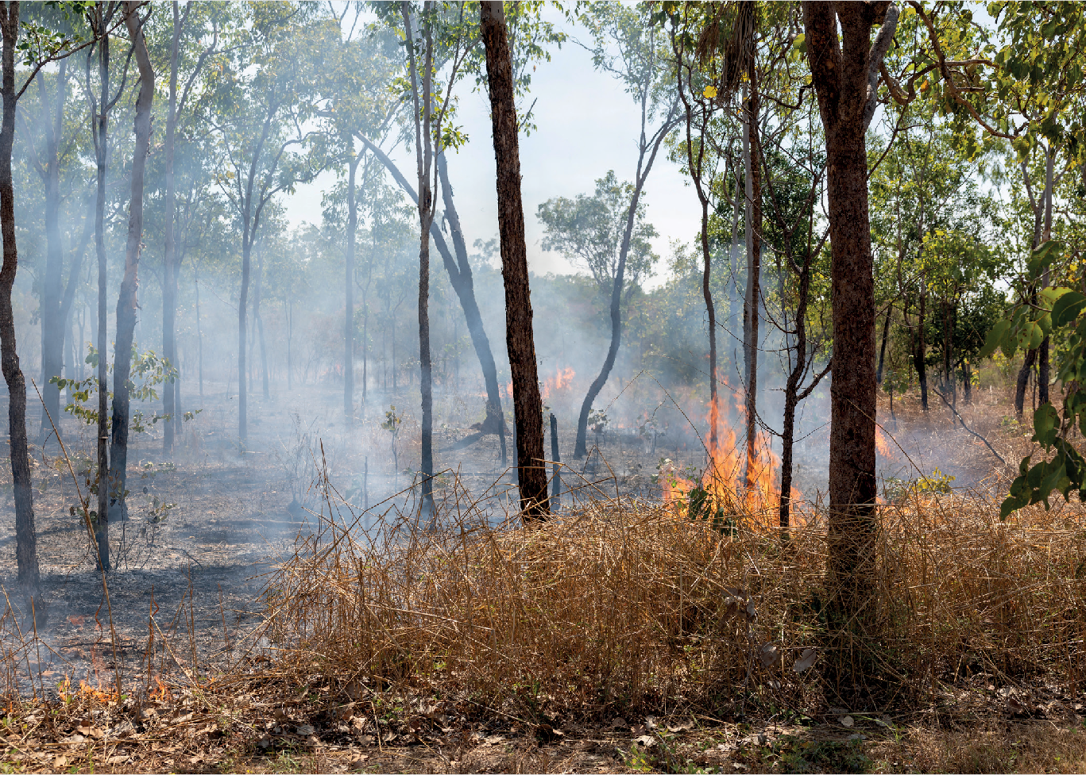

Box 3.2: Case study: First Nations traditional knowledge, savanna fire management and carbon
For thousands of years, First Nations peoples have used fire to care for Country, including smaller, cooler fires at the right time and place early in the dry season. These practices reduce fuel loads and create patchworks of burnt and unburnt country, lowering the risk of larger, hotter late dry season fires.
SFM is the clearest demonstration of First Nations knowledge informing the design and development of ACCU Scheme methods. The methods combine First Nations land management knowledge
with modern science, satellite monitoring and carbon accounting tools to estimate abatement from strategic early dry season burning.
The West Arnhem Land Fire Abatement project in the Northern Territory was the first major example of this approach. Covering 28,000 square kilometres, it began in 2006 and became a landscape-scale model for later savanna burning methods. The project was developed through collaboration between Traditional Owners, Indigenous ranger groups, scientists, government and industry partners. It has generated over 1.5 million ACCUs (ALFA, 2026).
SFM projects are an important source of ACCUs, and support First Nations employment, cultural practice, biodiversity protection and ongoing care for Country. In 2022–23, First Nations fire management in the West Australian Kimberley region avoided over 180,000 t CO2-e and continued to improve fire patterns across the region (Pollination Group, 2024). These projects provide a sustainable means for Indigenous rangers to look after Country and cultural values (Kimberley Land Council, 2024).
The SFM experience also shows why method development processes benefit from early, sustained engagement with people who hold practical, scientific and place-based knowledge of the activity being credited. In this case, engagement supported methods that reduce emissions while enabling ongoing land management practices with cultural, environmental and community benefits.

Updates made to SFM methods in 2026 were informed through deep consultation with First Nations groups. These updated methods better incorporate First Nations knowledge and reflect advances in measurement approaches by crediting carbon stored in living biomass and standing dead wood, alongside avoided emissions (DCCEEW, 2026a, 2026c). Previous
emissions-avoidance-only and the sequestration-and-emissions-avoidance methods were updated (DCCEEW, 2026h). The new methods are expected to increase ACCU supply, with forecasts anticipating annual ACCU issuance could increase from 1.6 million in compliance year 2024–25 to 4.4
million in 2029–30 (Reputex, 2026).
The Authority has previously recommended improving First Nations participation in the ACCU Scheme by:
- building capability for equitable access to carbon markets
- increasing resourcing to First Nations organisations
- supporting start-up funding for First Nations-led projects and supporting First Nations participation in method development (CCA, 2023).

The Government has responded to these recommendations, including through funding ERAC and the National Indigenous Australians’ Agency (NIAA) for First Nations engagement, and the Carbon Farming Outreach Program (CFOP) which provides support for ICIN to develop and deliver resources and training (DCCEEW, 2026m; ICIN, 2026b).
The Authority supports deeper and more genuine engagement with First Nations peoples.
Strengthening First Nations participation requires further alignment of the ACCU Scheme with FPIC principles (AIATSIS, 2020; DCCEEW, 2025b;
Indigenous Land and Sea Corporation, 2026).
It also requires conditions that support informed participation, and greater involvement in method development and scheme governance. These measures can help ensure First Nations peoples are not only consulted on carbon projects affecting Country, but are able to participate as project proponents, partners and decision-makers.
The Authority supports the Government’s commitment to introduce upfront and staged consent for projects on native title land as part of the draft 2026 amendments to the CFI Act (DCCEEW, 2026d). ICIN has welcomed these changes, describing the proposed amendments as a meaningful shift towards recognising and protecting First Nations rights and interests within Australia’s carbon market and closing the consent loophole (ICIN, 2026c). However, First Nations stakeholders have said further reforms will be required to ensure First Nations rights and interests are fully protected under the ACCU Scheme. Stakeholders have called for stronger
integration of FPIC principles into project approval processes, including to address information asymmetries and strengthen benefit sharing. For example, Kimberley Land Council recommended the CFI Act be amended to enshrine the principles of FPIC.
The Government’s proposed CFI Act amendments would introduce stronger consent requirements for ACCU projects on native title land and claimed native title land. However, similar arrangements do not apply uniformly across other land-use activities. For example, best-practice voluntary
guidelines aligned with FPIC exist for clean energy and mining sectors but are not a requirement
for projects to proceed (FNCEN, 2022; Storey & Ward, 2026).
Strengthening First Nations rights and interests in the ACCU Scheme should be pursued in a way that provides meaningful protections, while remaining practical and consistent with broader expectations for land-use decisions affecting Country. The Authority does not consider that carbon projects should face weaker consent and engagement expectations than other land uses, but nor should ACCU participation be made disproportionately difficult compared with other activities with significant impacts on Country.
The Authority suggests each of these existing pathways have a role to play in strengthening First Nations participation:
- expecting project proponents to comply with recognised conduct standards, such as the FPIC and agreement making guidance developed by ICIN (ICIN 2020, 2026d).
- ongoing funding for ERAC to support First Nations participation in method development
- increasing availability of information on benefit-sharing arrangements where appropriate
- publishing selected First Nations project attributes on the Unit and Certificate Registry.
Increasing the available information on the Unit and Certificate Registry is covered in Theme 4.4.

Regional and rural participation depends on trusted advice and capability
The ACCU Scheme delivers socioeconomic benefits for regional and rural communities. Carbon farming projects provide new revenue streams to landholders, support more diversified and sustainable farm businesses, improve climate resilience, strengthen natural capital and support regional jobs (CMI, 2025b; DCCEEW, 2022; South Australian Government, 2025).
3.3 Regional and rural participation depends on trusted advice and capability
The ACCU Scheme delivers socioeconomic benefits for regional and rural communities. Carbon farming projects provide new revenue streams to landholders, support more diversified and sustainable farm businesses, improve climate resilience, strengthen natural capital and support regional jobs (CMI, 2025b; DCCEEW, 2022; South Australian Government, 2025).
Box 3.3: Case study: Bonnie Doone Soil Carbon Project
Established in 2016, the Bonnie Doone Soil Carbon Project is a partnership between Bonnie Doone Beef Farm graziers and carbon project developer CarbonLink. Located in the North Burnett region of Queensland, the project covers over 5,000 hectares and has abated over 126,000 t CO2-e (Clima, 2025; CMI, 2025b).
The project increases carbon in soil in the agricultural system by altering the stocking rate and duration or intensity of grazing (CMI, 2025b). It delivered many non-carbon benefits to the farmers including improved soil health which bolstered drought resilience. It also created a new revenue stream contributing to more profitable farming in the wake of fluctuating climatic conditions and cattle prices (CMI, 2025b).

Expanding education and capacity-building for regional and rural communities remains important. The CFOP provides support for producers to explore options for managing emissions and storing carbon, including by delivering training for trusted independent advisers and an online knowledge hub (DAFF, 2025b).
Stakeholders welcomed these steps, but said gaps remain.
‘The Government’s CFOP provides a good national foundation for carbon market education among regional communities. CMI notes that there is still hesitancy from landholders over who to trust when assessing a potential project. Every effort should be made to ensure stakeholders across the value chain have access to clear, independent information, tools and resources.’
- Carbon Market Institute submission, 2026

Research by the New South Wales Government found 49% of farmers expressed high interest in generating carbon credits but reported low familiarity with carbon markets (New South Wales
Government, 2025). These findings underscore the need for clearer communication and practical guidance to help farmers understand how the ACCU Scheme works and whether participation is suitable for their circumstances.
Stakeholder feedback has suggested participation could be improved by expanding the CFOP to support more informed intermediaries, better tools, and more practical and locally relevant advice.

Regional planning can help align ACCU projects with local priorities
Regional plans can help align ACCU project development with local environmental, economic, cultural and social priorities. These include healthy country plans, caring for country plans, natural resource management (NRM) plans and bioregional plans.
Aligning ACCU project plans with regional priorities can support social licence for ACCU projects and the broader scheme. Regional plans are informed by local communities and can help identify where carbon projects may also deliver biodiversity, water, resilience, cultural and regional development outcomes.
‘Better alignment of carbon projects with NRM plans can support the achievement of numerous additional outcomes that align with Australian Government objectives for biodiversity and other outcomes, such as community development. Such alignment would also support social licence for the ACCU Scheme, because regional NRM plans are informed by, and developed in partnership with, the people that live in those regions.’
- NRM Regions Australia submission, 2026

The CFI Act already links ACCU projects to regional NRM plans. Section 22 requires project applications to include a statement about whether the project area is covered by a regional NRM plan and whether the project is consistent with it.
Stakeholders suggest this requirement may not be delivering its full potential because consistency is not routinely assessed or certified by the owners of regional plans.
‘From its inception the ACCU Scheme and Carbon Farming Initiative have been linked to regional NRM plans but only as a box-ticking exercise. That is, project proponents have had to declare whether their proposed project is consistent with a plan. However, this consistency is not required, and neither is the degree of consistency examined nor is there any process for the owners of the plans to certify or evaluate such consistency.’
- The Carbon Store submission, 2026

The Authority has not independently assessed the extent to which ACCU projects align with regional plans. However, stakeholder feedback indicates there may be scope to strengthen the practical role of regional planning in project
design, transparency and community confidence. This is consistent with the Authority’s 2023 recommendation that the Government expand the role of regional NRM plans and organisations in planning and establishing ACCU projects
and resource NRM organisations accordingly (CCA, 2023). The Government accepted this recommendation in principle and indicated it would
further explore the role of NRM organisations through Stage 3 ACCU Review reforms, but these changes are not included in the proposed 2026 CFI Act amendments (DCCEEW, 2026d).
As the Government progresses this work, it could consider how project proponents engage with relevant regional plans, including healthy
country plans, caring for country plans, NRM plans and bioregional plans. This would need to be designed carefully to improve project quality and regional alignment without creating unnecessary participation barriers.

Nature Repair Market interaction creates opportunities and integrity questions
The Nature Repair Market is designed to work alongside the ACCU Scheme. It is a national, legislated biodiversity market with methods that set out project requirements, like the ACCU Scheme (DCCEEW, 2026j). Where project proponents meet the requirements of both schemes, a project may be able to generate ACCUs and Nature Repair Market biodiversity certificates from the same area of land. This is described as stacking.
Stacking can support integrated land-management outcomes and make some projects more viable.
For example, a landholder may establish native vegetation that generates ACCUs through carbon sequestration, while also delivering measurable improvements in habitat quality recognised through a biodiversity certificate under the
Nature Repair Market. Projects can only be stacked where they meet the requirements under both schemes, such as the ACCU Scheme’s additionality criteria. These requirements help maintain the integrity of carbon and biodiversity outcomes and manage additionality and double-counting risks.
The first Nature Repair Market method – Replanting native forest and woodland
ecosystems method – was made in 2025, and allows stacking with the ACCU method Reforestation by environmental or mallee
plantings Full Carbon Accounting Model (FullCAM) method 2024 (CER, 2026i; DCCEEW, 2025d).
Projects under this method cannot be used as regulatory biodiversity offsets. The recent 2025 reforms to the Environment Protection and Biodiversity Conservation Act 1999 (EPBC Act) allow Nature Repair Market methods to specify whether biodiversity certificates can be used as environmental offsets, subject to additional requirements. The CFI Rule 2015 excludes
activities that compensate or offset environmental impacts, so Nature Repair Market projects used for offsetting cannot also receive ACCUs.
Stakeholders supported interoperability between the ACCU Scheme and Nature Repair Market.

‘The ACCU Scheme and the Nature Repair Market align and are designed to work together with shared administration by the CER, common tools, and methodologies in the Nature Repair Market that will permit stacking of projects. Interoperability is essential so that landholders can participate in both without unnecessary duplication or potential integrity risks.’
- Carbon Market Institute submission, 2026

As the Nature Repair Market grows, scheme design, registry functionality and guidance should support integrated projects while maintaining appropriate delineation of carbon, biodiversity and regulatory offset claims.

Theme 4: Market settings and investment confidence

Key points
    - ACCU demand now depends heavily on Safeguard Mechanism policy settings, particularly baseline decline rates and rules for ACCU use.
    - ACCU supply, demand and price outlooks are uncertain. Forecasts vary because analysts make different assumptions about safeguard demand, project delivery, technology deployment, method development, and the availability of existing ACCU holdings.
    - These differences matter for investment confidence. Carbon projects often involve upfront capital investment, long lead times and policy risk. Investors need more information about future demand, supply and policy settings to help manage risk.
    - Policy settings involve trade-offs. More ACCU supply can reduce safeguard compliance costs but also reduce incentives for higher-cost ACCU projects or onsite abatement. Stronger safeguard settings can increase demand for ACCUs and onsite abatement but also increase the cost of meeting safeguard obligations and reduce industry competitiveness.
    - Market transparency and registry interoperability are practical responses. Better project-level, unit-level and transaction information would support due diligence, price discovery, independent analysis and confidence in ACCU integrity.
    - Land-use trade-offs are important. Available evidence does not indicate widespread displacement of high-value agricultural land by ACCU projects to date. A broader look at potential cumulative land-use trade-offs and opportunities could be useful to guide future policy decisions.

The ACCU market is created and shaped by Australian Government policy. Supply depends on approved methods, project registration, crediting rules, permanence settings and issuance.
Demand is increasingly driven by the Safeguard Mechanism and will be affected by future decisions on baseline decline rates, Safeguard Mechanism credit units (SMCs) and rules for ACCU use.
This creates opportunities and risks. ACCUs can lower compliance costs, support more ambitious safeguard settings and mobilise private investment in abatement. However, carbon projects often require upfront capital and long lead times, so investment depends on confidence in future demand, integrity and policy settings.
Forecasts of ACCU supply, demand and prices are uncertain. Government projections provide an important reference case under current policy
settings (DCCEEW, 2025a), but stakeholders and market analysts contend that future demand may be higher, supply may be slower to materialise, and existing ACCU holdings may not be readily available to the market. This theme does not seek to resolve all forecast differences. It focuses on why uncertainty matters, how policy settings involve trade-offs, and how better transparency, data access and registry functionality can support confidence in the market.

The ACCU market is shaped by policy
The ACCU market is a product of Government policy. ACCUs can only be generated under approved methods, and demand is shaped by compliance obligations, government purchasing, voluntary cancellation and other policy settings. This means policy design affects both the amount of ACCU supply that can come forward and the demand for ACCUs over time.
This does not mean policy settings should seek to set an ACCU price. ACCU prices are determined by market participants. However, predictable policy settings, credible information and clear signals about future demand and supply are important for investment confidence.
Recent reforms have increased the role of private demand, particularly through the Safeguard Mechanism. This has changed the market from one primarily driven by Australian Government purchasing to one where the Safeguard Mechanism is central to ACCU market dynamics. Facilities covered by the Safeguard
Mechanism can use ACCUs, SMCs and other flexibility mechanisms to manage their compliance obligations. As baselines decline, demand for ACCUs is likely to increase.
The Safeguard Mechanism covered 208 large facilities, responsible for 132 Mt CO2-e of gross national emissions in 2024–25 (CER, 2026d). Under current policy settings, facility baselines decline by 4.9% each year to 2030. Post-2030 decline rates are to be set through the Australian Government’s 2026–27 Safeguard Mechanism review, informed by the Authority’s input (CCA, 2026b).
The shift in ACCU demand is visible in ACCU use data (Figure 4.1). Safeguard-related surrenders increased sharply following the 2023 reforms and now account for most ACCU demand. In 2024–25, safeguard compliance accounted for around 80% of ACCUs surrendered or cancelled, with voluntary and other non-safeguard purposes accounting for the remainder.

ACCUs (millions)

Figure 4.1: ACCU surrenders, cancellations and delivery to Government

Source: Authority analysis of (CER, 2023), September quarter 2023 to March quarter 2026 and (CER, 2026h)5.
16

14

12

10
Carbon abatement contract delivery
8
Non-safeguard
6 cancellations
4
Safeguard surrenders
2

0
2019
2020
2021
2022
2023
2024
2025
2026

5 Cancellations includes ACCUs cancelled for voluntary purposes and non-safeguard compliance and cancellations by or on behalf of government entities

This shift means future ACCU demand will depend heavily on safeguard settings, including post-2030 baseline decline rates, the availability of SMCs and any future rules for ACCU use. Changes to these settings will be determined following the Government’s current Safeguard Mechanism review, but they will directly affect ACCU demand, prices and investment incentives.
Voluntary buyers and government purchasing remain relevant, but they are no longer the dominant sources of ACCU demand. Businesses may also buy and cancel ACCUs to meet voluntary targets or certification requirements. Government demand now largely reflects delivery under remaining Carbon Abatement Contracts. These ACCUs are used to support the Safeguard Mechanism cost containment measure (CER, 2026c).

Supply, demand and price outlooks are uncertain and contested
Government projections provide an important reference case for ACCU supply and demand under current policy settings (Figure 4.2). They show ACCU issuance increasing over time, demand growing as safeguard baselines decline, and a substantial stock of ACCUs remaining in holdings through much of the projection period (CER, 2026h; DCCEEW, 2025a).
However, projections are not, and should not be read as, a definitive forecast of future market conditions. They assume current safeguard settings, and currently available information about project delivery, method availability, technology deployment, market behaviour and the availability of existing holdings. In particular, they assume a 4.9% baseline decline rate to 2030 and the statutory indicative default decline rate of 3.285% from 2031 (DCCEEW, 2025e).
The Government’s 2026–27 Safeguard Mechanism review will consider the decline rates for 2030–31 to 2034–35, informed by the Authority’s advice (CCA, 2026b). Stronger post-2030 decline rates would increase the net emissions reduction task for covered facilities and would be expected to increase demand for ACCUs and SMCs.

Figure 4.2: ACCU supply, demand and private holdings
ACCUs (Millions)

Source: (CER, 2026g; DCCEEW, 2025a)
90
80
Holdings
(ACCUs + SMCs)
70
60
50
40
Projected holdings
(ACCUs + SMCs)
Surrenders and cancellations
30
20
Projected demand
10
ACCUs issued
0
Projected issuance
2020
2021
2022
2023
2024
2025
2026
2027
2028
2029
2030
2031
2032
2033
2034
2035
2036
2037
2038
2039
2040
Note: Projections are based on policy settings and decline rates at the time of original publication.

Existing registered projects are expected to continue generating ACCUs, but the composition of supply will change over time (Figure 4.3). Issuance from already registered projects will decline over the period to 2035, while new projects provide an increasing share of future issuance (Reputex, 2026). Maintaining and growing supply will depend on the successful development of new methods and projects.

Figure 4.3: Projected ACCU issuance from registered and new projects
ACCU supply (millions)

Source: (Reputex, 2026).
45
40

35

30
25

20

15
New
Registered
10
5

0
2025 2026 2027 2028 2029 2030 2031 2032 2033 2034 2035
Compliance year
Note: This figure shows projected issuance from registered projects and new projects. It does not distinguish between supply from existing methods, remade methods and new methods.

Forecasts of ACCU supply and demand differ because assumptions differ. This is expected in a market with long project lead times, evolving policy settings and uncertain technology deployment. However, large differences in assumptions can make it harder for project proponents, investors and safeguard facilities to plan. It can heighten perceived policy risk, increase due diligence costs, delay investment decisions and make it harder for Government and market participants to form a shared view of whether settings are well calibrated.
The availability of existing holdings is a key example. ACCU holdings have increased in recent years, and safeguard or safeguard-related entities now hold a large share of ACCUs (Figure 4.4). Holdings can help these entities manage near-term compliance and price risks, but these aggregate holdings are not necessarily readily available for sale. Some units may be held for future compliance, contractual commitments, voluntary claims, risk management or strategic reasons. Holdings should therefore be interpreted as a potential buffer, not as a fully liquid supply source.

Figure 4.4: ACCU holdings by participant type
ACCUs (millions)

Source: (CER, 2026h).
45
40
35
30
25
20
15
10
5
0
Safeguard ACCU Intermediary and related project
proponent
Cost containment measure
Government Business

Supply uncertainty is also linked to method and project performance. Human-induced regeneration (HIR) projects have, to date, been the largest cumulative source of ACCUs, but new project registration concluded with the expiry of the method in 2023 (CER, 2025; Figure 4.5). The Integrated Farm and Land Management (IFLM) method is intended to include land-based sequestration activities such as planting and regeneration of native forest, with more activities to be added over time. Development of the method has taken much longer than expected, with a final draft method expected for ERAC consideration by the end of 2026 (DCCEEW, 2026l). The method has attracted significant stakeholder interest as a potential successor to HIR and may therefore influence expectations regarding future land sector ACCU supply.
Soil carbon project registrations have increased strongly, but only a small proportion of projects have received credits to date, and future issuance remains uncertain.

Figure 4.5: ACCU project registrations and issuance by method
Number of projects
1000
900
800
700
600
500
400
300
200
100
0
ACCUs issued (millions)
70
60
50
40
30
20
10
-

Source: (CER, 2026a).
Soil carbon
HIR
Reforestation
Plantation
Landfill gas
SFM
Avoided deforestation
Other waste
Energy efficiency
Other
HIR
Landfill gas
Avoided deforestation
SFM
Other waste
Reforestation
Energy efficiency
Managed regrowth
Other
Note: Project registrations and ACCU issuance measure different things. High project registrations do not necessarily translate into substantial issued ACCUs.

On the demand side, setting safeguard baselines in 5-year increments helps establish a predictable framework while ensuring policy settings can
be calibrated to national objectives and latest information. Setting decline rates earlier may increase investor confidence in the near term. However, it would reduce flexibility to respond if circumstances change and may ultimately result in policy shifts which damage rather than support investor confidence.
The Government’s Carbon Abatement Contract exit arrangements also affect near-term supply and prices. The average ACCU price across historical Government auctions was around
$12.10, while recent spot market prices have been around 3 times that (CER, 2023; Reputex, 2026). Permanent contract exit arrangements were announced in December 2025. These arrangements allow eligible contract holders
to sell the majority of their contracted ACCUs into the secondary market instead of delivering them to Government. This increases near-term availability of ACCUs in the secondary market and places downward pressure on prices.
The scale of the effect is uncertain because participation in the arrangements will depend on project-specific circumstances and the extent to which eligible contract holders choose and are able to exit contracts.
Despite this uncertainty, generic ACCU prices have been relatively stable in recent years, trading broadly in the mid-to-high $30 range. This provides important context for longer-term forecasts. Market analysts project, by 2030, prices in the range of $38 to $79 per ACCU. By 2035, forecasts widen further, from $44 to $139 per ACCU.
The variance in price forecasts reflects differing assumptions about future market conditions. On the demand side, assumptions include changes in the Safeguard Mechanism decline rate, Safeguard Mechanism coverage and voluntary demand. On the supply side, assumptions vary regarding potential future crediting under new methods, and the impact of the Government’s contract exit arrangements.
Stakeholders raised concerns that price uncertainty affects investment decisions. Downside price risk is particularly relevant for higher-cost project types, including environmental plantings and emerging activities. Some stakeholders argued that stronger protection against downside risks, or clearer long-term demand signals, would support investment.

‘Protection against downside price risk of credits removes a key impediment for capital investment in emerging industries such as bioenergy.’
- Orange New Energy and Oil Mallee Association Australia submission, 2026

‘For example, revisions to the landfill gas method are expected to introduce substantial new credit volumes, which may place downward pressure on prices and undermine the viability of higher cost project types such as environmental plantings.’
- South Pole Australia submission, 2026

The Authority acknowledges stakeholder concerns about uncertain market conditions but also recognises exposure to price risk is an inherent feature of all markets. Lower ACCU prices do not necessarily indicate market failure. They may reflect the availability of lower-cost abatement, which can reduce safeguard compliance costs and support more ambitious settings. Price discovery, whereby market participants identify the value of abatement through their interactions, is a core function of carbon markets. Nevertheless, very low or uncertain prices can weaken incentives to invest in higher-cost ACCU projects that may be important for public benefits, diversity of supply or meeting future abatement goals.
Taken together, evidence points to substantial uncertainty about future ACCU supply, demand and prices. While different forecasts are a normal feature of any market, the important issue for this review is whether market participants have enough information to understand those differences, test assumptions and make informed decisions. This supports the case for improved transparency, data access and registry functionality discussed in section 4.4. The Authority will also continue to engage stakeholders on this issue to build a better shared understanding of the market.

Policy settings involve trade-offs
Policy settings can affect ACCU supply, demand, prices, onsite abatement incentives and safeguard compliance costs in different ways. There is no single preferred ACCU market outcome. Lower ACCU prices can reduce compliance costs and enable stronger safeguard baseline decline rates – but they may also weaken incentives to bring on higher-cost ACCU projects and onsite abatement at safeguard facilities. Higher ACCU prices can support investment in new supply and strengthen incentives for onsite abatement – but the increased compliance costs for facilities may make achievement of strong decline rates unfeasible. Increases in compliance costs may also have broader implications for trade-exposed industries, including impacts on the international competitiveness of Australian exports.
Stakeholders expressed different views about how these trade-offs should be managed. Some emphasised the role of ACCUs in supporting least-cost emissions reductions and maintaining flexibility for safeguard facilities.
‘As the Productivity Commission advises in its recent interim report on net zero transformation, the use of ACCUs by Safeguard Mechanism facilities should remain unrestricted so that the scheme continues to encourage least-cost emissions reduction across the economy.’
- Australian Energy Producers submission, 2026

Others argued that safeguard settings should place greater emphasis on onsite abatement and reduce reliance on offsets.
‘The Australian Government should reform the ACCU Scheme – and its use under the Safeguard Mechanism – to prioritise onsite abatement, phase down reliance on offsets, and prohibit the use of ACCUs to enable new or expanded fossil fuel production.’
- Greenpeace Australia Pacific submission, 2026

These competing views reflect real policy trade-offs. This review addresses some of these policy choices. Others are better considered through the Government’s 2026–27 Safeguard Mechanism review (and the Authority’s input to that review). Table 4.1 summarises some of the main interactions.

Table 4.1: Policy options and potential market effects

Policy setting | Main effect | Likely ACCU market effect | Where best considered
Faster method development or more eligible methods | Increases potential ACCU supply if methods are scalable and trusted | May reduce prices or moderate price increases if supply is material | ACCU Scheme review/ method roadmap  Theme 5
Higher post-2030 safeguard  decline rates | Increases the net emissions reduction task for covered facilities | Likely to both increase demand for ACCUs and strengthen onsite abatement incentives | Authority input to Safeguard Mechanism review
Discounting ACCUs used for safeguard compliance | Increases demand by requiring more than one ACCU to offset one tonne above baseline | Could cause ACCU and SMC prices to diverge, strengthen onsite abatement incentives, increase safeguard compliance costs and reduce competitiveness of covered facilities. May increase total abatement achieved in some circumstances | Authority input to Safeguard Mechanism review
Limits on ACCU use | Requires more abatement onsite | Could cause ACCU and SMC prices to diverge, strengthen onsite abatement incentives and increase safeguard compliance costs. May increase  total abatement achieved in some circumstances | Authority input to Safeguard Mechanism review
Targeted Government purchasing | Increases demand for selected ACCU types (e.g. those with co-benefits) | Stimulates supply from selected project types, increases public benefits. Could increase ACCU prices and, in turn, costs for safeguard facilities. Could also reduce competitiveness of safeguard facilities to some extent | ACCU Scheme review Theme 3
Better data and registry interoperability | Improves due diligence and price discovery | May improve confidence and liquidity, and in turn market efficiency | ACCU Scheme review  Theme 4
Changes to cost  containment settings | Changes the price, volume or access  arrangements for Government-held ACCUs available to safeguard facilities | A higher cost containment price may strengthen signals for new ACCU supply and incentives for onsite abatement but increases potential compliance cost and may reduce industry competitiveness. Lower prices or greater access may reduce compliance costs, but could dampen investment incentives for new ACCU supply and onsite abatement | Government’s Safeguard Mechanism review
Expanded safeguard coverage | Brings more facilities or emissions sources into the Safeguard Mechanism | Likely to increase demand for ACCUs and increase onsite abatement opportunities. May increase compliance costs and regulatory burden for newly covered facilities | Government’s Safeguard Mechanism review

Better transparency and registry functionality would support confidence
Better market information would help participants manage risk and uncertainty. As the ACCU market becomes more compliance-driven, market participants could benefit from understanding not only how many ACCUs exist, but what attributes they have, how they were generated, what risks may affect their use, and how supply and demand are changing over time.
Stakeholders have consistently called for more accessible, comparable and reusable information about ACCU projects, unit attributes, issuance, holdings and transactions. This information would support due diligence, price discovery, independent analysis and confidence in ACCU integrity.
‘The demand side of the market ordinarily expends considerable resources conducting its own project level due diligence… and this can be minimised with more transparent project level information.’
- Business Council of Australia submission, 2026

CER and DCCEEW have already made important transparency improvements. Recent reforms have expanded information available through the ACCU project register and Unit and Certificate Registry. Further integrity and transparency reforms are also under consideration (CER, 2026e; DCCEEW, 2026m).
Nevertheless, stakeholders report that information can still be difficult to access, interpret or reuse, and is not always available in forms that support comparison across projects, independent analysis or
integration with market systems. Some project information can be linked to an ACCU through the project ID, but that does not make key project-linked attributes readily available and usable at the unit level. For example, information such as permanence period may be available through project records, but it may not be immediately accessible to buyers and analysts in the registry.
Improving the accessibility and usability of information across the Project Register and the Unit and Certificate Registry could reduce these frictions. Transparency improvements are most valuable where they support practical market functions, including due diligence, valuation, assurance, contracting and automated compliance processes.
Registry functionality is also important. CER has identified interoperability as a priority, including stronger connectivity between the Unit and Certificate Registry and external systems, trading platforms and
data services. CER also identified legislative, regulatory or system changes needed to support modern registry functionality. Further work to progress these identified changes would support modern registry functionality while maintaining account integrity, security, fit-and-proper-person requirements, privacy and commercial confidentiality.
The objective is not to require publication of all information or remove confidentiality protections. Rather it is to ensure information held within the ACCU Project Register and Unit and Certificate Registry can be more readily accessed, compared and linked by users. This would support due diligence, price discovery and confidence in the ACCU market.

Recommendation 4:
Give buyers clearer information about the carbon credits they are buying.
Build on CER register, data services and registry reforms by improving access to detailed, standardised and reusable project, unit and market information by:
- improving visibility of material ACCU attributes and project-level information relevant to due diligence and valuation across the Project Registry and the Unit and Certificate Registry
- improving the accessibility, comparability and reusability of project, unit, holdings and transaction information
- progressing any legislative, regulatory or system changes needed to support modern registry interoperability and secure system-to-system functionality.

Land-use trade-offs need monitoring beyond the ACCU Scheme
Land-use change is of strong interest to landholders, regional communities and agricultural industries. Stakeholders raised concerns that rising demand for ACCUs could encourage conversion of agricultural land to carbon projects. Increased conversions could have potential impacts on food production, regional employment, community identity and neighbouring landholders.
‘High offset demand risks driving land-use change at a scale that affects food production, regional economies and community identity.’
- Australian Dairy Farmers submission, 2026

Land-use decisions are ultimately made by landholders in response to market conditions, land capability, expected returns, risk, regulatory requirements and personal or business objectives. ACCU projects create new income opportunities, particularly on lower-productivity or marginal
land. However, the Authority heard concerns from stakeholders that high returns for carbon projects may displace agricultural production, which could have cumulative impacts on local economies.
There are existing controls in place to address land-use impacts from ACCU projects.
Landholders must comply with a range of regulatory and other requirements before undertaking ACCU projects, including obtaining relevant approvals under Federal, state and territory laws, and obtaining consent from eligible interest holders (Business Queensland, 2020; CER, 2025a; NSW DPIRD, 2025). Projects may also be subject to water-related approvals and local planning restrictions, depending on project type and location.
Under the ACCU scheme’s Plantation Forestry method, proponents proposing to convert non-forest land to forest must notify the Department of Agriculture, Fisheries and Forestry (DAFF) before applying to register the project. This enables the Minister for Agriculture or delegate, supported by DAFF, to assess whether the project would have an undesirable impact on agricultural production in the region. If the Minister or delegate forms that view, the project is excluded from being declared
an eligible offsets project under the ACCU Scheme (DAFF, 2025a; DCCEEW, 2024b).
The Authority’s preliminary analysis does not indicate widespread overlap between ACCU project areas and agricultural land at the national scale to date. Our spatial analysis indicates ACCU project areas are concentrated on grazing native vegetation and non-agricultural land uses (Figure 4.6). Around 1% of total ACCU project area is
on land classified as cropping, horticulture and intensive animal production, 2% is on grazing on irrigated pasture, around 59% is on grazing native vegetation, and 39% is on non-agricultural land uses (Table 4.2).

Table 4.2: Proportion of current ACCU project area by land-use type

Land use type* | Percentage of ACCU project area
Cropping, horticulture and intensive animal production | 1%
Grazing on irrigated pasture | 2%
Grazing on native vegetation (rangeland grazing) | 59%
Non-agricultural land use | 39%

Source: Authority analysis based on CER data.
Note: Percentages may not sum to 100% due to rounding.
* Land use types are based on ABARES land use classifications.



Figure 4.6: ACCU project areas overlaid on land-use type

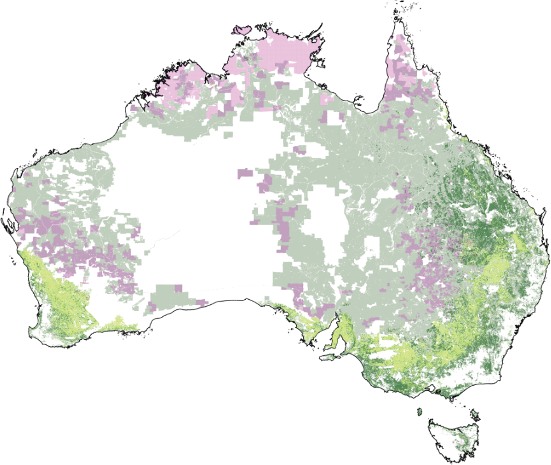


Grazing native vegetation Grazing modified pastures
Cropping, horticulture and intensive animal production Non-agricultural land use
CER ACCU project areas

Source: Authority analysis based on (ABARES, 2026a; CER, 2026a).

The national map (Figure 4.6) illustrates where current ACCU project areas overlap with broad Australian Bureau of Agricultural and Resource Economics and Sciences (ABARES) land-use categories. It presents a current-state snapshot of registered ACCU project areas, not a forecast of future land-use change. Biodiversity and nature repair projects are likely to overlap with productive agricultural landscapes because biodiversity assets, remnant vegetation and habitat restoration opportunities are often located within cleared
and actively managed farming regions. As these schemes encourage activity and other market, social and transition-related land uses emerge, the landscape will continue to change.
The analysis has an important spatial caveat. ACCU ‘project areas’ do not necessarily represent land taken out of agricultural production. In many land sector methods, only part of a registered project area actively contributes to carbon abatement. These areas are known as ‘carbon estimation areas’ and are generally a subset
of the total project areas. Estimates based on project area will therefore tend to overestimate the
potential impact of the ACCU Scheme. Figure 4.7 illustrates this difference using publicly available data for NSW projects where both project and carbon estimation areas are available. Land that is within a project area may be excluded from carbon estimation areas where the land is ineligible,
such as where baseline forest already exists, or is unsuitable for revegetation. Early analysis suggests approximately one third of the area of these projects contributes directly to quantified carbon abatement.
Further, the existence of a project does not necessarily exclude agricultural activity. Projects may occur on land that is unsuitable for agriculture and some project types may be compatible with, or complementary to, ongoing agricultural activities, such as soil carbon projects.
Results of this preliminary analysis should be interpreted with caution given potential inaccuracies in the underlying land-use and
project data. Land uses may also have changed since the ABARES land use mapping exercise was completed.

Figure 4.7: Project areas and carbon estimation areas in northwest NSW

ACCU project carbon estimation areas ACCU project areas
Source: Authority analysis based on (ABARES, 2026a; CER, 2026a).
Note: only includes projects that have both a project area and carbon estimation area available

This analysis suggests ACCU projects have had limited national-scale overlap with high-value agricultural land to date. However, national results can mask localised impacts, for example, where projects are concentrated in particular districts, where landholders and communities
perceive competition between carbon projects and agricultural production, or where projects interact with other land-use pressures.
Achieving net zero at least cost is expected to require substantially more sequestration of carbon on land to balance residual emissions elsewhere in the economy. Still, sequestration and the value of agricultural production can grow in tandem rather than directly compete. ABARES has built on Treasury’s modelling for the Government’s
Net Zero Plan to assess how revegetation and managed regeneration sequestration projects may influence land use, agriculture and regional economies (ABARES, 2026b).
Under a scenario where Australia transitions to net zero by 2050, ABARES estimates around 18 million hectares of sequestration project development cumulatively by 2050, which is equivalent to 4% of agricultural land in Australia. This is estimated to generate landholder profits of around $9 billion annually in 2050. Over the
same period, agricultural revenue is estimated to increase by 39%. Additional findings include:
- 45% of the area will be established in the pastoral zone
- 55% is estimated to occur in the wheat-sheep and high rainfall zones
- 59% of the area would retain some agricultural production.
Under a scenario without land-based sequestration, ABARES estimates agricultural revenue increases by 42% – this corresponds to an additional $2.8 billion of agricultural revenue in 2050. However this scenario foregoes the $9 billion of landholder profits from sequestration projects in 2050.
Land-use pressures are broader than the ACCU Scheme. Land use has changed substantially over the past decades in response to policy, markets and social and environmental drivers. It will continue to change in response to these drivers.
A broader assessment is needed to understand the cumulative land-use trade-offs across the transition and the opportunities available for new economic development.
The Authority sees merit in integrated analysis of how much land may be needed, where pressures are likely to arise, and how food production, carbon sequestration, biodiversity, energy infrastructure and regional development objectives can be managed together. The
Authority plans to consider this issue further in its 2026 Annual Progress Advice, including whether a dedicated piece of work is needed to guide future policy decisions.

Theme 5: Method development
Key points
- Method development is the primary supply-side lever in the ACCU Scheme because only activities covered by an approved method can generate ACCUs.
- Recent reforms have improved the method development process, including the proponent-led model, clear triage criteria, Expression of Interest (EOI) summaries, method tracking and DCCEEW process guidance.
- Current projections do not suggest ACCU supply problems in the near term under existing policy settings, but future demand, long development lead times and uncertainty about major supply sources mean forward planning remains important.
- A strategic forward view, or roadmap, of method development and review would help governments, proponents and investors understand where and when to focus their effort, what dependencies must be resolved, and when existing methods may require review. This could lead to a more predictable, diverse and resilient ACCU supply.
- A roadmap would enhance, not replace the Emissions Reduction Assurance Committee’s (ERAC) prioritisation advice or the proponent-led process.

Method development is the primary supply-side lever in the ACCU Scheme. Only activities covered by an approved method can generate ACCUs.
Methods therefore determine which activities can participate, how abatement is measured and when new supply can come to market. Methods and projects take time to develop so decisions
made now will shape the supply available later this decade and beyond (Box 5.1).
Recent reforms have improved the method development process, such as:
- the Government has introduced a proponent-led model
- the Minister has determined triage criteria for ERAC to apply to proposals
- DCCEEW has published process guidance
- the method tracker provides visibility of methods already in train.
These reforms will take time to mature. This review does not assess specific method gaps or rank individual method proposals. Its focus is on the process and planning framework for method development.

Box 5.1: How ACCU methods are developed

What is a method?
An ACCU method sets out the rules for generating ACCUs from a specific activity (DCCEEW, 2026i). It defines:
- the activity that can generate emissions reductions or sequestration
- how abatement is measured and calculated
- conditions for project eligibility and crediting
- monitoring, reporting and verification requirements.
Only activities covered by an approved method can generate ACCUs. Methods therefore determine which parts of the economy can participate in the scheme and how abatement is quantified.

How are methods prioritised for development?
New and varied methods are proposed through the proponent-led method development process (DCCEEW, 2026n). Prospective proponents can submit potential methods for consideration during scheduled expressions of interest rounds. ERAC assesses proposals against the legislated Offsets Integrity Standards and published triage criteria, including abatement potential, implementation complexity, readiness of measurement approaches, integrity risks, innovation potential and broader policy alignment (DCCEEW, 2026e).
ERAC provides advice to the Minister on which proposals should be prioritised for development. Prioritised methods then move through detailed design, public consultation, independent assurance and final ministerial consideration before they can be made as legislative instruments (DCCEEW, 2026e).

What reforms have been made?
Recent reforms have strengthened the transparency, prioritisation and governance of method development (DCCEEW, 2026g), such as:
- the proponent-led method development process, allowing proponents to identify and propose new method opportunities
- published triage criteria, giving proponents clearer information on how proposals are assessed
- ERAC’s EOI assessment summaries, explaining why proposals have or have not been prioritised
- DCCEEW’s method development process guide, setting out stages, roles and indicative timeframes
- the ACCU method tracker, providing visibility of methods currently in force, under development or under review.
These reforms have improved openness and participation. The next task is to provide clearer strategic visibility about future method priorities, timing and review triggers, and to improve delivery of prioritised methods.

Method development as a supply-side lever
Demand for ACCUs is projected to rise as Safeguard Mechanism obligations tighten and covered entities seek credible offsets for emissions (DCCEEW, 2025a). Given the time
required to develop methods, register projects and generate credits, ACCU supply to 2030 will depend on methods and projects already in place or close to implementation. The Clean Energy Regulator’s June 2025 Quarterly Carbon Market Report recognises this trend, and notes new method and project development are essential for securing future supply (CER, 2025c).

Current projections suggest supply is manageable, but uncertain
Current Government projections suggest ACCU supply is expected to broadly keep pace with demand under existing policy settings (see Theme 4.3). Future ACCU demand could be higher
if post-2030 Safeguard Mechanism settings are strengthened to align with Australia’s 2035 emissions reduction target. A higher baseline
decline rate would increase demand for ACCUs and place additional pressure on supply. This means method development does not need to respond to an immediate supply cliff, but it does need to occur far enough in advance to meet future demand and maintain confidence in the market.
Supply also remains uncertain because the major sources of ACCUs are changing. The IFLM
method is expected to provide a potential pathway for a range of land sector activities, including native vegetation regeneration and revegetation activities. While the IFLM method remains
under development, the level of market interest highlights the importance of maintaining visibility over prospective future sources of ACCU supply, particularly where development timelines may span several years. The development process of IFLM also underscores the challenge of ensuring that future ACCU supply pathways are identified, prioritised and progressed sufficiently in advance of future demand. This follows the expiry of the human-induced regeneration method in 2023.
Similarly, soil carbon project registrations have increased strongly, but only a small share of these projects have received credits to date. New and updated savanna fire management (SFM) methods may add material supply by crediting both avoided emissions and sequestration, and the new landfill gas method has improved supply expectations by extending crediting opportunities from landfill projects.
These factors underscore the challenge and point to a need for better forward planning, rather than urgent expansion of the method portfolio.
Method development needs to occur strategically and sufficiently far in advance so projects can be developed, registered and generate ACCUs when future demand requires them.
Figure 5.1 shows existing and in-development methods that can support ACCU supply but also highlights why clearer forward planning is needed as older methods close, expire or are remade.

The method tracker and ERAC’s published EOI assessment summaries provide useful transparency about methods in force, methods in development and proposals considered (DCCEEW, 2026b, 2026f). A roadmap would build on these tools by providing a prospective view of areas for future method development, key dependencies, review points, and help
proponents and investors understand how method development may support ACCU supply over time.
Because method development takes time, delays can create risks for market depth, price stability and the availability of high-integrity abatement.
A forward roadmap would help manage these risks by providing guidance on method areas likely to deliver material, additional, measurable and cost-effective abatement within relevant policy timeframes. The roadmap would also help align method priorities with forecast demand, development lead times, departmental and proponent capacity.

Figure 5.1: Existing, recently expired and anticipated new ACCU methods
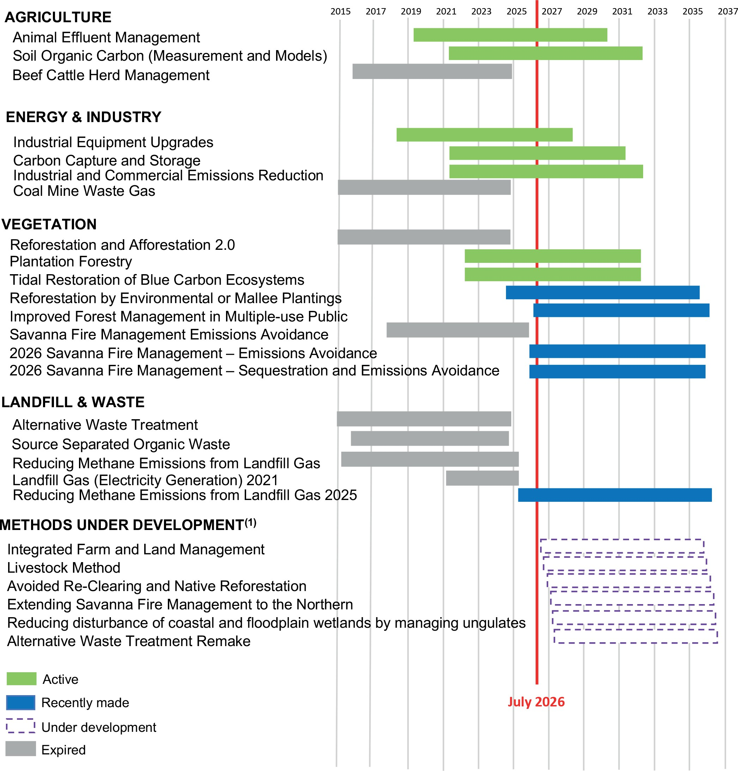
(1) Timeframes for methods under development are illustrative only and not indicative of delivery dates

Source: Authority analysis, 2026.

Some potential method areas do not yet have a clear pathway
The proponent-led method development process has generated substantial interest in new and varied methods. DCCEEW’s 2024 EOI process identified 39 proposals with potential abatement value, but only 4 were prioritised for near-term development. Some EOI proposed activities also face unresolved barriers, including measurement complexity, legislative eligibility or technology readiness (DCCEEW, 2026f).
The submission of numerous EOI proposals does not, of itself, establish an immediate need to
expand the method portfolio. They do however illustrate why a roadmap would be useful. A roadmap could show where future proponent-led proposals would be particularly valuable.
Method development is also only one way of supporting emissions reduction and carbon removal activities. Some activities may be more effectively supported through research and development programs, demonstration projects, innovation funding, procurement mechanisms, regulatory reform or other policy approaches.
The existence of a potentially beneficial activity does not necessarily imply a need for a new ACCU method (Refer to Section 1.2).

Box 5.2: Why some engineered removals are not yet eligible under the ACCU Scheme
Some engineered carbon dioxide removal activities may be important for Australia’s longer-term transition to net zero but are not yet clearly eligible for ACCU crediting. The Carbon Farming Initiative (CFI) Act defines sequestration projects by reference to removing carbon dioxide from the atmosphere and storing carbon in living biomass, dead organic matter or soil. This accommodates biological and land-based sequestration activities but does not clearly extend to engineered storage pathways such as direct air capture with geological storage, mineralisation, enhanced weathering or long-lived engineered products.
The legislative definition would need to change to enable crediting of some engineered removals. Engineered storage would also require rules to ensure carbon is accurately measured, securely stored and properly managed over time. Method development should only proceed where activities can meet the Offsets Integrity Standards, including additionality, measurable and verifiable abatement, conservative estimation and eligible carbon abatement for Australia’s emissions reduction commitments.
‘Supporting novel carbon dioxide removal methods within the ACCU framework could contribute to national emissions targets and enhance Australia’s capacity for innovation in climate mitigation.’
- Australian Academy of Technological Sciences and Engineering submission, 2026

For some engineered carbon dioxide removal activities, greenhouse gas accounting approaches are still being developed internationally. The Intergovernmental Panel on Climate Change is developing updated guidance for a range of carbon dioxide removal activities, with outputs expected from
2027. Australia is participating in this process and may consider updates to national greenhouse gas accounting approaches once the guidance has been finalised. For some engineered removals, further inventory, accounting and methodological development may be required before they can be assessed against ACCU Scheme requirements. As the CFI Act requires ACCUs to credit eligible carbon abatement that can contribute to Australia’s emissions reduction commitments, the treatment of these activities within national and international accounting frameworks will directly influence their future suitability for ACCU crediting.
This example illustrates why a method development roadmap should distinguish between activities ready for ACCU crediting now and those that may require further research, demonstration, measurement development, inventory work or legislative reform before they can progress.

Risk-based triggers for method reviews
Under the CFI Act, ACCU methods face a combination of periodic reviews, crediting period extension reviews, and ad hoc variations. ERAC undertakes these reviews to assess whether methods continue to meet the Offsets Integrity Standards (OIS), including whether credited abatement remains additional and credible. ERAC also provides advice before the minister makes, revokes or varies a method. These reviews are important, particularly when methods are nearing expiry or being remade. However, these existing review mechanisms are not supported by a consistent, system wide framework for identifying when emerging risks should trigger early or rapid review.
Explicit risk-based review triggers would strengthen those existing processes. Many of the risks captured by these triggers, such as additionality, measurement uncertainty and leakage,6 are directly considered in the OIS.
Embedding these considerations within a more systematic and forward-looking review framework would help identify emerging risks earlier and provide greater visibility about the circumstances that may warrant review. Climate-related risks provide one example, as changing fire, drought and reversal risks are not currently reflected in an explicit review trigger framework.
Proposed amendments to the CFI Act may provide a further mechanism for responding to integrity risks in methods in use by existing projects, including new ministerial powers to manage critical method-level integrity risks through an integrity risk method declaration where specified criteria are met (DCCEEW, 2026m). If legislated, this mechanism could complement risk-based review triggers by enabling action where continued ACCU issuance under a method presents a material risk to scheme integrity.
These review triggers are one part of a broader need for clearer forward planning. A method development and review roadmap would help identify both priority areas for future methods and the circumstances in which existing methods may need reassessment.

Additionality in the ACCU Scheme
Additionality is dynamic and can change over time. Activities that are additional when a method is first made may later become common practice, commercially viable or required by regulation.
Ongoing method reviews and risk-based review triggers therefore play an important role in ensuring ACCUs continue to be issued only for genuinely additional abatement. Indicators of declining additionality may include increasing uptake across a sector (beyond ACCU projects), falling technology costs, incorporation into industry standards or regulation, or evidence that productivity gains or other non-carbon benefits are driving adoption without ACCU revenue.
These types of changes may signal that a method warrants review, variation or retirement.

Climate risk is one example of why risk-based triggers matter
A significant share of ACCU supply is expected to continue to come from land-based activities,
including tree planting, native vegetation regrowth, soil carbon and SFM. These methods can deliver valuable abatement and non-carbon benefits, but land-based sequestration is exposed to climate variability and long-term climate change. Fire, drought, flood and other disturbances can affect stored carbon and may become more material in some regions as climate change impacts increase. The ACCU Scheme’s permanence requirements and risk of reversal buffer help manage the risk that stored carbon is later released, including through natural disturbances. As climate conditions change, these settings and relevant land-based methods may need review to ensure credited abatement remains robust.
As discussed in Theme 2, the Authority’s 2023 review recommended regular assessments of the risk of reversal buffer and permanence discount settings to ensure they remain appropriately calibrated over time (CCA, 2023). While the Government agreed to this recommendation, its response focused on existing arrangements for managing reversal events, including notification and relinquishment requirements after a reversal has occurred (DCCEEW, 2024a). While these current arrangements are important, they do not

6 Market leakage occurs when emissions reductions achieved within a project boundary lead to increased emissions elsewhere, reducing the net environmental benefit of the credited activity. This can arise where production, land-use activities or market demand are displaced to other locations rather than genuinely reduced.

establish a framework for periodically reassessing whether reversal buffer or permanence settings remain appropriate for changing climate risks, scientific evidence or environmental conditions.
Explicit risk-based review triggers would provide a complementary, forward-looking perspective. The focus of risk-based triggers is not on how reversal events are managed after they occur, but on when changing circumstances may justify earlier review of the assumptions and settings that underpin method integrity.

A roadmap would provide clearer strategic visibility
A clearer forward view of priority method areas and their expected timing would improve the predictability of method development. In this context, priority method areas are opportunities for emissions reduction or carbon removal where evidence suggests method development may be particularly valuable in supporting ACCU supply, integrity objectives or climate policy goals in the near term. Many potential methods depend on factors such as scientific evidence, technology readiness, legislative change, policy decisions or
the development of new measurement approaches before they can proceed. Greater visibility of these key dependencies, along with decision points
and review triggers, would help stakeholders understand how method opportunities may progress over time.
While DCCEEW’s method tracker provides useful information on methods already in train and ERAC's triage criteria support the assessment of proposals, the remaining gap is strategic visibility. There is no clear forward view of how method priorities align with projected ACCU demand, broader climate policy objectives, future supply needs, or when existing methods may require review.
A forward method development and review roadmap would help fill this gap. Supported by clear responsibilities, milestones and periodic updates, it could provide greater visibility of future priorities, development pathways, review triggers and dependencies. This would help the Government, proponents and investors
understand where future method innovation and
development opportunities may emerge, what evidence or enabling work may still be required, and how different parts of the method portfolio may evolve over time. A roadmap should clearly signal areas where:
- future abatement opportunities appear significant
- future supply may be needed
- integrity, science or policy work is required
- proponents may wish to focus effort.
ERAC would continue to assess and triage proposals, and proponents would still decide what to bring forward.
The roadmap should help distinguish between method activities that may contribute to near-term ACCU supply and activities that may become important over the longer term. In considering priorities, attention should be given to factors such as expected abatement potential, delivery timeframes, technology readiness and
implementation feasibility. Any future activity would still need to satisfy the OIS, including requirements relating to additionality, and the measurement and verification of abatement.
Longer-term planning should identify activities that may be important in the future to address residual emissions and Australia’s transition to net zero, including engineered removals,
industrial transformation and advanced carbon sequestration technologies (recall Box 5.2).
Some of these activities may not or not yet be suitable for ACCU crediting because
measurement systems, technology readiness, legislative eligibility or commercial maturity are not sufficiently developed. These activities may initially be better supported through research and development, pilot programs, innovation funding, and regulatory development or initiatives under the Government’s sectoral emissions reduction plans (DCCEEW, 2025c).

Recommendation 5:
Publish and maintain a forward method development and review roadmap.
This would:
- provide guidance on the characteristics of activities likely to be suited to ACCU crediting and, without limiting the proponent-led process, signal where future proposals could support the role of the scheme, projected demand and broader policy objectives
- provide a forward view of development timelines, key dependencies and decision points across the method work program
- include risk-based triggers for reviewing existing methods, including evidence of eroding additionality, measurement issues, climate-related risks, market leakage risks or changes in relevant laws, standards or common practice
- support timely consideration of whether methods need to be varied, suspended or revoked to maintain integrity.

Improving method development capacity and delivery
Clearer priorities and review triggers will only improve the scheme if prioritised methods can progress in a timely and predictable way.
Recent reforms have strengthened the method development framework. The proponent-led process has expanded participation, ERAC’s triage criteria and EOI assessment summaries have improved transparency, DCCEEW’s process guide has clarified roles and indicative timeframes, and the method tracker provides visibility of methods currently in train. These reforms need time to mature before any further review.
The remaining task is delivery within that framework. Method development requires specialist policy, scientific, technical, legal and assurance capability. The ACCU Scheme cannot progress all potential methods at once, so resources need to
be directed to methods that can make the greatest contribution to Australia’s emissions reduction objectives while maintaining integrity.
DCCEEW’s process guide indicates that new methods typically take 18 months to 3 years or more from prioritisation to finalisation. Remaking existing methods requires at least 18 months (DCCEEW, 2026k). These timeframes reflect the technical, legal and consultation requirements needed to maintain integrity.
Still, stakeholders continue to raise concerns about long development timeframes, unclear progress, resourcing constraints and coordination across the method development process. Delivery within the current framework could be improved by monitoring progress against project plans and indicative timeframes, identifying bottlenecks earlier, improving coordination between DCCEEW, ERAC, CER and proponents, and ensuring method development functions are adequately resourced.

‘Increased capacity in the ERAC Secretariat for case managing and supporting method development, and for increased development capacity in DCCEEW where they have responsibility for method remakes, is an ongoing area that requires attention.’
- Australian Climate and Biodiversity Foundation submission, 2026

ACCU methods are legislative instruments. This can add time to method development, but it also supports transparency, enforceability, accountability and parliamentary scrutiny. The Authority does not recommend changing the legislative status of methods at this time. The
priority is to improve efficiency within the current framework, while preserving the governance features that support confidence in ACCUs.
Qualified external legal drafting support may help where legal drafting capacity is a bottleneck. Any use of external drafting support would need to preserve ministerial decision-making, ERAC’s independent assurance role, departmental oversight, probity, consistency across methods and parliamentary scrutiny. External support should only be used where it improves timeliness without weakening integrity, accountability or scrutiny.

Recommendation 6:
Improve the efficiency, capacity and predictability of the ACCU method development process.
This would involve:
- monitoring and reporting progress against method development project plans and indicative timeframes
- addressing process, resourcing and coordination constraints in method development, variation and remake as early as possible
- improving coordination across agencies and proponents involved in the method development process
- ensuring method development functions are adequately resourced, including considering the use of additional sources of qualified external legal drafting support where appropriate.

References
Australian Bureau of Agricultural and Resource Economics (ABARES). (2026a). Land use data download.
https://www.agriculture.gov.au/abares/aclump/land-use/data-download
ABARES. (2026b). Sequestration on Agricultural Land: Impacts and Policy Trade-offs.
https://www.agriculture.gov.au/abares/products/ insights/sequestration-ag-land-impacts-policy-trade-offs
Aboriginal Carbon Foundation. (2025). Carbon Farming: Core Benefits.
https://www.abcfoundation.org.au/carbon-farming/ core-benefits
Australian Competition and Consumer Commission (ACCC). (2023). Making environmental claims: A guide for business.
https://www.accc.gov.au/system/files/greenwashing-guidelines.pdf
Australian Institute of Aboriginal and Torres Strait Islander Studies (AIATSIS). (2020). Engaging with Traditional Owners.
https://aiatsis.gov.au/publication/94688
Arnhem Land Fire Abatement (ALFA). (2026). Our Projects.
https://www.alfant.com.au/projects
Business Queensland. (2020). Plantation legislation and regulation.
https://www.business.qld.gov.au/industries/farms-fishing-forestry/forests-wood/plantation-forestry/ plantation-legislation-regulation
Climate Change Authority (CCA). (2023). 2023 Review of the Carbon Credits (Carbon Farming Initiative) Act 2011.
https://www.climatechangeauthority.gov.au/2023-review-accu-scheme-0
CCA. (2025). 2035 Targets Advice.
https://www.climatechangeauthority.gov.au/ sites/default/files/documents/2025-09/2035%20 Targets%20Advice.pdf
CCA. (2026a). 2026 ACCU Scheme review public consultation.
https://consult.climatechangeauthority.gov.au/2026-accu-scheme-review

CCA. (2026b). 2026 Annual Progress Advice consultation paper.
https://shorturl.at/9wmzz
Clean Energy Regulator (CER). (2023). Quarterly Carbon Market Report – June Quarter 2023.
https://cer.gov.au/markets/reports-and-data/quarterly-carbon-market-reports/quarterly-carbon-market-report-june-quarter-2023
CER. (2025a). Eligible interest-holder consent.
https://cer.gov.au/schemes/australian-carbon-credit-unit-scheme/how-to-participate-accu-scheme/apply-to-participate-accu-scheme/eligible-interest-holder-consent
CER. (2025b). Human-induced regeneration of a permanent even-aged native forest (closed).
https://cer.gov.au/schemes/australian-carbon-credit-unit-scheme/accu-scheme-methods/closed-methods/ human-induced-regeneration-permanent-even-aged-native-forest-closed
CER. (2025c). Quarterly Carbon Market Report – June Quarter 2025.
https://cer.gov.au/markets/reports-and-data/quarterly-carbon-market-reports/quarterly-carbon-market-report-june-quarter-2025
CER. (2026a). ACCU project and contract register.
https://cer.gov.au/markets/reports-and-data/accu-project-and-contract-register
CER. (2026b). ACCU Scheme project timelines.
https://cer.gov.au/schemes/australian-carbon-credit-unit-scheme/managing-risk-and-integrity-accu-scheme/accu-scheme-project-timelines
CER. (2026c). Cost containment measure.
https://cer.gov.au/schemes/safeguard-mechanism/ managing-excess-emissions/cost-containment-measure
CER. (2026d). Explore 2024-25 safeguard mechanism data.
https://cer.gov.au/news-and-media/news/2026/april/ explore-2024-25-safeguard-mechanism-data
CER. (2026e). Improvements to the Australian Carbon Credit Unit Scheme project and contract register.

https://cer.gov.au/news-and-media/public-consultations/improvements-to-australian-carbon-credit-unit-scheme-project-and-contract-register
CER. (2026f). Permanence obligations.
https://cer.gov.au/schemes/australian-carbon-credit-unit-scheme/how-to-participate-accu-scheme/ permanence-obligations
CER. (2026g). Quarterly Carbon Market Report – June Quarter 2026 (data release).
https://cer.gov.au/markets/reports-and-data/quarterly-carbon-market-reports
CER. (2026h). Quarterly Carbon Market Report – March Quarter 2026.
https://cer.gov.au/markets/reports-and-data/quarterly-carbon-market-reports/quarterly-carbon-market-report-march-quarter-2026
CER. (2026i). Replanting native forest and woodland ecosystems method.
https://cer.gov.au/schemes/nature-repair-market-scheme/replanting-native-forest-and-woodland-ecosystems-method#stacking-show
Clima. (2025). Bonnie Doone Soil Carbon.
https://www.clima.com.au/projects/bonnie-doone-soil-carbon-project/
Carbon Market Institute (CMI). (2025a). Integrity Measures in the ACCU Scheme.
https://carbonmarketinstitute.org/app/ uploads/2025/07/Integrity-Measures-in-the-ACCU-Scheme.pdf
CMI. (2025b). Landholder guidance: a checklist for partnering on carbon farming projects.
https://carbonmarketinstitute.org/landholder-guidance/
Cornell Law School. (2024). Article 5 - California Cap on Greenhouse Gas Emissions and Market-Based Compliance Mechanisms.
https://www.law.cornell.edu/regulations/california/17-CCR-95802
Department of Agriculture, Fisheries and Forestry (DAFF). (2025a). Australian Carbon Credit Unit Scheme plantation forestry notification.
https://www.agriculture.gov.au/agriculture-land/farm-food-drought/climatechange/cfi/plantation-forestry-notifications
DAFF. (2025b). Carbon Farming Outreach Program. https://www.agriculture.gov.au/agriculture-land/
farm-food-drought/climatechange/carbon-farming-outreach-program
DAFF. (2026). Carbon Farming Outreach Program:
5.2. Australian Carbon Credit Units.
https://www.agriculture.gov.au/agriculture-land/ farm-food-drought/climatechange/carbon-farming-outreach-program/training-package/topic-5/2-australian-carbon-credit-units
Department of Climate Change, Energy, the Environment and Water (DCCEEW). (2022). Independent Review of Australian Carbon Credit Units: Final Report.
https://www.dcceew.gov.au/climate-change/ emissions-reduction/accu-scheme/reviews-and-reforms/independent-review-accus
DCCEEW. (2024a). Australian Government response to the Climate Change Authority’s 2023 and 2020 Reviews of the Carbon Credits (Carbon Farming Initiative) Act 2011.
https://www.dcceew.gov.au/sites/default/files/ documents/government-response-cca-cfi-act-review. pdf
DCCEEW. (2024b). Plantation forestry method.
https://www.dcceew.gov.au/climate-change/ emissions-reduction/accu-scheme/methods/ plantation-forestry
DCCEEW. (2025a). Australia’s emission projections 2025.
https://www.dcceew.gov.au/climate-change/ publications/australias-emissions-projections-2025
DCCEEW. (2025b). First Nations Engagement: the principles of Free, Prior and Informed Consent.
https://www.dcceew.gov.au/about/reporting/first-nations-strategy
DCCEEW. (2025c). Net Zero.
https://www.dcceew.gov.au/climate-change/ emissions-reduction/net-zero

DCCEEW. (2025d). Replanting native forest and woodland ecosystems method.
https://www.dcceew.gov.au/environment/ environmental-markets/nature-repair-market/ replanting-native-forest-woodland-ecosystem-method
DCCEEW. (2025e). Safeguard Mechanism overview.
https://www.dcceew.gov.au/climate-change/ emissions-reporting/national-greenhouse-energy-reporting-scheme/safeguard-mechanism/overview
DCCEEW. (2025f). Safeguard mechanism reforms factsheet 2023.
https://www.dcceew.gov.au/sites/default/files/ documents/safeguard-mechanism-reforms-factsheet-2023.pdf
DCCEEW. (2026a). 2026 Savanna fire management methods.
https://www.dcceew.gov.au/climate-change/ emissions-reduction/accu-scheme/methods/ savanna-fire-management-2026
DCCEEW. (2026b). ACCU method tracker.
https://www.dcceew.gov.au/climate-change/ emissions-reduction/accu-scheme/methods/current
DCCEEW. (2026c). ACCU Scheme Savanna Fire Management Methods Consultation.
https://consult.dcceew.gov.au/accu-scheme-savanna-fire-management-methods
DCCEEW. (2026d). Carbon Credits and Other Legislation Amendment (Integrity and Transparency) Bill Consultation Paper.
https://consult.dcceew.gov.au/cc-legislation-amendment-integrity-transparency-bill
DCCEEW. (2026e). Emissions Reduction Assurance Committee Publications.
https://www.dcceew.gov.au/climate-change/ emissions-reduction/accu-scheme/assurance-committee/publications
DCCEEW. (2026f). Expressions of Interest for ACCU method development.
https://www.dcceew.gov.au/climate-change/ emissions-reduction/accu-scheme/methods/method-development
DCCEEW. (2026g). Implementing reforms to the ACCU Scheme.
https://www.dcceew.gov.au/climate-change/ emissions-reduction/accu-scheme/reviews-and-reforms/implementation
DCCEEW. (2026h). Joint media release: New savanna fire methods to turbo charge northern jobs and communities.
https://minister.dcceew.gov.au/wilson/media-releases/joint-media-release-new-savanna-fire-methods-turbo-charge-northern-jobs-and-communities
DCCEEW. (2026i). Methods for the Australian Carbon Credit Units (ACCU) Scheme.
https://www.dcceew.gov.au/climate-change/ emissions-reduction/accu-scheme/methods
DCCEEW. (2026j). Nature Repair Market.
https://www.dcceew.gov.au/environment/ environmental-markets/nature-repair-market
DCCEEW. (2026k). Process guide for developing a proponent-led ACCU Scheme method: How to develop a method for the ACCU Scheme.
https://www.dcceew.gov.au/sites/default/files/ documents/process-guide-accu-scheme-method-development.pdf
DCCEEW. (2026l). Proposed Integrated Farm and Land Management method.
https://www.dcceew.gov.au/climate-change/ emissions-reduction/accu-scheme/methods/ integrated-farm-and-land-management
DCCEEW. (2026m). Reforming the ACCU Scheme – Progress report 2023–2025.
https://www.dcceew.gov.au/climate-change/ publications/reforming-accu-scheme-progress-report-2023-25
DCCEEW. (2026n, June 7). Developing new ACCU Scheme methods.
https://www.dcceew.gov.au/climate-change/ emissions-reduction/accu-scheme/developing-new-methods
European Union (EU). (2024). Carbon Removals and Carbon Farming (CRCF) Regulation.
https://climate.ec.europa.eu/eu-action/carbon-removals-and-carbon-farming/carbon-removals-and-carbon-farming-crcf-regulation_en
Ernst & Young (EY). (2026). A time for clarity and confidence
https://www.ey.com/en_au/insights/sustainability/a-time-for-clarity-and-confidence

First Nations Clean Energy Network (FNCEN). (2022). Aboriginal and Torres Strait Islander Best Practice Principles for Clean Energy Projects.
https://www.firstnationscleanenergy.org.au/network_ guides
Indigenous Carbon Industry Network (ICIN). (2020). Seeking Free Prior & Informed Consent (FPIC).
https://www.icin.org.au/icin_seeking_fpic
ICIN. (2025). Analysis: State of the Indigenous Carbon Industry.
https://www.icin.org.au/state_of_the_indigenous_ carbon_industry#_ftnref2
ICIN. (2026a). Final statement - 2026 SFF and NICF. https://www.icin.org.au/2026_final_statement
ICIN. (2026b). First Nations Carbon Farming Outreach Program.
https://www.icin.org.au/carbon_farming_outreach_ program_micnlmivac3gfnt17y4beq
ICIN. (2026c). ICIN welcomes release of proposed changes to carbon farming laws.
https://www.icin.org.au/icin_welcomes_release_of_ proposed_changes_to_carbon_farming_laws
Indigenous Land and Sea Corporation. (2026).
Engagement and consent.
https://www.ilsc.gov.au/sites/default/ files/2026-02/03%20Engagement%20and%20 consent.pdf
Kimberley Land Council. (2024). Savanna Burning Carbon Projects.
https://www.klc.org.au/savanna-burning-carbon-projects
New South Wales Government. (2025). Ground truths: Understanding farmers’ views on carbon farming and environmental markets.
https://www.energy.nsw.gov.au/business-and-industry/programs-grants-and-schemes/primary-industries-productivity-and-abatement/understand-farmers-views
New South Wales Department of Primary Industries and Regional Development (NSW DPIRD). (2025). Plantation Authorisation.
https://www.dpird.nsw.gov.au/forestry/plantations/ plantation-authorisation
Productivity Commission (PC). (2025). Closing the Gap.
https://assets.pc.gov.au/2025-10/closing-the-gap-annual-data-compilation-july2025.pdf
Prime Minister & Cabinet (PM&C). (2023). Reforms to the Safeguard Mechanism.
https://oia.pmc.gov.au/published-impact-analyses-and-reports/reforms-safeguard-mechanism
Pollination Group. (2024). Indigenous Carbon Case Studies.
https://pollinationgroup.com/wp-content/ uploads/2024/10/Indigenous-Carbon-Credit-Case-Studies-Pollination-Foundation-October-2024-compressed.pdf
Queensland Government. (2026a). Land Restoration Fund Investment Rounds Report.
https://www.qld.gov.au/environment/climate/climate-change/land-restoration-fund/funded-projects/ investment-rounds-report
Queensland Government. (2026b). Land Restoration Fund Market support.
https://www.qld.gov.au/environment/climate/climate-change/land-restoration-fund/growing-market/ market-support
Queensland Government. (2026c). Land Restoration Fund Overview, vision and objectives.
https://www.qld.gov.au/environment/climate/climate-change/land-restoration-fund/about/overview
Reputex. (2026, accessed 16 July 2026). Reputex EnergyIQ Platform.
https://www.reputex.com/forecasts-data/medium-term-forecast/
South Australian Government. (2025). Growing Carbon Farming Demonstration Pilot Case study: Thomas Foods International.
https://pir.sa.gov.au/regions-and-support/programs-and-initiatives/climate-change/carbon-farming/pilot_ projects?shorturl_carbon-farming-pilot
Storey & Ward. (2026). IRMA is taking a deep dive into FPIC in mining.
https://www.storeyward.com.au/insights/irma-is-taking-a-deep-dive-into-fpic-in-mining
United Nations Framework Convention on Climate Change (UNFCCC). (2025). A6.4-SBM018-A13
- Standard: Addressing non-permanence and reversals in mechanism methodologies.
https://unfccc.int/event/Supervisory-Body-18

Appendix A: Assessment of costs and benefits
The Authority is required to have regard to the principles set out in the Climate Change Authority Act 2011 when performing its functions. In addition, the CFI Act requires that the Authority, in formulating a recommendation that the Government take particular action, must analyse the costs and benefits of that action. The table below summarises the potential costs and benefits associated with the
recommendations in this report. Further analyses of the costs and benefits of the recommendations are made throughout the report.

Table A.1: Potential costs and benefits of recommendations

 | Recommendation | Cost | Benefit
1 | Complete and publish the first assessment of the risk of reversal buffer and permanence period discount by the end of 2027.  Examine whether the buffer and discount remain appropriate in light of climate risks and reversal events. Specifically consider  appropriate discounts for projects with 25-year permanence periods. | Analytical and administrative cost to undertake and publish the assessment. | Better understanding of permanence settings with climate risks and market context.  Increased confidence in long-term durability of abatement. Enables better scrutiny and calibration of existing mechanisms.
2 | Through the 2026-27 Safeguard Mechanism review, assess whether ACCUs from  25-year permanence projects provide sufficient durability to be used for Safeguard Mechanism compliance.  Consider options to better align compliance use with the durability of the emissions being offset, with appropriate transition arrangements. | Analytical and administrative costs to conduct the assessment. | Provides greater certainty on the role of 25-year permanence ACCUs in Safeguard Mechanism compliance, strengthening stakeholder confidence, supporting informed investment decisions, and assessing opportunities to  better align ACCU use with international permanence expectations and  environmental integrity objectives.

3 | Prioritise credible public benefits in any future Government purchasing.  Any future Government purchasing of ACCUs should prioritise projects with credible public and First Nations benefits, supported by clear criteria. | Fiscal cost of any future Government purchasing.  Administrative cost to design and implement purchasing criteria.  Risk of increased program complexity. | Increased delivery of environmental, social and regional non-carbon benefits.  Improves overall public value of ACCU Scheme. Can support participation (including First Nations and regional stakeholders).
4 | Give buyers clearer information about the carbon credits they are buying  Build on CER register, Data Services and registry reforms by improving access to detailed, standardised and reusable project, unit and market information by:  a) improving visibility of material ACCU attributes and project-level information relevant to due diligence and valuation across the Project Registry and the Unit and Certificate Registry | Administrative cost to Regulator to expand data publication and maintain systems.  Upfront investment in registry upgrades, APIs and interoperability.  Compliance and confidentiality management costs. | Improved market transparency and price discovery.  Reduced due diligence costs for buyers.  Increased confidence in ACCU integrity and market functioning.
 | b) improving the accessibility, comparability and reusability of project, unit, holdings and transaction information
 | c) progressing any legislative, regulatory or system changes needed to support modern registry interoperability and secure system-to-system functionality.

5 | Publish and maintain a forward method development and review roadmap.  This would:  - provide guidance on the characteristics of activities likely to be suited to ACCU crediting and, without limiting the  proponent-led process, signal where future proposals could support the role of the scheme, projected demand and broader policy objectives  - provide a forward view of development timelines, key dependencies and decision points across the method work program  - include risk-based triggers for reviewing existing methods, including evidence of eroding additionality, measurement issues, climate-related risks, market leakage risks or changes in relevant laws, standards or common practice  - support timely variation, suspension or revocation of methods where required to maintain integrity. | Administrative cost to develop and maintain roadmap and reporting processes. Ongoing cost of monitoring, updating and stakeholder communication. | Increased transparency and predictability  for investors and proponents.  Improved prioritisation of highimpact methods. Supports timely updates, variation and revocation of methods. Strengthens alignment with emissions targets and policy settings.  Reduced risk of future ACCU supply gaps.
6 | Improve the efficiency, capacity and predictability of the ACCU method development process.  This would involve:  - monitoring and reporting progress against method development project plans and indicative timeframes  - addressing process, resourcing and coordination constraints in method development, variation and remake as early as possible  - improving coordination across agencies and proponents involved in the method development process  - ensuring method development functions are adequately resourced, including considering the use of additional sources of qualified external legal drafting support where appropriate. | Increased resourcing costs for Government and supporting bodies.  Administrative cost to implement  process reforms and governance changes. Potential transition costs in adopting new practices  (e.g. external legal drafting). | Faster and more predictable method development.  Reduced risk of future ACCU supply gaps.  Improved investor confidence in project pipeline.  Maintains integrity while improving delivery capacity.

Appendix B: Background on the ACCU Scheme

About the ACCU Scheme
The ACCU Scheme is a voluntary carbon crediting scheme enabled by the Carbon Credits (Carbon Farming Initiative) Act 2011. It supports projects that avoid emissions or remove and store carbon from the atmosphere. Project proponents can earn one ACCU for each tonne of carbon dioxide equivalent emissions reduced, avoided or stored by eligible projects.
Box B.1: Objects of the CFI Act
- Remove greenhouse gases from the atmosphere, and avoid emissions of greenhouse gases, in order to meet Australia’s obligations under international agreement
- Create incentives for people to undertake certain offset projects
- Increase carbon abatement in a manner consistent with the protection of Australia’s natural environment and improve resilience to the effects of climate change
- Authorise the Commonwealth’s purchase of units representing carbon abatement
- Facilitate the achievement of Australia’s greenhouse gas emissions reduction targets.

ACCU Scheme participants can sell ACCUs to voluntary buyers, Safeguard Mechanism facilities and the Australian Government. ACCUs may also be cancelled voluntarily by holders to offset their own emissions.
The scheme has evolved since it commenced in 2011. It was initially focused on land and waste-sector abatement and designed to complement the former Carbon Pricing Mechanism. In 2014, the Government repealed the carbon price and established the Emissions Reduction Fund (ERF) to purchase ACCUs through long-term contracts. The Government also expanded the ACCU Scheme’s coverage to the industry, energy and transport sectors, and Government purchase
of ACCUs became Australia’s main emissions reduction policy. In 2016, the Government introduced the Safeguard Mechanism to ensure abatement delivered by the ERF was not displaced by a significant rise in industrial emissions.
In 2023, the market context changed again. Reforms to the Safeguard Mechanism reset facility baselines and introduced a 4.9% annual baseline decline rate to 2030. Safeguard facilities can use ACCUs to help meet their compliance obligations, and safeguard demand has replaced Government purchase as the main source
of ACCU demand. The ACCU Scheme now operates as part of a broader suite of emissions reduction policies, alongside the Safeguard Mechanism and sector-specific policies such
as the New Vehicle Efficiency Standard and the Capacity Investment Scheme.

Governance and legislative framework
The CFI Act and Carbon Credits (Carbon Farming Initiative) Rule 2015 provide the legislative framework for the ACCU Scheme. The framework covers method development, project registration, crediting and ACCU issuance, assurance, compliance, registry controls and transparency.

Figure B.1: ACCU legislative framework

Establishes the Australian National Registry of Emissions Units, an electronic system that records and tracks the ownership of ACCUs and other types of units.

Australian National Registry of Emissions Units Act 2011

Australian National Registry of Emissions Units Regulations 2011

Australian National Registry of Emissions Units Rules 2023
Registry

Methodology determinations establish the rules and specific reporting requirements for running
an ACCU Scheme project.
Methods

Establishes the functions of the Regulator to implement, regulate and enforce the ACCU Scheme.

Clean Energy Regulator Act 2011

Clean Energy Regulator Regulations 2018
Regulator

Establishes the national reporting fram ework for reporting greenhouse gas emissions, energy consumption and production, and the Safeguard Mechanism.
National Greenhouse and Energy Reporting Act 2007

National Greenhouse and Energy Reporting (Measurement) Determination 2008

National Greenhouse and Energy Reporting (Safeguard Mechanism) Rule 2015
Reporting and demand
Carbon Credits (Carbon Farming Initiative) Act 2011 Carbon Credits (Carbon Farming Initiative) Rule 2015
Australian Carbon Credit Unit Scheme

Source: Authority analysis, 2026.

Establishes the audit thresholds for eligible offsets projects.
Carbon Credits (Carbon
Farming Initiative) (Audit Thresholds) Instrument
2015
Audit instrument

Governance of the ACCU Scheme is shared across several bodies. The Minister holds responsibility for ACCU Scheme policy, including legislative reforms, and also makes and varies methods. The ERAC independently assesses whether methods meet the Offsets Integrity Standards and advises the Minister. The Clean Energy Regulator (CER) administers the scheme, registers projects and proponents, assesses abatement claims, issues ACCUs, oversees compliance and administers
carbon abatement contracts. DCCEEW provides policy advice and supports method development. The Authority periodically reviews the operation of the CFI Act and provides advice to the Minister.

Figure B.2: Governance structure and roles

Apply to the Clean Energy Regulator to participate in methods under the ACCU Scheme.

Project proponents

Implements the CFI Act by approving ACCU Scheme project applications and proponents, verifying emissions reductions or removals, and issuing ACCUs to approved projects. Provides advice to the ERAC. Enforces compliance across the ACCU Scheme.
Clean Energy Regulator

Provides independent policy advice every 3 years to the Minister on the functioning of the CFI Act and its supporting instruments. The advice includes making recommendations for how the ACCU Scheme can be improved.
Climate Change Authority

Assesses draft methods and advises the minister on whether the method meets the Offsets Integrity Standards (OIS) and should be approved for entry into the ACCU Scheme.
The Emissions
Reduction Assurance Committee can suspend a method if it no longer meets the OIS.

Emissions Reduction Assurance Committee

Provides overarching policy advice for the ACCU Scheme.
Supports the development of methods. Responsible for legislative updates.
Department of Climate Change, Energy, the Environment and Water

Holds responsibility for ACCU Scheme policy and legislative reforms. Makes and varies methods on the advice of the to Emissions Reduction and Assurance Committee. The Minister may only approve a method that has been endorsed by the Emissions Reduction Assurance Committee. If approved, projects can be registered under the method by application to the Clean Energy Regulator. If rejected, the development process begins again. The Minister may also set priorities for method development.
Minister for Climate Change

Submit method proposal to the Department and ERAC and progress development.
Method development proponents

Source: Authority analysis, 2026.

The Government consulted on legislative reforms to the CFI Act and related legislation in April 2026 (DCCEEW, 2026d). Proposed reforms include strengthening native title consent requirements, enhancing integrity and transparency, establishing the Carbon Abatement Integrity Committee to replace ERAC, clarifying proponent-led method development arrangements and improving scheme administration. These reforms are relevant to several issues considered in this review.

Integrity settings in the ACCU Scheme

Offsets Integrity Standards
An ACCU represents a tonne of emissions abatement and can be used to offset emissions from safeguard facilities to help meet their baseline limits. It is therefore important that each ACCU genuinely represents a tonne of emissions reduced or sequestered. The Offsets
Integrity Standards (OIS) are central to achieving this. The OIS are specified under the CFI Act and are legislated criteria all methods under the ACCU Scheme must meet. The OIS are based on international standards and ensure credits issued under methods represent real emissions reductions countable towards meeting Australia’s international emissions reduction obligations (DCCEEW, 2026m).
The 6 OIS are:
- Additionality: A method should result in carbon abatement unlikely to occur in the ordinary course of events.
- Measurable and verifiable: The outcomes of a method involving the removal or reduction of
emissions should be measurable and capable of being verified.
- Eligible carbon abatement: A method should provide abatement able to be used to meet Australia’s emissions reductions targets.
- Evidence-based: A method should be supported by clear and convincing evidence of genuine carbon abatement.
- Project emissions: Material greenhouse gas emissions emitted as a direct result of the project should be deducted.
- Conservative: Where a method involves an estimate, projection or assumption, it should be conservative.

The Emissions Reduction Assurance Committee
The Emissions Reduction Assurance Committee (ERAC) is an independent statutory committee established under the CFI Act. It helps protect the integrity of the ACCU Scheme by ensuring all
ACCU methods comply with the OIS. ERAC’s key responsibilities include:
- assessing expressions of interest for new or varied methods and advising the minister on priorities for development
- assessing draft and existing methods for compliance with the OIS
- advising the minister on whether methods should be made, varied, or revoked
- conducting periodic reviews and crediting period extension reviews to ensure ongoing integrity, and advise the minister and secretary on the outcomes of reviews and method assessments
- undertaking and overseeing public consultation as part of these processes
- monitoring compliance of methodology determinations with the OIS
- responding to requests to review methodology determinations
- providing advice to the minister or the department on matters relating to offsets projects.
ERAC’s independence from project proponents and the CER is a central integrity consideration highlighted in multiple reviews of the scheme (CMI, 2025a).
The Government has proposed reforms to the CFI Act. One of the proposed changes is to re-establish ERAC as the Carbon Abatement
Integrity Committee, placing a greater emphasis on ensuring the integrity of scheme methods (DCCEEW, 2026d). Submissions to comment on the package of legislative updates closed in May 2026 and will inform the legislation amendments to be introduced to parliament.

Box B.2: Integrity measures in the scheme
In addition to the Offsets Integrity Standards, the ACCU Scheme includes a range of integrity measures to help ensure that each ACCU represents a genuine and verifiable emissions reduction or removal.
Method-specific rules and crediting frameworks
Each method sets out detailed rules, including how abatement is calculated, baseline conditions, eligibility requirements, and how uncertainty is managed. These rules are designed to ensure consistency and conservatism in crediting.
Monitoring, reporting and verification (MRV)
Project proponents must regularly monitor and report abatement outcomes and are subject to audit requirements. Reported data is assessed before ACCUs are issued, providing assurance that credited abatement has occurred.
Compliance and enforcement framework
The Clean Energy Regulator (CER) is an independent statutory regulator. It administers the scheme and has a range of compliance and enforcement powers, including audit oversight, investigation of non-compliance, and the ability to require relinquishment of ACCUs where credited abatement is later invalidated. Cancellations could be due to project revocation, false or misleading information, or reversals of stored carbon attributable to human actions or failures to manage reversal risks.
Transparency and public reporting
Information on projects, methods and ACCU issuance is published through public registers and reporting. Ongoing reforms are improving the accessibility and usability of this information to support market confidence and oversight.

Appendix C: Status of recommendations from recent ACCU Scheme reviews

Recommendations from the 2023 Review of the Carbon Credits (Carbon Farming Initiative) Act 2011
Recommendation 1: Transfer ACCU projects to varied methods and require application of updated tools within 2 years of their making, unless the Carbon Abatement Integrity Committee advises otherwise.
Response: Agreed-in-principle.
Status: Not yet implemented.

Recommendation 2: When implementing the Chubb Review’s recommendation to amend the newness requirement, ensure methods continue to deduct abatement resulting from historic levels of activity.
Response: Agreed-in-principle.
Status: Partially implemented.

Recommendation 3: Require the Carbon Abatement Integrity Committee to more frequently review the additionality of methods and publish these assessments.
Response: Agreed.
Status: Partially implemented.

Recommendation 4: Require project baselines to account for:
- the risk of a proportion of project activity becoming non-additional over time
- climate-driven changes in carbon stocks.
Response: Agreed-in-principle.
Status: Partially implemented.

Recommendation 5: Publish:
- all information used to determine net abatement from project offsets reports
- adverse audit findings
- easy-to-understand material on the evidence base, assumptions and limitations of method tools.
Limited exceptions for (a) and (b) could be created to allow proponents to request non-disclosure of personal and commercially sensitive information.
Response: Agreed-in-principle.
Status: Partially implemented.

Recommendation 6:
- Make information about the permanence period of ACCUs (i.e., the permanence period of the project that generated the ACCU) readily available to buyers, such as in the forthcoming Unit Register.
- Allow projects to vary their permanence period from 25 to 100 years.
- In developing Australia’s plan to achieve net zero emissions by 2050, consider
  - the equivalence of carbon sequestration under the ACCU Scheme and the emissions ACCUs are used to offset
  - increasing the average permanence and durability of carbon stored under the scheme.
Response: Agreed-in-principle.
Status: Not yet implemented.

Recommendation 7: Undertake regular assessments of the risk of reversal buffer and permanence period discount to ensure they are well-calibrated. Publish the assessments, including:
- the volume of abatement corresponding to the risk of reversal buffer and permanence period discount.
- any impact of reversal events
- other relevant information.
Response: Agreed.
Status: Not yet implemented.

Recommendation 8: Task and resource the Carbon Abatement Integrity Committee to:
  - include the risk of market leakage in its method assessments to the extent practicable
  - regularly assess the risk of carbon leakage during the life of a method
  - publish its assessments of carbon leakage.
Response: Agreed-in-principle.
Status: Partially implemented.

Recommendation 9: Task and resource the Carbon Abatement Integrity Committee to:
- develop, adopt and apply an approach to prioritising methods for development that is evidence-based and takes account of the likely abatement outcome in the near and longer-term, cost, technology readiness, resource efficiency, risk of adverse impacts, and non-carbon benefits
- publish information about the approach and how it has informed decisions in the method triage process.
Response: Agreed.
Status: Fully implemented.

Recommendation 10:
- Enable non-carbon benefits to be reported as attributes of ACCUs in the forthcoming Unit Register, subject to meeting minimum quality standards.
- Support First Nations organisations to develop a self-determined approach for verifying benefits from ACCU projects flowing to First Nations communities and people.
Response: Agreed-in-principle.
Status: Not yet implemented.

Recommendation 11:
- Amend the CFI Act to require project proponents to have applied best-practice principles to seek free, prior and informed consent (FPIC) from Native Title holders and claimants over relevant land prior to the registration of an area-based project on that land; and
- When implementing the Chubb Review’s recommendation to support Native Title representative bodies and other relevant bodies in the application of FPIC, extend this support to include Native Title claimants, and consider supporting other service providers to advise people seeking and giving consent to ACCU Scheme projects.
Response: Agreed-in-principle.
Status: Partially implemented.

Recommendation 12: Enable better participation of First Nations people in the ACCU Scheme by:
- building the capability of First Nations people to have equitable access to the carbon market, including by making information more available and accessible
- resourcing First Nations organisations to provide advice about the ACCU Scheme and providing startup funding for First Nations-led projects
- supporting greater involvement in the development of new ACCU Scheme methods.
Response: Agreed-in-principle.
Status: Fully implemented.

Recommendation 13: In consultation with stakeholders, amend the CFI Act to expand the role of regional Natural Resource Management (NRM) plans and organisations in informing the planning and establishment of ACCU projects, and resource NRM organisations accordingly.
Response: Agreed-in-principle.
Status: Not yet implemented.

Recommendation 14: Support the establishment of a carbon dioxide removal industry by:
- continuing to engage internationally to identify technical solutions to reporting of engineered removals and promote their adoption into inventory reporting rules
- amending the CFI Act to include engineered removals
- calling for method development proposals in engineered removal technologies

- providing support through existing programs for the development of engineered removal methods.
Response: Agreed-in-principle.
Status: Not yet implemented.

Recommendation 15: Make information about the vintage of ACCUs readily available through a mechanism such as the forthcoming Unit Register.
Response: Agreed-in-principle.
Status: Fully implemented.

Recommendations from the 2022 Independent Review of ACCUs (Chubb Review)
Recommendation 1. The respective roles of scheme assurer, scheme regulator and related policy development should be clear, undertaken by visibly separate bodies, and each function resourced sufficiently to play its role effectively in administering the scheme and supporting well-functioning carbon offset markets.
Response: Agreed-in-principle.
Status: Fully implemented.

Recommendation 2. The Emissions Reduction Assurance Committee (ERAC) be re-established as the Carbon Abatement Integrity Committee (the CAIC) as soon as practicable with adjusted terms of reference, membership and functions, and that it
be well-resourced and supported by an independent secretariat.
  - The CAIC should have a membership of a full-time Chair and at least 4 part-time members with a range of skills, expertise and experience.
  - A skills matrix must be used to inform appointments.
  - At least one of the members of the CAIC should be a First Nations Australian with relevant expertise.
  - Resources should be allocated to cover the costs of the CAIC doing its job independently, effectively and efficiently.
  - Remuneration should reflect the members’ high level of expertise, their time, and the responsibility and accountability of their role.
  - The CAIC Secretariat should be independent and resourced to support the functions of the CAIC.
Response: Agreed-in-principle.
Status: Partially implemented.

Recommendation 3. The Clean Energy Regulator (CER) be responsible for project monitoring, compliance and enforcement, and providing transparent project and scheme information.
  - The remit of the CER should explicitly include monitoring and the publishing of information on the impact of the scheme in the protection of Australia’s natural environment and improved resilience
to the effects of climate change in accordance with the objects of the CFI Act (section 3).
  - The CER should:
    - continue to be responsible for education about the scheme and information concerning the carbon market
    - reduce complexity by simplifying scheme documents and improving the accessibility of scheme information
    - create a public registry of precedents and rulings.
  - Responsibility for Australian Government purchasing of ACCUs should be moved out of the CER and into another Australian Government body to avoid actual or perceived conflicts of interest.
Response: Agreed-in-principle.
Status: Partially implemented.

Recommendation 4. Provisions in the governing legislation should be amended to maximise transparency, data access and data sharing, while enabling protection of privacy and commercial-in-confidence information, to support greater public trust and confidence in scheme arrangements.
  - The default should be that data be made public, including carbon estimation areas.
  - The Government should explore using a national platform to share information
and data about the ACCU Scheme, in the spirit of continuous improvement.
Response: Agreed-in-principle.
Status: Partially implemented.

Recommendation 5. Establish a transparent proponent-led process for developing and modifying methods as soon as practicable, with the CAIC assuring the integrity of methods and the Department providing support for participants who otherwise may not be able to participate:
  - Replace current priority setting process with an open EOI process, with the CAIC involved in setting priorities for method endorsement and approval. The minister may nominate priorities but is not required to do so.
  - The minister is not obliged to approve any method.
    - The minister may only make or vary methods which have been endorsed by the CAIC.
    - Before making or varying a method, the minister must be satisfied that it complies with the Offsets Integrity Standards (OIS) and ACCU Scheme Principles.
  - The CAIC must only endorse a method if it is satisfied that it complies with the OIS.
  - The minister and the CAIC must publish reasons for recommendations and for decisions.
  - The Department should support method development, including supporting community and NGO participation. Support could include allocation of staff resources, grants and other mechanisms.
  - The proposed process should apply to methods currently in development.
  - Until the CAIC is established, the Department should develop a framework for proponents to follow when proposing and developing methods and modifications.
Response: Agreed-in-principle.
Status: Partially implemented.

Recommendation 6. The Offsets Integrity Standards (OIS) should be clearly defined and supplemented with ACCU Scheme Principles to support their consistent application in method development and project implementation and administration.
Response: Agreed-in-principle.
Status: Partially implemented.

Recommendation 7. The Authority should provide advice to the minister on the merits of a mechanism at the scheme level to provide further assurance of additionality and conservativeness in a transparent manner.
Response: Agreed-in-principle.
Status: Fully implemented.

Recommendation 8. Project administration for the human-induced regeneration (HIR) method should ensure that all HIR projects conform to its current intent: that it is reasonable to expect that the project area will become native forest, attain forest cover, and permanently store carbon as a direct result of project management actions.
  - The method should be interpreted as requiring:
    - evidence of a causal relationship between the nominated eligible HIR activity or activities and the dominant suppression mechanism(s) that occurred through the entirety of the baseline period
    - demonstration that these suppressors are directly addressed by the HIR activity or activities throughout the life of the project
    - demonstration that the application of FullCAM is consistent with the guidelines.

  - Each project must meet these criteria before future ACCUs may be issued.
  - The CER should include nominated suppression mechanism(s) and eligible HIR activities for new and existing projects on the project register, as soon as feasible, and routinely publish project assessment data and results.
Response: Agreed-in-principle.
Status: Fully implemented.

Recommendation 9. No new project registrations be allowed under the current avoided deforestation method. Consideration should be given to developing new methods that incentivise the maintenance of native vegetation that has the potential to become a forest, as well as maintaining existing forests at risk of land-use conversion.
Response: Agreed-in-principle.
Status: Fully implemented.

Recommendation 10. Landfill gas methods and crediting period extensions should incorporate upward sloping baselines.
  - The baseline of new landfill gas projects and crediting period extensions of existing projects should be adjusted during the lifespan of the project.
  - Arrangements should be made for the early review and voluntary adjustment to the baseline of existing projects.
Response: Agreed-in-principle.
Status: Fully implemented.

Recommendation 11. The CFI Act should be amended to remove the option to conditionally register ACCU projects on Native Title lands (as defined in the CFI Act) prior to obtaining consent, in alignment with the principles of Free, Prior and Informed Consent (FPIC):
  - The Australian Government should support Native Title representative bodies and other relevant bodies to ensure consistent standards in the application of FPIC.
Response: Agreed-in-principle.
Status: Partially implemented.
Recommendation 12. Carbon service providers and carbon market advisors, including agents, should be accredited and regulated.
Response: Agreed-in-principle.
Status: Not yet implemented.

Recommendation 13. The CER, in consultation with market participants and stakeholders, should develop procedures to support transparency of different project characteristics and types of co-benefits associated with ACCUs.
Response: Agreed-in-principle.
Status: Partially implemented.

Recommendation 14. The Australian Government should continue to support the capacity and capability of rural and remote communities, including First Nations Australians, to participate in and benefit from the ACCU Scheme.
Response: Agreed-in-principle.
Status: Fully implemented.

Recommendation 15: Reforms relating to First Nations Australians’ participation in the ACCU Scheme should align with the accepted recommendations of concurrent reviews and reforms.
Response: Agreed-in-principle.
Status: Fully implemented.

Recommendation 16. The mandatory requirement for Climate Active organisations to use a minimum 20% ACCU to achieve their emissions offsets should not come into effect.
Response: Agreed-in-principle.
Status: Fully implemented.

Appendix D: ACCU Scheme methods

ACCU methods in force as at August 2026 are listed below.

Method | Summary | Status | Expiry date
Animal effluent management method | Credits emissions reductions from managing piggery and dairy manure by destroying or avoiding methane emissions and, where applicable, producing biomethane. | In force | 1 April 2030
Estimating soil organic carbon sequestration using measurement and models method | Credit increases in carbon stored in agricultural soils under pasture, cropping, horticulture or mixed farming systems. | In force | 1 April 2032
Industrial and commercial emissions reduction method | Credits emissions reductions from industrial and commercial processes, including equipment upgrades, replacement and fuel switching. | In force | 31 March  2032
Industrial equipment upgrades method | Credits emissions reductions from improving efficiency of industrial equipment such as pumps, boilers, compressed air systems and refrigeration. | In force | 1 April 2029
Reducing methane emissions from landfill gas method 2025 | Credits emissions reductions from capturing landfill gas and combusting methane or upgrading biogas to biomethane. | In force | 20 November  2035
Carbon capture and storage method | Credits emissions reductions from capturing greenhouse gases and permanently storing them in underground geological formations. | In force | 1 April 2032
Plantation forestry method | Credits carbon sequestered in plantations, harvested wood products and permanent forests through eligible plantation forestry activities. | In force | 1 April 2032
Tidal restoration of blue carbon ecosystems method 2022 | Credits carbon stored and emissions avoided by restoring coastal wetland ecosystems, mainly by reintroducing tidal flow. | In force | 31 March  2032
Reforestation by Environmental or Mallee Plantings — FullCAM method 2024 | Credits carbon sequestration from establishing permanent non-harvest forests through mixed native species or mallee plantings, using FullCAM. | In force | 1 April 2035
Savanna Fire Management — Sequestration and Emissions Avoidance method 2026 | Credits both emissions avoidance and carbon sequestration from strategic early dry season fire management in northern Australian savannas. | In force | 30 September  2036
Savanna Fire Management — Emissions Avoidance method 2026 | Credits emissions avoidance from strategic early dry season fire management reducing the frequency and severity of late dry season fires. | In force | 30 September  2036
Improved Forest Management in Multiple-use Public Native Forests method | Credits emissions reductions where state government forest management agencies cease planned harvesting in defined public native forest areas. | In force | 30 September  2036

